

Employee Guide:

Changing Availability

  - Kronos version 8.1

Contents
EMPLOYEES: MAKING CHANGES TO AVAILABILITY 3
Availabilty Conditions 3
Changes to Availability 4

EMPLOYEES: MAKING CHANGES TO AVAILABILITY
Employee Availability can be set as a pattern. The manager can set a pattern of employee availability that the system can use to calculate schedules and coverage. The employees can make one-time changes to days within the pattern as needed.
The employee can only modify their availability for individual days. For long-term changes to availability, the employee may wish to speak with their manager about making changes to the availability pattern.

Availability Conditions
Availability conditions are:
Available – The employee is available to work during this time. Displays in Green.
Preferred – The employee prefers to work during this time. Displays in Dark Green.
Preferred Time Off – The employee prefers not to work during this time. Displays in Purple.
Unavailable – The employee is not available to work during this time. Scheduling an employee during time they have designated as Unavailable will cause a schedule rule violation. – Displays in Gray.
Unknown – The employee does not know their availability and is not specifying a preference. Employees can still be assigned shifts during time designated as Unknown. – Displays in White.

Changes to Availability
The employee uses the Request Change Availability button in the Calendar widget:
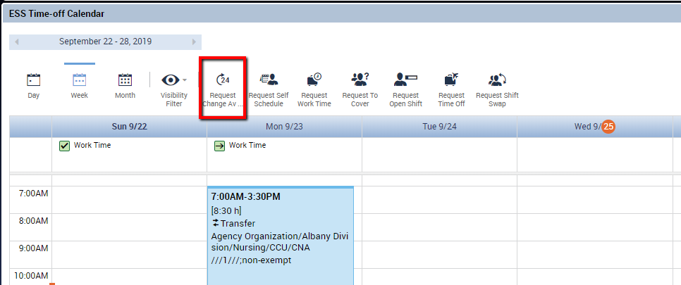

The Request window displays the employee’s current availability pattern.
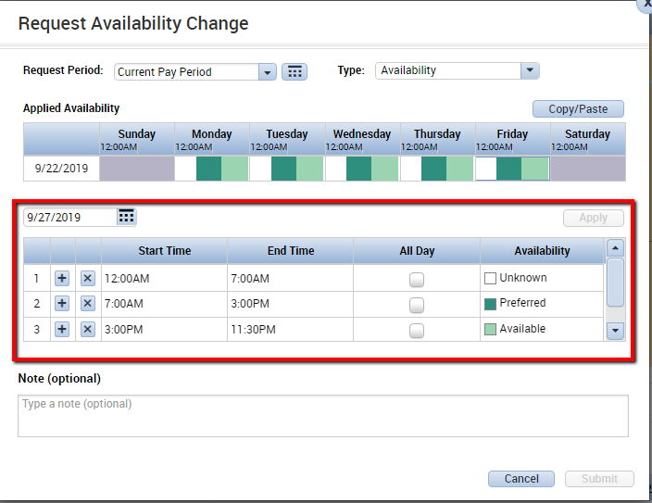
Applied Availability Section: This section displays the employee’s current pattern. The date in this section is the first day of the displayed week (in this case, Sunday, 9/22/19). The rest of the row displays the colors that correspond to the employee’s availability pattern.
The area selected in the red box shows the date for which the availability will be modified. The rows below show that the employee’s availability is set as:
Row 1: 12am-7am is set as Unknown. This does not prohibit this employee from being scheduled during this time, only that the employee has not indicated any preference here.
Row 2: 7am-3pm is set as Preferred. The employee has indicated that he prefers to work during this time frame.
Row 3: 3pm-11:30pm is set as Available. The employee is available to work during this time.
Scrolling down, Row 4: 11:30pm-12:00am is again set as Unknown.

To modify the Availability, the employee chooses the date to be modified. The employee can use the + and x buttons to add or remove rows as needed. The Start and End Time can be modified by typing directly in the box. Options for designating the availability during that time frame is chosen from the Availability dropdown.
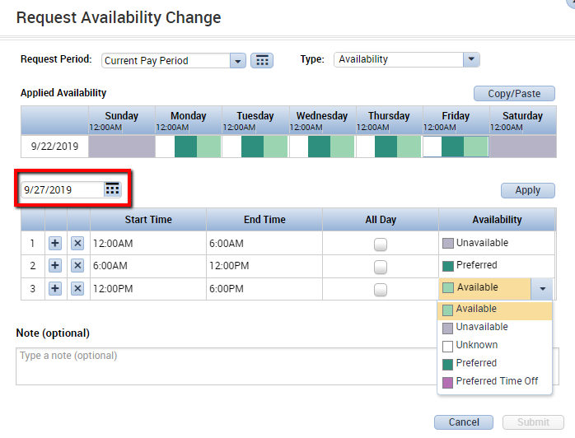
Once the employee has the availability set as needed, click Apply:
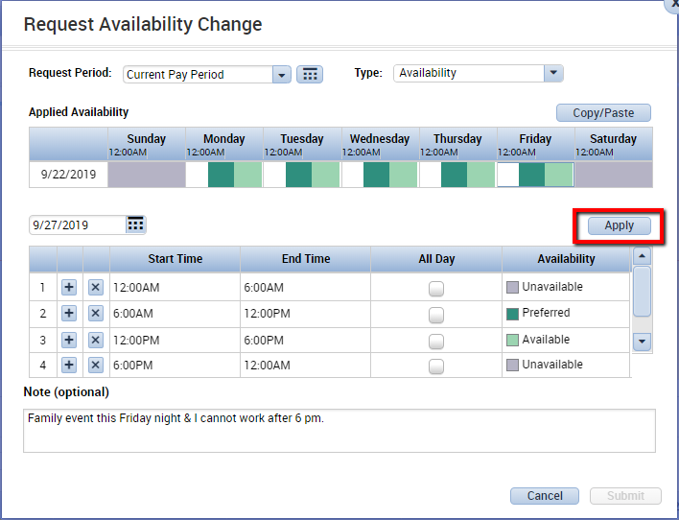

After clicking Apply, the color-coded availability for the chosen date changes:
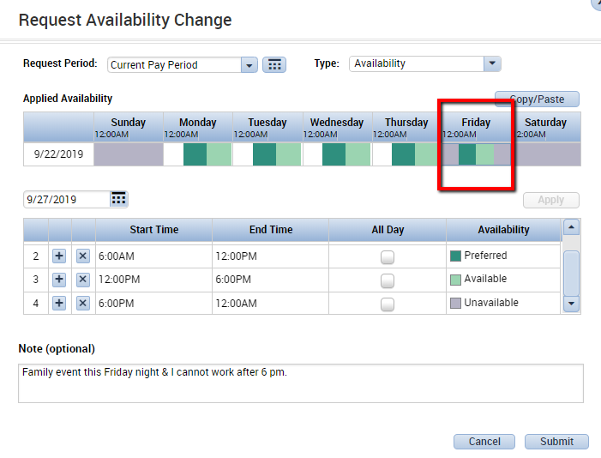
At this point the employee may click submit. This will complete the change of availability.
The Availability change indicator appears on the first day of the week where the availability was modified. Right clicking on the indicator will bring up details of how the availability was changed: 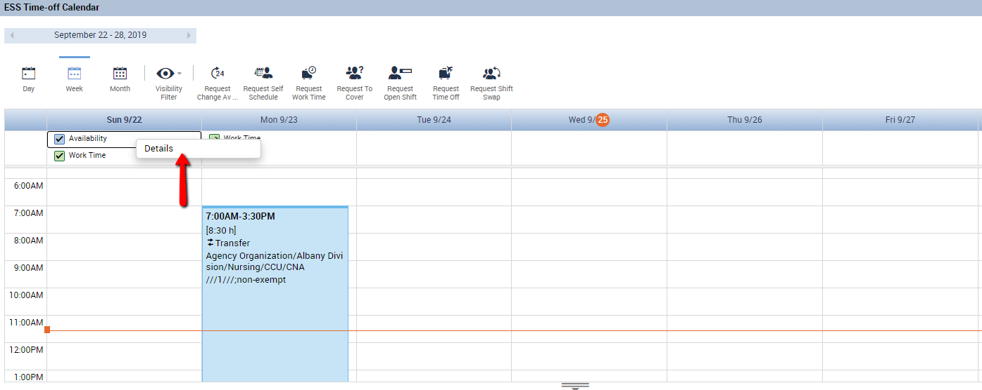
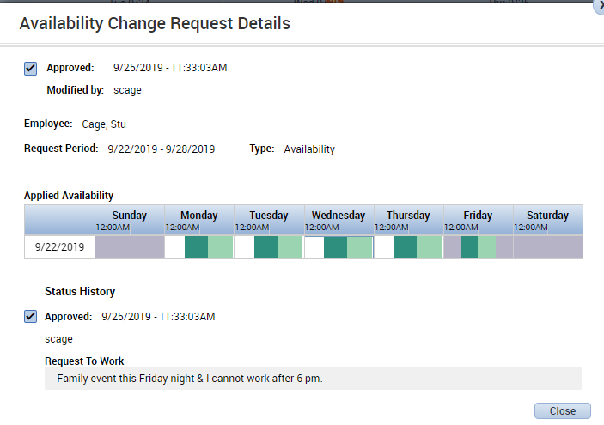

Notice that the availability was only modified for a single date, Friday. This change to availability only applies to the selected Friday and not every Friday.
If an employee does need to change availability for multiple days, each date must be selected in a separate availabililty request.
If an employee is changing multiple days in the same week, there is a Copy/Paste button in the Request that can be used to copy availability set in the same week.
- Select the Copy/Paste button
- Click the day with the availability to Copy
- Click the day to Paste that availability to.
