

Employee Guide

  - kronos version 8.1

Contents
USING WORKFORCE TIMEKEEPER 3
Logging In 3
Using the Navigator 4
Logging On to the Navigator 4
Navigator Layout 4
TIMESTAMPING 7
Recording Punches 7
Transferring Time 8
Job (Organizational) Transfer 8
Labor Account Transfer 9
Work Rule Transfer 9
Punch Time 11
Attestation Punching 11
USING TIMECARDS 14
Types of Timecards 15
Hourly View Timecards 15
Comments 15
Timecard Indicators and Colors 17
Project View Timecards 18
Entering Hours in a Project View Timecard 18
Transferring Hours in a Project View Timecard 19
Totals Tab 21
Additional Timecard Functions 21
Approvals 21
Printing a Timecard 22
Viewing Accruals Information 23
Information Included on Accruals Tab: 23
Additional Accrual Information: 23
REPORTS 24

USING WORKFORCE TIMEKEEPER
Workforce Timekeeper is accessed through Internet Explorer and other supported browsers. Kronos recommends using Firefox or Chrome if available. Once you are logged in, the application will display navigation buttons to help you move around. However, unlike in previous versions, you should not use your browser’s back and forward buttons as these will take you back to the logon page.
Version 8.1 uses Navigator view as the default. Navigators and Widgets allow users to see multiple work spaces and perform multiple functions from one screen.
Note: Because Workforce Timekeeper provides the opportunity of customizing the system to fit a variety of company policies and procedures, your screens may look different than those displayed in this manual.

Logging In
There are a variety of ways to access the Workforce Timekeeper logon page. If you have a shortcut on your desktop, simply double click it. Alternatively, you can save the Workforce Timekeeper URL in your browser favorites or type the URL in your browser’s address window where it can be recalled from the history list of your most recently visited sites. See your system administrator for help with accessing the Workforce Timekeeper URL.
When the log on screen appears, enter your User Name and Password in the appropriate fields, then click the Logon icon ( ) or simply hit the Enter key on your keyboard. The system will check the Access Profile assigned to your account to display the employees and functions that you are authorized to see.
Note: WFC uses either Oracle or SQL Server as its database engine. If your company is using an Oracle database, the User Name and Password are case-sensitive. If your database is SQL, only the password is case-sensitive.
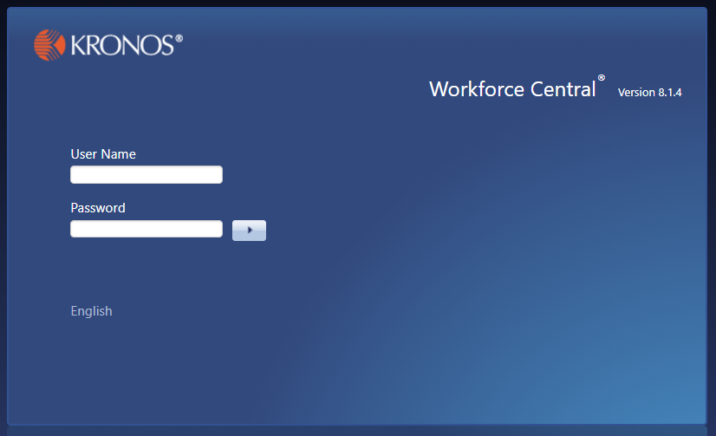

Using the Navigator

Logging On to the Navigator
The URL for the Workforce Central logon page will be http://[webserver]/wfc/logon where [webserver] is the name or IP address of your company’s Kronos application server. If your company uses SSL, it will be https:// instead of http://
See your Kronos Administrator if you need help logging into Workforce Central. Username and Password information will be provided by your organization.

Navigator Layout
After logging on, you will see the initial NGUI screen. Note that your company’s setup may vary from what is shown in this manual. The example below shows the “Timecard” widget in the middle, with additional widgets such as My Timestamp and My Calendar on the side.
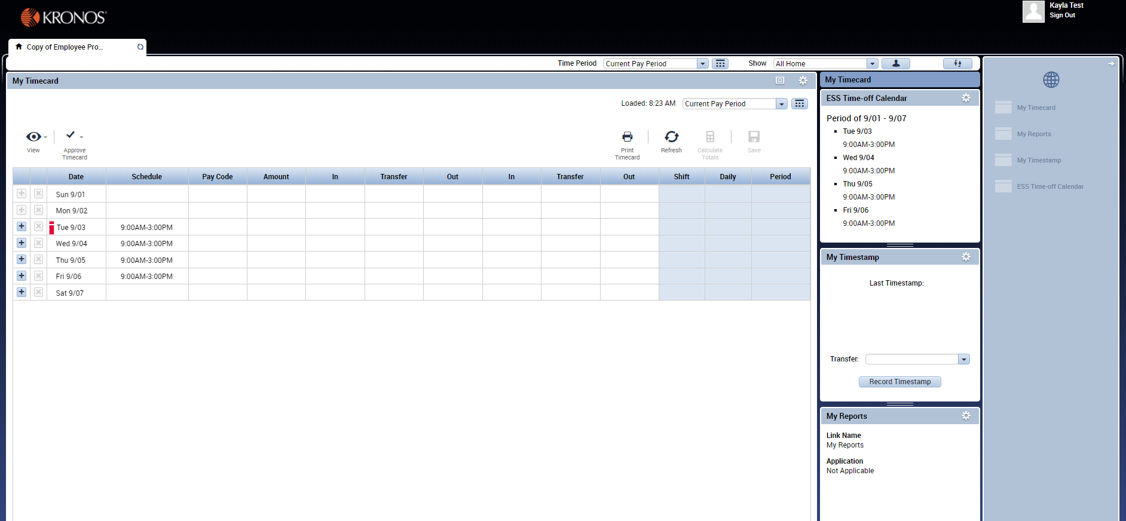

The middle widget is the active widget that you can work in; the widgets on the sides are the inactive widgets. You can make an inactive widget active by clicking on its title bar and dragging it into the center of the screen. You cannot move a widget from the center of the Navigator out; you must move another widget to the center, which will move the widget that was in the center to one of the side positions.

You can also click on the gear icon at the top right of an inactive widget and select Pop Out to make it active. Click Close to close the widget which will place it in the drawer on the right side of the screen for future use.
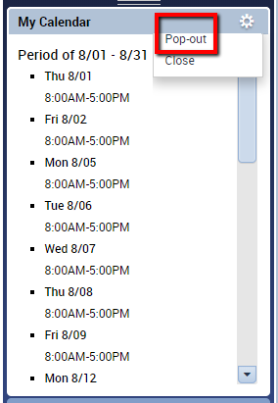
To expand the middle widget, click the Maximize icon. The widget will display as full screen.
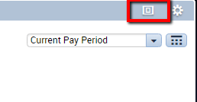
When a widget is maximized, click the Maximize button again to Restore Down to normal size.
To expand or shrink the widgets on the left and right sides of the active widget, click and drag the resize bar between widgets.
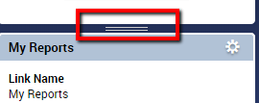

Widgets that have been closed can be accessed via the drawer, which is on the right side of the screen. The Navigator can have a maximum of three open at once, so any other widgets will be found in the drawer. Click the arrow in the upper right corner to expand the Drawer to see the names of the widgets, or simply hover your mouse over a widget icon to see the label.

The drawer contains all available widgets; the widgets currently displayed in the Navigator will be gray, while the widgets stored in the drawer will be white. To move a white widget out of the drawer, click and drag it to the left or right side of the Navigator. Simply clicking on a widget in the drawer will open it as the Active widget and will create a new tab on the Workspace line. Clicking the X in the tab will close the widget and restore the previous Workspace.
You have may access to Reports and Audits within the drawer.
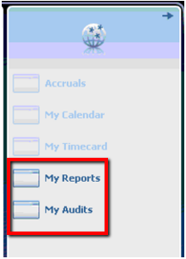

TIMESTAMPING

Recording Punches
Punches recorded at a timeclock will automatically flow into your employee timecard
Some employees may punch in and out via the My Timestamp widget. If more than a simple in/out punch is necessary, click the gear icon in the right corner and select Pop Out to move the My Timestamp widget to the middle of the screen as the main widget. Click the Record Timestamp button each time that you need to punch. A successful punch is shown:
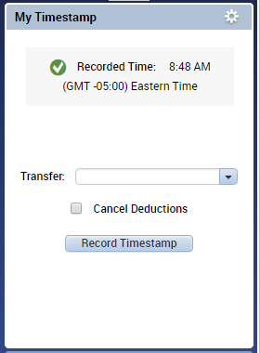
Punches entered from the My Timestamp widget will automatically flow into your employee timecard.

Transferring Time
Your organization may also require you to build a transfer into the punch if you are working outside your normal role or location. Use the Transfer dropdown to access the transfer options. The system will remember your last 5 transfers, or you can click Search to bring up additional options.
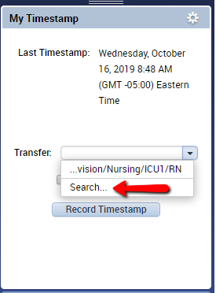
Depending on your organization’s setup, you may have access to a combination of these options. Available selections will be determined by your organization. Check with your manager for specifics on when to apply transfers and which transfers to apply.

Job (Organizational) Transfer
For organizations using Advanced Scheduler, Job Transfers allow an employee to allocate their worked time to a different location or role:
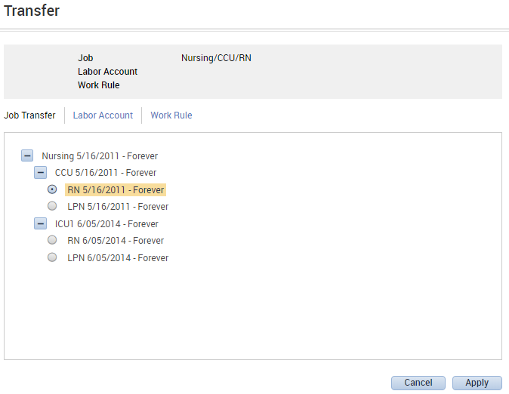

Labor Account Transfer
Labor Account Transfers allow an employee to select from a combination of dropdowns to allocate their worked time to a different location or role:
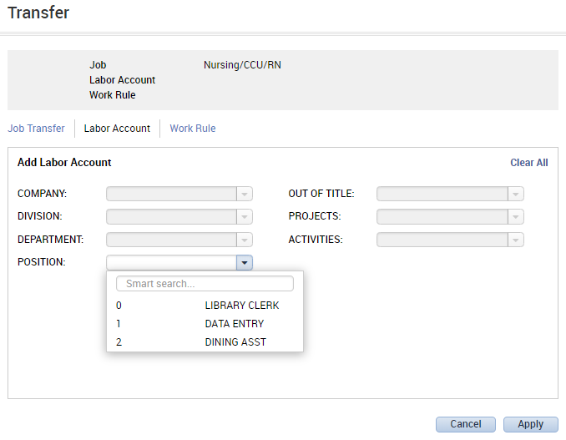

Work Rule Transfer
Work Rule Transfers are used when an employee is being paid at a rate other than their normal rate:
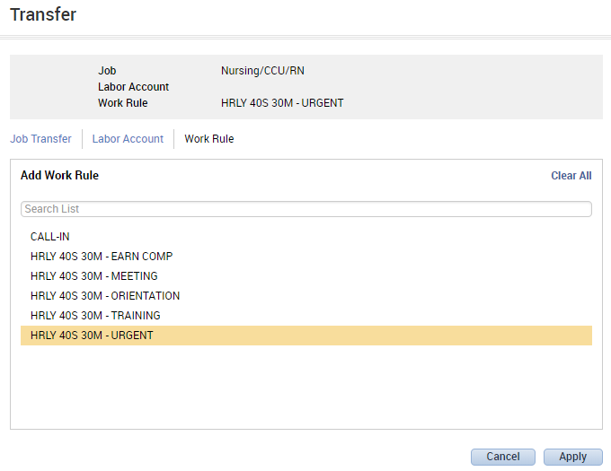

Choosing a combination of the available transfer options and clicking Apply will build the transfer into the punch:
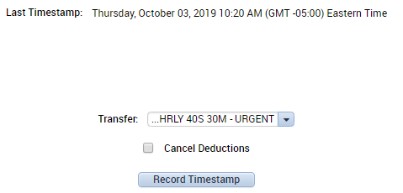
Click Record Timestamp as usual. The transfer then appears in the timecard along with the punch:
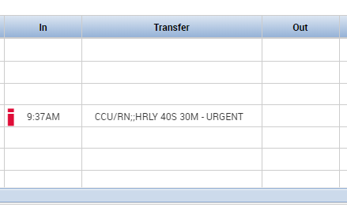
Worked Through Meal
Check the Cancel Deductions box to indicate that you worked through a meal. Then click Record Timestamp. This will flag the previous punch with an indicator that you worked through a meal. After that, you need to click Record Timestamp again to record an Out Punch.
If preferred, you may punch out first, then punch again with Cancel Deductions selected.
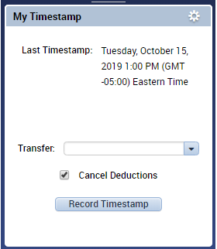

Punch Time
In and Out punches submitted at a timeclock or through the My Timestamp widget will flow directly to the timecard. Depending on your organization’s configuration, the punches may appear as rounded punches. For example, a 9:14am punch at the clock may round to a 9:15am punch. Right click on the punch to see the punch time as well as the rounded time.
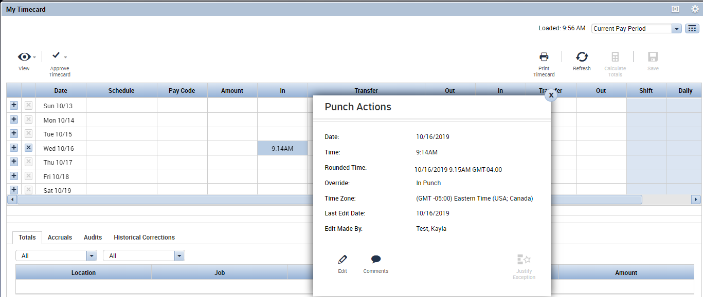

Attestation Punching
If your organization uses Attestation, you will need to follow a different procedure when punching in and out. You will need to Pop Out the My Timestamp widget.
Before punching, you will be presented with the date of your last punch and buttons for punching in and out. The displayed text can be customized by organization, so what you see may not exactly match the example:
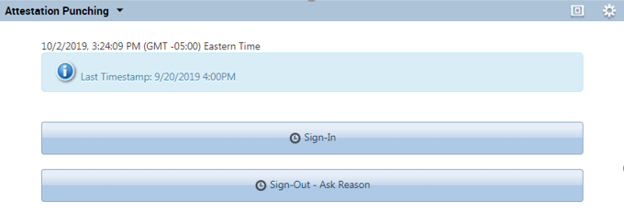

Here, selecting Sign-In will create an In Punch:
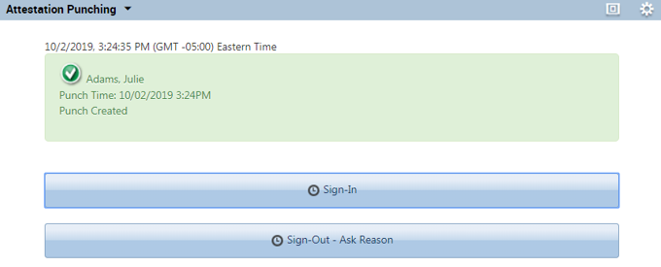

When selecting Sign-Out, you will be prompted with an additional question, asking you to verify whether you took your full scheduled meal break that day. Again, the exact wording of the question will be different based on your organization. Select Yes or No and then click Submit.
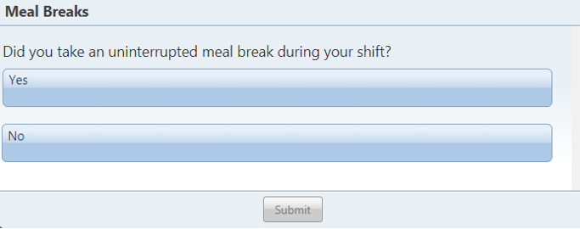
Selecting Yes will generate an Out Punch.

If you select No, you will be prompted with an additional question, and you will need to select the reason that you did not take your full scheduled meal break. The reasons to choose from will be determined by your organization. Select your reason, then click Submit. This will complete the Out Punch.
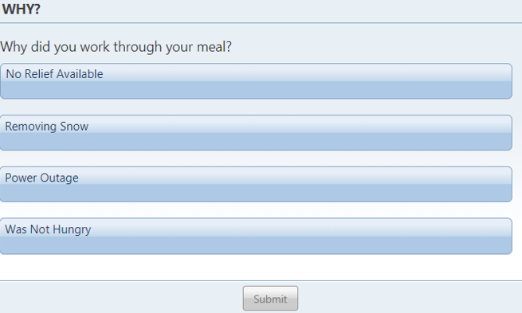
Depending on your schedule, you may or may not need to verify that you took your meal break. For example, an employee scheduled for only a few hours may not be expected to take a meal break during that time. An employee scheduled for a long shift may be expected to take more than one meal break. Each organization will have a unique set of questions and reasons that work best with the employees’ schedules, shifts, and expectations.

USING TIMECARDS
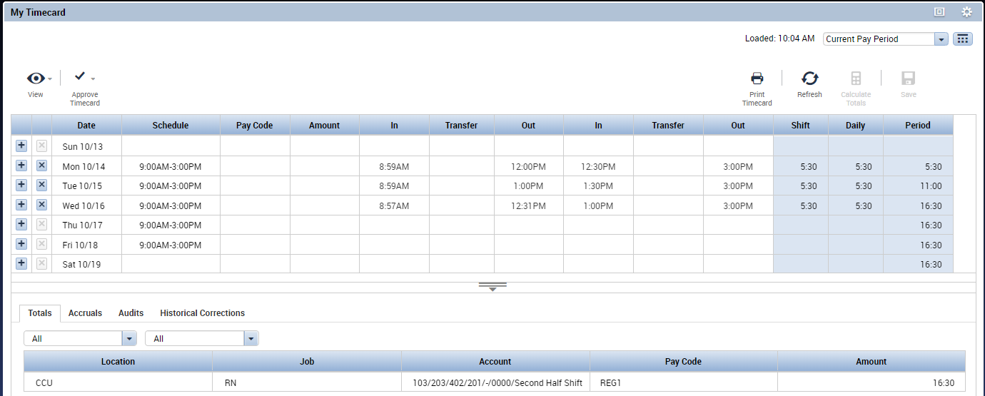
Your timecard may be the active widget when logging in. The default time frame displayed is Current Pay period, but you can change the time frame by clicking the displayed Time Period then click the down arrow and select one of the pre-defined intervals (ex: Previous Pay Period). Or, click the icon and select a Start and End date range. Then click Apply.
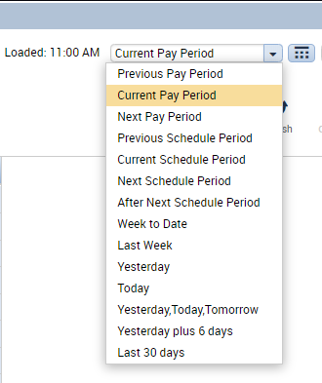

Types of Timecards
There are two timecard formats available for use in WFC: Hourly View timecards and Project View timecards.

Hourly View Timecards
Hourly View timecards display employee punches as received from data collection devices or as entered directly into the timesheet by a manager or employee.

Comments
Although not typical, your organization may allow you to add a comment to existing punches. To add a comment to a punch on your timecard:
- Right click the punch.
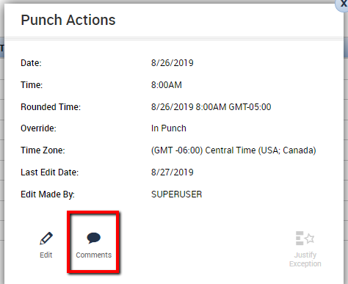
- Click Comments in the Punch Actions dialog box.
- Choose the comment from the dropdown. You may also have the capacity to type a note. All comments and notes added to your timecard will be seen by your manager.
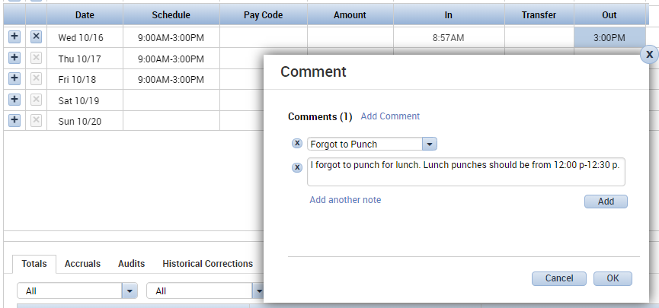
- A comment indicator () will now appear in the cell you have just edited. Comments and notes can be viewed by hovering your mouse over the Comment indicator in the cell.

Note: Pre-defined comments can be added to the selection list by your Kronos System Administrator.

Timecard Indicators and Colors
Indicator | Description
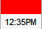 | A solid red cell indicates a missing punch. Positioning the mouse over the red box will display the words “Missed Punch.”
A red punch or i in a cell indicates an exception, such as a late or early punch, or an Unexcused Absence. Positioning the mouse over the cell will tell you what the exception is.

A triangle at the top right corner of a punch or pay code indicates that it has been added or modified by a manager.
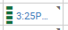 | A green punch or green vertical hash marks in a cell indicate an exception (previously marked as i) has been Marked as Reviewed.
 | A Blue date or blue vertical hash marks in a date cell indicates an Absence has been Excused.
 | A small blue dialog balloon in a cell indicates a comment has been attached to that cell. Hover your mouse over the balloon to view the comment. If there is a free-text note attached to the Comment, it will appear in parentheses after the Comment.
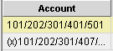 | An “(x)” before a labor account in the “Totals” section indicates that the account is not the Home labor account.

Project View Timecards
Project View timecards display durations of time. The Project View timecard is generally used by salaried or exempt employees who charge time to various projects or departments.
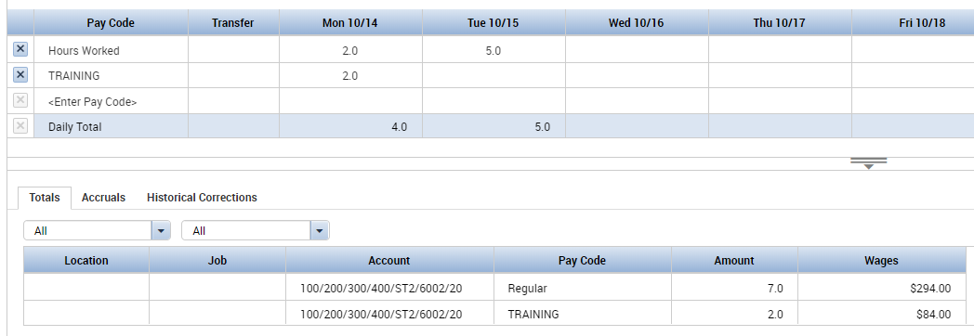

Entering Hours in a Project View Timecard
Because Project View timecards do not contain punches, hours are entered as durations.
To enter hours in a Project View timecard:
Click the Pay Code column and select the appropriate pay code. The default pay code for the Project View timecard is “Hours Worked.”
Click the cell under each day on the pay code line and enter the appropriate hours for each day.
To add different pay codes or assign hours to a different labor level, click the Insert Row icon () on the left side of the timecard and select the appropriate pay code and/or Labor Account.
Note: Both the Hourly and Project View timecards can be pre-populated for certain employees such as Salaried or Professional. This is known as exception editing; the timecard is edited only when the employee works something other than his/her normal schedule.

Transferring Hours in a Project View Timecard
If an employee works in more than one department or job, the hours can be allocated to Non-home department(s) by performing a transfer at the time clock or through the browser. The system will remember previous transfers so a repeat assignment can be easily selected from the transfer pick list.
To transfer all hours in a shift:
- Double click the Transfer column for the day on which the transfer occurred. Select a previous transfer or choose Search to build a new one.
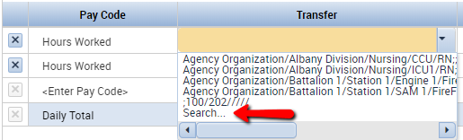
- Depending on your organization’s setup, you may have options to choose Job transfer, a Labor Account transfer, or a combination:
For organizations using Advanced Scheduler, Job Transfers allow an employee to allocate their worked time to a different location or role. Job Transfer:
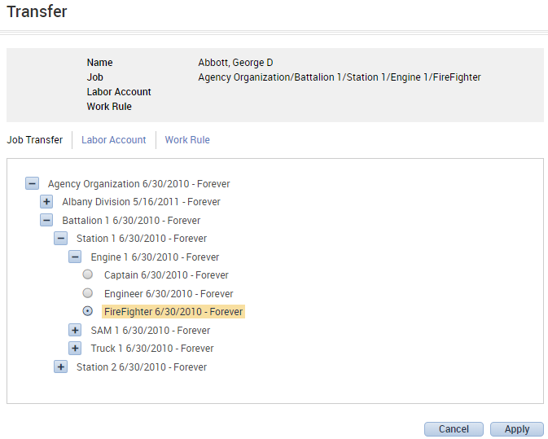

Labor Account Transfers allow an employee to select from a combination of dropdowns to allocate their worked time to a different location or role. Labor Account Transfer:
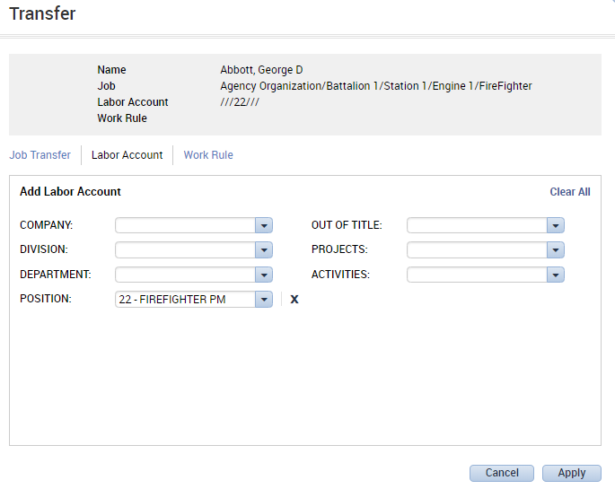
3. Click OK.
4. Click Save or Calculate Totals to see the result of the transfer in the timecard. 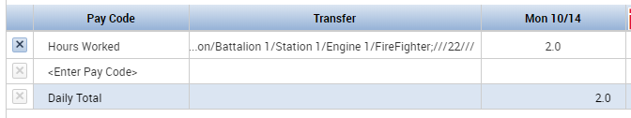
To continue to enter worked time for the same day, simply click in the <Enter Pay Code> field and select Hours Worked again from the dropdown. Without a transfer applied, the hours will automatically allocate to the employee’s home department and pay rate. Enter the worked time as needed and click Save or Calculate Totals.
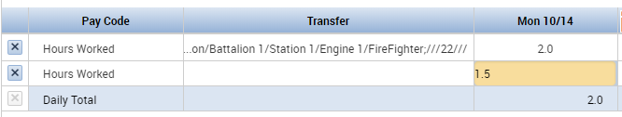

Totals Tab
Both Hourly View and Project View timecards will have a Totals tab.
The Totals tab displays the number of hours allocated to regular time and transferred time, as well as any pay codes such as sick time or vacation time.
With both Hourly View and Project View timecards, transferred hours are denoted in the Totals tab of the timecard with “(x)” preceding the labor account.
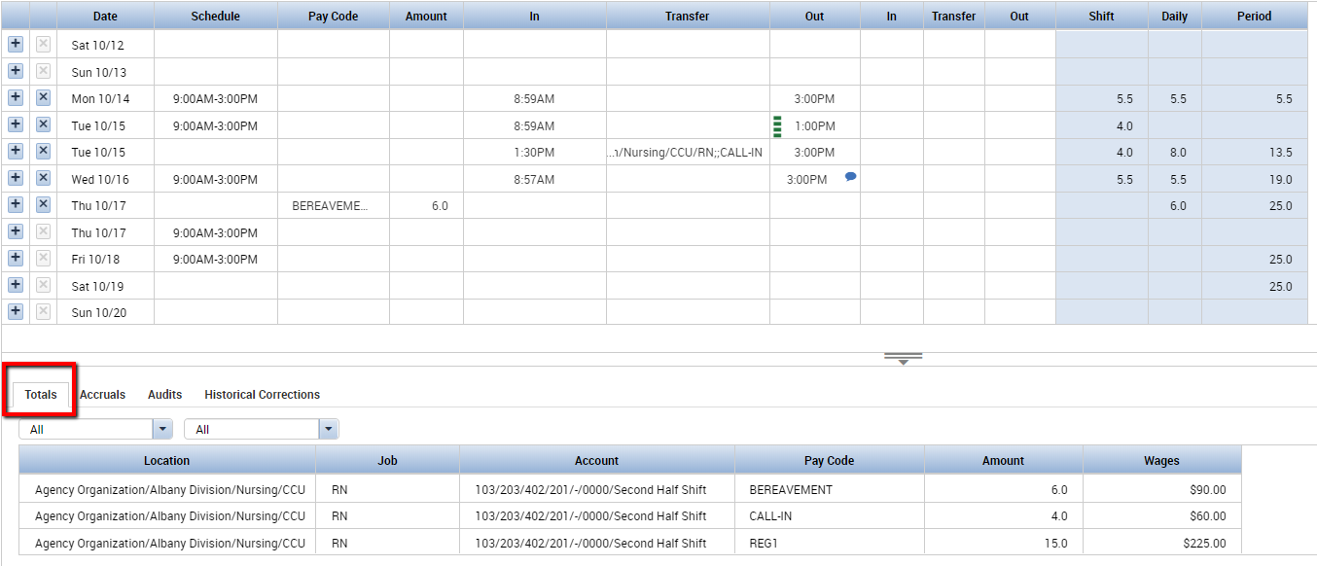

Additional Timecard Functions

Approvals
There are two levels of approval in Workforce Timekeeper, Employee Approval and Manager Approval. Your company may choose to use both, one, or neither. Approvals serve as a documentation and communication device for indicating that a timecard has been reviewed by the employee or manager.
Important facts about approvals:
Approvals can be done any time before the timecard is signed off. This means approvals can be done while still in the current pay period.
An Employee Approval locks the timecard from any further edits by the employee. Depending on your system configuration, employees may or may not be allowed to remove their approval which will unlock the timecard and allows further editing by the employee. Supervisors and/or managers can still edit the employee’s timecard after an Employee Approval. An approval can be removed if you have been given this privilege in your Access Profile. Approvals can only be removed by the person who originally performed the approval.
When a timecard has been approved by either the employee or manager, the background color of the timecard will change.
Performing an approval while viewing the timecard:
Select the Approve Timecard icon in the left corner. After approval, the background color of the timecard will change color. If you have permission to remove the approval, you will be able to click the Approve Timecard option again to remove the approval.
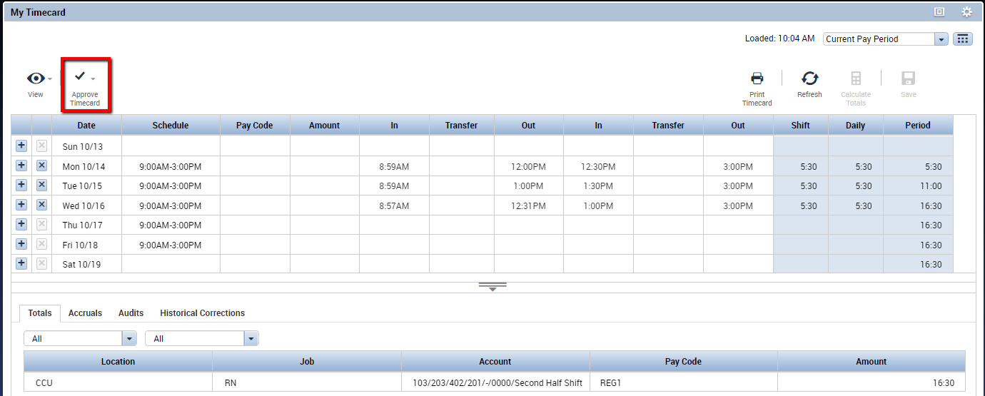

Printing a Timecard
To print a timecard:
1. Click the Print Timecard button. A separate window will open with a preview of the timecard as it will print.
2. In the Print dialog box select the printer, then click Print.
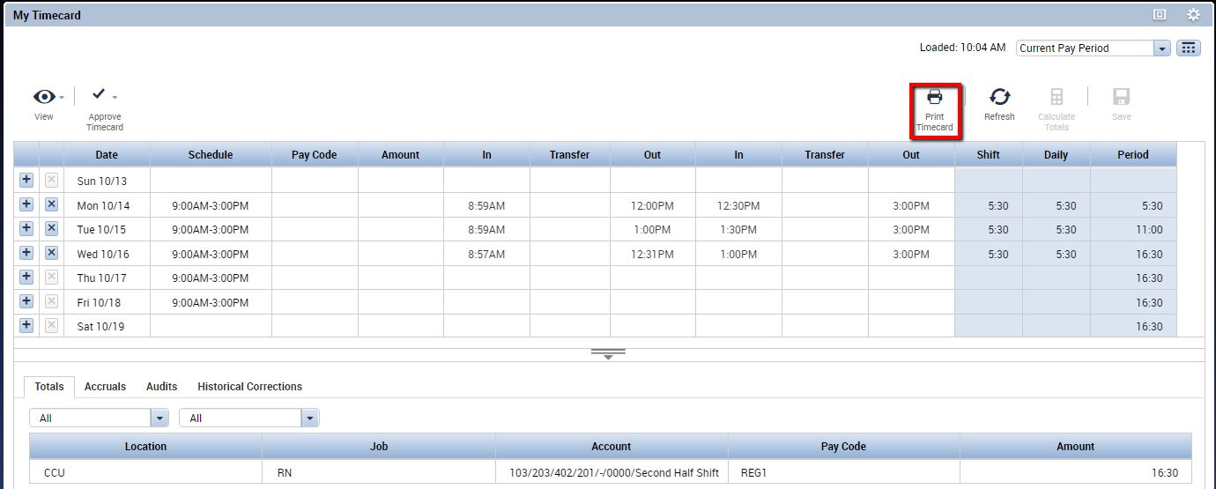

Viewing Accruals Information
Accruals are amounts of time that employees earn as benefits such as vacation, sick, or personal time. You can view your accrual balances by clicking the Accruals tab located directly beneath the timecard grid.
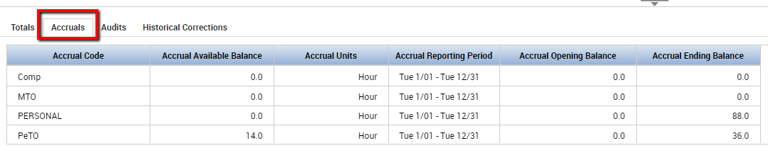
Workforce Timekeeper contains a powerful accruals engine which can handle virtually any accrual policy. Your company may elect to have Workforce Timekeeper calculate your accruals, or if your accruals are calculated by your payroll system, the balances can be imported into Workforce Timekeeper for easy viewing by the manager and/or employees.

Information Included on Accruals Tab:
Accrual Code – the code that identifies and holds the type of accrual balance, such as vacation, sick, or personal time.
Accrual Available Balance – the balance for the accrual code as of the day selected in the timecard. If no day is selected, the balance will be as of the last day of the time period being displayed in the timecard.
Accrual Units – the unit associated with an accrual code; either hours, days, or money.
Accrual Reporting Period – this is generally the calendar year (1/01-12/31) or your company’s fiscal year as defined in System Settings
Accrual Opening Balance – the balance as of the first day of the Accrual Reporting Period.
Accrual Ending Balance – the balance as of the last day of the Accrual Reporting Period. This will include any future requests for time off as well as any accrual earnings, such as an anniversary grant.

Additional Accrual Information:
Projected credits in the Accrual Ending Balance only apply to companies where Workforce Timekeeper is calculating the accrual balances. Projected credits are based on fixed grants, not earned grants. A fixed grant defines periodic accrual increases in preset amounts. An earned grant uses one or more pay codes to calculate the amount of accrual credit an employee earns during a pay period or other interval of time.
Workforce Timekeeper calculates accrual balances from the last day in the selected time period (e.g. “Current Pay Period”). Accrual balances are updated when the timecard is totaled.
If hours have accrued, but the employee is still in a probation period, the probation status (p) is indicated in the hour or money values.

REPORTS
Pop Out the My Reports widget to see the reports available to you. Each report provides a short description of the information it contains.
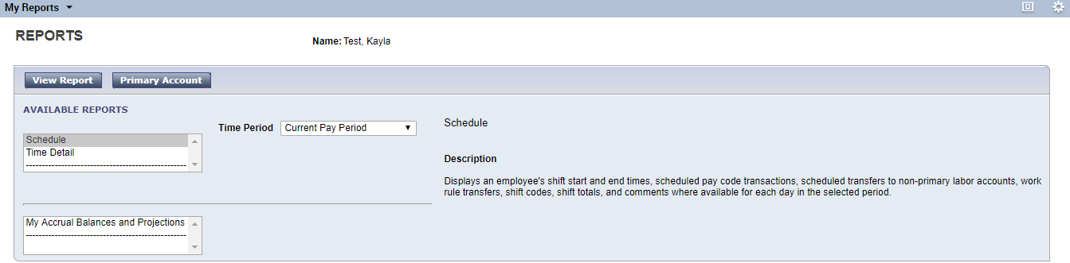
Select from the report choices and choose View Report to see the information.

