

Request Open Shifts

  - kronos version 8.1

Contents
REQUEST OPEN SHIFTS 3
Creating a New Request 3

REQUEST OPEN SHIFTS
Requesting an Open Shift allows an employee to request to work a shift that is currently not assigned to anyone. The employee submits the request and the manager must approve. Employees can only see open shifts that they are qualified to cover.

Creating a New Request
- The employee will see the open shifts in the Calendar widget. The open shifts appear in red: 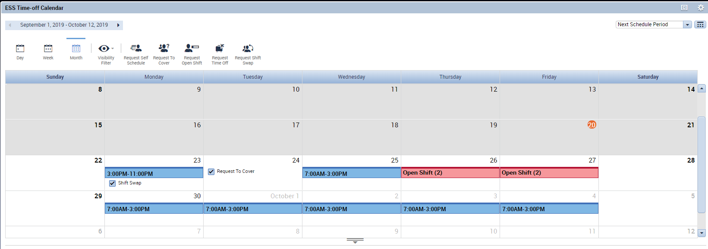
- Hovering over the open shift will show brief detail about what shifts are open. The employee can also use the Location Schedule tab beneath the calendar to see what other employees are scheduled to work at the location at the time. 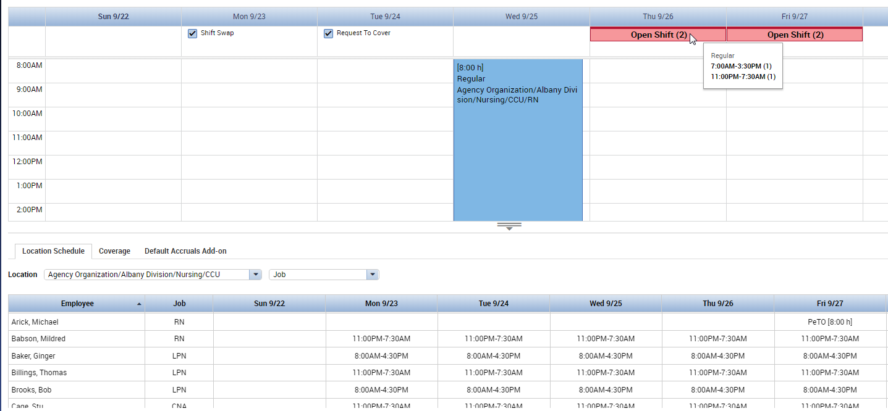

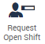
- The employee can use the Request Open Shift button ( ), or right click on the red Open Shift banner to request to work one of the open shifts:
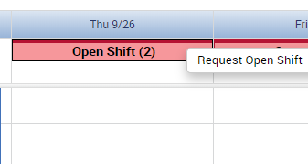
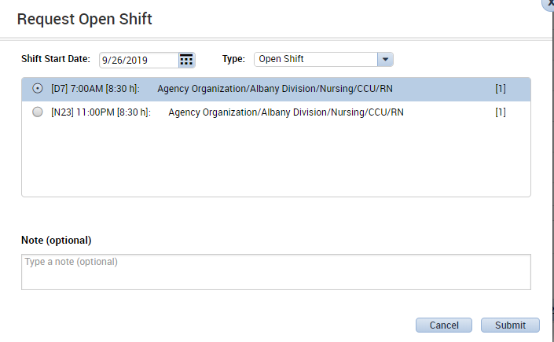
- The Request Open Shift window appears. Any open shifts that the employee qualifies to work will be displayed. The employee can select one of the shifts, type a note if necessary, and click submit.
- The employee’s calendar shows that the request to work the open shift was submitted, but the shift is not assigned to the employee until approved by the manager. 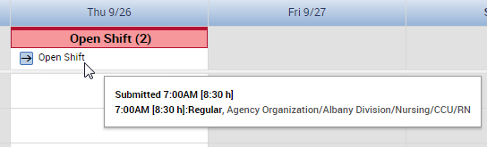
- Until the manager approves one employee to be assigned to the shift, other employees can still request to take the open shift. The manager will see all submitted requests in the Requests Widget and can then decide which employee request to approve.
- The manager will see an alert in the Requests Alert and can navigate to the Requests Widget to approve the change to the employee’s schedule. If email notifications are set up, the manager will also receive an email letting them know to log into Kronos to approve or deny the request. The manager will see the Open Shift Request in the Request Widget and can use the buttons at the top to approve or refuse the request: 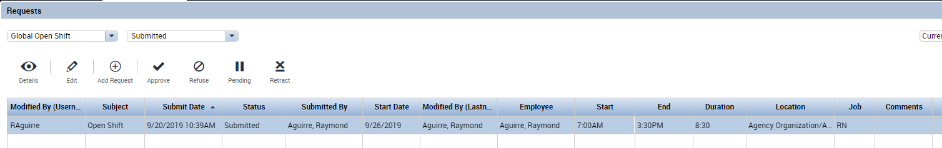
- Once the manager has approved the request, the employee’s schedule will be modified: 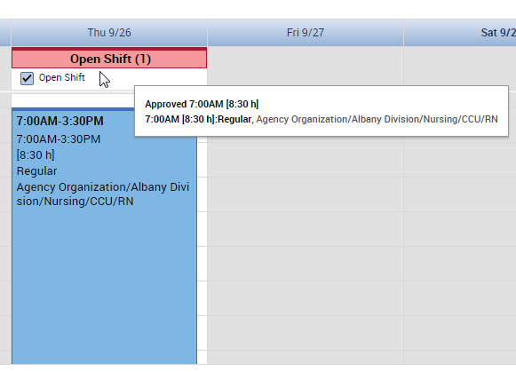
The employee is now scheduled for the 7a-3:30p shift that they requested. The red Open Shift banner displays that there is still 1 open shift to be picked up on that day, since the employee chose 1 of 2 available shifts.

