

Summary of Changes:

Version 8.0 to Version 8.1

  - kronos version 8.1

Contents
Summary of Changes 3
General 3
Name and Sign Out Button 3
Manager Tasks 3
Workspaces 3
Exceptions 4
Overtime Approvals 8
Staff Management Widget 9
Employee Tasks 12
Time Off Requests 12

Summary of Changes
Kronos Version 8.1.4 no longer requires Flash and can be used in any browser. For best performance, Chrome or Firefox are recommended. Due to the removal of Flash, some of the views and functionality have changed. This brief guide explains those changes.

General

Name and Sign Out Button
The Name/Sign out button have been moved to the upper right of the screen. They were previously on the left.

Manager Tasks

Workspaces
If you have access to additional workspaces, they were previously located in a carousel at the top right of the page. You can now open additional workspaces just by clicking on the “+” next to the open workspace. Please note you will only have this if you have access to additional workspaces.
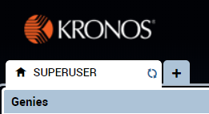

Exceptions
The Exceptions widget view has changed to be integrated into the timecard widget.
Please Note: Opening the Timecards widget or using the “Go To” Timecards from any other genie will still open the normal timecard view.
The Exceptions Summary view still has the same columns for types of exceptions. (Unexcused Absence, Missed Punch, etc.)
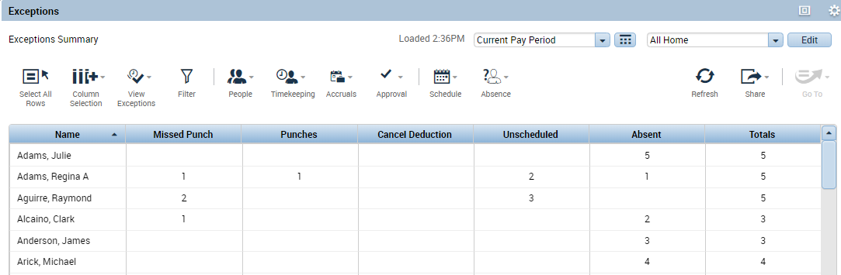
You can select employees and use the “Go To” Timecards to open a selection of exception timecards.
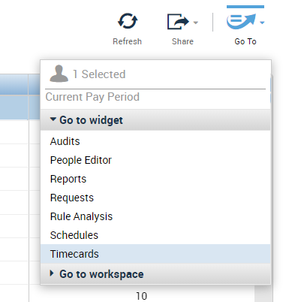

You can also use the “View Exceptions” button at the top to choose which type of exception timecards to look at. This replaces hovering over the column and selecting it.
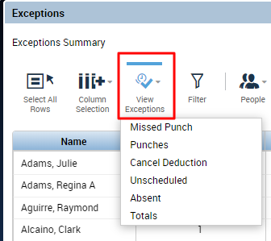
When the Exceptions timecard has been opened, you will see a message stating that it is in the “Exceptions” view. This is circled below. This means that only days with exceptions are shown, instead of the entire pay period.

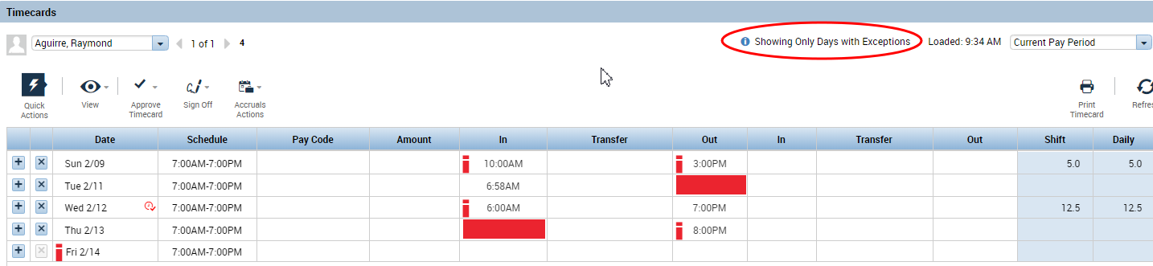

At the top left there is a new button called “Quick Actions”. Click on this to expand the options. You would then click on the action you would like to use. Once selected, it will give you a selection pointer.
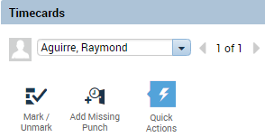
The Mark/Unmark action is selected below (highlighted in blue). This allows you to click on any punches with exceptions (in red) to mark them as reviewed (in green). When you are done with an action, click on the action button again to unselect. Please remember to save any changes. The save button is still located at the top right.
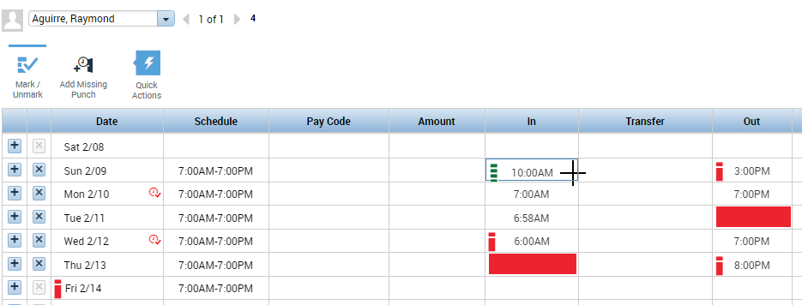
The other action available is “Add Missing Punch”. Clicking on any day with a missing punch will add the scheduled time if the schedule is set.
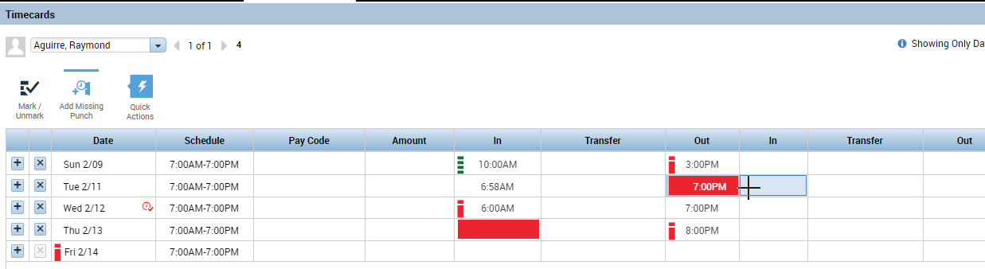

You can easily switch to the full timecard view by choosing the “View” button and unchecking the “Only Days with Exceptions” view.
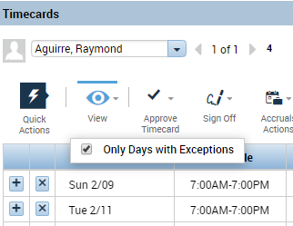

Overtime Approvals
If you are using Overtime Approvals, more approval options have been added. The icon remains the same in the timecard (red clock appears on the date). Right click to open the Date Actions window, then choose Approve Overtime:
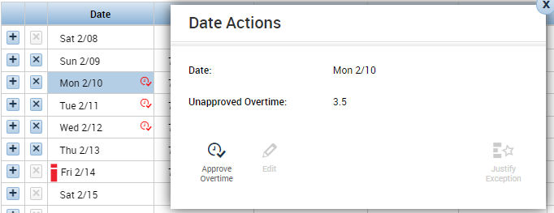

In the screen below, you can see that a new time window has been added for approving the overtime if needed.
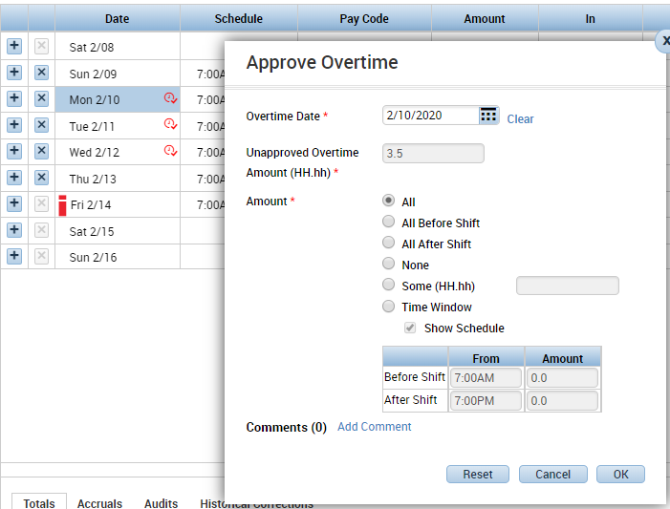

Staff Management Widget
For organizations with Advanced Scheduler, changes have been made to the Staff Management widget.
When opening the Staff Management widget, the landing page is now a summary screen, as shown below:
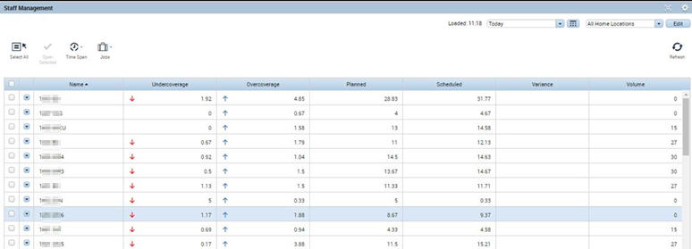

Clicking the blue arrow () next to a cost center will display a more detailed breakdown of all jobs within that cost center.
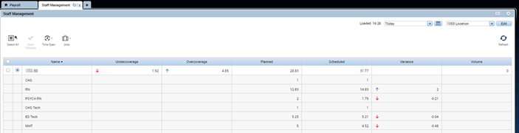
For more detail, select one or more cost centers and choose the Open Selected icon.
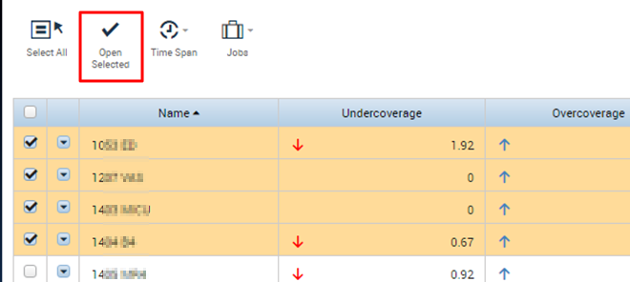
This will display the details for each selected cost center. The panel view on this screen is similar to the layout that was seen in the previous version. Notice that the Time Period and Hyperfind selection dropdowns have moved to the right corner.
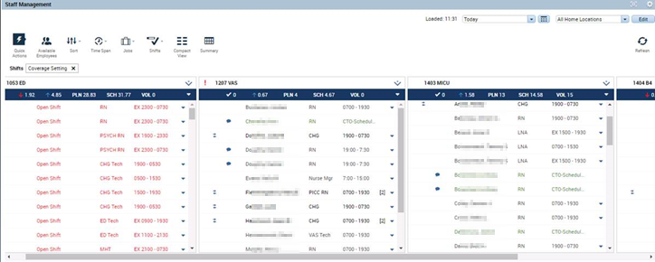

The previous selection dropdowns for All Day, All Jobs, and All Shifts have now been replaced with icons. The icons are labeled Time Span, Jobs, and Shifts. The functionality remains the same.
Previous look:
New look:

The previous action icons for Delete Shift, Unassign Shift, and Lock are now together under the Quick Actions icon. Click the Quick Actions icon to expand the menu.
Previous look:
New look:
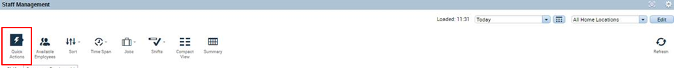

The Available Employees icon opens the pane on the left showing available employees.
Previous look:
New look:
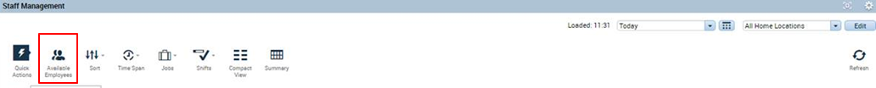

The Compact View icon will shrink the size of the displayed panels so that more cost centers can be displayed on the screen. The Summary icon will return you to the summary screen as displayed on the landing page when first opening the widget.

Employee Tasks

Time Off Requests
To request time off, employees use the Request Time Off icon.
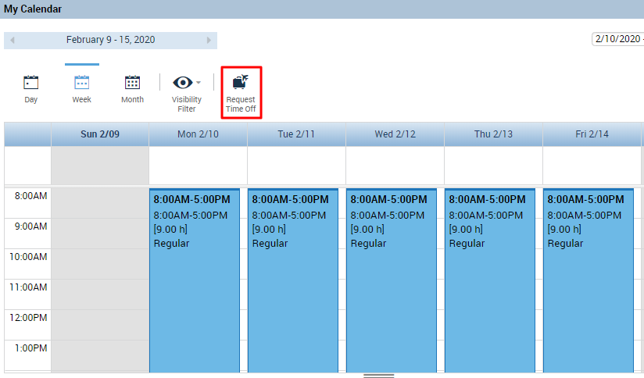
The window to complete the time off request will display.
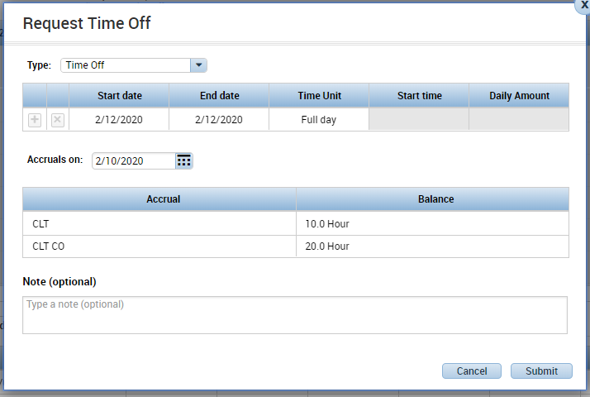

Once the time off request is submitted, the Time Off Request appears on the requested day along with an icon of a green arrow. This shows that the request is in Submitted status.
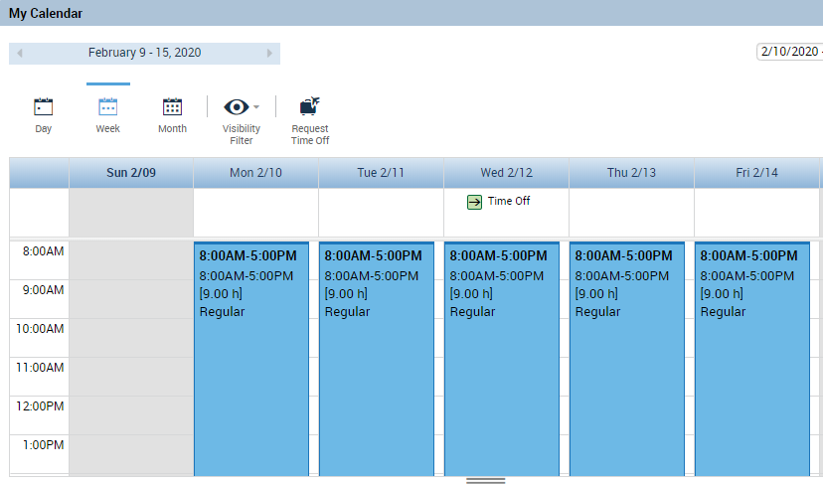

The employee can right click to get details or cancel the request. This was previously accessed by hovering over the request. Now the request must be right clicked in order to perform one of these actions.
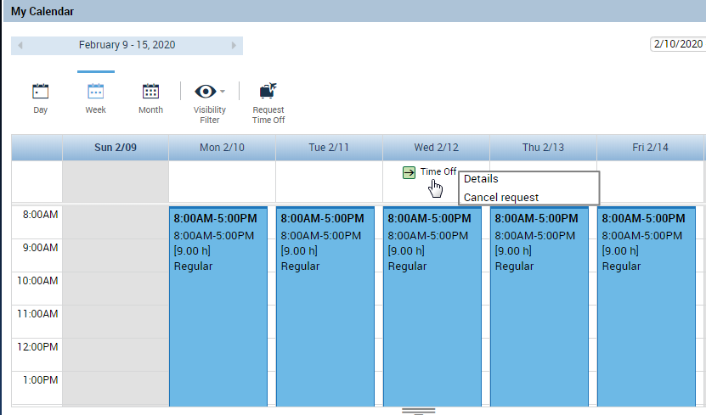
Once the request is approved, the icon becomes a check mark in a green box. Again, the user can right click to get details or cancel the request.
