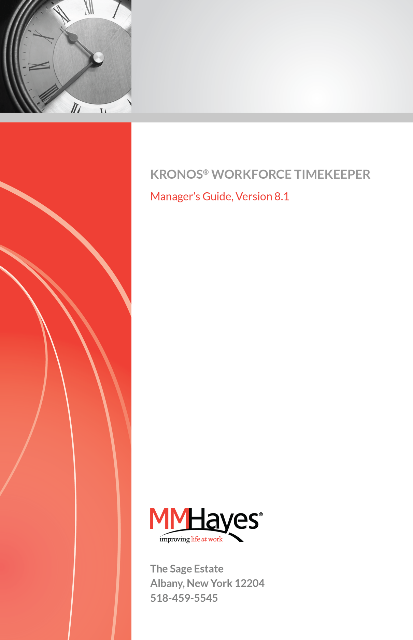

Workforce Accruals, Workforce Central, Workforce Central Suite logo, Workforce Genie, Workforce Manager and Workforce Employee are trademarks of Kronos Incorporated.
Acrobat is a registered trademark of Adobe Systems Corporation.
Windows, Internet Explorer and SQL Server are registered trademarks of Microsoft Corporation.

When using and applying the information generated by Kronos products, customers should ensure that they comply with the applicable requirements of federal, state and local law, such as the Fair Labor Standards Act.

Using Workforce Timekeeper 4
Logging In 5
Using the Navigator 6
Logging On to the Navigator 6
Navigator Layout 6
Alerts 9
Using Help 10
Changing Your Password 10

Workforce Timekeeper Genies 12
About Workforce Timekeeper Genies 12
Types of Genies 13
Using Genies 14
Selecting and Sorting Columns in Genies 15
Selecting Employees 15
Applying Workforce Functions to Selected Employees 16

Using Timecards 17
Types of Timecards 18
Saving and Calculating Timecard Totals 18
Saving Changes 18
Calculating Totals 19
Refreshing 19
Common Timecard Tasks 19
Adding Missing Punches 19
Editing Punches 20
Timecard Indicators and Colors 23
Entering Hours in an Hourly View Timecard 24
Entering Hours in a Project View Timecard 25
Timecard Quick Actions 26
Timecard View Option 27
Transferring Hours in a Timecard 28
Approving Overtime 34
Moving Hours 37
Viewing Hours for Specific Days 38
Historical Correction Totals 38
Approving and Signing Off Timecards 39
Approvals 39
Sign-Off 41
Printing a Timecard 42
Supporting Timecard Tabs 42

Group Editing 46
Performing Group Edits 46
Performing a Group Edit from a Workforce Genie 46
About Group Edits 47

HyperFind Queries 49
Types of HyperFind Queries 49
Query Conditions 50
Creating HyperFind Queries 50

People Editor 52
Accessing the People Editor 52

Calendar Genies 54
Time Off Requests 56

Scheduling in Workforce Timekeeper 60
Employee Patterns: Creating Initial Pattern 62
Employee Patterns: Changing Patterns 63
Making Temporary Changes to Employee Schedules 65
Schedule Quick Actions 66
Schedule Views 67

Reports 68
Running Reports 68
Creating Favorite Reports 69

Using Workforce Timekeeper
Workforce Timekeeper is accessed through Internet Explorer and other supported browsers. Once you are logged in, the application will display navigation buttons to help you move around. However, unlike in previous versions, you should not use your browser’s back and forward buttons as these will take you back to the logon page.
Prior to version 6.3, WFC screens could be accessed only one at a time and only the functions on that screen were available for immediate use. For example, when logging into WFC v6.2 the user would see only the default genie assigned to his or her login, and from there could access Timecards, Schedules, Attendance, People records and Reports using Launch Buttons.
In version 6.3 of Workforce Central, Kronos introduced Navigators and Widgets which allow users to see multiple work spaces and perform multiple functions from one screen.
In versions 6.3 through 7.x, users were given the option of using the Classic UI (user interface) or the new Navigator based UI (NGUI).
With the elimination of Java from the user interface in version 8, the Classic view is no longer available
Note: Because Workforce Timekeeper provides the opportunity of customizing the system to fit a variety of company policies and procedures, your screens may look different than those displayed in this manual.

Logging In
There are a variety of ways to access the Workforce Timekeeper logon page. If you have a shortcut on your desktop, simply double click it. Alternatively, you can save the Workforce Timekeeper URL in your browser favorites or type the URL in your browser’s address window where it can be recalled from the history list of your most recently visited sites. See your system administrator for help with accessing the Workforce Timekeeper URL.
When the log on screen appears, enter your User Name and Password in the appropriate fields, then click the Logon icon ( ) or simply hit the Enter key on your keyboard. The system will check the Access Profile assigned to your account to display the employees and functions that you are authorized to see.
Note: WFC uses either Oracle or SQL Server as its database engine. If your company is using an Oracle database, the User Name and Password are case-sensitive. If your database is SQL, only the password is case-sensitive.
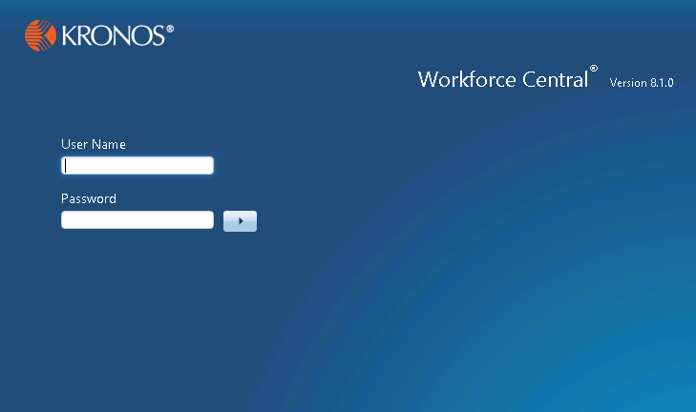

Using the Navigator

Logging On to the Navigator
The URL for the Workforce Central logon page will be http://[webserver]/wfc/logon where [webserver] is the name or IP address of your company’s Kronos application server. If your company uses SSL, it will be https:// instead of http://
See your Kronos Administrator if you need help logging into Workforce Central.

Navigator Layout
After logging on, you will see the initial NGUI screen. Note that your company’s setup may vary from what is shown in this manual. The example below shows the “Genies” widget in the middle, with additional widgets such as Reports, Quick Links, Time Off Requests, Schedules, etc., in the drawer. During your implementation, you will be able to review your options and modify your own Workspaces.
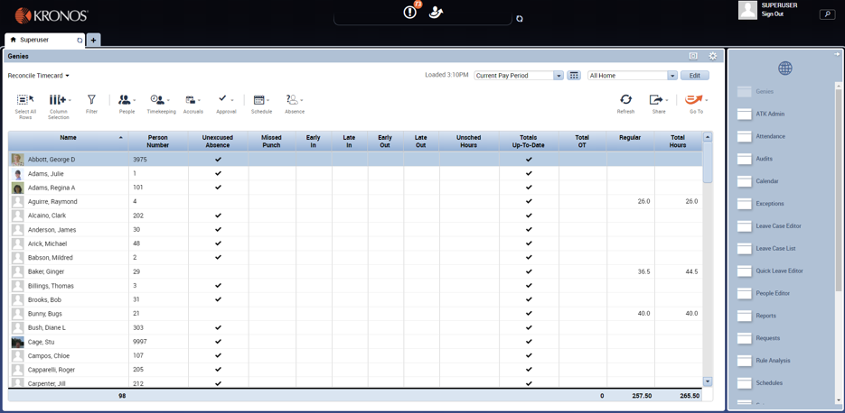
The middle widget is the active widget that you can work in; the widgets on the sides are the inactive widgets. You can make an inactive widget active by clicking on its title bar and dragging it into the center of the screen. You cannot move a widget from the center of the Navigator out; you must move another widget to the center, which will move the widget that was in the center to one of the side positions.
You can also click on the gear icon at the top right of an inactive widget and select Pop-out to make it active. Click Close to close the widget which will place it in the drawer on the right side of the screen for future use.
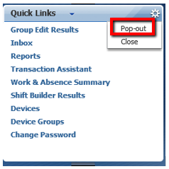
To expand the middle widget, click the Maximize icon.
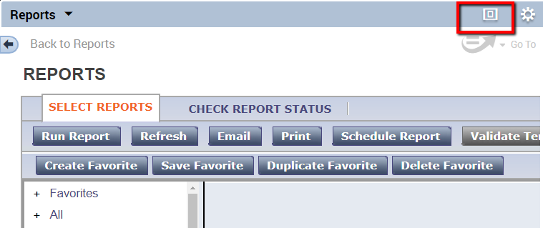
When a widget is maximized, click the Maximize button to Restore Down to normal size.
To expand or shrink the widgets on the left and right sides of the active widget, click the resize bar between widgets, and drag up or down.
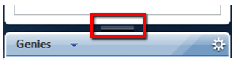
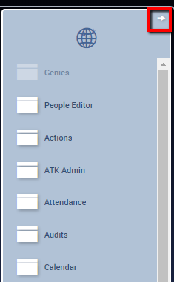
Widgets that have been closed can be accessed via the drawer, which is on the right side of the screen. The Navigator can have a maximum of seven widgets open at once, so any other widgets will be found in the drawer. Click the arrow in the upper right corner to expand the Drawer to see the names of the widgets, or simply hover your mouse over a widget icon to see the label.
The drawer contains all available widgets; the widgets currently displayed in the Navigator will be gray, while the widgets stored in the drawer will be white. To move a white widget out of the drawer, click and drag it to the left or right side of the Navigator. Simply clicking on a widget in the drawer will open it as the Active widget and will create a new tab on the Workspace line. Clicking the X in the tab will close the widget and restore the previous Workspace.
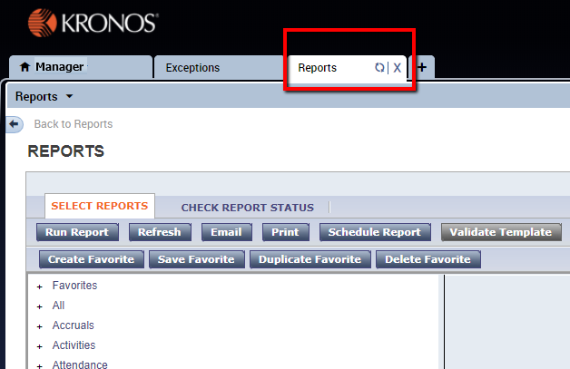

Alerts

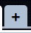
Alerts are found at the top middle of the page. The most common alerts are Exceptions and Time Off Requests. Each alert has a severity associated with it. Low severity alerts will have a blue balloon icon, medium severity alerts will have an orange exclamation point in a triangle, and high severity alerts will have a red exclamation point in a circle. Clicking on an Alert will open a separate window where you can drill down to the Exception or Request detail so that you can correct or act on the Alert.
Additional Workspaces can be accessed via the icon next to the default workspace:
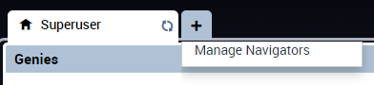
Depending on your system setup, you may have 1 or more additional workspaces available to you.
Once opened, Workspaces will appear as separate tabs, allowing you to switch from one workspace to another easily. You can Refresh or Close it by clicking the buttons on the applicable tab.
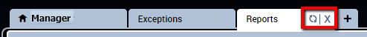

Using Help
Online help is available by clicking the Help workspace from within the Navigator which will launch the Workforce Timekeeper Help site map, from which you can select a specific topic or click Index to search for your topic.
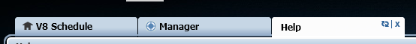

Changing Your Password
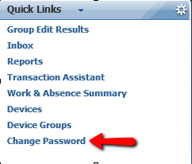
If your company is using Kronos authentication and your system administrator has given you a generic password, the first time you log on to Workforce Timekeeper you may be prompted to change your password.
From that point on, you can change your password whenever you want by clicking Change Password in the Quick Links widget.

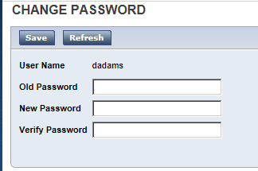

Workforce Timekeeper also supports LDAP and NT (Active Directory) authentication. If your company chooses to use one of these methods, your Kronos password will always be the same as your network password and you will not see the “Change Password” feature on your screen.

Workforce Timekeeper Genies

About Workforce Timekeeper Genies
Workforce Genies are a key component of the system, offering several advantages to managers including:
- The ability to view information such as hours, exceptions, and schedules for all employees on one screen
- Perform Group Edits on all, one, or a selected group of employees
- Select a specific employee or employees to view or edit detailed information such as timecards, punches, or scheduled shifts
Genies which are available for your use will be listed in the Genie widget which will be located in the Workspace (can be made full-screen using Pop Out) or the drawer on the right side of the Navigator (as shown below). Genies can be customized by your Kronos System Administrator to display specific information and default to specific employees and a selected time period.
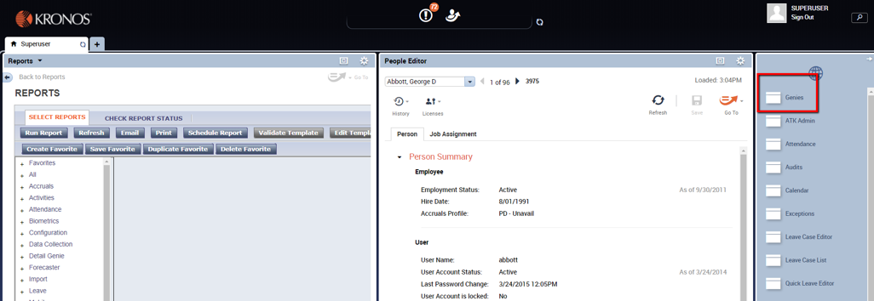

Types of Genies
Detail Genie | Displays time and attendance information for individual employees. Detail Genies are the starting point for viewing and editing timecards and People records, as well as running reports.
Roll-up Genie | Displays summary information by labor level. Ex: Department
Schedule Genie | Displays schedule information for individual employees and groups. Schedule Genies are the starting point for editing employee schedules.
Calendar Genies | Displays past and future events for employees in a calendar format with a legend to describe specific events.

Using Genies
When the Genie widget is moved to the center of the Navigator, the default genie (first one in the list) will be displayed. You can select other genies from the drop-down list in the upper left corner of the widget.
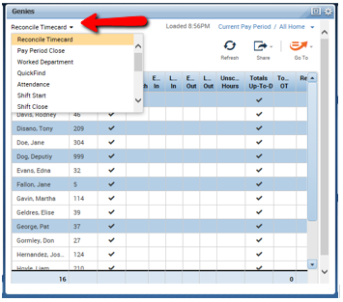
The header displays the functions which can be performed in a genie, as well as drop-down selection options for Time Period and HyperFind Queries in the upper right corner.
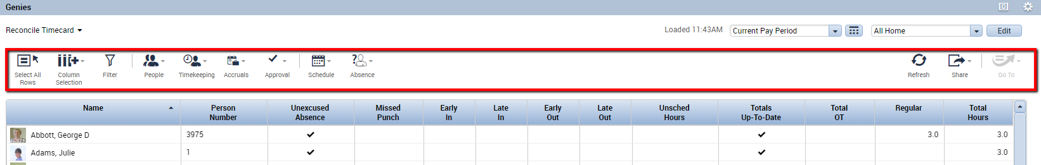

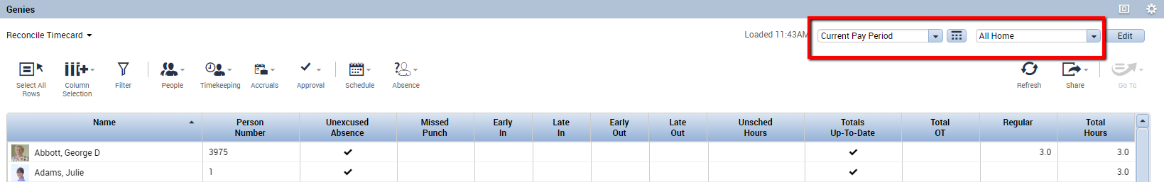

Selecting and Sorting Columns in Genies
You can select which columns are visible in the genie by clicking the Column Selection icon in the genie header and unchecking any columns in the dialog box that you do not want to see. Restore hidden columns by clicking the Column Selection icon and clicking the box next to the column.
To sort the information in a Genie column in ascending order, click the column heading once. Click again to sort in descending order.
For example, to sort all employees with missing punches, simply click twice on the column label for Missed Punches to sort in descending order. All employees with missing punches will now be grouped together at the top of the Genie. Most genies are sorted by Name by default, so clicking the Name column will return to the original sort.

Selecting Employees
You must select employees from a Genie before you can access their timecards, People records, schedules, or reports.
To select all employees, click the Select All Rows icon in the header. This will highlight all employees in the Genie.
To select multiple employees, click and drag if the employee names are next to one another or use Ctrl/click to select non-contiguous employees.
To select a specific employee, simply click the name to highlight it.
For example: to select employees with missing punches, hold the Ctrl key down while clicking on employees who have a check mark () in the Missed Punch column.

Applying Workforce Functions to Selected Employees
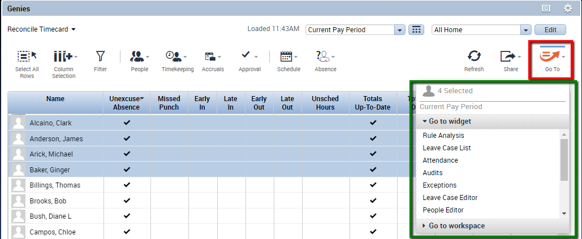
Once you’ve selected your employees, click the Go To icon on the right side of the genie header, then click the appropriate selection: Timecards, Schedules, People Editor, Reports, etc., in the Go To dialog box. The options in your Go To dialog box will be determined by the system administrator.

Using Timecards
As a manager, you can review, edit, or approve the timecards of the people who report to you. You can select one timecard or many timecards at the same time.
To open a timecard for a single employee from a Genie, double click the employee’s name. To open multiple employee timecards, follow the steps for Selecting Employees on page 15, then click Go To > Timecards, as described on the previous page. The timecard(s) will load for the same time period that was selected for the Genie from which the employee(s) were selected. Once the timecard appears, you can change the timeframe by clicking the displayed Time Period (ex: Previous Pay Period), then click the down arrow and select one of the pre-defined intervals, or click the icon and select a Start and End date range.
Then click Apply.
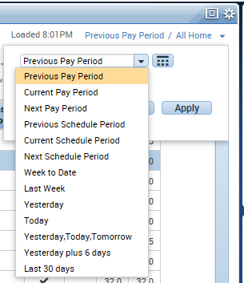

Types of Timecards
There are two timecard formats available for use in WFC:
Hourly View Timecard – Displays employee punches as received from data collection devices or as entered directly into the timesheet by a manager or employee.
Project View Timecard – Displays durations of time. The Project View Timecard is generally used by salaried or exempt employees who charge time to various projects or departments.
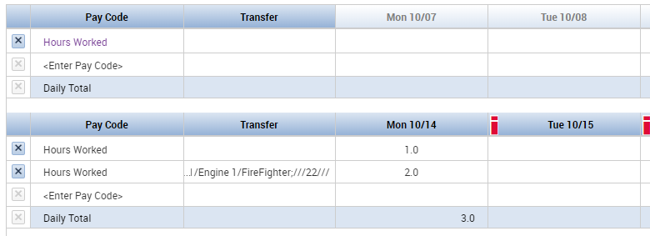

Saving and Calculating Timecard Totals
One of the characteristics of web-based programs is that work is performed on a local PC, and the database is not updated and totals are not calculated until the work is saved. When you make changes to a timecard, the effect of those changes may not be visible until you Save the changes or Calculate Totals.

Saving Changes
As soon as you make a change to a timecard, the Calculate Totals and Save icons in the Timecard header will change from grayed-out to a color to indicate that you have unsaved changes in the timecard. The color will depend on which theme your Kronos system is using. In the basic theme that most companies use, the color will be orange. Clicking the Save button will save your changes to the database and update the screen with new totals. The Calculate Totals and Save icons will revert to grayed-out.

Calculating Totals
There may be times when you want to see the effects of timecard edits before saving them. Once you’ve performed the edits, clicking Calculate Totals will update the timecard totals based on your changes. The Calculate Totals icon will be grayed-out, but the Save icon will remain active (colored) indicating that you have not yet saved the changes.

Refreshing
Every screen in Workforce Timekeeper has a “Refresh” button, which is usually located in the header. Clicking Refresh will restore the information to the screen as of the last time it was saved to the database. If you have not saved your changes before clicking Refresh, the system will prompt you with a warning message and allow you to save before refreshing.

Common Timecard Tasks

Adding Missing Punches
If the employee has a schedule, the missed punch indicator (red cell) will be displayed in the cell where the punch is missing.

To fix the missing punch:
- Click on the solid red cell (one click).
- Enter the time using the keyboard. Ex: 3:00pm = 3p.
- Press the Enter or Tab key.
- Save.
If there are more than two punches on a day and one of the punches is missing, insert a blank row for that day by clicking the Insert Row icon () at the left side of the timecard. Enter the missing punch on the blank row in the applicable In or Out column, then Save.
Note: If the employee does not have a schedule, determine what day contains the missing punch, add a blank row for that day, and enter the missing punch on the blank row.

Tips for entering time:
- When adding or editing punches, you may use either 12 hour (standard) or 24 hour (military) time format, e.g. 3:00pm can be entered as either 3p or 15.
- When entering punches, the system defaults to 24 hour time. When entering time in 12 hour format, add a “p” to all punches after 12pm. For example, to enter a time of 7:00am, simply hit the “7” key and then hit Enter. To enter 1:00pm, type 1p or 13, then hit Enter.
- You do not need to type the colon that separates hours and minutes. Ex: 3:30pm can be entered as 330p or 1530.

Editing Punches

To change a punch time:
- Double click on the punch to be edited.
- Type the new time from the keyboard.
- Press Enter or Tab.
- Save.

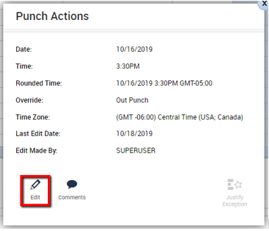
To change an existing punch:
- Right click the punch.
- Click the Edit icon in the
Punch Actions dialog box.
- Select the appropriate field.
You can change the punch
Time, Override the punch
e.g. “New Shift”, or
Cancel a Deduction, such
as a meal.
Click OK, then Save.

To Review an Exception:
Early in, Late in, or Unscheduled punches may be flagged as Exceptions. The Exceptions indicator appears as a red bar on the flagged punch. Right click the punch to see the type of exception.
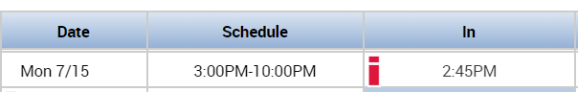
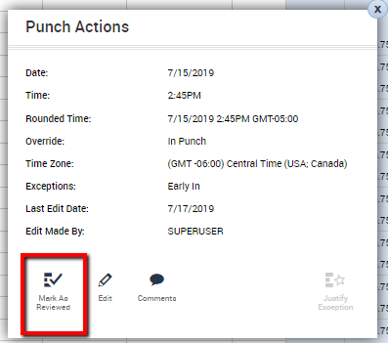
- Right click the punch.
- Click Mark as Reviewed
in the Punch Actions
dialog box.
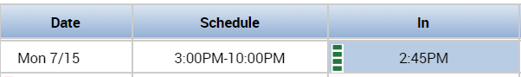
- The Exception flag will turn
green to indicate the exception has been Reviewed:

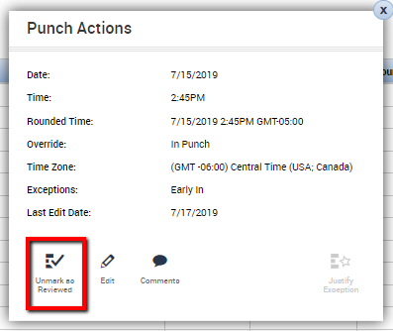
- To undo, right click the
punch again
and select
Unmark as
Reviewed.

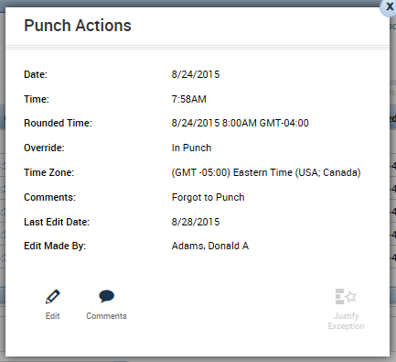
To Add a Comment to a punch:
- Right click the punch.
- Click Comments in the Punch Actions dialog box.

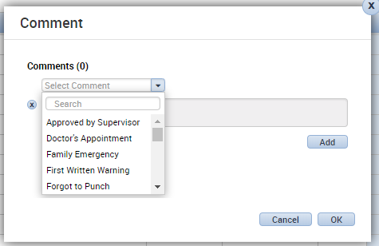
- Select your comment(s)
from the dropdown list.
Once the comment is
selected, there may be
a freeform Note section
that can be used to type
additional information.
- Click OK, then Save.

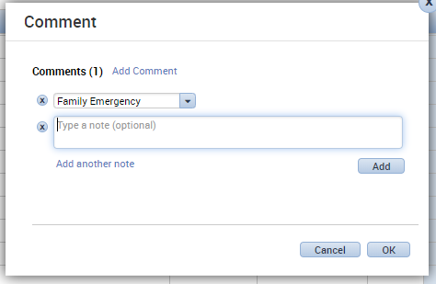

A comment indicator () will now appear in the cell you have just edited. Comments and notes can be viewed by hovering your mouse over the Comment indicator in the cell.
Note: Pre-defined comments will be added to the selection list by your Kronos System Administrator.

Timecard Indicators and Colors
Indicator | Description
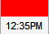 | A solid red cell indicates a missing punch. Positioning the mouse over the red box will display the words “Missed Punch.”
 | A red punch or i in a cell indicates an exception, such as a late or early punch, or an Unexcused Absence. Positioning the mouse over the cell will tell you what the exception is.
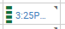 | A Green punch or green vertical hash marks in a cell indicate an exception (previously marked as i) has been Marked as Reviewed.
 | A Blue date or blue vertical hash marks in a date cell indicates an Absence has been Excused.
 | A small blue dialog balloon in a cell indicates a comment has been attached to that cell. Hover your mouse over the balloon to view the comment. If there is a free-text note attached to the Comment, it will appear in parentheses after the Comment.
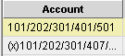 | An “(x)” before a labor account in the “Totals” section indicates that the account is not the Home labor account.

Entering Hours in an Hourly View Timecard

To enter hours in an Hourly View timecard (also known as a pay code edit):
- Double click the Pay Code column for the appropriate day.
- Select the correct pay code from the list, e.g. “Jury Duty.”
- Press the Tab key; the cursor will move to Amount.
- Enter the number of hours to be added, e.g. “8.0.”
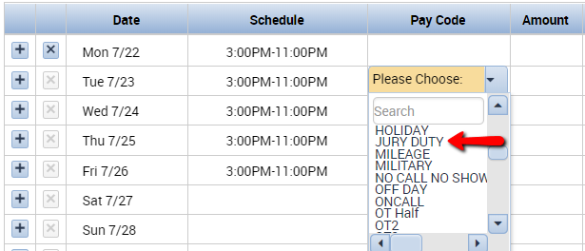
- Save.

Tips for entering hours in the timecard:
- You may enter the time in hours-minutes or hours-decimals. For example, seven and a half hours can be entered as “7:30” or “7.5.”
- You cannot enter hours on a line that contains punches. To add hours on a day that contains punches, click the Insert Row icon () on the left side of the timecard for the date you’re working on and enter the hours on the blank line.

Entering Hours in a Project View Timecard
Because Project View timecards do not contain punches, hours are entered as durations.
To enter hours in a Project View timecard:
- Click the Pay Code column and select the appropriate pay code. The default pay code for the Project View timecard is “Hours Worked.”
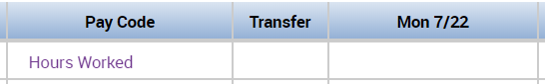
- Click the cell under each day on the pay code line and enter the appropriate hours for each day.
- To add different pay codes or assign hours to a different labor level, click the Insert Row icon () on the left side of the timecard and select the appropriate pay code and/or Labor Account.
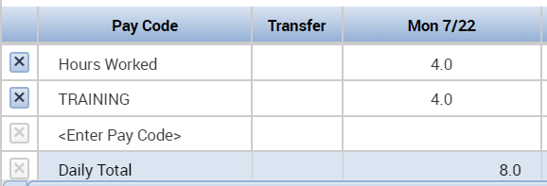

Note: Both the Hourly and Project View timecards can be pre-populated for certain employees such as Salaried or Professional. This is known as exception editing; the timecard is edited only when the employee works something other than his/her normal schedule.

Timecard Quick Actions
Timecard Quick Actions can be accessed by clicking this icon:
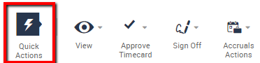
Clicking the Quick Actions icon opens a new tray of Quick Actions:
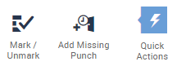

Click the Quick Actions icon again to close the Quick Actions tray.

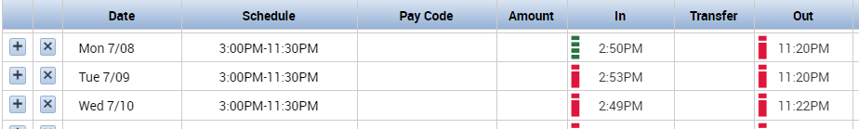
Mark/Unmark: Using this icon allows to repeatedly Mark Exception As Reviewed. Once the icon is selected, the cursor turns to a crosshair (+) which can be used to repeatedly approve exceptions. Click the icon again to turn this feature off.

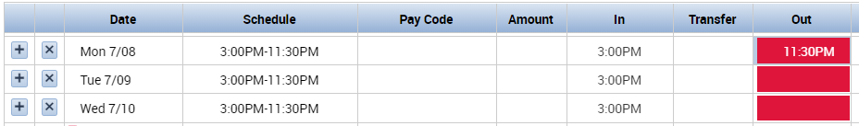
Add Missing Punch: Using this icon allows to repeatedly Add A Missing Punch. Once the icon is selected, the cursor turns to a crosshair (+) which can be used to repeatedly fill in punches based on the employee schedule. Click the icon again to turn this feature off.

Timecard View Option
Using the View icon on the timecard gives the option to View Only Days with Exceptions.

This timecard is showing all days in the Pay Period:
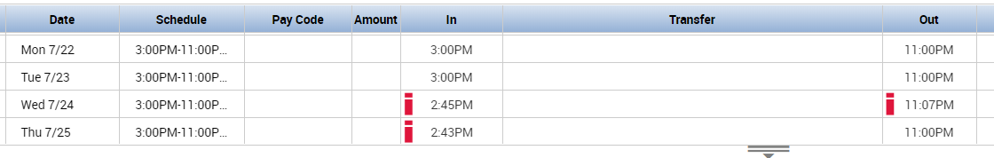

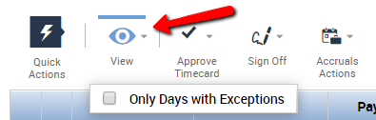
After choosing to View Only Days with Exceptions, the timecard will only show Wednesday and Thursday, because they are the only days where exceptions appear:

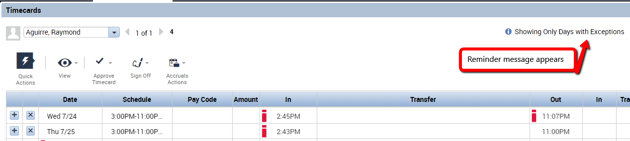

To return to the normal view, click the View icon again and un-check the check box.

Transferring Hours in a Timecard
If an employee works in more than one department or job, his hours can be allocated to the Non-home department(s) by performing the transfer at the time clock or through the browser. If the supervisor is performing the transfer in the timecard, the system will remember previous transfers that the manager performed so a repeat labor level assignment can be easily selected from the transfer pick list.
To transfer all hours in a shift:
- Double click the Transfer column for the day on which the transfer occurred.
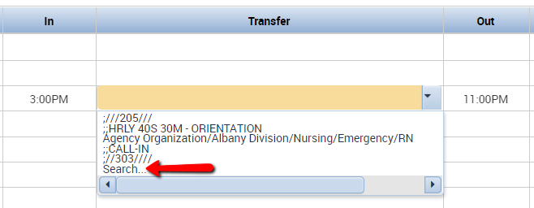
- Select the correct labor account from the displayed pick list or click Search:
- Note that the Transfer dialog box has three tabs, Job Transfer, Labor Account, and Work Rule. All three types of transfers can be performed from this dialog box. A combination of these transfers can also be performed.

Job (Organizational) Transfer
Access to Job Transfers will be determined by your system administrator.
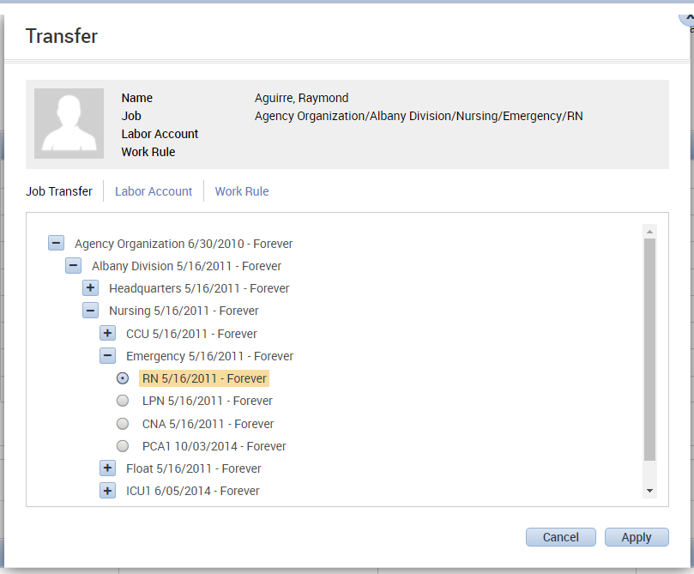
1. Select the appropriate level(s) and entry(s) in the Transfer dialog box.
2. Click Apply, then Save or Calculate Totals to see the results in the timecard.

Labor Account Transfers
Labor Account Transfers can also be performed from the Transfer dialog box. Select the appropriate descriptions from the dropdowns and click Apply. Again, Save or Calculate Totals.
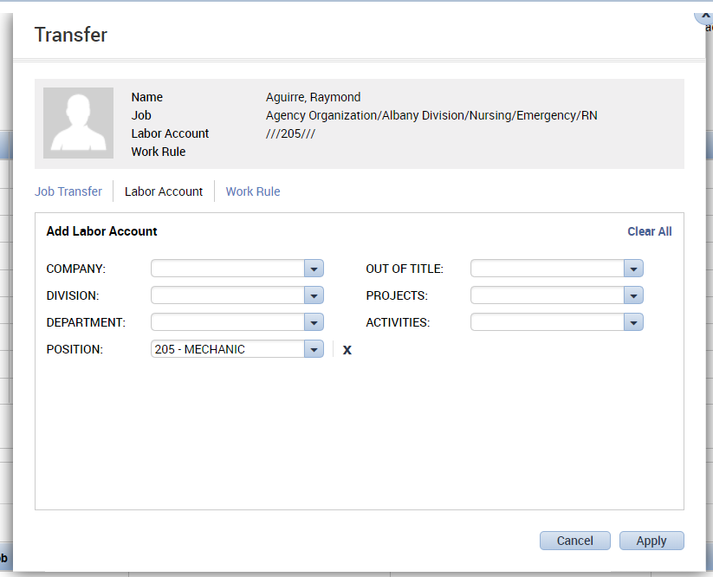
Labor Account transfers are used to track employee’s work in different departments. System settings can be configured so managers can see and approve time for employees who transfer in to their departments.

Work Rule Transfers
Work Rule transfers can be performed independently or along with a Job Transfer or Labor Account transfer. When performing either a Job Transfer or a Labor Account transfer, if the employee’s Work rule changes when working in a Non-home labor account, click the Work Rule option in the Transfer dialog box and select the appropriate Work Rule from the list.
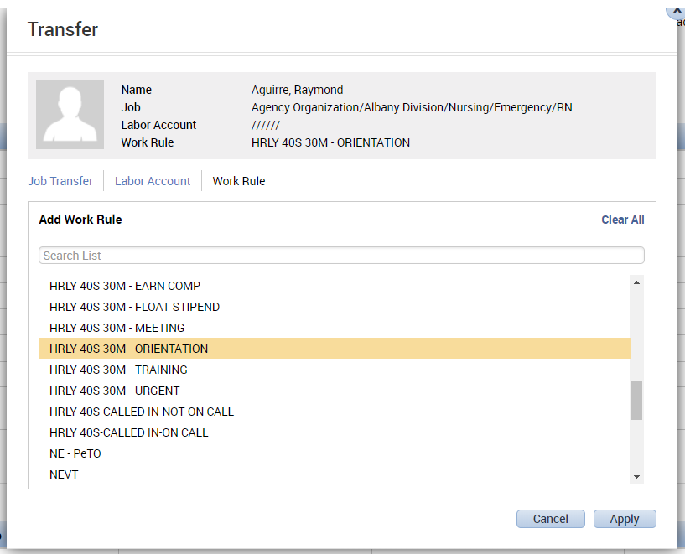

Work Rules are often used with shift differentials or other situations that affect pay.

Click Apply, then Save or Calculate Totals to see the results in the timecard.

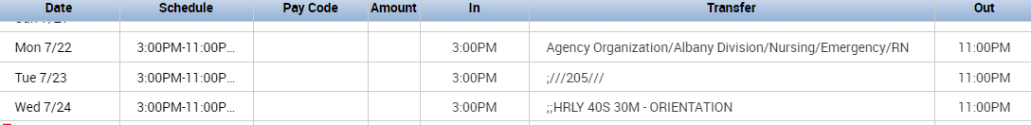
Transfer Results Displayed in Timecard:

After choosing Save or Calculate Totals, the results will be displayed in the transfer column on the timecard.

The results will also be visible in the Totals Tab beneath the timecard:
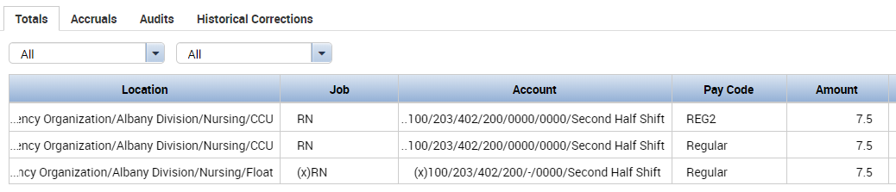

Transferred hours are denoted in the Totals section of the timecard with “(x)” preceding the labor account.

To transfer a portion of a shift to another labor level, insert a punch at the point where the transfer occurred:
- Click on the left to insert a blank line on the appropriate day.
- Double click the In punch cell on the inserted line.
- Enter the time the employee started work in the other labor level.
- Press the Tab key on your keyboard.
- Double click the Transfer column cell for that day.
- Select the correct labor account from the displayed pick list or click Search and select the appropriate labor level(s) and entry(s) in the Transfer window.
- Click OK.
- Click Save or Calculate Totals to see the result of the transfer.
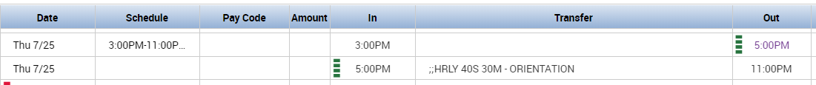

Note:
The number of previous transfers the system keeps in the pick list is controlled by your Kronos System Administrator. By default, the most recent five transfers are displayed, along with the Search option.

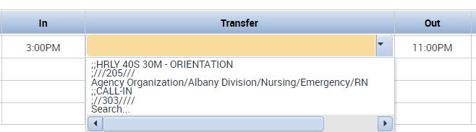

Approving Overtime
Ability to approve overtime is determined by your system administrator.
If an employee works overtime, a red clock icon will appear on the date, indicating there is overtime that needs to be approved:

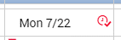

Unscheduled Overtime also appears as the Pay Code in the Totals tab beneath the timecard:
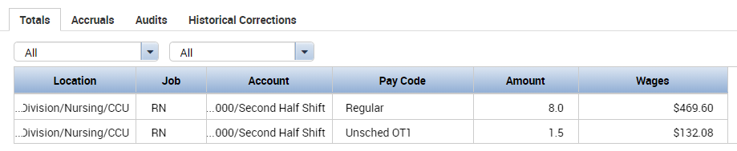
To approve overtime:
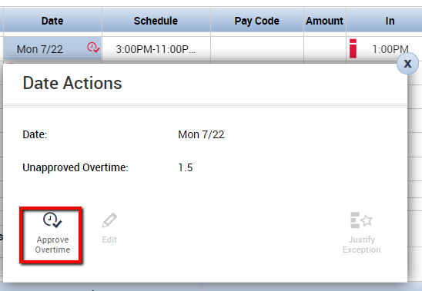
- Right click on the date and choose to Approve Overtime:
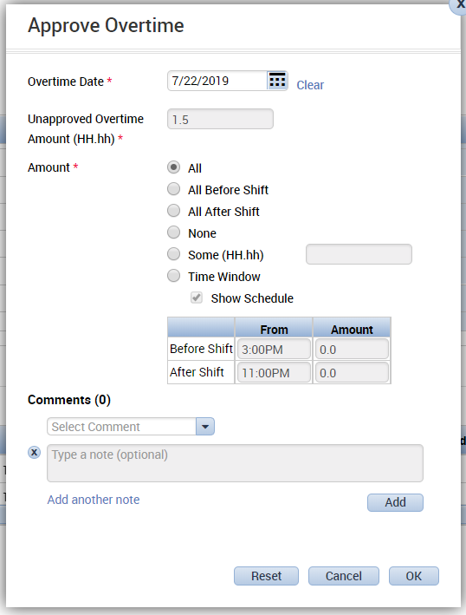
- This will bring up an additional dialog box which can be used to approve all, none, or a partial amount of the overtime. A comment can be added by selected a comment from the dropdown. A freeform text box is also available for a note.
- Click OK to return to the timecard.
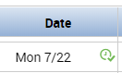
- When all overtime is approved, the clock icon on the date will change from red to green:
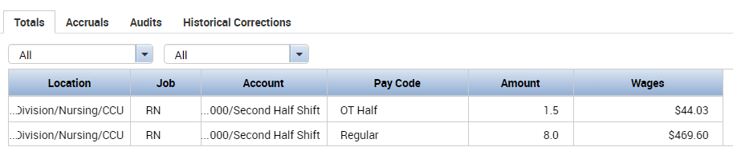
The Pay Code in the Totals Tab changes to an overtime pay code:

- To undo or modify, right click on the date again, select the Approve Overtime icon again, and choose Reset.

Moving Hours
*Please Note: This method of moving hours is not recommended. Best practice suggests disabling access to move hours in this way. It is demonstrated here only in case the company allows it. Any transferring of hours should be done in the timecard. *
Sometimes it may be necessary to move hours from one pay code to another or from one labor account to another. The “Move Hours” function may be used in situations like this.

To move hours:
- Right click the pay code in the Totals section that you want to move hours from.
- In the Totals Actions window, click Move Amount
- In the Move Hours window, select the pay code that you are moving hours to.
- Enter the number of hours to be moved in the Amount box.
- Select the correct Effective Date.
- If applicable, select the Labor Account the hours are being charged to.
- Click OK.
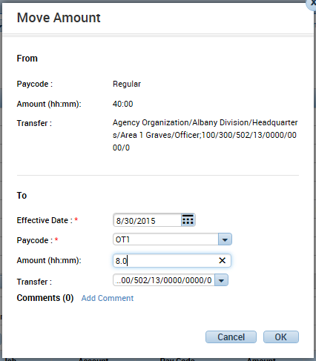
Note: The hours being moved must be associated with the correct Effective Date, otherwise you may wind up with negative hours being displayed in the “Totals” section.

Viewing Hours for Specific Days
To view hours calculated for a specific day or days, click the arrow in the box just below the Totals tab:
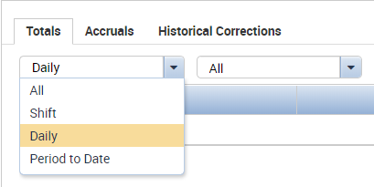
Select Daily, then click on a date in the timecard. The totals in the “Totals” section will display the hours for the selected day as they will be paid. When Shift is selected, hours as calculated from punches will appear in the Totals section for the selected day. When Period to Date is selected, the totals in the Totals section will be cumulative through the day that is selected. To return to the pay period totals, click All.


Historical Correction Totals
This icon will appear in the Totals tab way off to the right, when Historical Corrections from the previous pay period are affecting the totals in the current pay period. The drop down can be used to view the totals with or without the corrections.
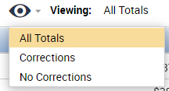

Approving and Signing Off Timecards
Timecards can be approved or signed off from either a Detail Genie or from the timecard. The only difference is that multiple timecards can be approved or signed off from a Genie, whereas the approval or Sign-Off from a timecard is only for that specific employee. The ability to perform an approval or Sign-Off is based on your company’s policies and your access rights. If you have questions about the approval and/or Sign-Off policy in your company, see your Kronos system administrator.

Approvals
There are two levels of approval in Workforce Timekeeper, Employee Approval and Manager Approval. Your company may choose to use both, one, or neither. Approvals serve as a documentation and communication device for indicating that a timecard has been reviewed by the employee or manager.

Important facts about approvals:
- Approvals can be done any time before the timecard is signed off. This means approvals can be done while still in the current pay period.
- An Employee Approval locks the timecard from any further edits by the employee. Depending on your system configuration, employees may or may not be allowed to remove their approval which will unlock the timecard and allows further editing by the employee. Supervisors and/or managers can still edit the employee’s timecard after an Employee Approval.
- A Manager Approval locks the timecard from any further edits by the employee. Depending on how your system is configured, supervisors/managers may still edit timecards after a Manager Approval has been applied, or the timecard can be locked from further edits unless the approval is removed.
- When a timecard has been approved by either the employee or manager, the background color of the timecard will change. Clicking the Go To button and selecting Audits, will display when the approval or Sign-Off was performed and who performed it.
- An approval can be removed if you have been given this privilege in your Access Profile. Approvals can only be removed by the person who originally performed the approval.

Performing an approval while viewing the timecard:
- Click the Approvals menu tab in the header.
- Click the Approve Timecard option.
- Click the Go To button, click Audits >Type of Edit = Approvals/Sign-offs to see who performed the approval and when.

Approving timecards in a Detail Genie, e.g. Pay Period Close:
- Select the employee(s) whose timecards you are going to approve. If approving all employees click Select All Rows.
- Click the Approvals menu tab in the header.
- Click the Approve Timecard option.
- Click Yes when the system asks if you want to approve the timecards.
- Click the Refresh button in the header. The Manager Approval column in the Genie will contain a numeric value signifying the number of approvals for the timecard and the name of the person(s) who approved the timecard will appear in the Approved By column.

Sign-Off
Sign-Off differs from approval in that there is only one Sign-Off per employee per pay period. The Sign-Off function can be done from either a Genie (multiple Sign-Offs) or from the timecard (single Sign-Off) and is performed the same way as approvals (see above).

Important facts about Sign-Off:
- Sign-Off can only be done for the previous pay period. For example, a pay period that ends at Saturday midnight can only be signed off on Sunday (the first day of the new pay period) or thereafter.
- Sign-Off locks the timecard and schedules from further editing by employees and managers for the associated time period.
- Edits may be done to a signed off timecard by first removing the Sign-Off. You must have the “Remove Sign-Off” privilege in your Access Profile in order to perform this function. In most companies this privilege is reserved for payroll personnel.
- Sign-Off can be removed by anyone who has the “Remove Sign-Off” privilege. Unlike approvals, Sign-Offs do not have to be removed by the person who originally performed the Sign-Off.

Printing a Timecard

To print a timecard:
- Click the Print Timecard button. A separate window will open with a preview of the timecard as it will print.
- In the Print dialog box select the printer, then click Print
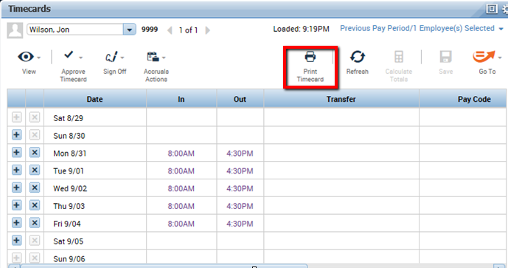

Supporting Timecard Tabs
The tabs below the timecard grid display additional information about employee hours.

Totals Tab
The Totals tab displays information about worked hours, the account the hours are being charged to, the pay codes, and the associated wages.
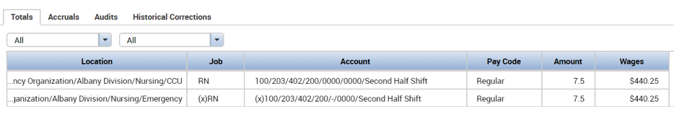
As mentioned previously, an (x) in the totals indicates transferred hours.

Accruals Tab
Accruals are amounts of time that employees earn as benefits such as vacation, sick, or personal time. You can view an employee’s accrual balances by clicking the Accruals tab located directly beneath the timecard grid.
Workforce Timekeeper contains a powerful accruals engine which can handle virtually any accrual policy. Your company may elect to have Workforce Timekeeper calculate your accruals, or if your accruals are calculated by your payroll system, the balances can be imported into Workforce Timekeeper for easy viewing by the manager and/or employees.
The following information is displayed when the Accruals tab is clicked:
Accrual Code – the code that identifies and holds the type of accrual balance, such as vacation, sick, or personal time.
Accrual Available Balance – the balance for the accrual code as of the day selected in the timecard. If no day is selected, the balance will be as of the last day of the time period being displayed in the timecard.
Accrual Units – the unit associated with an accrual code; either hours, days, or money.
Accrual Reporting Period – this is generally the calendar year (1/01-12/31) or your company’s fiscal year as defined in System Settings
Accrual Opening Balance – the balance as of the first day of the Accrual Reporting Period.
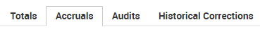
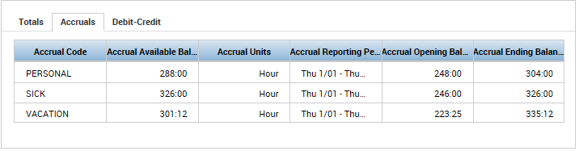
Accrual Ending Balance – the balance as of the last day of the Accrual Reporting Period. This will include any future requests for time off as well as any accrual earnings, such as an anniversary grant.

Other important information about accruals:
Projected credits in the Accrual Ending Balance only apply to companies where Workforce Timekeeper is calculating the accrual balances. Projected credits are based on fixed grants, not earned grants. A fixed grant defines periodic accrual increases in preset amounts. An earned grant uses one or more pay codes to calculate the amount of accrual credit an employee earns during a pay period or other interval of time.
Workforce Timekeeper calculates accrual balances from the last day in the selected time period (e.g. “Current Pay Period”). Accrual balances are updated when the timecard is totaled.
If hours have accrued, but the employee is still in a probation period, the probation status (p) is indicated in the hour or money values.

Historical Corrections Tab
Historical Corrections show changes that have been made to a previously signed-off period. This Summary View shows that an amount previously paid as regular was changed to be paid as sick.
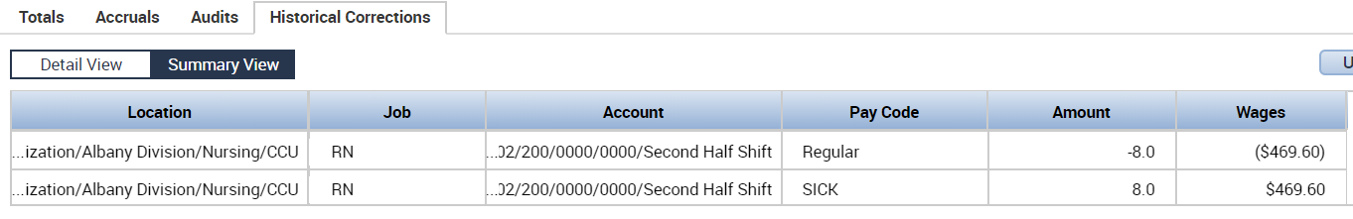

The Historical Corrections Detail View shows further information about the edit, including what date the change was made and which user was responsible.

Timecard Audits
Timecard Audits may be an additional tab available below the timecard grid. Audits show recent changes to the timecard, as well as which user made the edits and the time the edit was made.
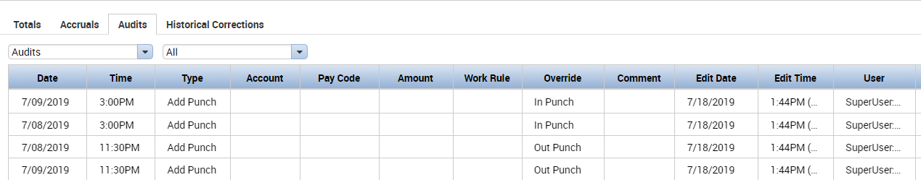

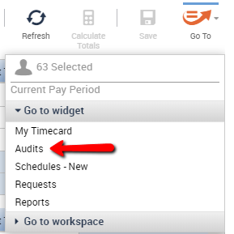
If not visible as a tab, Timecard Audits
may be selected from the Go To menu.
Access to this function is determined
by your system administrator.

Group Editing
You can perform transactions on multiple employees at the same time by using one of the Group Edit functions. Depending on the privileges granted to you in your Access Profile, Group Edits allow you to add or delete punches; add or delete amounts; apply an approval or Sign-Off to timecards; reset, update, suspend, or reinstate accruals; or add/edit transactions for employee schedules.

Performing Group Edits

Performing a Group Edit from a Workforce Genie
- Select the employees to be included in the Group Edit by holding down the Ctrl key and clicking on their name, or click Select All Rows to perform the Group Edit on all employees.
- Select an option from one of the menu tabs and complete the applicable dialog box.
For example, as a manager you may want to approve your employees’ timecards after editing them at the end of the pay period.

To perform this Group Edit, you would:
- Select the employees whose timecards you want to approve from the Pay Period Close Genie.
- Click the Approval button in the header.
- Click the Approve Timecard option.
- Click Yes to the “Are you sure you want to Approve?” prompt
- Refresh
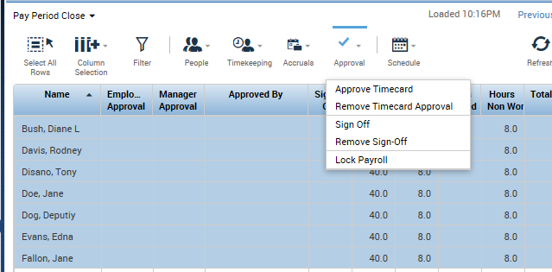
Note: The options which appear under each Group Edit function are defined in your Function Access Profile. You may not have access to all of the options shown in the above example.
Menu tabs are also available for you to:
- Add/edit punches for multiple employees.
- Add/delete amounts for multiple employees.
- Update, reset, suspend, or pay out accruals.
- Add/edit or duplicate a person in Workforce Timekeeper.
- Populate timecards from schedule (pay from schedule).

About Group Edits
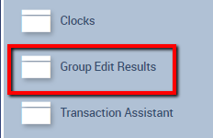
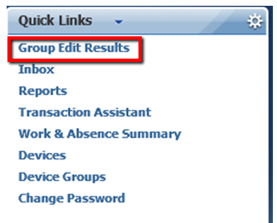
Group Edits are processed by your Kronos web server, not your PC. Consequently, depending on the type of Group Edit and the number of employees selected, it may a few seconds or several minutes for the edit to be completed. After performing a Group Edit, you can check to see the status of what was processed by clicking on the Group Edit Results link, which may be located in the drawer or in the Quick Links widget:

Group Edit Results will display your completed Group Edits you have performed starting with the most recent and working backward, listing the date and time that the Group Edit was performed, who performed it, the status, and results. If the results indicate any failures in the Group Edit transaction, a “Details” link will be displayed. Click the link to see more specific information about the failures.
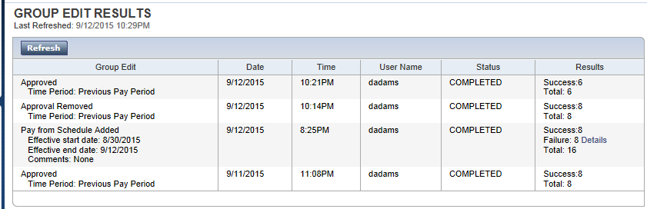
Group Edits also appear in the Audits tab of the employee timecard listing the username of the person who performed the edit along with various other information including the date and time the transaction occurred.

HyperFind Queries
HyperFind Queries are simply filters which allow managers to select a subset of employees from all of their Home employees. Unless changed by your Kronos System Administrator, widgets and genies default to the All Home HyperFind which allows managers to see all their employees. If a manager has responsibility for more than one department or unit, he or she may want to create HyperFind Queries so employee timecards for each department can be viewed and/or approved separately. The ability to create HyperFind Queries is granted in the Function Access Profile assigned to each manager.
Different HyperFind Queries can be selected from the drop down located in the upper right corner of a genie.
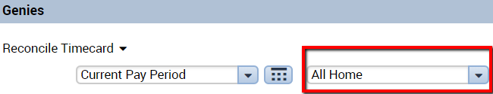

Types of HyperFind Queries
Depending on the rights granted in their Function Access Profile, managers can have the ability to create one or more of the following types of HyperFind Queries:
Ad Hoc – a temporary Query, good for as long as the manager is logged in or until it is changed.
Personal – visible only to the person who created it or to whom it is assigned.
Public – visible to all Workforce Managers. The ability to create public Queries is generally reserved for the Kronos System Administrator.

Query Conditions
The manager’s Function Access Profile controls what filters can be used to create HyperFind Queries. Some of the filters that you may have access to include: Employee Name or ID, Primary Account, Worked Account, Pay Codes, Pay Rules, Exceptions, Employment Status, and many others. The conditions you have access to will be displayed on the HyperFind Query screen under the Filter column.

Creating HyperFind Queries
As previously mentioned, there are many conditions (filters) that may be used to create HyperFind Queries. The most commonly used filter is Primary Account, which will segregate employees based on one or more labor entries which make up their Home account.

To create a HyperFind Query based on department using the Primary Account filter:
- Go to Setup > Common Setup > HyperFind Queries.
- On the HyperFind screen, click New
- Click the Primary Account filter (depending on the settings in your Function Access Profile, this may be the default).
- Click the tab of the labor level which designates departments in your company, e.g. “Department.”
- Select the department for which you are creating the Query. You can either select it from the “Search Results” list and then click the Add button or, if you know the code for the department, you can key it directly in the box to the right of the Department labor level.
- Click the Add Condition button. You should now see this condition displayed in the Selected Conditions box at the bottom of the screen.
- Click the + sign next to the Timekeeper filter.
- Click Employment Status. Notice that it defaults to employees whose status is active as of today.
- Click the Add Condition button to select this as a condition.
- Click Save.
- Click the Visibility dropdown in the top left and choose Personal – this will be saved as a personal Query, visible only to you.
- Name the personal Query with the name of the department you selected in step 5 above.
- Click OK.
To test the Query, go to any Workforce Genie and click the down arrow in the Show box at the top of the screen. The Query you created will be displayed in the list along with any other Queries you have access to.
Note 1: You can select multiple departments within one Query.
Note 2: You can create Queries using other filters using the same logic used in the Query you created using the Primary Account filter.

People Editor
The People Editor is where specific information is kept on all people who are entered in the Workforce Timekeeper system. A person can be a Workforce Timekeeper Employee (anyone who has a timecard), a Workforce Employee (an employee who is able to access his or her own timecard), and/or a Workforce Manager (able to access other people’s timecards).
The ability to access the People Editor is controlled by privileges granted in your Function Access Profile. For example, a payroll or human resources supervisor may have the ability to add, edit, and view all employee information. Managers, on the other hand, may only be able to view information on their employees.

Accessing the People Editor

To access the People Editor:
- Select the employee(s) from a widget such as the Exceptions widget, or a Detail Genie such as the Reconcile Timecard genie.
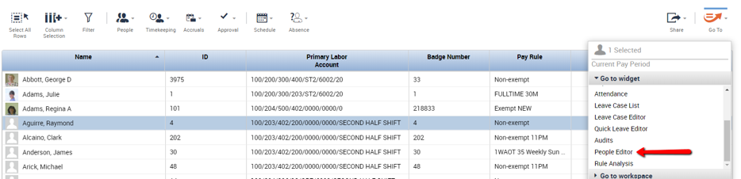
- Click the GoTo button and choose People Editor from the pop-up menu.

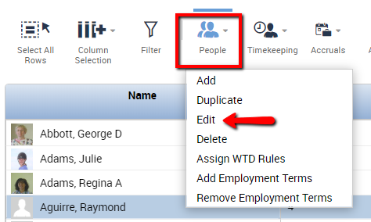
If you are working from a detail genie, you can also click the People icon in the header, then click Edit.

- The Summary screen of the employee’s record will appear. If your Access Profile allows you to see other information, simply click the other screens in the People Editor which appear under the Summary screen.
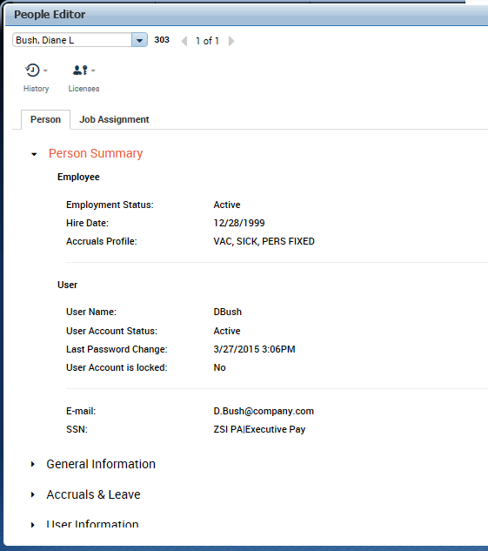
Information in the People Editor is displayed on two tabs: the Person tab and the Job Assignment tab. Each tab has a Summary section at the top and additional information when the areas below are expanded. If you have access to the People Editor, most information may be read-only. The information in the People Editor will likely be brought in automatically from your company’s HR/Payroll system.

Calendar Genies
Calendar Genies provide managers and employees with a graphical picture of timekeeping, scheduling, and attendance activities for any date range. Viewable formats include weekly, monthly, and multi-monthly.
Calendar Genies can display exceptions, pay codes, hours worked (e.g. regular and overtime), shifts, comment and transfer indicators, and attendance events (requires Workforce Attendance licensing). Colors and text are used to designate different events and event descriptions. The events and activities displayed in your Calendar Genies are controlled and maintained by your Kronos System Administrator.
The Calendar genie that comes with the system is called Work and
Absence Summary. It is located in the Quick Links widget. Below are examples of a Calendar Genie displayed in both weekly and monthly formats.
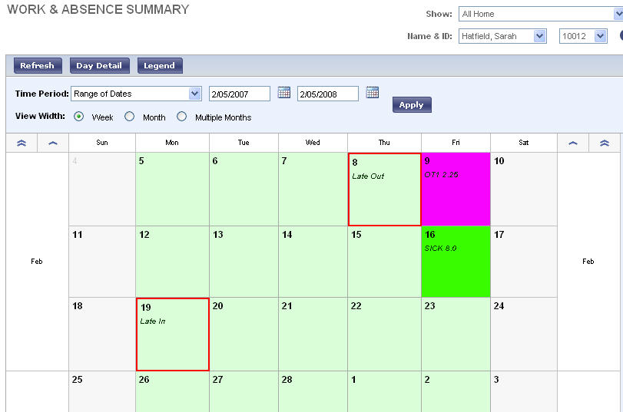

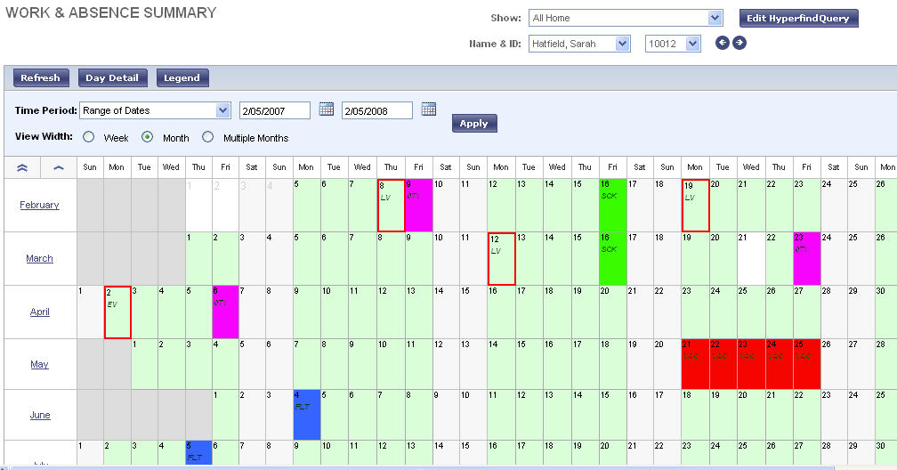

The buttons in the top left of the calendar provide further information:
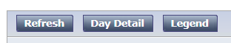
One or multiple days can be selected and the Day Detail button at the top will provide more information about the schedule or pay codes that apply to the day.
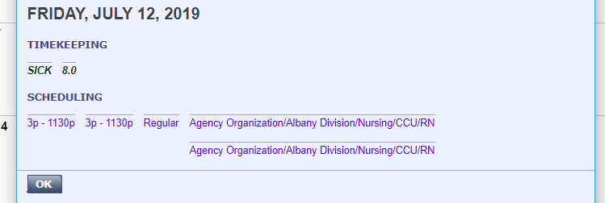
The Legend button will provide information about the color code used for your view.

Time Off Requests
The Requests widget allows managers to see all requests submitted by his/her employees. Other pertinent information is also available such as who requested, for what time period, when it was submitted, etc. The Request widget is activated by moving it to the Center workspace of the Navigator, or by clicking the Request Manager Alert icon at the top of the screen.
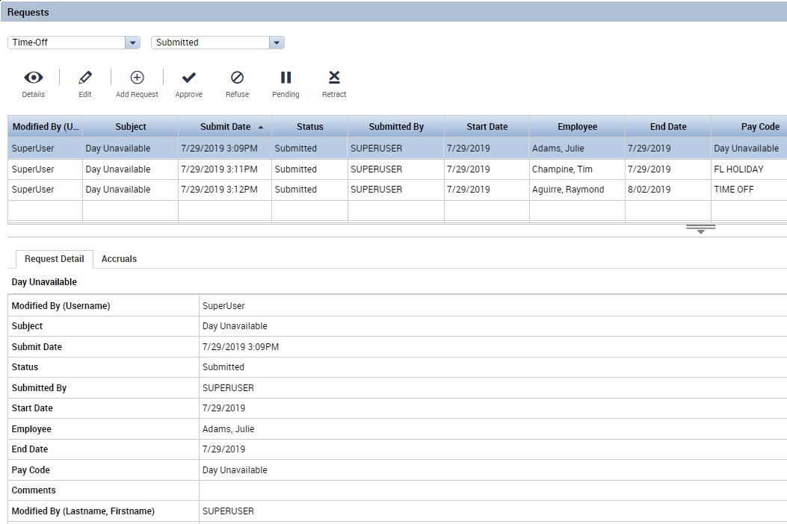
Using the dropdown menu selection at the top, you can specify the time period for which you want to view requests.
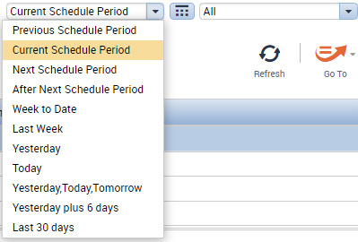
The calendar icon to the right of the dropdown menu can also be used to select a start and end date.
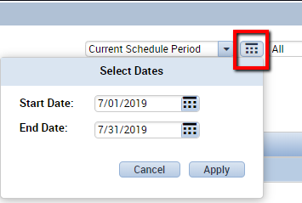
Use the Status drop down to select which requests you would like to see (Submitted, Approved, Rejected, etc.).
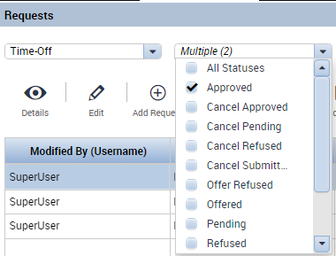
Click the request to highlight it, then use the buttons at the top of the Requests widget: Edit, Approve, Refuse, Pending, or Retract to perform the appropriate action. 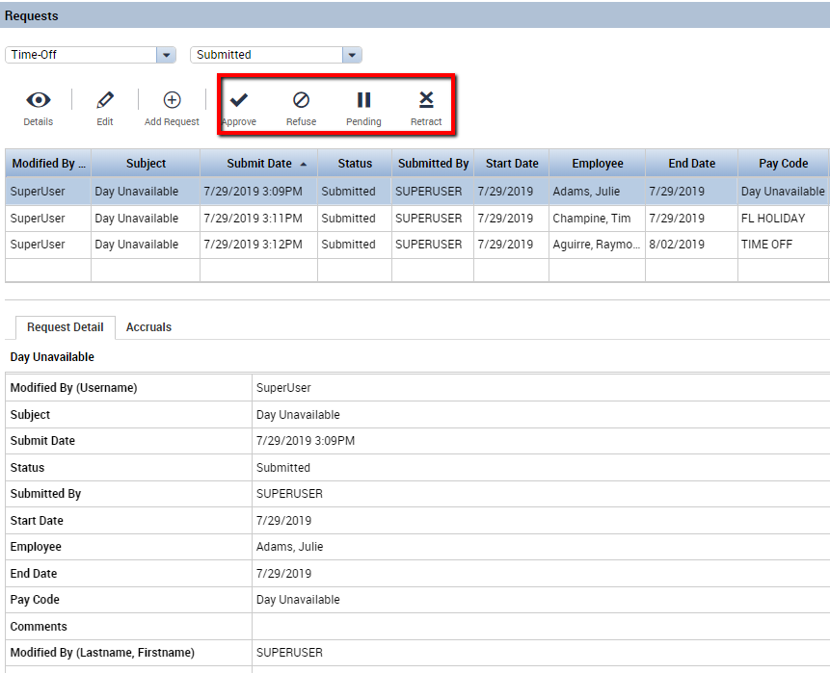
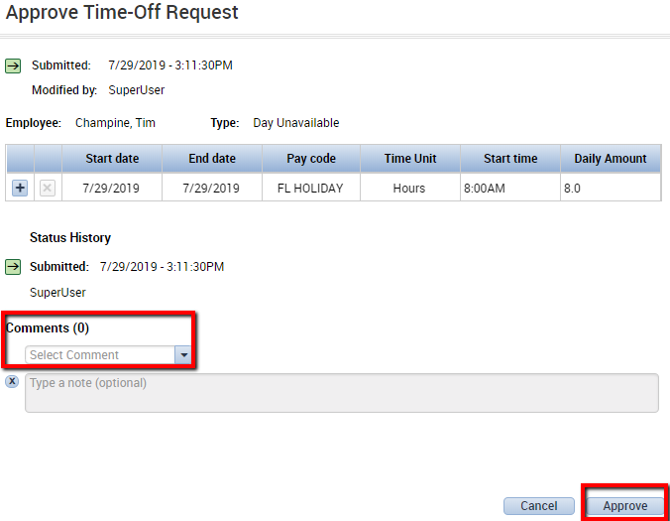
Clicking one of the action buttons will open a dialog box where you can complete the action including adding a Comment.

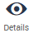
After the action has been performed,
double click the request or
highlight the request and click the Details
button at the top of the Request widget
to view the history of the request.
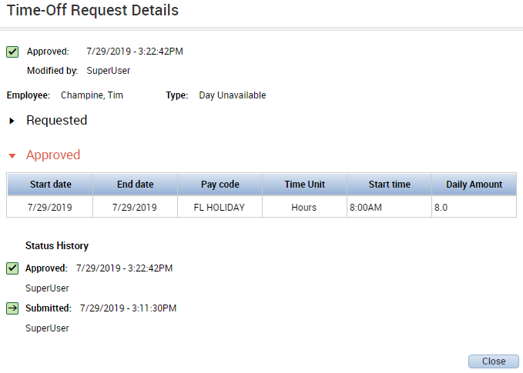
A request that has been approved will now be reflected in the employee’s schedule.
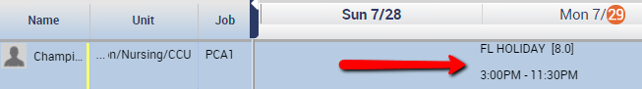

Scheduling in Workforce Timekeeper
Employee schedules are administered in the Schedule widget.
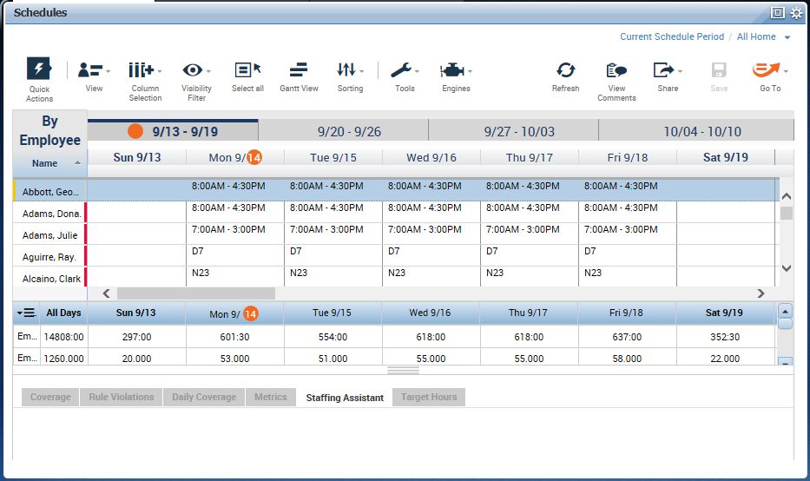
Access to scheduling features is controlled by the Function Access Profile assigned to each manager. Some of the functionality described below may not be available to all managers depending on the privileges granted in their Function Access Profile.
Schedules are made up of three building blocks, some or all of which may be used in your company.
- Shift – A unit of time with a designated start and end (ex: 7a-3p)
- Pattern – A series of shifts over time (ex: 7a-3p Mon-Fri)
- Group – A way of classifying employees whose schedules are the same (e.g. First Shift, Second Shift, Third Shift)
Schedules can be assigned to employees in several different ways:
- Shifts can be manually assigned to an employee on a daily or weekly basis. This is rarely done, but may be useful in the case of part time or per diem employees.
- Schedule Patterns can be assigned to employees. Once assigned, the manager or scheduler needs only to adjust the schedule if the employee’s work day deviates from the schedule. For example, if one employee swaps shifts with another employee.
- Employees can be assigned to a Group Schedule. There are two types of Group Schedules: Inheritance and non-inheritance. When an employee is assigned to an Inheritance Group, they automatically acquire the schedule pattern assigned to the Group. Non-inheritance Groups have no schedule pattern assigned to them. Employees assigned to a Non-Inheritance Group generally have their own individual schedule patterns.
Helpful Tools
Shift Templates – predefined shifts which can be used over and over for creating and modifying schedules
Pattern Templates – predefined patterns which can be assigned to individual employees and group schedules

Shift Templates, Pattern Templates, and Schedule Groups will be created by your system administrator.

Employee Patterns: Creating Initial Pattern
If a Pattern Template does not exist that matches a specific employee’s schedule, you can build a pattern for the employee on the fly:
- In the Schedule widget, right click on the employee’s name and select Schedule Pattern
- In the Schedule Pattern screen, change the “Define Pattern for” number to reflect how often the pattern repeats. For example, a Monday through Friday schedule repeats every 1 week. An “every other weekend” pattern repeats every 2 weeks.
- Highlight the days in the pattern that the employee works the same shift. Hold the Ctrl key down to select multiple days.
- Click the Add Shift button.
- Enter the Start and End times for the shift. Remember that this is only for the days that are highlighted on the previous screen.
- Click OK. The highlighted days should now have shifts in them.
- Repeat this process if the employee works other shifts on different days of the week until all worked days have been accounted for.
- Enter the Start Date that the employee begins this new pattern. The Start Date may be different from the Anchor Date if the employee is not starting on Day 1 of the pattern.
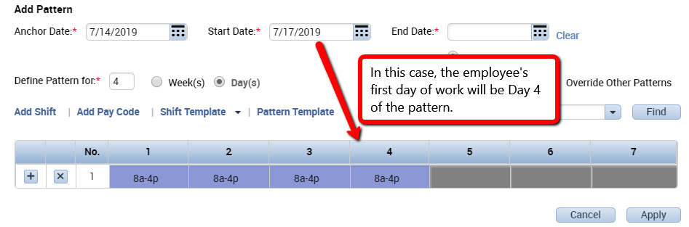
  - In this example, an employee will have a schedule where he works 4 days on and 3 days off.

- Leave the Forever box checked for the End Date.
- Click OK. You should now see the pattern assigned to the employee in the Schedule widget. Refresh if needed.
- Save.

Employee Patterns: Changing Patterns
If an employee already has an existing pattern with an end date of Forever, it is possible to assign them a new pattern.

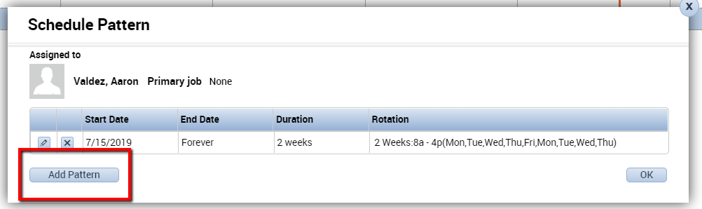
- Right click on the Employee name and choose Schedule Pattern. You should see a window with a summary of the existing pattern. Do not modify the existing pattern. Instead, select Add Pattern in the lower left corner.

- Add the new pattern and choose the correct start date. Check the box next to Override Other Patterns.
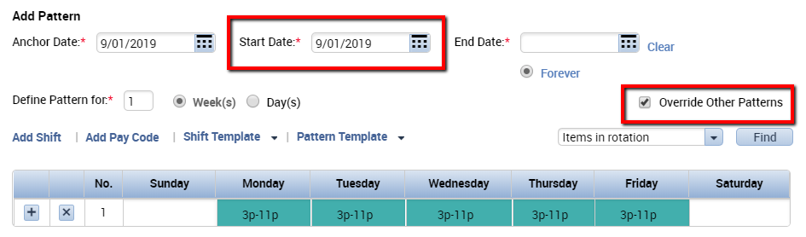
Note: Selecting Override Other Patterns
will cause warning messages to appear:
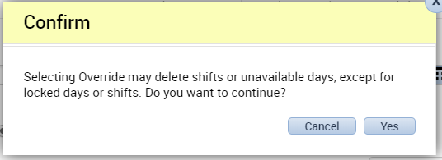

- Click Apply and click Yes to continue through the warning messages.
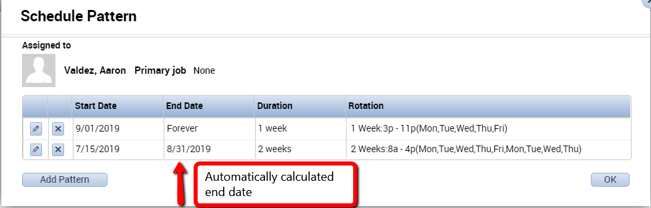
- Notice that Kronos will automatically calculate the end date of the previous pattern. This is based on the start date you entered for the new pattern.
- Click OK to apply the new pattern and click Save.

Making Temporary Changes to Employee Schedules
If an employee works something other than his or her normal schedule on a given day, you can make temporary changes that will not become part of the permanent schedule. For example, an employee who normally works 8:00am to 4:30pm Mon-Fri may be asked to work 10:00am to 6:30pm on a given day. The manager can change the employee’s schedule for that one day using one of three methods:
- In Cell Editing – simply click the cell for the day in question, delete the existing schedule, and type the new shift into the cell using the following format: 10a-630p.
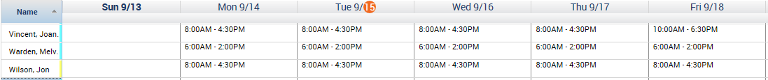
- Copy/Paste – click on a cell from another employee which matches the shift start and stop times that you want, hit Ctrl/C on your keyboard to copy the shift to the Clipboard, then click on the appropriate cell for your employee and hit Ctrl/V to paste the shift to the new cell. You can also use Ctrl/X – Ctrl/V to cut and paste shifts
- Insert Shift Template – right click on the cell for the day in question and choose Add Shift from the dialog box. Click the Insert Template button that matches the start and stop times for the employee’s temporary shift and click OK. This feature is particularly useful for inserting shift templates which are already configured with transfers to other departments or jobs.

Schedule Quick Actions
The Quick Actions buttons in Schedules opens a new set of icons that can be used to quickly modify the schedule.
The Quick Actions icon is in the top left corner of the Schedule widget:
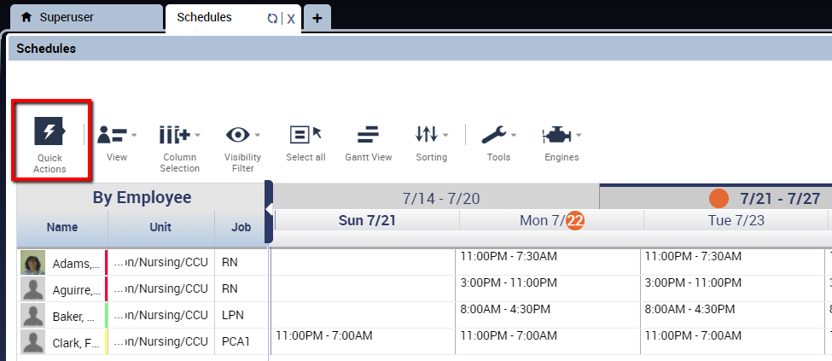
Clicking the Quick Actions icon opens a new tray of Quick Actions:
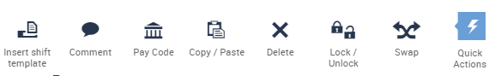

Click the Quick Actions icon again to close the tray.

The options you have available as Quick Actions will be determined by your system administrator, but here are some of the most common:
Insert Shift Template – Select a pre-defined shift and select the
employee and date to assign.
Comment – Add a comment to a shift
Pay Code – Select a pay code and then select a shift, the pay code will replace the scheduled shift for the number of hours
Copy/Paste – Select to copy and paste
Delete – Delete schedule items (shifts, pay codes)
Swap – Choose two employees shifts to swap

Once you select an action, directions will appear. Here, Copy/Paste is selected:
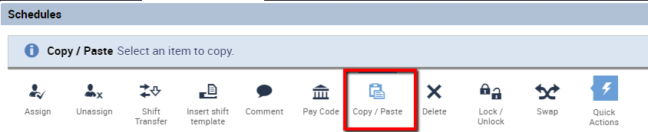

Schedule Views
Employee Schedules can be viewed in either the Tabular View or the Gantt View.
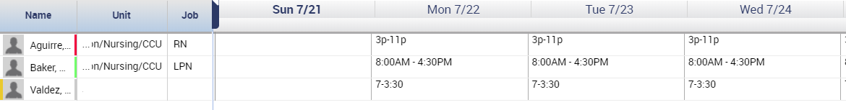
Tabular View displays the schedule in cells:


When in Tabular View, click this icon to switch to Gantt View:

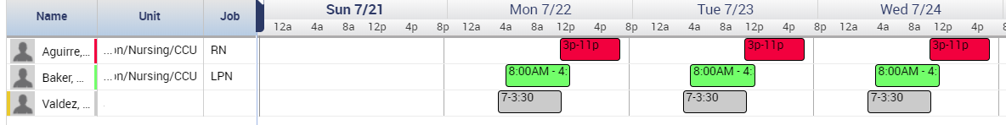
Gantt View displays the schedules in bubbles. This visual representation can be used to show gaps or overlap in coverage:


In Gantt View, the scheduled time can be lengthened or shortened by dragging the boundary of the bubble to the left or right.
When in Gantt View, click this icon to switch to Tabular View:

Reports
Workforce Timekeeper comes with standard reports which are assigned to managers via their Report Profile, which allows them to run only the reports that are applicable to their operation.
Reports can be run for timecards, schedules, accruals, employee information, audit trails, and configuration profiles.
All reports default to the screen and are produced in PDF format, which requires Adobe Acrobat Reader version 4.0 or higher to view the report. Adobe Acrobat Reader can be downloaded free of charge from http://www.adobe.com.

Running Reports

To run a report, follow these simple steps:
- From a Detail Genie (such as Pay Period Close), select the employee(s) to be included in the report. If all employees are to be included, click Select All Rows in the Genie header.
- Click the Go To button and select Reports. The Reports widget will become active in the center workspace.
- On the Reports screen, select a report from the categories listed on the left side of the screen. As soon as you click on the report name, a description of the report and additional selection criteria are displayed. Note: Different reports have different options available.
- If you want to change the employees selected for the report, click the People down arrow and select a HyperFind query.
- Select the appropriate Time Period.
- Change the Report Output as appropriate. All reports default to PDF format. Some reports may also be available in Excel format.
- Click Run Report. The Check Run Status screen will appear.
- Click Refresh Status until the Status column says “Complete.”
- Click View Report. This will open an Adobe Acrobat Reader session and the report will be displayed on your screen. When finished viewing the report, close Adobe Acrobat Reader by clicking the X in the upper right corner of the screen.
Note: The maximum number of employees selected from a Genie to be included in a report is 250. If the number of employees to be included in the report is higher than 250, use a HyperFind Query on the Reports page to run the report.

Creating Favorite Reports
When a certain report needs to be run frequently, a Favorite report can be created to run with the specified conditions. These reports are saved in the “Favorite Reports” section. From the “Reports” screen, select a report and click Create Favorite.
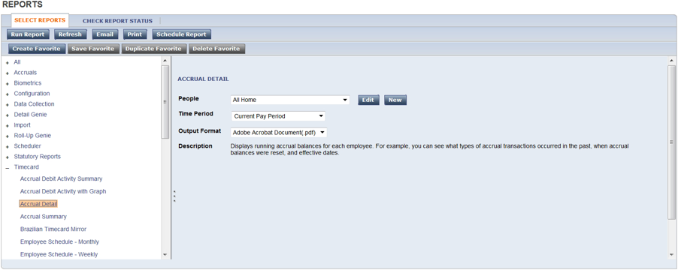
You will then have the ability to give the report a name, add a description, and specify a HyperFind Query or time period. When you have finished configuring your report, click Save Favorite. The report will then appear in the Favorite Reports section.
