Adding a New Paycode
  - kronos version 8.1

Contents
ADDING A NEW PAYCODE 3
New Pay Code Initial Setup 4
Suite-Wide Options 5
Time and Attendance Options 7
Combined Pay Codes 9
Manager and Employee Access to Pay Codes 11
Setting up Pay Code Access Profiles 11
Assigning Pay Code Access Profiles – Manager Access 14
Assigning Pay Code Access Profiles – Employee Access 15
Pay Codes and Accruals 15
Additional Pay Policy Considerations 17
Pay Code Distribution 17
Genies 18
Adding a Pay Code to a Calendar Genie 18
Adding a Pay Code to a Detail Genie 20
Generic Data Access Profiles 22
Payroll Interfaces 23
Adjusting the Pay Code Display Order 25

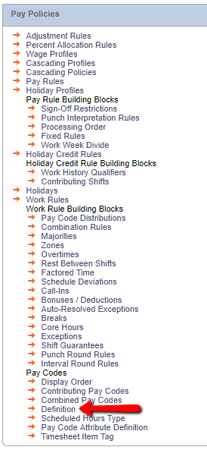
ADDING A NEW PAYCODE
To create a new pay code,
access Setup and the Pay Policies menu.
Under Pay Codes, choose Definition:

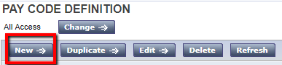
Choose New to create a new Pay Code:

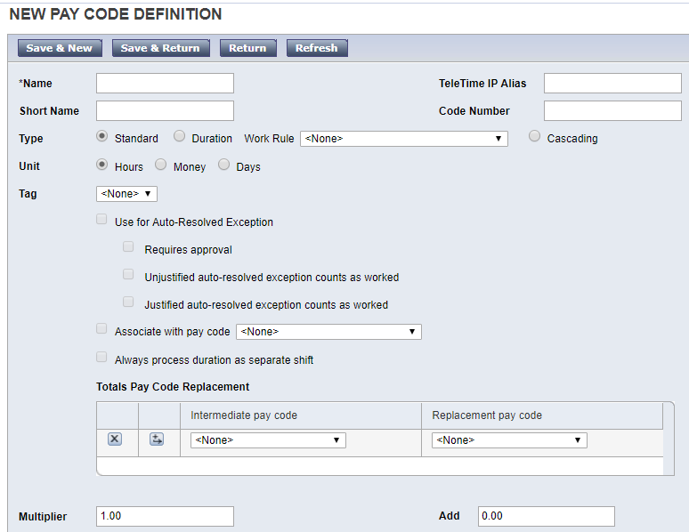
New Pay Code Initial Setup

- Name – the pay code name must be unique. When naming money pay codes, it is recommended to use a dollar sign after the pay code name (example: Bonus$). Otherwise, special characters should not be used in pay code names.
- Short Name – the Short Name is a maximum of 3 characters. This is used for data collection device displays.
- Teletime Alias – the Teletime IP alias is a maximum of 10 digits. This allows pay code to be entered via telephone.
- Code Number – the code number is a 4-digit number. This allows users to look up pay codes at a data collection device.
- Type – whether the pay code is standard or will need to account for shift differential.
- Unit – select whether this pay code will be used to track hours, money, or days. Time pay codes track worked (examples: Regular, Overtime) or non-worked (example: Vacation) time. Money pay codes accrue monetary amounts (example: Bonus$).
- Multiplier – Use the multiplier field when the wages are based on the employee’s base wage rate. For example: An employee needs to be paid at 1.5 times their rate when earning overtime. The Overtime pay code would be set up with a multiplier of 1.50.
- Add – Use the add field when the employee is paid a flat hourly rate. For example: An employee needs to be paid Hazard Pay at $20.00/hour, regardless of their base wage. This pay code would be set up with a multiplier of 0.00 and an add of 20.00.
- Multiplier and Add – Multiplier and Add can be used in conjunction. For example: An employee needs to be paid a differential for working at night. The employee needs to earn their base wage plus an additional $2.50 per hour. This would be set up with a multiplier of 1.00 and an add of 2.50.

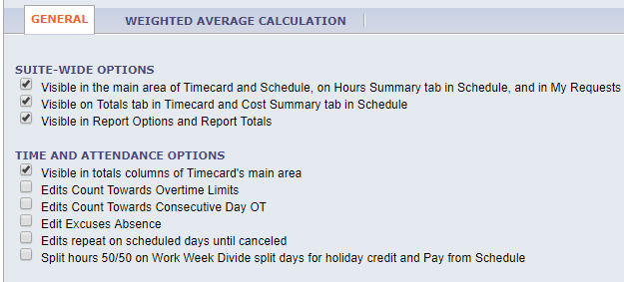
Suite-Wide Options

- Visible in the main area of the Timecard and Schedule, and in associated Reports
Allows a pay code edit and its associated hours to be seen after it has been added to the employee’s timecard. If Workforce Scheduler is installed, the pay code is also visible on the Hours Summary tab in Scheduler.
- Visible on the Totals tab in the Timecard
Totals show in the Totals and Schedule Tab in the timecard. If Workforce Scheduler is installed, the pay code will also visible on the Cost Summary tab in Scheduler.
- Visible in Report Options and Report Totals
Allows the pay codes to be selected for reports where Pay Codes is an option.

Examples:
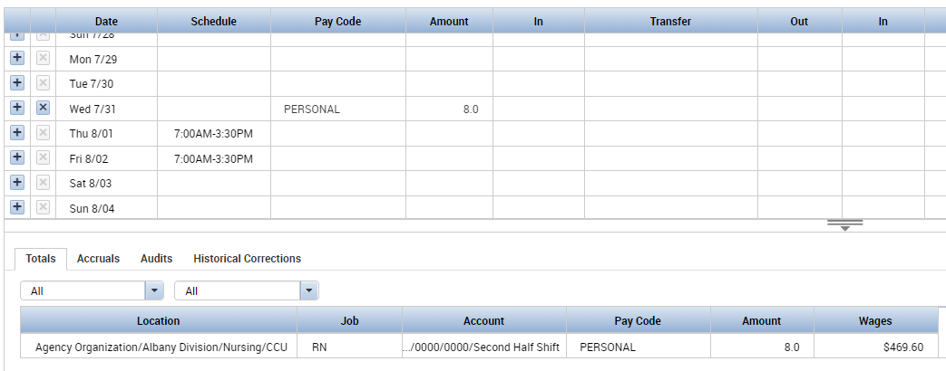
- The below example shows where the chosen suite-wide options appear in the timecard.

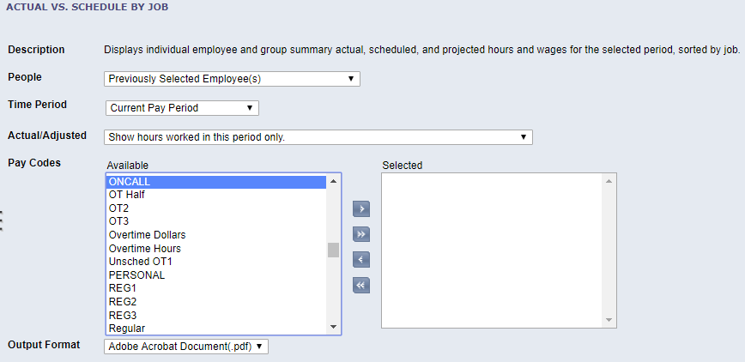
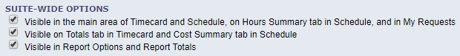
- The below shows pay codes available to be included in a report. Selecting the
Visible in Report Options and Report Totals checkbox will allow the pay code to appear here to be selected when running a report.

Time and Attendance Options
- Visible in the Totals column of the Timecard's main area - Select to have pay code displayed in the Daily and Cumulative Totals column on the timecard.
- Edits Count Toward Overtime Limits - Select to have hours from pay code edits count toward overtime limits. This option only refers to pay code edits generally performed by a manager or an employee and not hours generated through clocking in and out.
- Edits count toward Consecutive Day OT - Select to have hours from pay code edits count toward the minimum hours required for a day to count toward consecutive day overtime.
- Edit Excuses Absence - Select to specify that an edit to this pay code excuses the absence. This option might be selected for Vacation, but not for sick.
- Edits repeat on scheduled days until canceled - Select to allow the system to continually generate pay code edits for a range of days in which the amount of each edit is calculated from the employee's schedule. Pay code edits based on schedule continue until a new transaction (employee punch, Timecard edit, or Group Edit) is entered.
Examples:
- The below example shows where the chosen time & attendance options appear in the timecard.
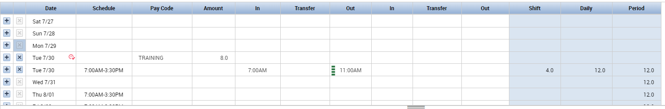
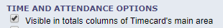

- The below employee only worked 7a-11am, which was 4 hours of their scheduled shift.
This is reflected in the Shift total column.
Their manager added a Pay Code Edit to reflect that the rest of this employee’s day was spent at an 8-hour training. The Daily total column reflects the 12 hours the employee spent at work.
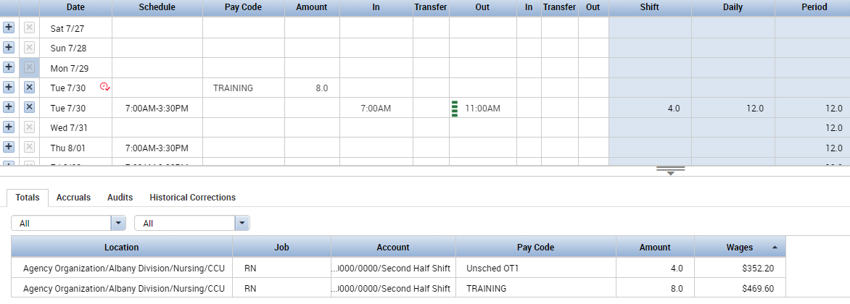
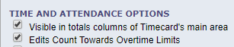
The Totals tab beneath the timecard reflects that 12 hours as 8 regular pay hours and 4 overtime hours, because the Edits Count Towards Overtime Limits checkbox was selected.

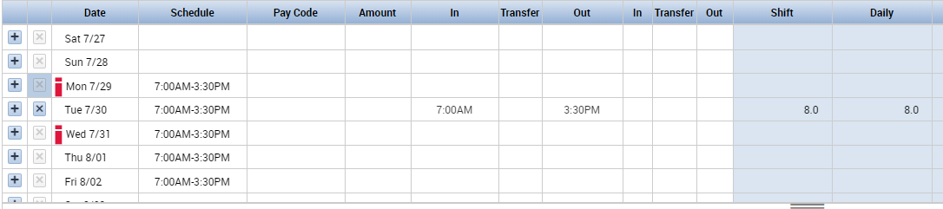
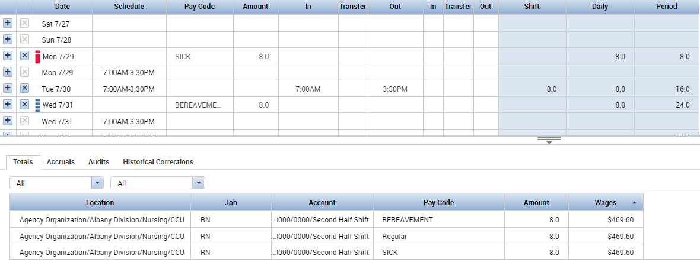
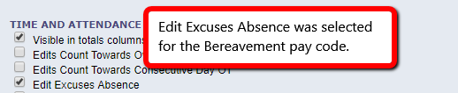
3. The below employee has an unexcused absence on Monday and Wednesday.
We will add a Sick pay code for Monday and a Bereavement pay code for Wednesday.
After saving, we can see that the Sick pay code does not excuse the absence and the exception marker remains red. The Bereavement pay code does excuse the absence and the exception marker changes to blue.

Combined Pay Codes
After you have created a new pay code, you may wish to add it to a combined pay code. Combined pay codes are used to summarize information from individual pay codes. Combined pay codes are most frequently used for reporting purposes. Examples of combined pay codes include:
- All Overtime: summarize information from all types of overtime pay codes
- All Worked Hours: summarize all worked time, such as Regular, OT, Training
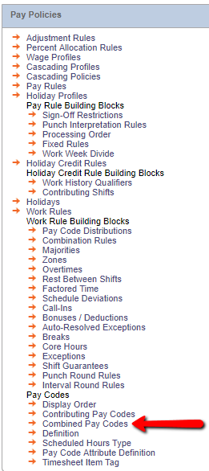
- All Non-Worked Hours: summarize all non-productive time, such as Personal, Sick, Vacation, Floating Holiday
To add a pay code to a
combined pay code, access Setup
and the Pay Policies menu.
Under Pay Codes, choose
Combined Pay Codes.

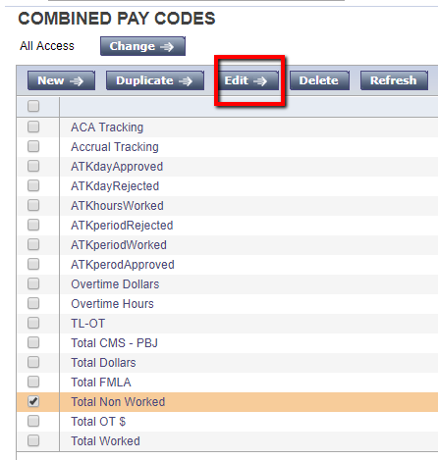
Choose the Combined Pay Code you wish to
update and choose Edit.
In this example we will add the Jury Duty pay code to the combined pay code used to track Total Non-Worked Hours:
Choose the Jury Duty pay code from the list of available pay codes. Use the right arrow to move it to the list of selected pay codes. Save and Return.
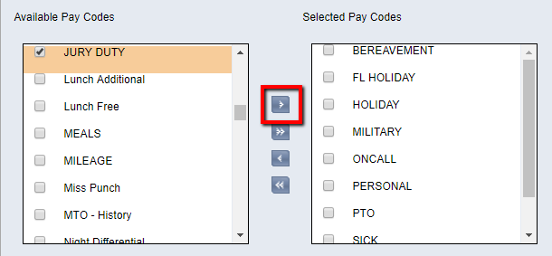

Now the Jury Duty pay code will be included when running a report for Total Non-Worked Hours.
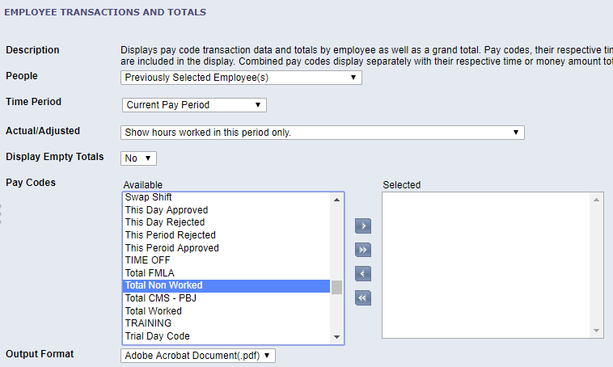

Manager and Employee Access to Pay Codes
After creating a new pay code, you may wish to add it to Pay Code Data Access Profiles so it can be accessed by employees and/or managers.

Setting up Pay Code Access Profiles
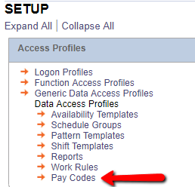
Under Setup and Access Profiles, choose Pay Codes.

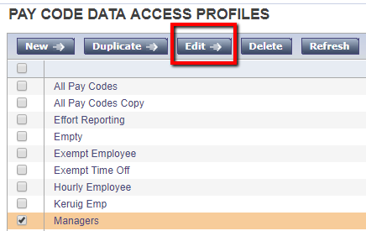
Select the Pay Code Data Access
Profile you wish to update and
choose Edit.

In this example we will add a pay code that managers can apply to their employees’ timecards.
We can add Jury Duty to the list of available pay code for users who are assigned the Managers Pay Code Data Access Profile. Select this pay code from the Available Pay Codes box on the left. Use the right arrow to move this pay code to the Selected Pay Codes box on the right. Click Save and Return.
This pay code is now included in the group of pay codes in the Managers Pay Code Data Access Profile. Any users who are assigned this profile can use the specified pay codes.
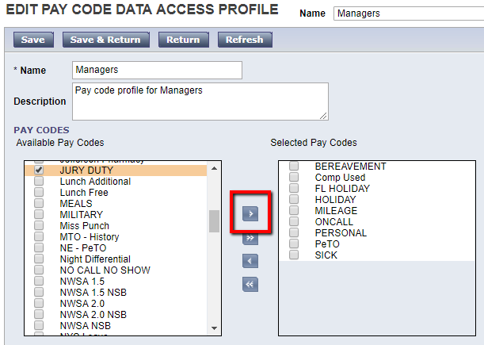

In this example we will add a pay code that employees can use when updating their own timecard.
We can add Sick to the list of available pay code for users who are assigned the Hourly Employees Pay Code Data Access Profile. Select this pay code from the Available Pay Codes box on the left. Use the right arrow to move this pay code to the Selected Pay Codes box on the right. Click Save and Return.
This pay code is now included in the group of pay codes in the Hourly Employees Pay Code Data Access Profile. Any users who are assigned this profile can use the specified pay codes.
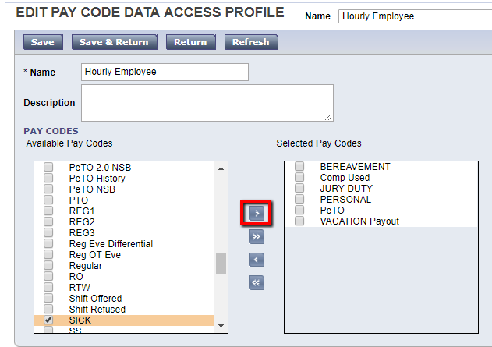
.

Assigning Pay Code Access Profiles – Manager Access
Manager Access to Pay Codes can be set in the manager’s People Record.
Under the Job Assignment tab, expand Manager Role – General.
The Pay Codes “Edit” Profile defines which pay codes the managers can use when making edits to employee timecards and schedules.
The Pay Codes “View” Profiles defines which pay codes managers can see in reports, calendars, and other areas.
We will assign this manager the Managers Pay Code Data Access Profile as their Pay Code Edit Profile. This manager will be able to use any of the pay codes in the included in the Managers profile when they are making edits to their employees’ timecards.
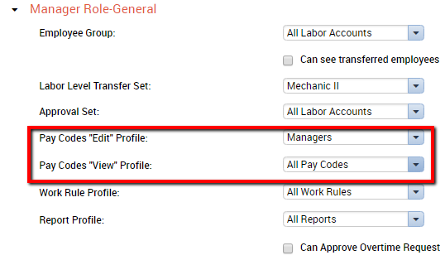
Next, we will leave the Pay Codes “View” Profile setting as All Pay Codes. With these settings,
the manager is limited on what pay codes they can apply to their employees’ timecards, but the manager is not limited on what pay codes they can include in reports.

Assigning Pay Code Access Profiles – Employee Access
Access the People Editor for the employee you wish to update.
Note: The Employee Role can also be assigned for a manager, if the manager will be editing their own timecard.
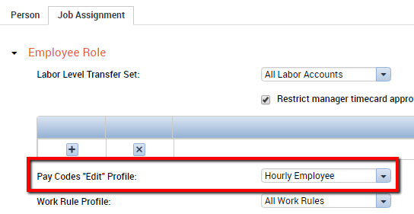
Under the Job Assignment tab, expand Employee Role. Under the Pay Codes “Edit” Profile, we will select the Hourly Employees profile. Now, this person will only be able to use the pay codes assigned in the Hourly Employees profile when making changes to their own timecard.

Pay Codes and Accruals
After you have created a new pay code, you may need to associate it with an accrual.
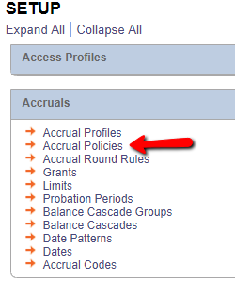
Under Setup, access Accrual Policies.

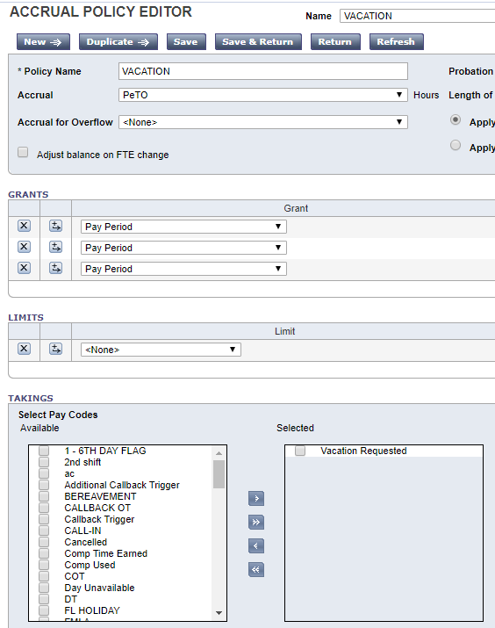
Select the policy you need to update and select Edit.
Here we are updating the
Vacation Accrual Policy.
Currently, only the use of the
Vacation Requested pay code
will cause amounts to
deduct from the vacation balance.

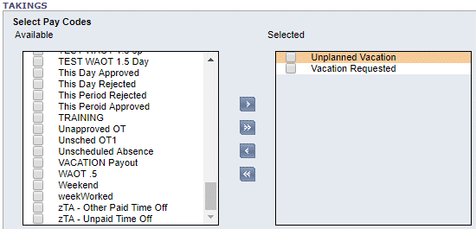
After creating a new pay code
called Unplanned Vacation,
we want this pay code to
deduct from the
Vacation balance as well.
Use the right arrow to
move the pay code to the
Selected pay codes box on the
right. Use of the Unplanned
Vacation pay code will now
cause deductions from the
Vacation accrual.

Additional Pay Policy Considerations
If your organization uses Adjustment Rules, Percent Allocation Rules, or Wage Profiles, you may need to modify these after creating a new pay code. Access Setup and the Pay Policies menu if your new pay code needs to become part of the rule sets for an existing policy.
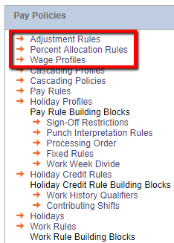

Pay Code Distribution
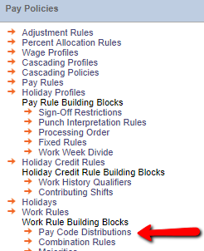
After you have created a new pay code, you may need to update the Pay Code Distribution. You will need to do this if the pay code needs to be generated based on swipes or punches. Examples could include pay codes for overtime or shift differentials. If you do need to update the Pay Code Distribution, we highly recommend contacting the M.M. Hayes helpdesk before proceeding.

Genies
After you have created a new pay code, you may wish to include this pay code in existing genies.

Adding a Pay Code to a Calendar Genie
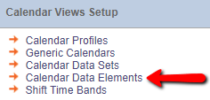
In Setup, access Calendar Data Elements.

From the list of Data Elements, select an existing element that is similar to the new element that you need to add. Select Duplicate. Here we want to add a data element for the Unplanned Vacation pay code, so we will duplicate the existing Vacation data element.

Type in the Data Element Name as well as a Description if necessary.
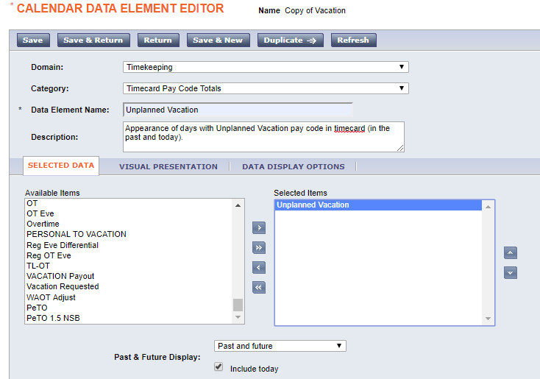
Under Selected Data, remove any pay codes that were associated with the original pay code that was duplicated. Choose the pay code that will cause this Data Element to appear. In this case, we will select the Unplanned Vacation pay code.

Under Visual Presentation, choose the color that you would like associated with this Data Element in the calendar view. When finished, click Save and Return.
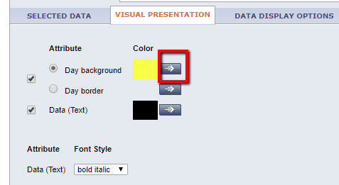

After saving, return to Setup and access Calendar Data Sets.
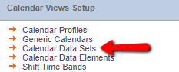

From the list, choose the existing calendar you would like to add this Data Element to. We will add the Unplanned Vacation Data Element to the Work & Absence Summary Calendar.
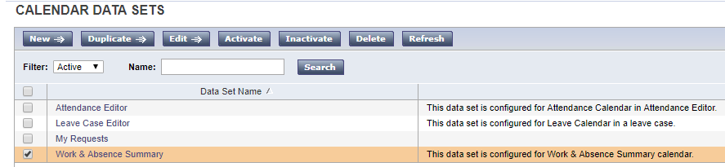

Choose the correct Domain from the left column. Select the Data Element you wish to add from the Available Data Elements box. Use the arrow to move that element to the Selected Data Elements box. Click Save and Return when finished.
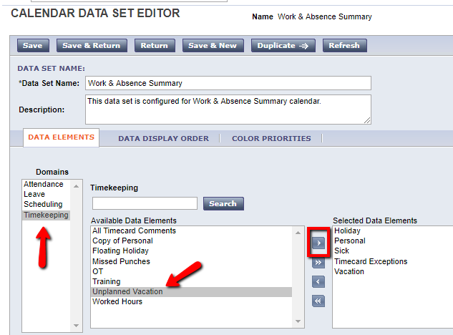

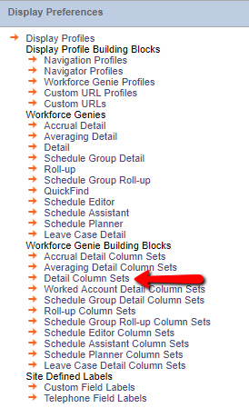
Adding a Pay Code to a Detail Genie
Access Setup and Display Preferences.
Choose Detail Column Sets.

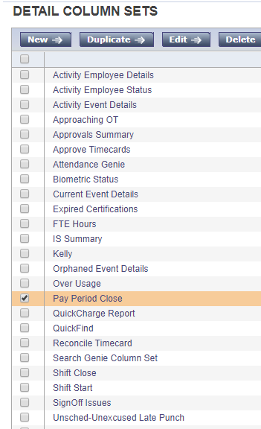
Select the genie you wish to modify. We will use the Pay Period Close genie. Choose Edit.

The list displays the columns in the order they appear, left to right, on the genie.
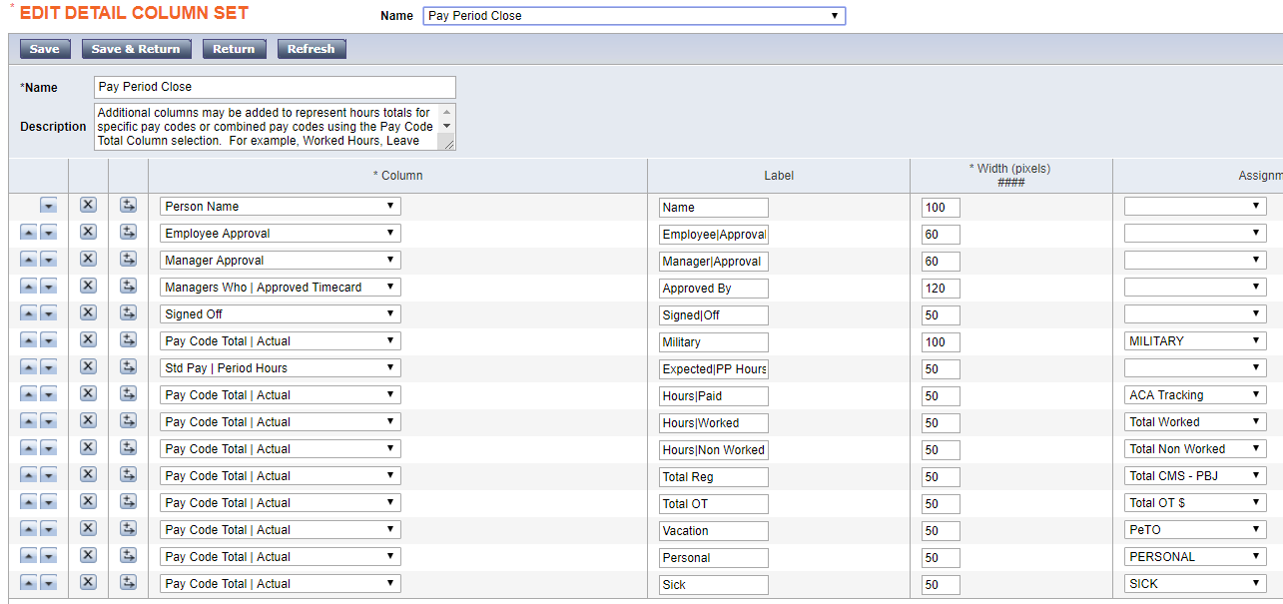
Use the icon to insert a new row where you want the new column of the genie.
In the Column dropdown, select Pay Code Total | Actual.
In the Label field, type the name that you want to appear as the label of the column.
In the Assignment dropdown, choose the pay code that you want to assign to this column.

Generic Data Access Profiles
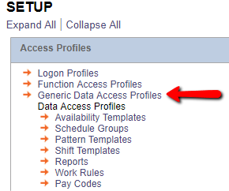
It is possible for pay code access to be restricted at the Generic Data Access Profile level. This may be used in larger organizations, particularly ones where there are multiple companies within an organization. This could be used to prevent employees of one company accessing the information of the other companies.

Payroll Interfaces
After creating a new pay code, you now need to update your payroll interface mapping table. Even if this pay code will not send information to payroll, you still need to update the mapping table. This is accessed outside of Kronos. Please note that your interface may look different than the ones represented in these examples.
To update the interface to include the new pay code, you will need to open the interface and access the mapping table. This will be under one of the menu options, such as Setup.
Newer interfaces, such as the one pictured here, will automatically pull in new pay code information once the pay code mapping table is open. The new pay code will appear in the list in alphabetical order. If the new pay code does not need to affect payroll, simply click Save and Close. If the new pay code will affect payroll, complete the table by providing the needed information. When finished, click Save and Close.
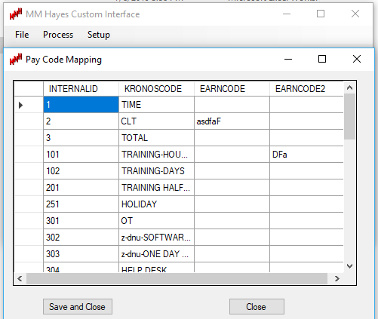

Older interfaces may have a button at the top to manually update the interface and pull in the new pay code. The new pay code will appear at the bottom of the list. Again, after updating, if the pay code does not impact payroll, the interface can be closed. If the pay code will impact payroll, complete the table by providing the needed information.
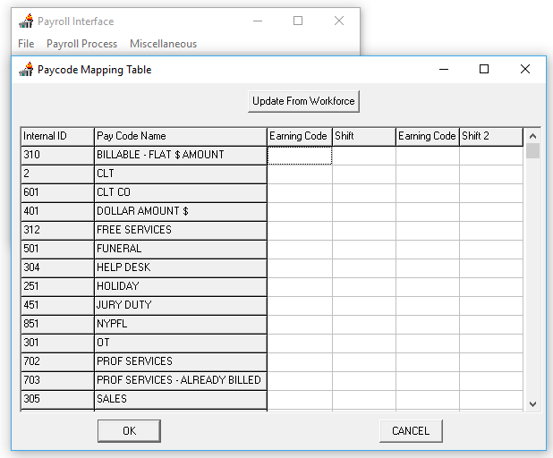

Adjusting the Pay Code Display Order
After creating a new pay code, you may wish to update the pay code display order. This controls how pay codes appear in the dropdown in the Pay Code column of the timecard.
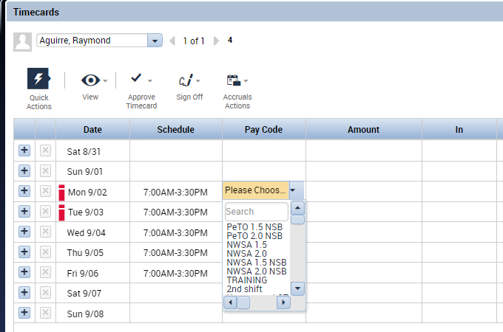

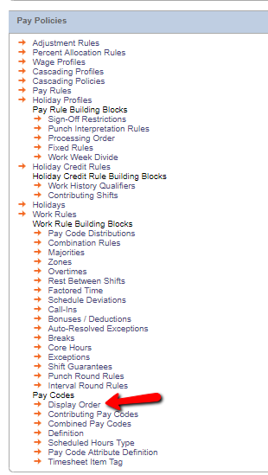

Navigate to Setup. Under Pay Policies and
Pay Codes, select Display Order.

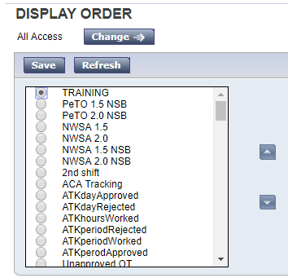
Select the pay code you wish to move & use the arrow keys to move it up or down in the list.
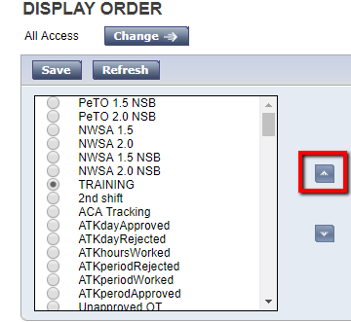

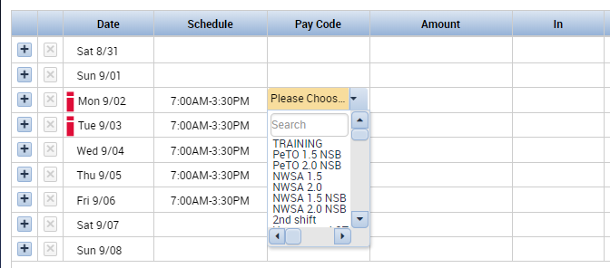
Save when finished. Sign out and sign back in for the change to take effect. Navigate back to an employee’s timecard to see the results of the change.

