Approving Time Off Requests
  - Kronos version 8.1

Contents
APPROVING A TIME OFF REQUEST 3
Approving a Time Off Request (Full Day) 4
Approving a Time Off Request (Partial Day) 8
Canceling a Time Off Request 9

APPROVING A TIME OFF REQUEST
When a manager logs in, the Request Manager Alerts are displayed at the top of the screen. Here we can see there is 1 new Request that the manager needs to view.
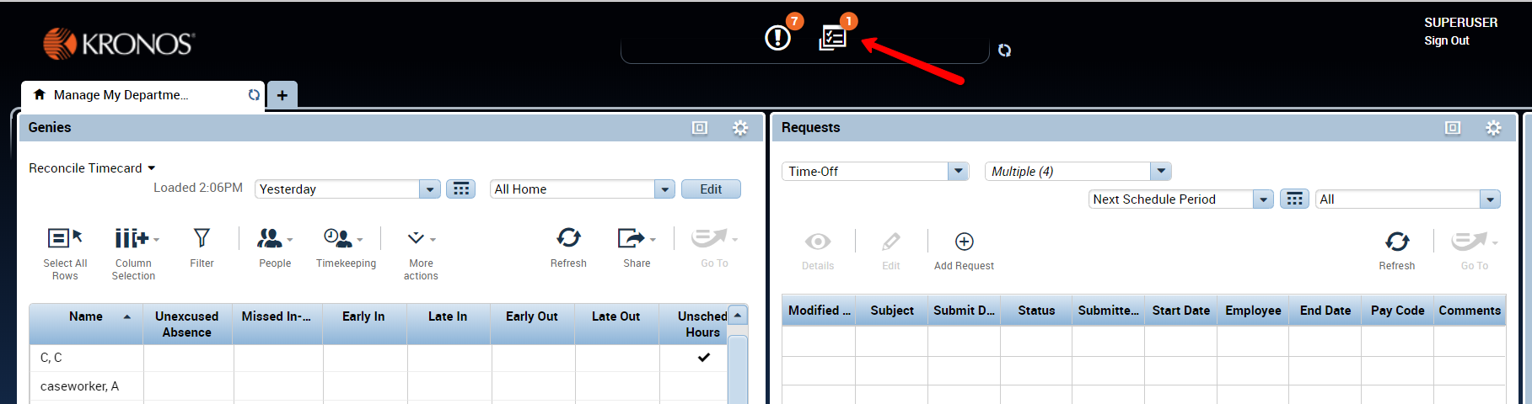
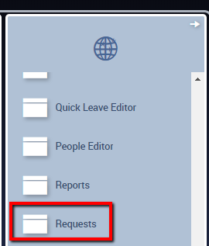
Click on the Alert to open the request.
Or, access the Requests widget from the drawer.

Approving a Time Off Request (Full Day)
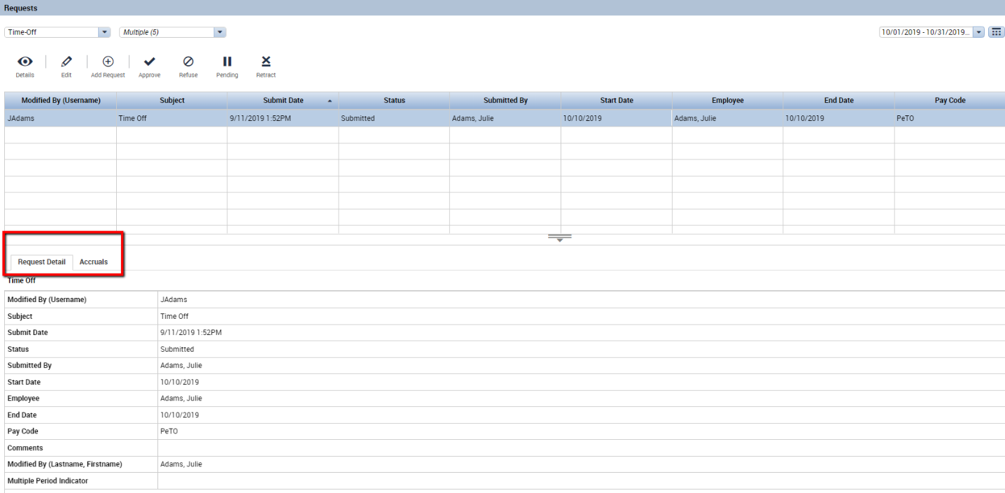
Selecting the request brings up the Request Detail as shown below. This employee has requested a full day of Personal Time Off (PeTO).
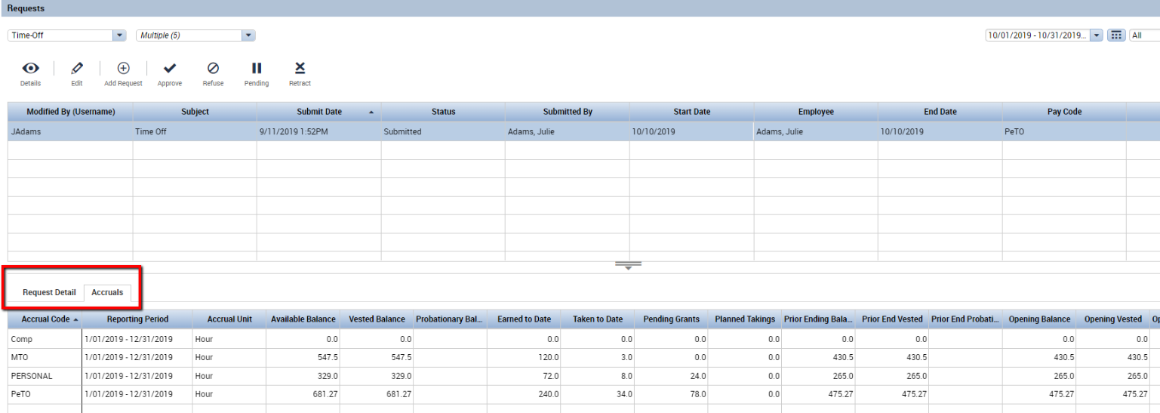
Switch to the Accrual tab to view related accruals information.
Accruals information is displayed for reference, but the system automatically validates each request, and the request cannot be approved if the employee does not have enough time accrued.

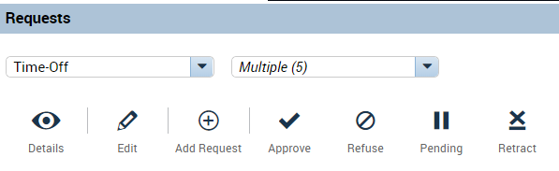
Icons that appear in the top left of the widget:
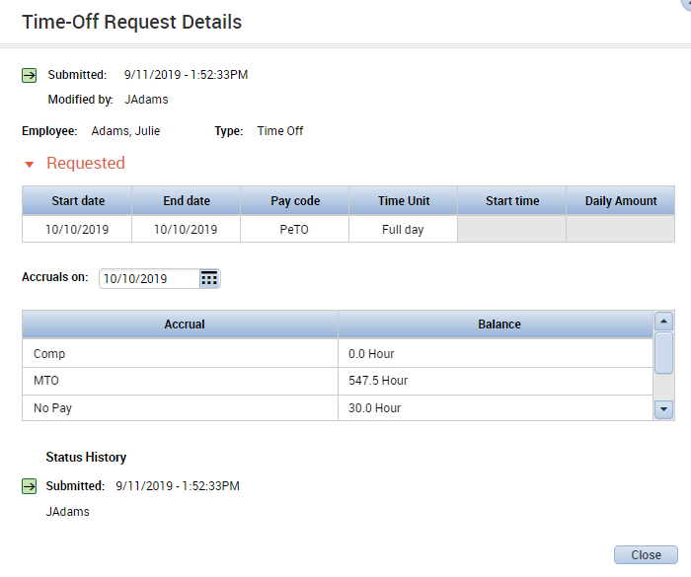
Use the Details icon to display the Request details in a different view:
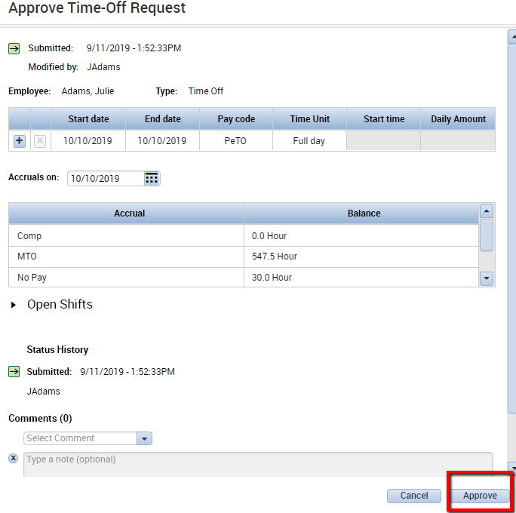
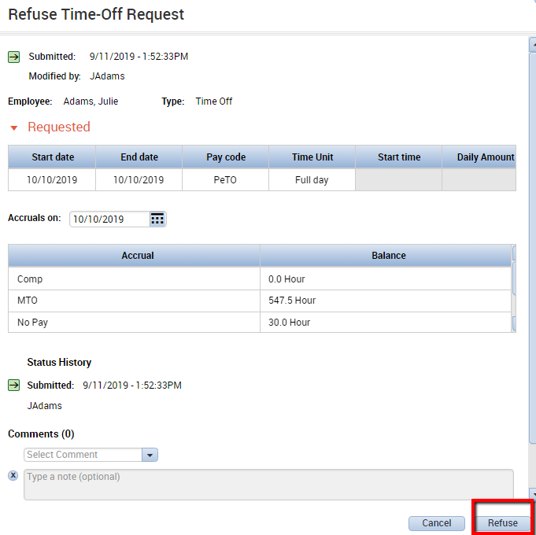
Approve the Request:
Deny the Request:
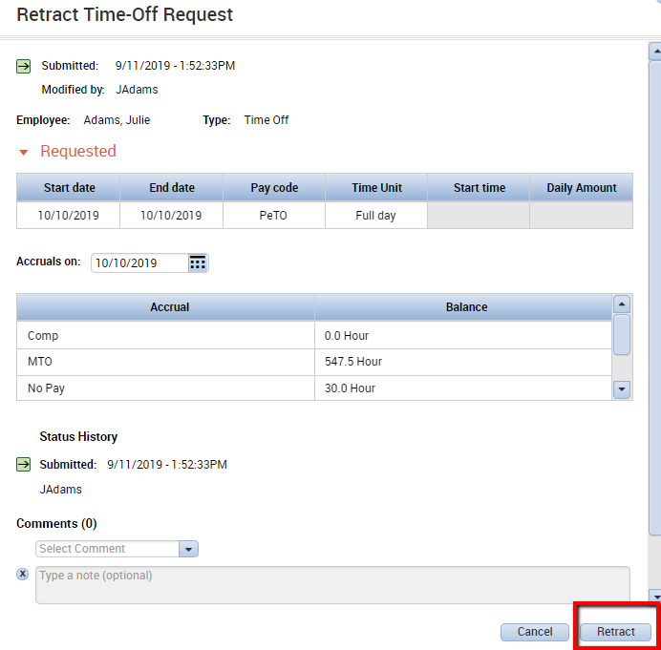
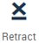
Retract the Request:
Retracting a request
can only be done if the
request has not yet been approved.
After approving a time off request, the request will automatically populate into the employee’s schedule and timecard:
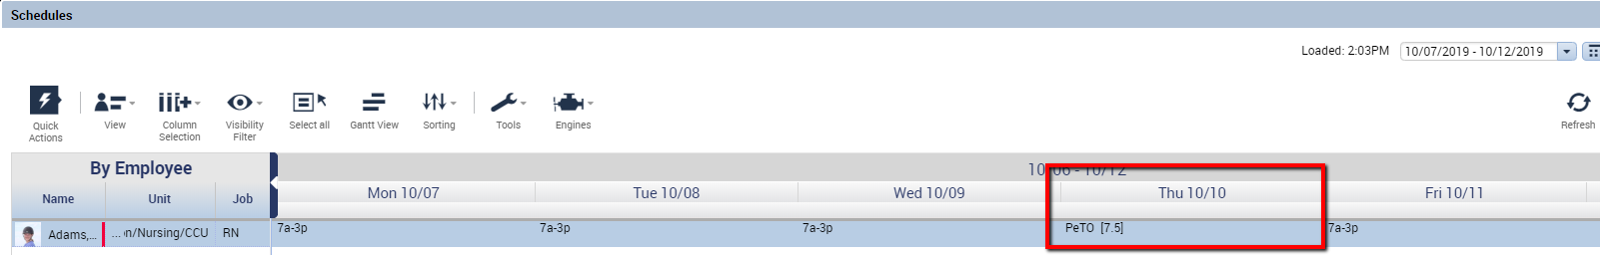

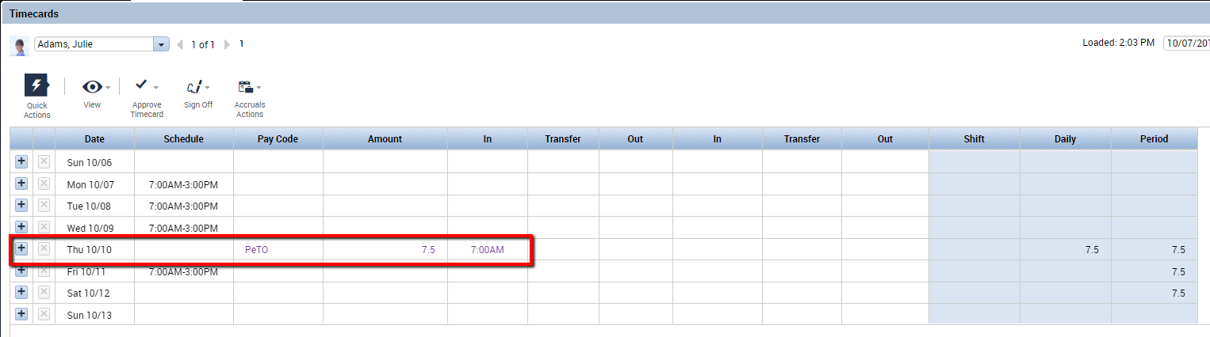

Approving a Time Off Request (Partial Day)
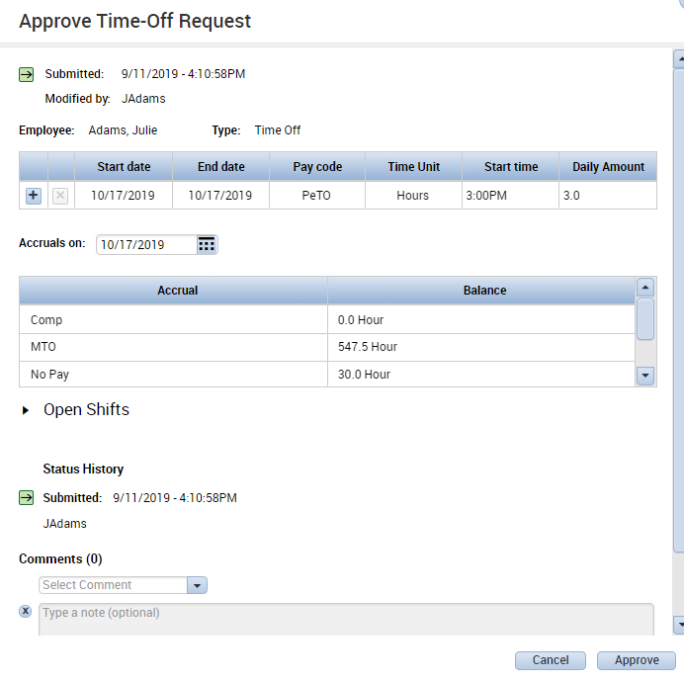
Employees may also submit time off requests in hours increments. Here this employee has requested 3 hours off, starting at 3pm:

After approving this request, it automatically populates into the schedule and the timecard.
In the schedule, we can see that her Personal Time Off that she requested at 3pm fills in, and Kronos has modified her scheduled start time to 6pm.
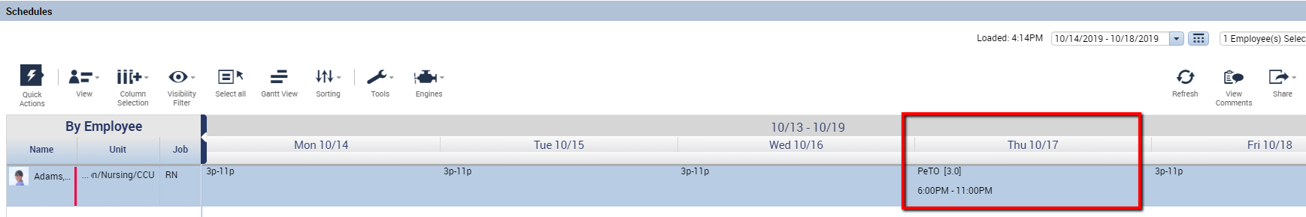
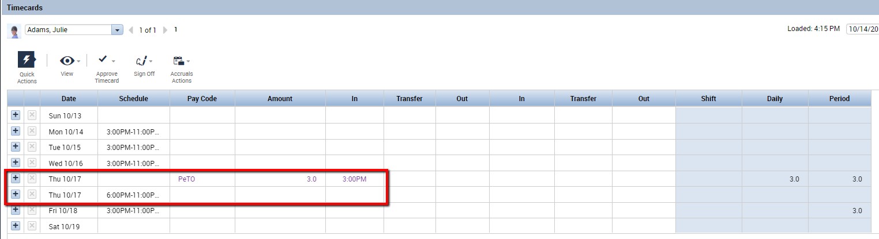
In the timecard, there is a row for the 3 hours of PeTO, and an additional row to accommodate the In and Out punches once she does arrive at work.

Canceling a Time Off Request
If you have already approved a time off request and the employee no longer needs the time off, the employee may submit a cancel request.
Note: Depending on your system configuration, Cancel Requests may be set up to auto-approve. If this is the case, an employee will be able to cancel approved time off without the involvement of a manager.
However, if employee Cancel Requests need to be approved by a manager, they will still create an alert and appear in the Request widget.
The Request appears with a status of Cancel Submitted and the choices for Cancel Approved,
Cancel Refused, and Cancel Pending appear across the top.

Cancel Approved: Cancels the time off request.
Cancel Refused: Leaves the time off request as is.

If the cancellation is approved, the time off will no longer show in the employee’s timecard or schedule.

