Attestation
  - kronos workforce central

Contents
Attestation Module 3
Overview 3
Punch In with Questions 4
Punch In Using Timestamp 4
Punch In Using InTouch Clock 6
Results Shown in Timecard 9
Punch In with Transfer and Questions 10
Punch In With Transfer Using Timestamp 10
Punch In With Transfer Using InTouch Clock 12
Results Shown in Timecard 13
Questions Without Punch 14
Using Timestamp 14
Using InTouch Timeclock 15
Results Shown in Timecard 16
Genies 17
Reports 17
Additional Attestation Functions 19
Out Punch 19
Time Review 20

Attestation Module

Overview
The Attestation Module is used to record employee responses to a set of questions. The questions and multiple-choice responses are customizable to meet the needs of the organization. Questions can be used to determine if employees work through meals, have the correct equipment, or present certain health symptoms. This overview will be focused on questions related to COVID-19 screening.
Attestation is supported through:
- clocks (4500 and InTouch)
- web timestamp (requires employee license)
- mobile devices (requires mobile license)

4500 Clocks | InTouch Clocks
Minimum Firmware Version: 3.0.9 | Minimum Firmware Version: 3.0.8
Limitations:  Cannot add freeform notes  Cannot time review older pay period  Cannot view totals in time review screen  Cannot perform missed punch attestation | Limitations:  None, all features are supported.

Punch In with Questions
This option allows the employee to respond to the set of questions, then submit a normal In Punch. If an employee reports that they have no symptoms, then the In Punch is added with a comment indicating they are symptom free. If the employee reports that they do have a symptom, the process is ended, the punch is not submitted, and the employee is notified to contact their manager. In this case, the system would add a pay code to indicate they had symptoms and were not punched in. The time of the punch can be set to the time the employee started or finished answering the questions. For example, an employee arriving for a 4pm shift may start answering the questions at 3:58pm and finish answering at 3:59pm. The time recorded for the in punch can be either the start time or the end time.

Punch In Using Timestamp
Employees will see the available buttons on the timestamp screen. In this example, the employee will select the “COVID In Punch” button.
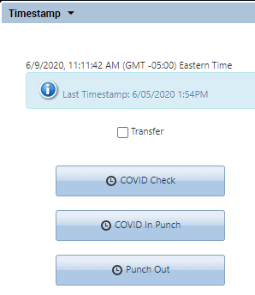
The employee will then be prompted with questions to respond to. The text of the questions and answers are fully configurable.
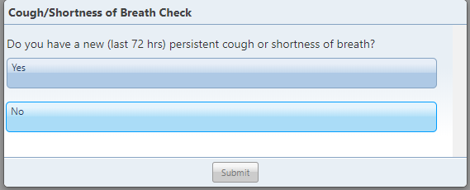
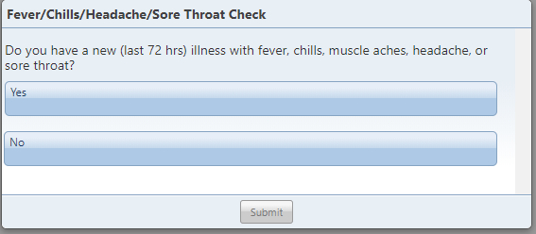
If the employee answers No to all questions, the process completes, and the punch is added. The screen will display a message showing a summary of the answers.
The “Punch Created” message displays as shown:
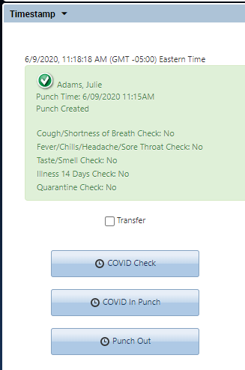
If the employee answers Yes to a question, the timestamp displays the message below. No punch is added, and no further questions are asked. The message can indicate that the employee needs to speak with their manager. The “No punch was added” message displays as shown:
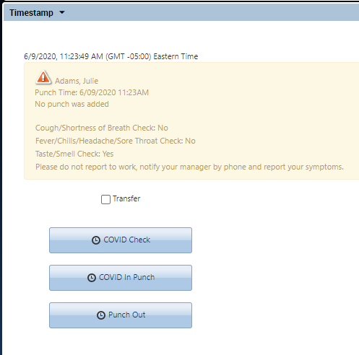
Please note: If needed, this procedure can be changed so that the punch is still recorded on the timecard.

Punch In Using InTouch Clock
The punch process is similar for employees who punch at an InTouch Clock. In this example, the employee will select the “COVID In Punch” button.
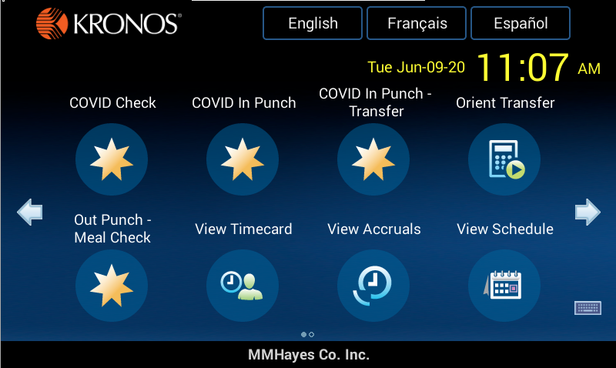
The questions display for the employee to respond to:
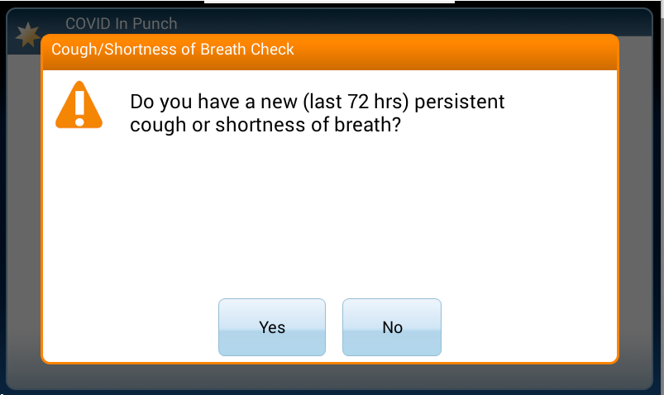
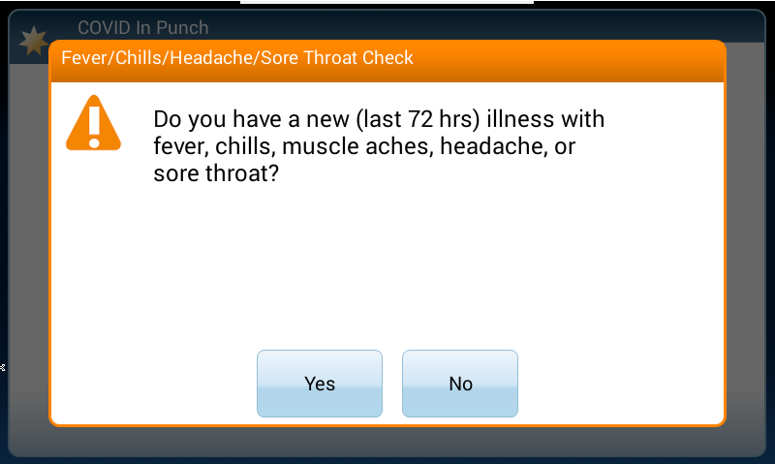
If the employee answers No to all questions, the process completes, and the punch is added. The screen will display a message showing a summary of some of the answers. Depending on the length of the questions, the screen may not be able to display all answers in the summary. The “Punch Created” message displays as shown:
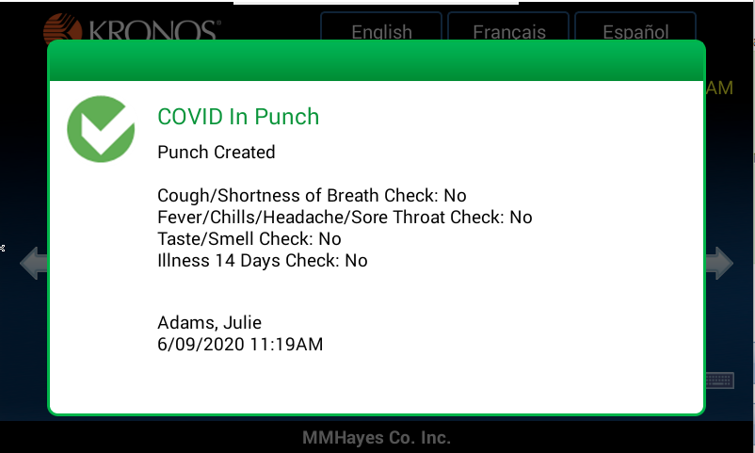
If the employee answers Yes to a question, the timeclock displays the message below. No punch is added, and no further questions are asked. The message can indicate that the employee needs to speak with their manager. The “No punch was added” message displays as shown:
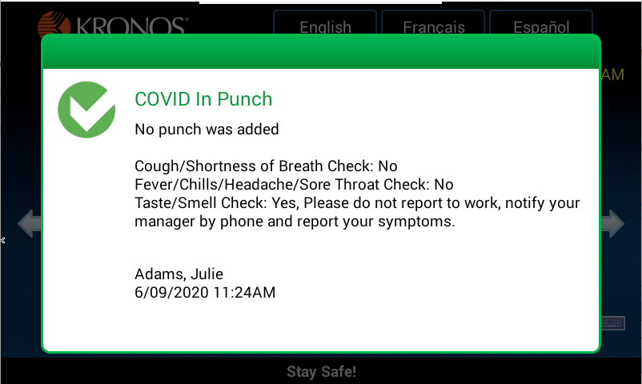
Please Note: At this point, an email could be sent to the employee’s Reports To manager and a defined email address when a question is answered Yes. The email message can be customized with tags indicating the employee name, punch time and date, etc.

Results Shown in Timecard
Whether the employee punches at a clock or from a web browser, the results of the punch process can be seen in the timecard.
For an employee who has been successful at completing the questions and generating a punch, the timecard will show the punch and will show a blue comment indicator on the punch. Hovering over the punch will show the comment. The text of the comment is fully configurable.

For an employee who did not complete the questions and was not able to generate a punch, the timecard will show a pay code. The pay code is added with a comment showing which question they answered that prevented them from punching in.
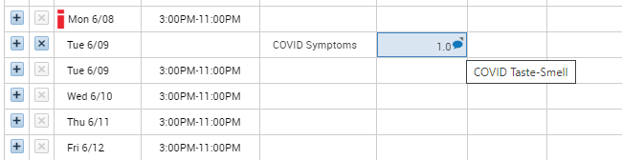

Punch In with Transfer and Questions
This option is used if the employee needs to perform a transfer on the In Punch. This can be a Labor Level transfer or a Work Rule transfer.

Punch In With Transfer Using Timestamp
In Timestamp, the employee must first check the “Transfer” box, then use the “COVID In Punch” button.
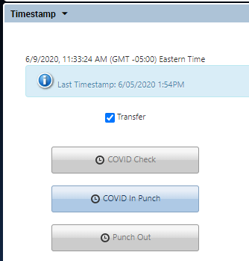
This will take the employee through the same set of questions. After completing the questions, the employee will be prompted to select the Labor Entries and/or Work Rules needed to complete the transfer.
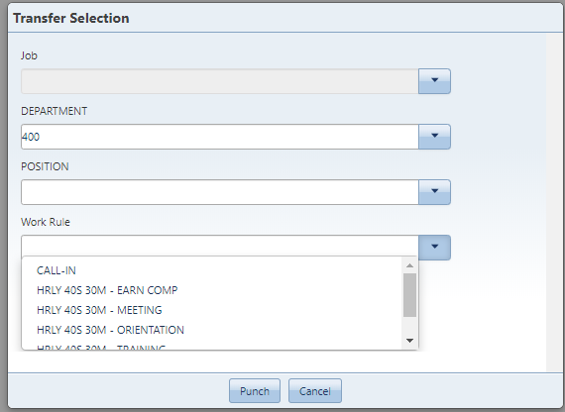
The summary then displays as shown. The “Punch Created” message displays, as well as the “Transfer to” line that confirms the transfer.
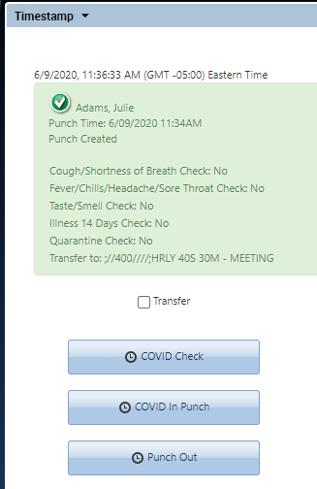

Please Note: The Labor Entries and Work Rules the employee has access to are determined from their Person Record, on the Job Assignment tab under the Employee Role section. The Labor Level Transfer Set and Work Rule Profile are what determine these values.
This does allow a more accurate set of choices to display for each employee but may require additional setup. If the employee does not have a value for a Labor Level Transfer Set or Work Rule Profile, they will not see the option.

Punch In With Transfer Using InTouch Clock
At the clock, the employee would select the “COVID In Punch – Transfer” button if they needed to punch in and include a transfer.
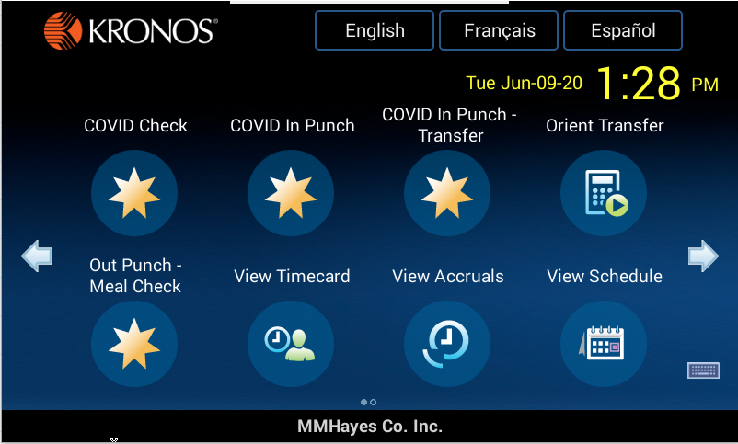
This will take the employee through the same set of questions. After completing the questions, the employee will be prompted to select the Labor Entries and/or Work Rules needed to complete the transfer. Like the timestamp, these are based off options in the employee’s record.
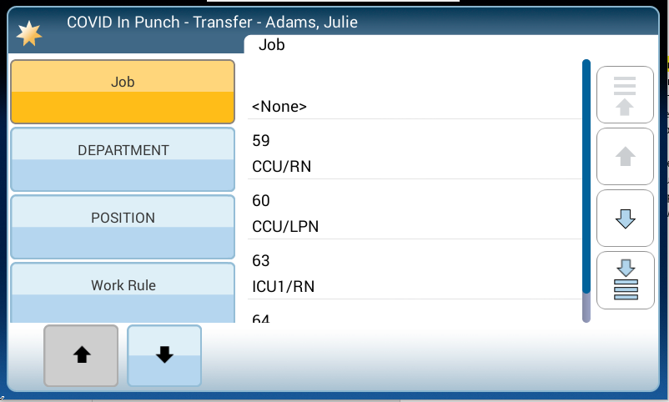
A review screen displays before the employee submits the punch.
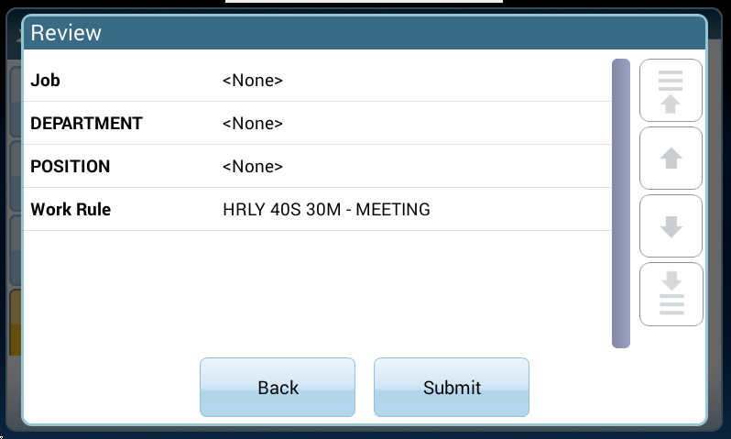

Results Shown in Timecard
Whether the employee punches at a clock or from a web browser, the results of the punch and transfer process can be seen in the timecard.

Questions Without Punch
This process collects the employee’s response to questions without generating an In Punch. This could be used for salaried employees or other types of employees who do not usually record daily punches. This function would be a separate button on the clock or timestamp. This function will not add a punch, but the pay code will appear on the timecard. The responses can be viewed in genies and reports.

Using Timestamp
The employee will use the “COVID Check” button in timestamp.
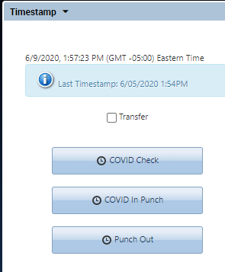
The employee will be prompted with the same set of questions. The last prompt will confirm that all responses have been received. At this point the employee could punch in if necessary. If the employee does not typically punch, then there are no other steps the employee would need to take.
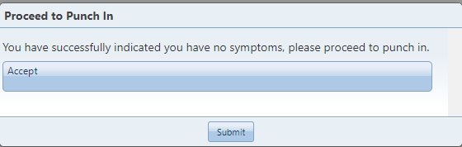

The summary screen will show all response information as well as the punch reminder.
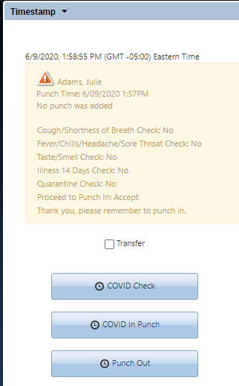

Using InTouch Timeclock
At the clock, the last prompt to confirm looks slightly different.
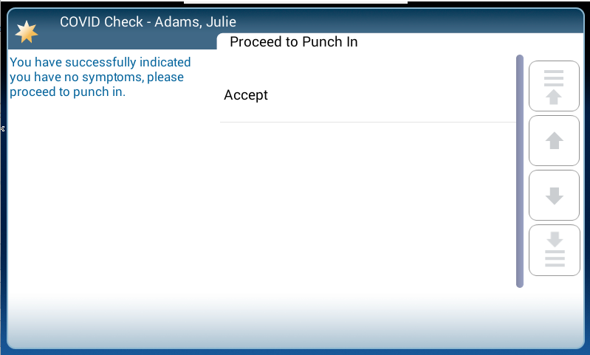
Performing the same procedure but answering Yes to a question presents the message to notify the manager, as shown:
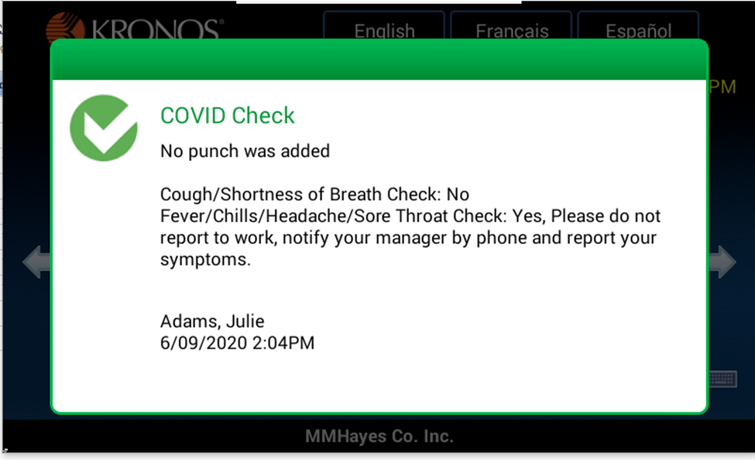

Results Shown in Timecard
An employee who has answered No to all questions and is able to work will have a “COVID Cleared” pay code display in the timecard. This can be configured not to show in totals.
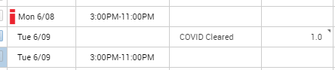

An employee who has answered Yes to a question and was directed to notify their manager will have a “COVID Symptoms” pay code display in the timecard, along with information about which question they answered Yes to.

Genies
Genies can be customized to easily view the responses in real time. The example genie shown below loads a time period of “Today” with the hyperfind configured to show anyone who indicated they had a symptom, or anyone who had hours scheduled on the day but did not answer the questions.
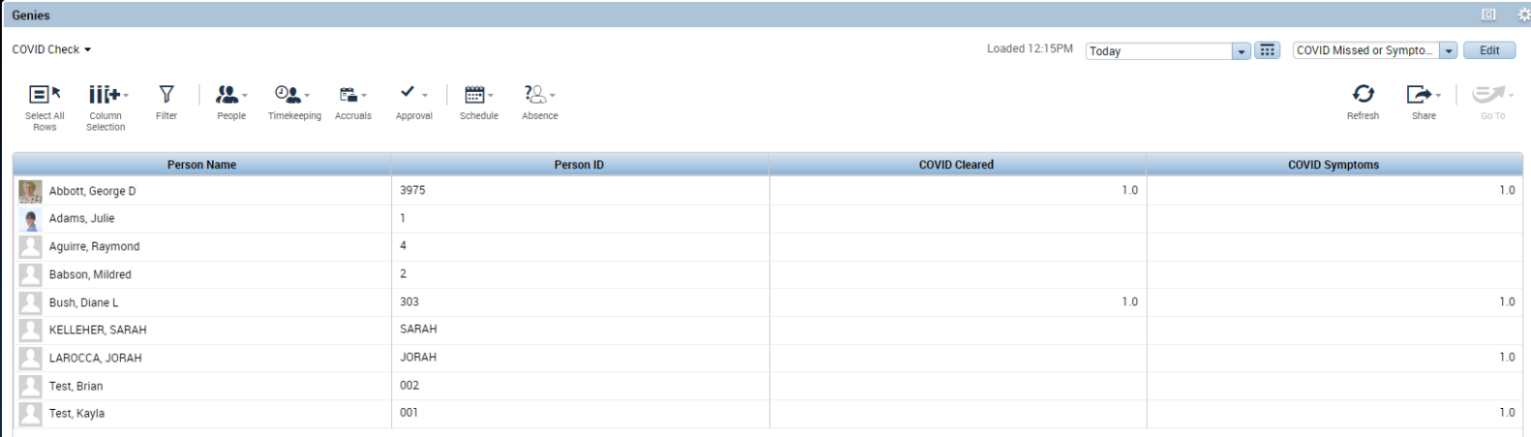
Other hyperfinds can be configured to look for certain responses. The genie set up will depend on each organization’s configuration.

Reports
Attestation comes with two reports for the timestamp responses: TimeStamp Detail and TimeStamp Summary. There are other reports available for the approvals, time review, etc.
Below is an example of the “MyTimeStamp Question and Answer Detail” report. This shows detailed data of each response from the employee along with times.
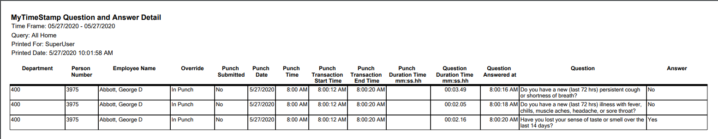
The TimeStamp Summary report groups answers by department and all responses.
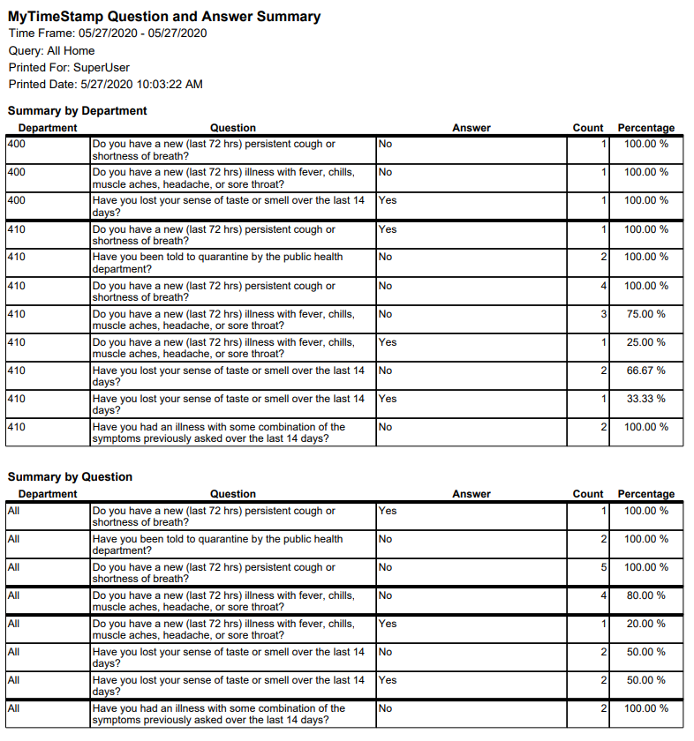
The reports can be scheduled to run and email automatically.

Additional Attestation Functions

Out Punch
Attestation can also prompt questions when employees punch out at the end of a shift. These usually relate to meal breaks but can be anything needed. Employees use the Punch Out button, then respond to the questions on meal breaks. If Yes is answered, the punch is submitted normally. If they answer No, then additional questions come up.
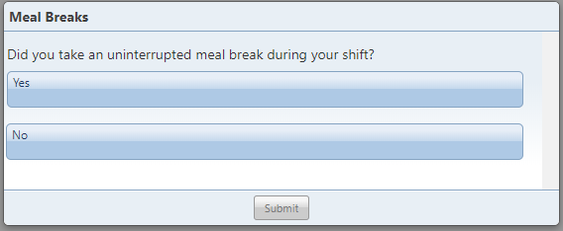
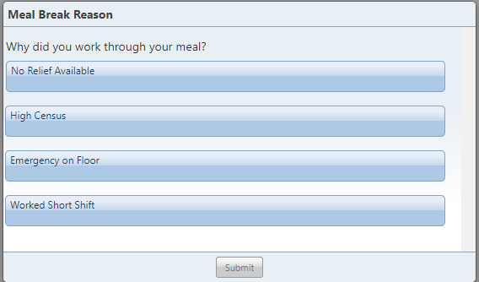
In the timecard, the Out Punch shows with a comment indicating the response. The meal deduction can be cancelled based on the employee’s response. This is a configurable option.
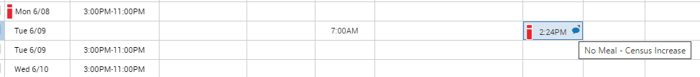

Time Review
Time Review allows employees to submit missed punches and perform timecard approvals.

Using Web Browser
Employees can log in, open the Time Review widget, and go to Daily Approvals.
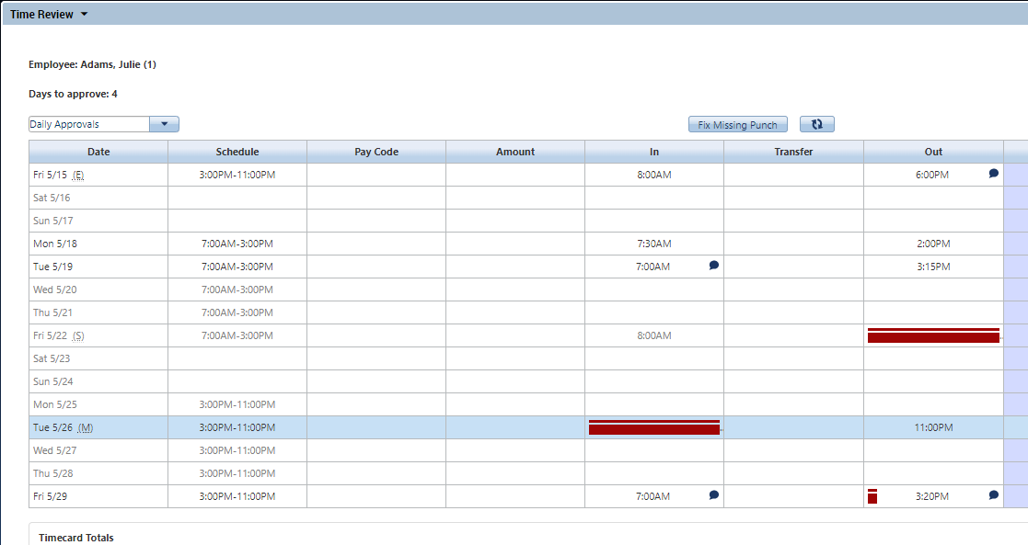
The indicators to the right of the date indicate status:
Missed (M) represents a missing punch that the employee can fill in.
Submitted (S) represents that the employee has submitted the information needed to correct the punch, and it is awaiting manager approval. A red box will still display until the time has been approved.
Edited (E) represents that the manager has reviewed and approved the employee’s submission. The punch is no longer missing.
The employee would click on day (5/26 shown above) to add the missing punch. On InTouch clocks or web browsers, the employee can add a freeform note adding more detail as to why the punch was missed.
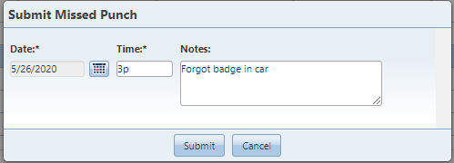

Submitted punches can either be automatically approved or go to a table for approval by the manager.

Using InTouch Clock
The employee can also review their time from the clock. First, the employee selects the period to review:
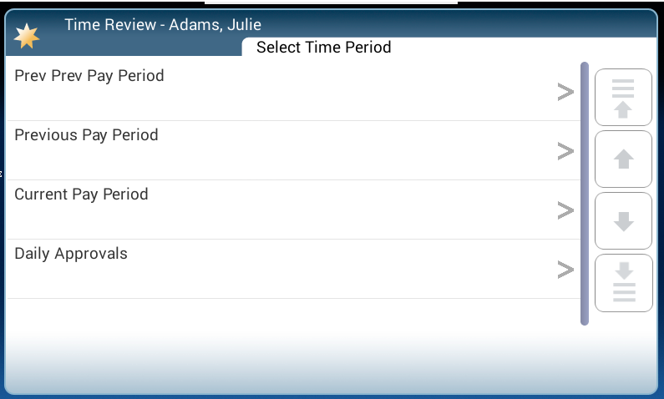
The employee is presented with the Missed Punches they can choose to review:
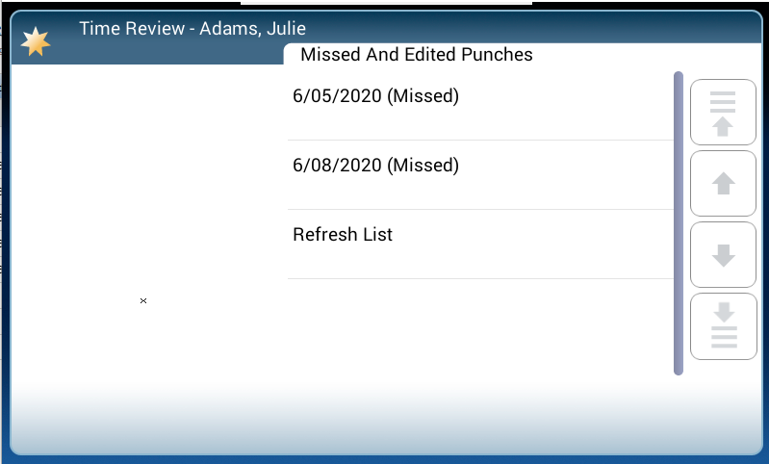
The employee can then fill in the time to correct the missing punch, and add a note if needed:
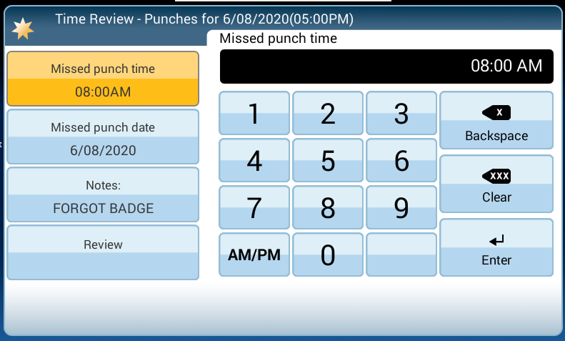
Finally, the employee can confirm their entry before submitting.
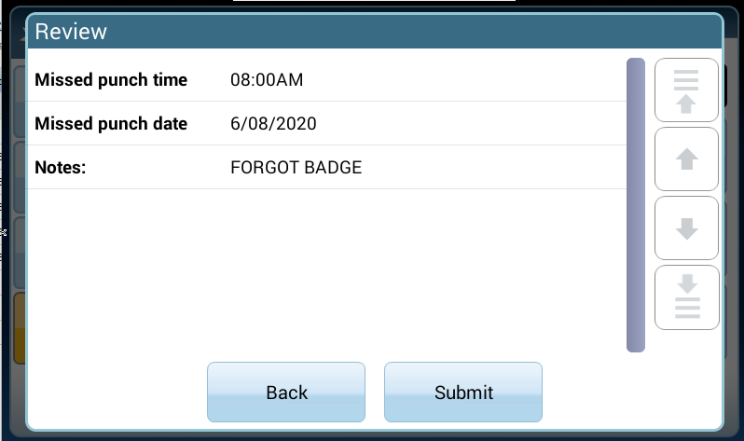

Manager Approval
The manager would use the “All My Approvals” widget to approve or reject any submitted punches.
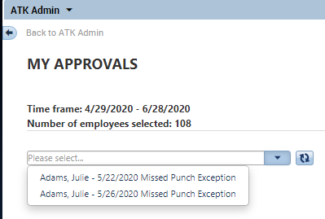
Each punch to be reviewed displays with additional detail. The manager has buttons at the top of the screen to Approve or Reject the punch submission.
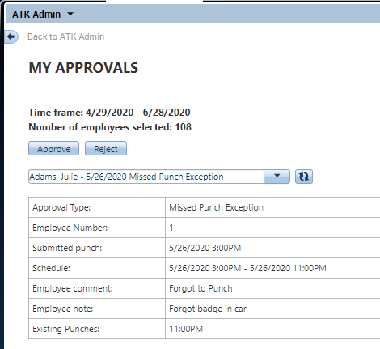
Once approved, the punch goes into the timecard.
