Combined Pay Codes
  - Kronos version 8.1

Contents
COMBINED PAY CODES 3
Creating a New Combined Pay Code 4
Using Combined Pay Codes in Reports 7

COMBINED PAY CODES
Combined pay codes are used to summarize information. They are useful on timecards, in reports, and in genies. These types of pay codes sum up information that is provided by individual pay codes. Combined pay codes can summarize time or money pay codes. 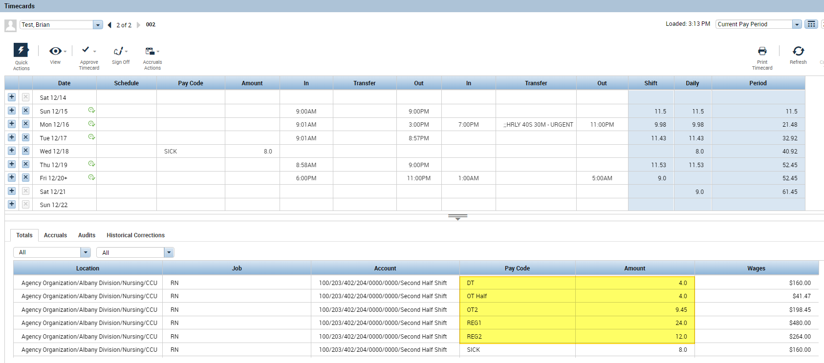
Combined pay codes can be used in the Totals Tab beneath the timecard. Common combined pay codes summarize Total Worked Time, Total Paid Time, or Total Overtime. We can create a combined pay code to give a total of all the worked time that this employee was paid for.

Creating a New Combined Pay Code
- Navigate to Setup. Under Pay Policies, select Combined Pay Codes. 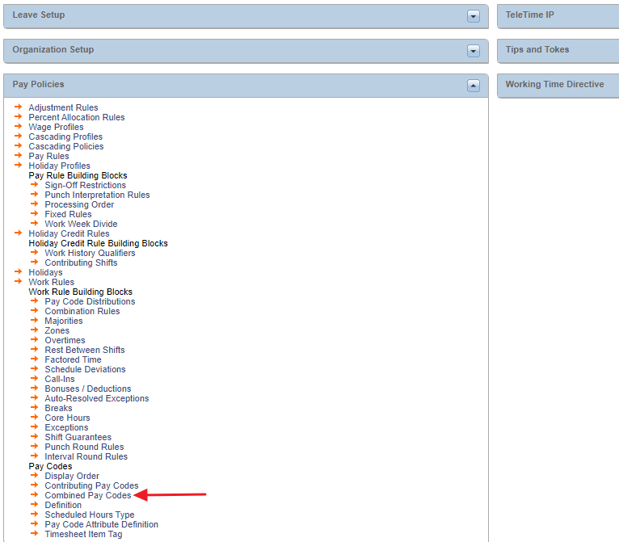

- Select New to create a new combined pay code:
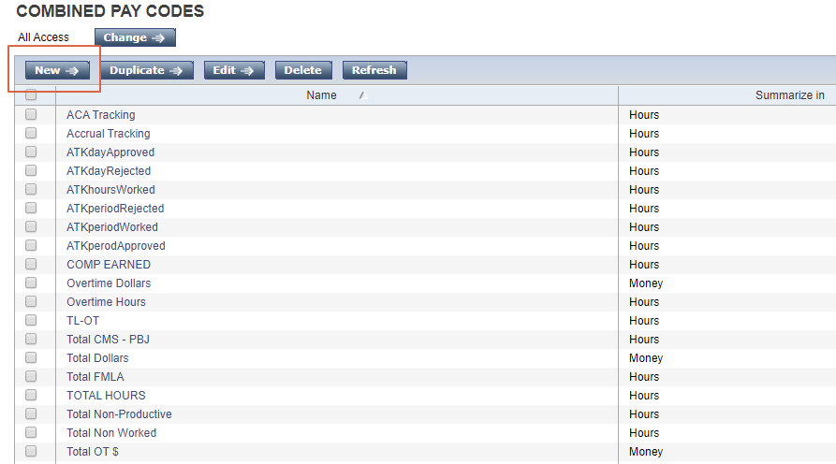
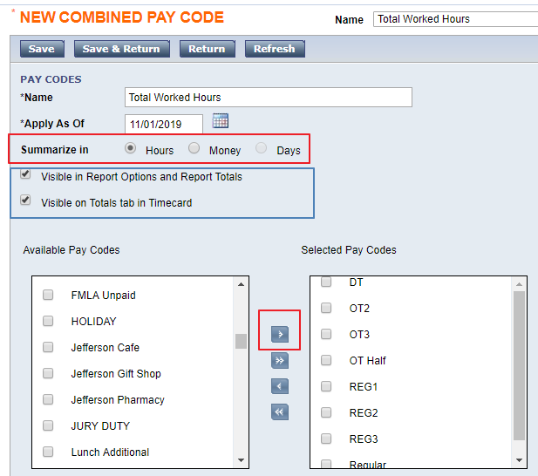
- Name the new pay code.
- Choose an effective date. The pay code will not summarize any information before the chosen date.
- Choose what information you are summarizing: Time (hours, days) or Money.
- The Visible in Report Options and Report Totals and Visible on Totals tab in Timecard are checked off by default. The recommendation is to leave these checked. The combined pay codes provide summary information that is especially useful in reports and on the timecard screen.
- Use the right arrow ( > ) to move the pay codes that relate to your employees from the Available Pay Codes pane on the left to the Selected Pay Codes pane on the right.
- When finished, choose Save & Return.
- Return to the employee’s timecard.
The new pay code now appears in the Totals Tab beneath the timecard:
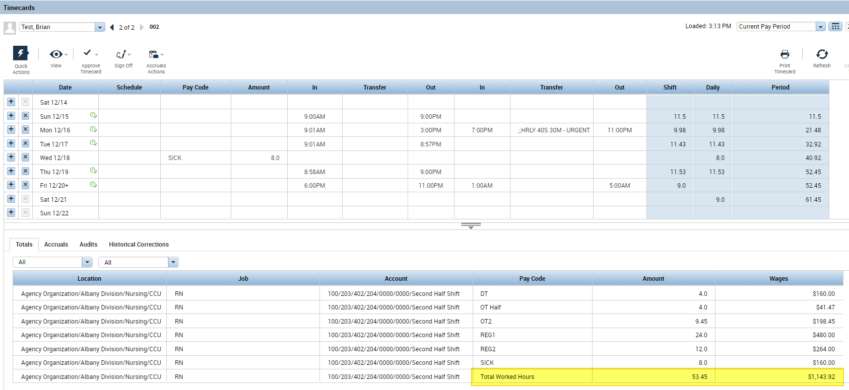
Additional pay codes could be created to show other types of totals.

Using Combined Pay Codes in Reports
Combined pay codes can be used to quickly include needed information in reports.
- Select an employee and use the Go To button to access Reports. 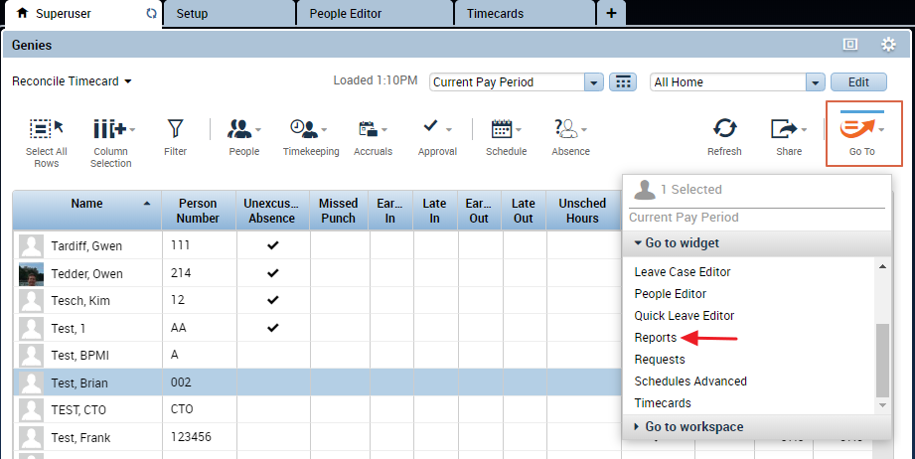
- For reports that require you to select individual pay codes, you only need to select the combined pay code: 