Creating HyperFinds
  - kronos version 8.1

Contents
HYPERFIND QUERIES 3
Types of HyperFind Queries 3
Query Conditions 3
Creating HyperFind Queries 4
Common HyperFind Queries: Employees with Missed Punch and/or Unexcused Absence 6
Common HyperFind Queries: Employees with Overtime 7
Common HyperFind Queries: Accrual Balances 8

HYPERFIND QUERIES
HyperFind Queries are simply filters which allow managers to select a subset of employees from all of their Home employees. Unless changed by your Kronos System Administrator, widgets and genies default to the All Home HyperFind which allows managers to see all their employees. If a manager has responsibility for more than one department or unit, he or she may want to create HyperFind Queries so employee timecards for each department can be viewed and/or approved separately. The ability to create HyperFind Queries is granted in the Function Access Profile assigned to each manager.
Different HyperFind Queries can be selected from the drop down located in the upper right corner of a genie.
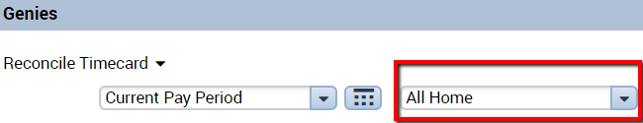

Types of HyperFind Queries
Depending on the rights granted in their Function Access Profile, managers can have the ability to create one or more of the following types of HyperFind Queries:
Ad Hoc – a temporary Query, good for as long as the manager is logged in or until it is changed.
Personal – visible only to the person who created it or to whom it is assigned.
Public – visible to all Workforce Managers. The ability to create public Queries is generally reserved for the Kronos System Administrator.

Query Conditions
The manager’s Function Access Profile controls what filters can be used to create HyperFind Queries. Some of the filters that you may have access to include: Employee Name or ID, Primary Account, Worked Account, Pay Codes, Pay Rules, Exceptions, Employment Status, and many others. The conditions you have access to will be displayed on the HyperFind Query screen under the Filter column.

Creating HyperFind Queries
As previously mentioned, there are many conditions (filters) that may be used to create HyperFind Queries. The most commonly used filter is Primary Account, which will segregate employees based on one or more labor entries which make up their Home account.
To create a HyperFind Query based on department using the Primary Account filter:
- Go to Setup > Common Setup > HyperFind Queries.
- On the HyperFind screen, click New.
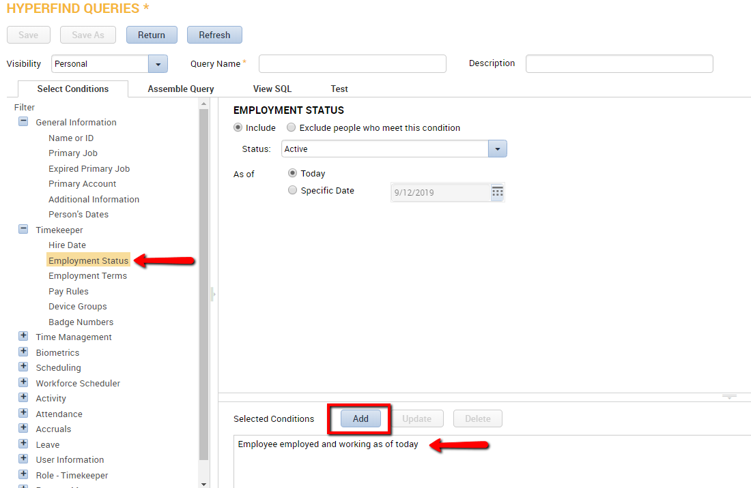
- A good rule of thumb for creating HyperFinds: Begin by selecting the + sign next to the Timekeeper filter. Click Employment Status. Notice that it defaults to employees whose status is active as of today. Click the Add Condition button to select this as a condition. By selecting this condition, you will limit your search to only active employees without cluttering the results with anyone inactive or terminated.
- Click the Primary Account filter (depending on the settings in your Function Access Profile, this may be the default).
- Click to the tab which for the labor level which designates departments in your company, e.g. “Department.”
- Select the department for which you are creating the Query. You can either select it from the “Search Results” list and then click the right arrow ( > ) button or, if you know the code for the department, you can key it directly in the box to the right of the Department labor level.
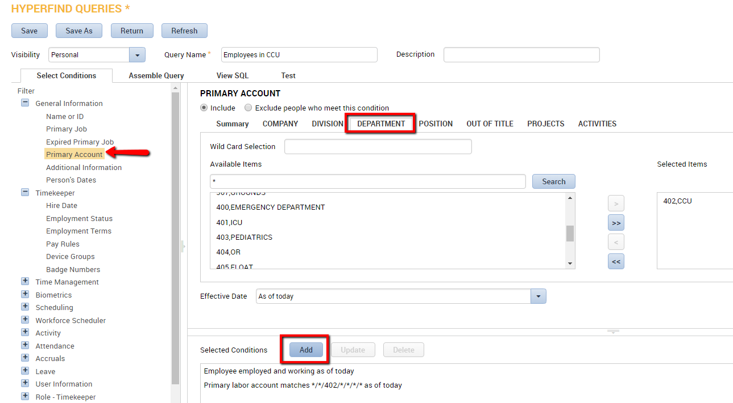
- Click the Add Condition button. You should now see this condition displayed in the Selected Conditions box at the bottom of the screen.
- Click the Visibility dropdown in the top left and choose Personal – this will be saved as a personal Query, visible only to you.
- Name the personal Query with the name of the department you selected in step 5 above.
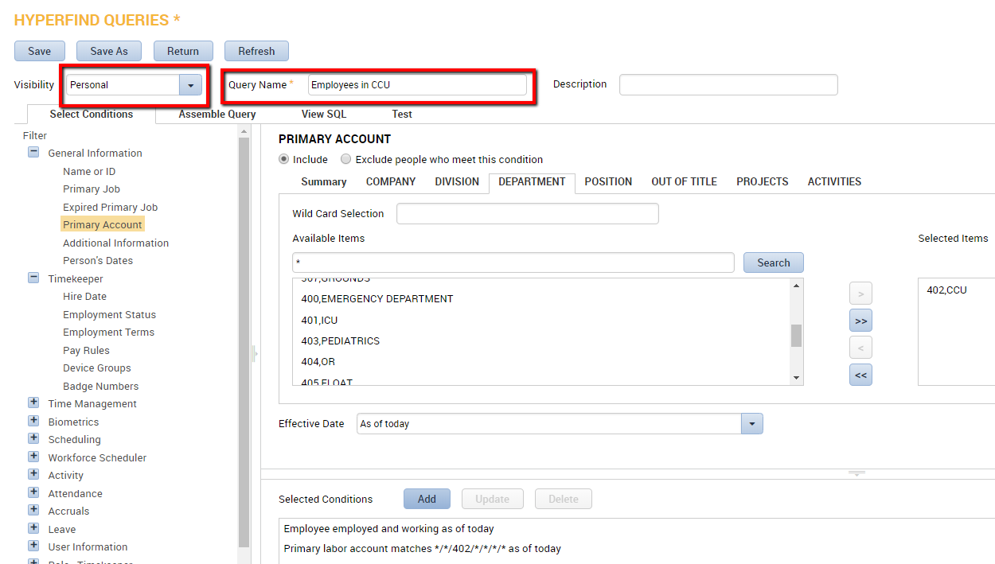
- Click Save.

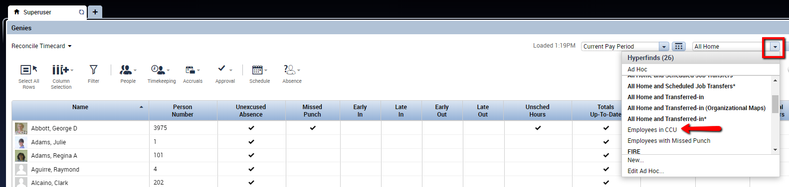
To test the Query, go to any Workforce Genie and click the down arrow in the Show box at the top of the screen. The Query you created will be displayed in the list along with any other Queries you have access to.

Note: You can select multiple departments within one Query.

Note: You can create Queries using other filters using the same logic used in the Query you created using the Primary Account filter.

Common HyperFind Queries: Employees with Missed Punch and/or Unexcused Absence
- Go to Setup > Common Setup > HyperFind Queries.
- On the HyperFind screen, click New.
- Under Timekeeper, select Employment Status. Add the condition for “Employee employed and working as of today.”
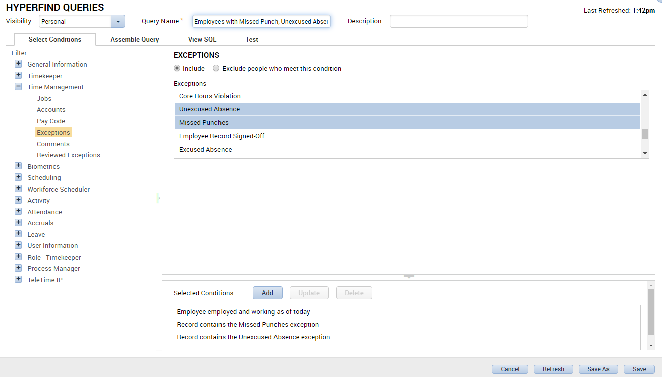
- Under Time Management, select Exceptions. To identify employees who have a Missing Punch and/or an Unexcused Absence, select both conditions. Click Add to add the conditions.

Common HyperFind Queries: Employees with Overtime
- Go to Setup > Common Setup > HyperFind Queries.
- On the HyperFind screen, click New.
- Under Timekeeper, select Employment Status. Add the condition for “Employee employed and working as of today.”
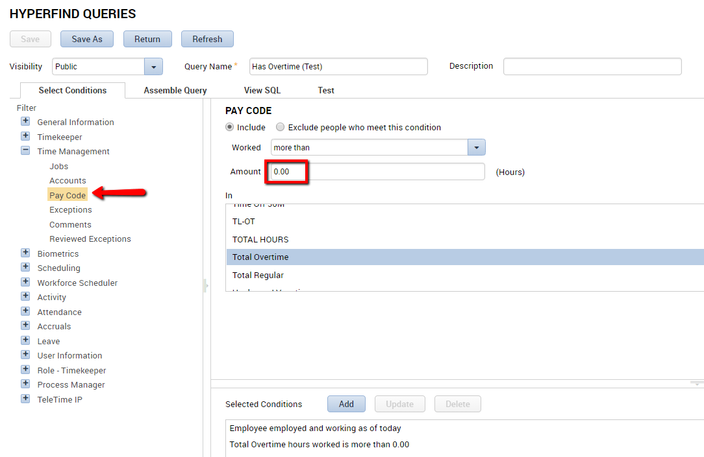
- Under Time Management, select Pay Code. Choose the pay code used to track overtime. The most efficient method may be to choose a combined pay code that collects multiple overtime pay codes. Set the Worked to “more than.” Set the Amount to 0.00. Choose Add when complete. This HyperFind will collect any employees who are being paid in an overtime pay code.
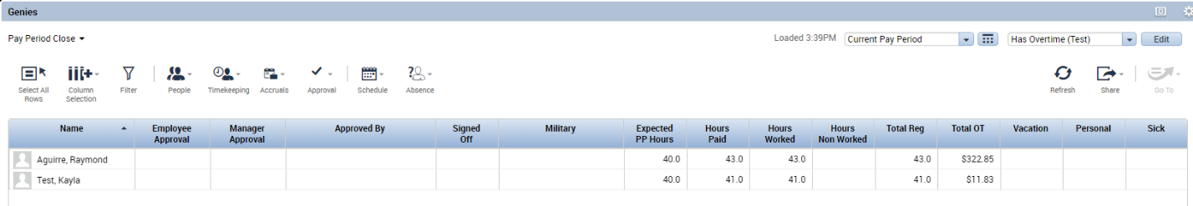
- When applied in a genie, this HyperFind will display only employees who have earned time under the paycode selected.

Common HyperFind Queries: Accrual Balances
- Go to Setup > Common Setup > HyperFind Queries.
- On the HyperFind screen, click New.
- Under Timekeeper, select Employment Status. Add the condition for “Employee employed and working as of today.”
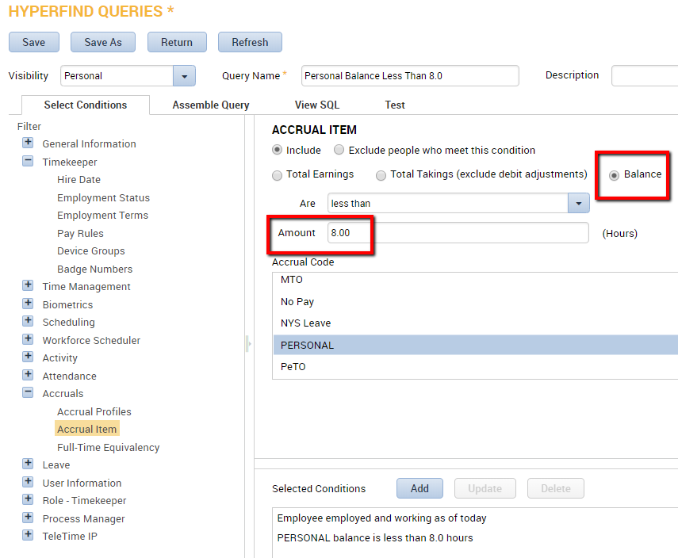
- Under Accruals, select Accrual Item. Select Balance. Set the Are condition to “less than.” Set the amount to the minimum balance (for this example we will use 8 hours.) Select the Accrual Code that you wish to apply. Choose Add when complete.

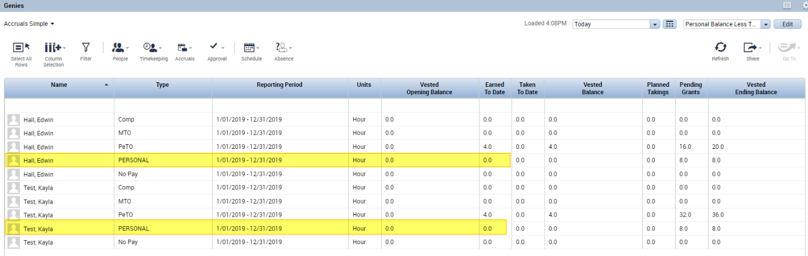
- When applied in a genie, this HyperFind will display only employees who have a PERSONAL time balance below 8.0 hours:

