Employee Self-Scheduling
  - kronos version 8.1

Contents
EMPLOYEE SELF-SCHEDULING 3

EMPLOYEE SELF-SCHEDULING
Employee Self-Scheduling allows employees to select their own shifts during a time period determined by the manager. The manager sets the time period that scheduling is open. The manager can set the open shifts, or, when coverage requirements are provided, the system can create open shifts based on the type and number of employees needed at each shift. The employees can then build their own schedules by selecting combinations of open shifts. Once the self-schedule period closes, the employees are assigned the shifts they have selected.
Employees can use the Request Self-Schedule button during a time period that scheduling is open. Before self-scheduling, the employee’s Calendar Widget will not display any scheduled shifts:
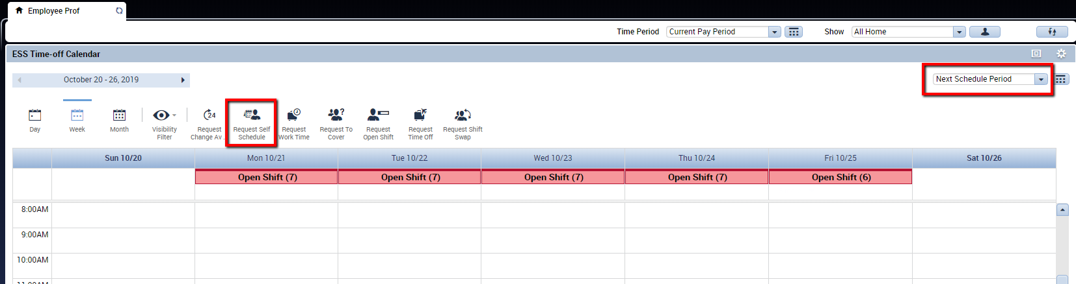
The shifts the employee can choose from display with checkboxes. The employee can use the checkboxes to select the shifts to include in their schedule.
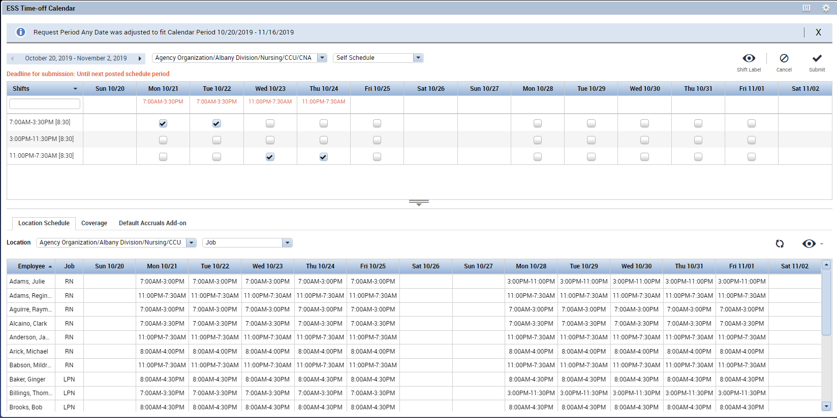

The employee may also choose to use the eye icon to toggle between Shift Time and Shift Label views.
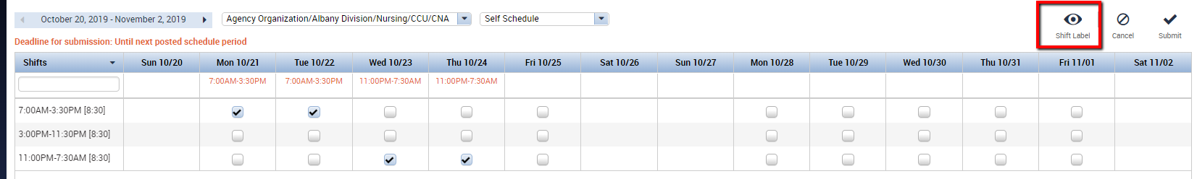
Shift Time displays the shifts as a time period, for example 7:00 AM – 3:30 PM:
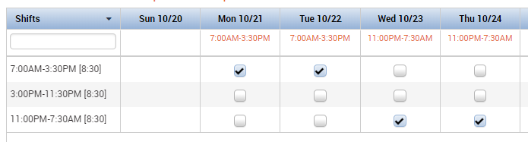

Shift Label displays the shifts with a short name. For example, the short name for the day shift of 7:00 AM – 3:30 PM is D7 because it is a day shift starting at 7am. These labels, if used, will depend on the organization’s setup.
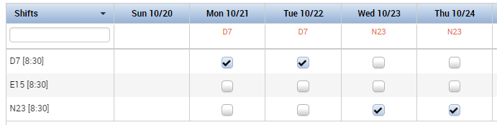

The Location Schedule Tab at the bottom of the screen displays the other employees at the location, their job, and their schedules for that time period.
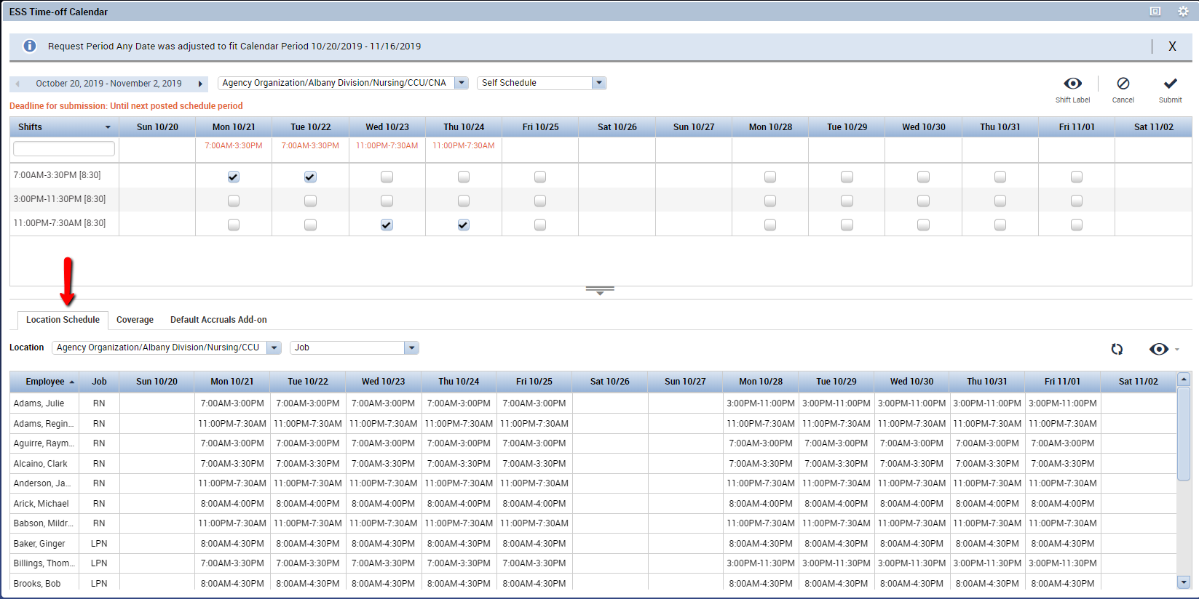

The Coverage Tab provides how many employees are needed for each shift. The red arrow indicates that the schedule has under-coverage. Blue arrows would indicate that the schedule has over-coverage. No arrow appears when the schedule meets the coverage requirement.
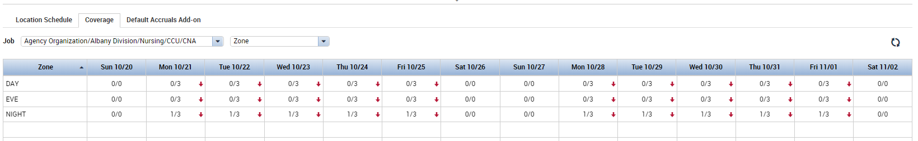
Once the employee has chosen the shifts, they will click Submit:
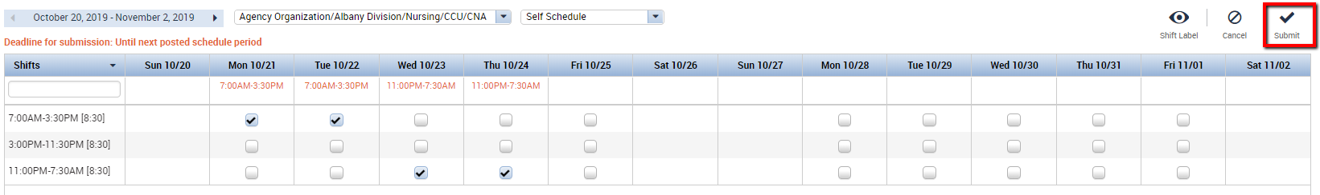

The four shifts that the employee selected now appear in the Calendar widget.
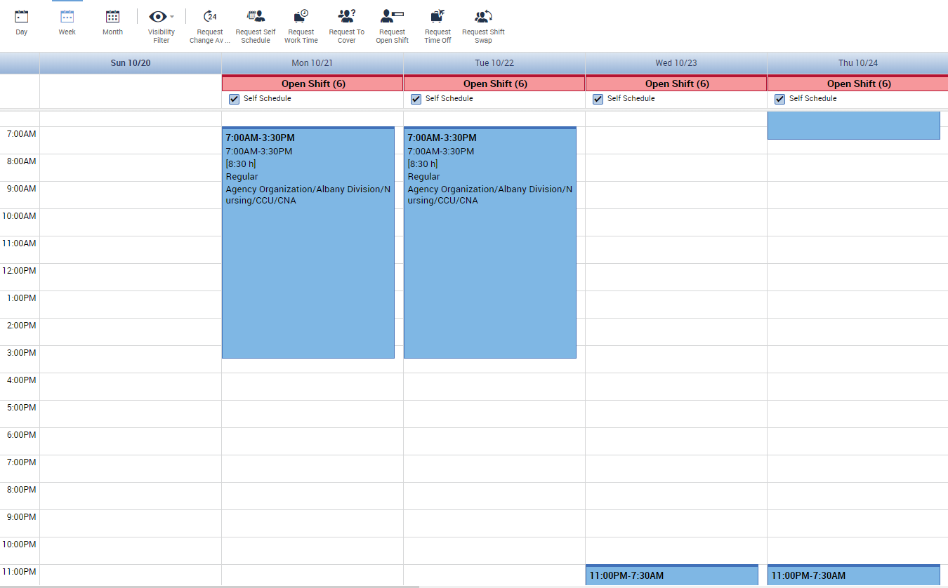

As long as the scheduling period is still open, the employee may go back in and deselect shifts that had been checked off. The employee may also choose different shifts. Again, the employee will need to click the Submit icon in the upper right corner when finished making changes.
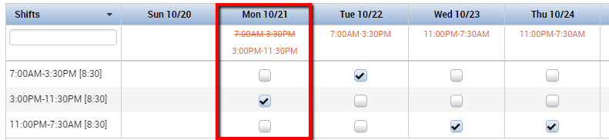

These schedule changes will then appear in the Calendar widget:
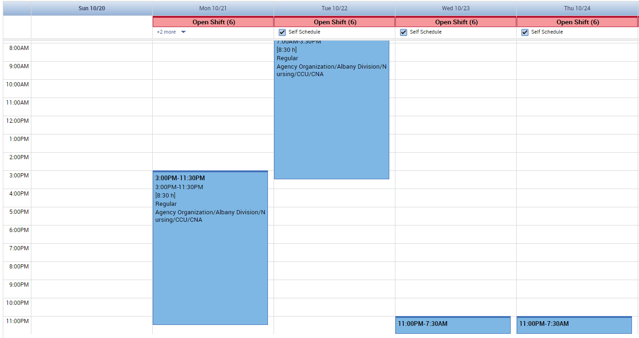

The employee may modify the selected shifts as needed while Self-Scheduling is open. Once the submission period is closed, the employee would need to use Requests to Cover, Swap, or take Time Off in order to modify the schedule. The manager can modify these shifts in the Schedule Widget as usual.

