Employee Time Off Requests
  - kronos version 8.1

Contents
EMPLOYEE TIME OFF REQUESTS 3
Submitting a Time Off Request 3
Time Off Days 4
Time Off Hours 6
Refused Time Off Request 7
Canceling a Time Off Request 8

EMPLOYEE TIME OFF REQUESTS

Submitting a Time Off Request
Using the My Calendar widget:
- Click on the Request Time Off icon.
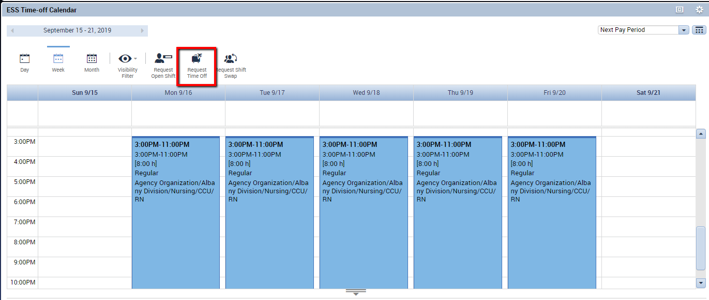

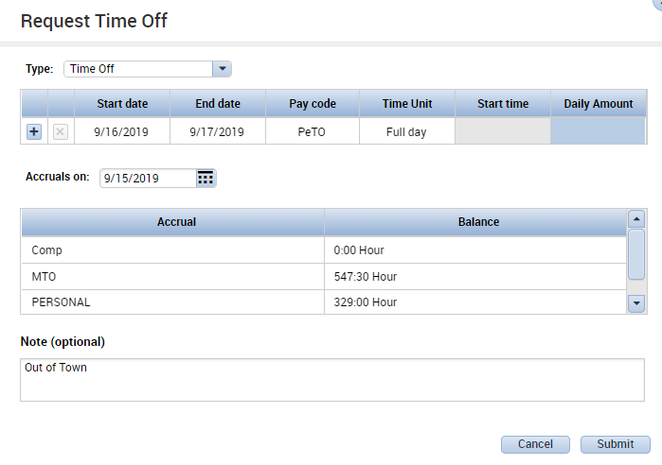
- Depending on your organization’s setup, you may need to choose a separate request for Time Off Days (full day off) or Time Off Hours (partial day off). Or you may need to use the Time Unit dropdown in the request to choose Time Off Days (full days) or Time Off Hours (partial days).
Other options may be available depending on your system configuration.

Time Off Days
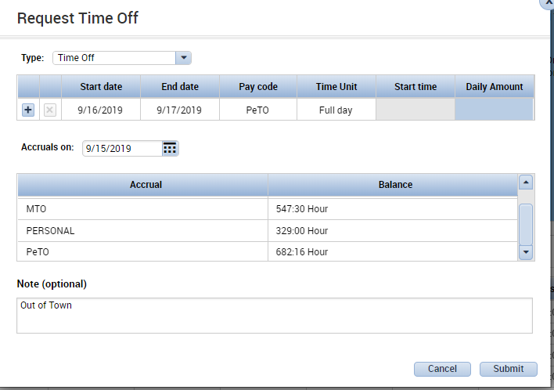
Choose Time Off Days or set the time unit to Full Day to request time off in full-day increments.
- Choose Start Date
and End Date.
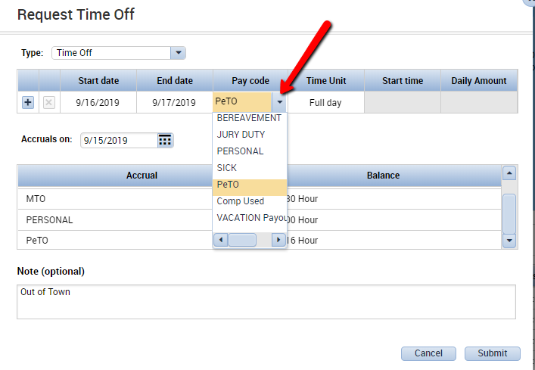
- The accruals
information is
displayed for
reference.
- Click in the Pay Code
cell to choose a different
pay code for the time
to deduct from.
Options that appear
here are determined by
your system administrator.
For this example, we will use a
Personal Time Off (PeTO)
pay code.
- If needed, use the
Note section
to type a note.
- Click Submit to submit the request.
- After submitting the request, the submitted request is shown in the top of each day that has been requested off. Hovering over the request will show the status.
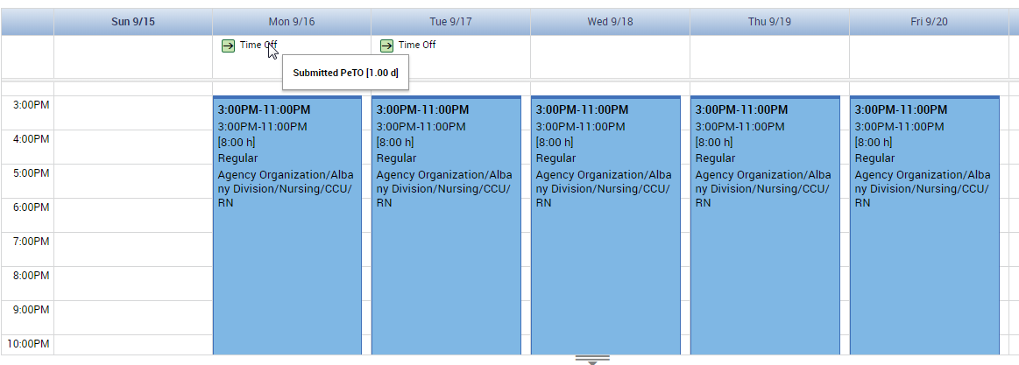
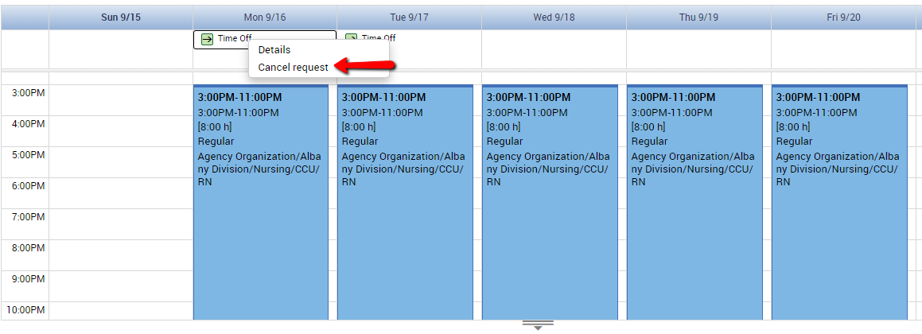
- If you change your mind before the manager approves the request, right click and select Cancel Request.
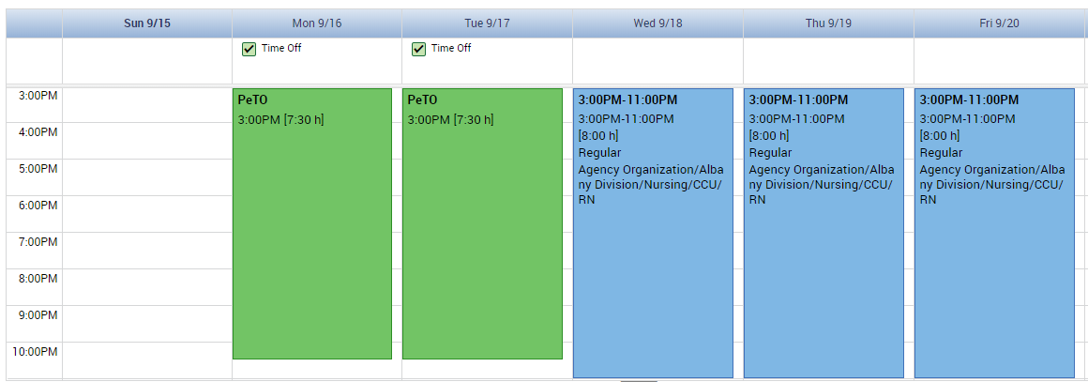
- Once the request is approved, it will appear in your calendar as shown below:
The days that are approved for Time Off will display in a different color.
- Again, hovering over the request will show the status. If you no longer need the time off, but it has already been approved, right clicking will give the option to cancel the request. (See Canceling a Time Off Request.)

Time Off Hours
Choose Time Off Hours to request time off in hour increments. There may be a separate request called Time Off Hours or you may just need to adjust the time unit and choose hours.
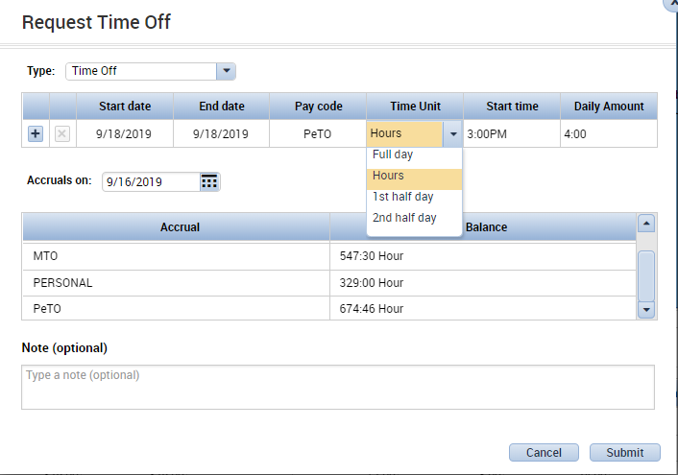
- If needed, adjust the
Start Date and End Date.
For a Time Off Hours
request, these are
typically the same date.
- If needed, adjust the
Pay Code.
- The Start Time is when
the time off will start.
- The Daily Amount is how
many hours are being
requested as time off.
In this example, the
employee is requesting
4 hours off,
starting at 3PM.
- If needed, use the Note section to type a note.
- Click Submit to submit the request.
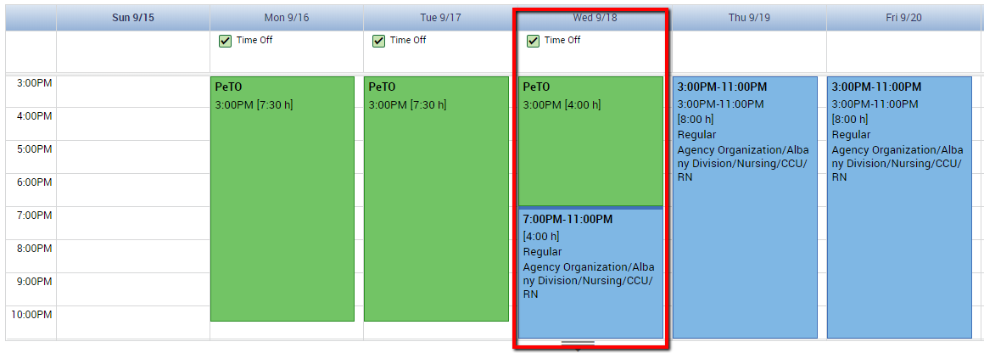
- Once approved, the hours of time off will appear in the employee’s Calendar widget
as shown below:
- Hovering over the request will show the status. If the request has been approved, but you no longer need the time off, right click on the request to cancel. (See Canceling a Time Off Request.)

Refused Time Off Request
If your manager refuses your request, here is how it will appear:
Again, hovering over the request will show the status. Here the request appears with an X icon and the popup informs you it has been Refused. The day has also remained the same color.
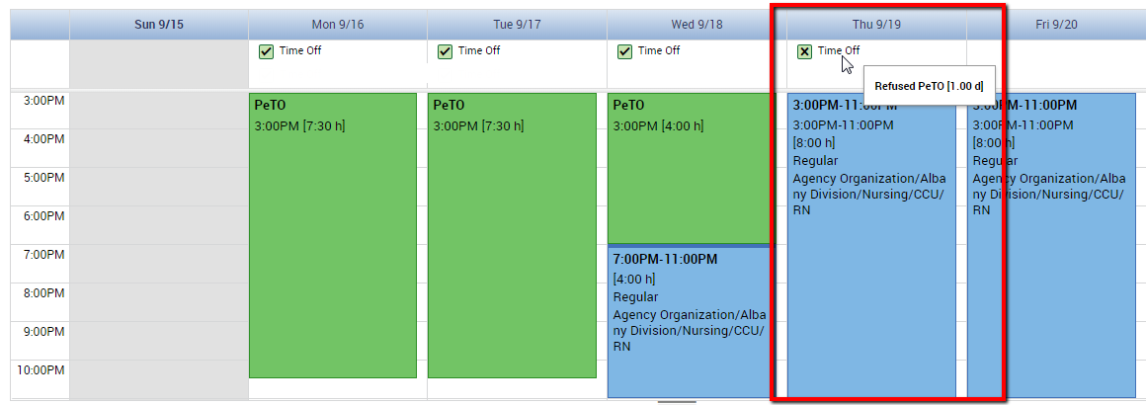

Canceling a Time Off Request
Once a time off request has been approved by your manager, you will need to submit a Cancel Request if you no longer need the time off. Right click on the request in your calendar and select Cancel Request. This will create a cancel request that is sent to the manager to approve.
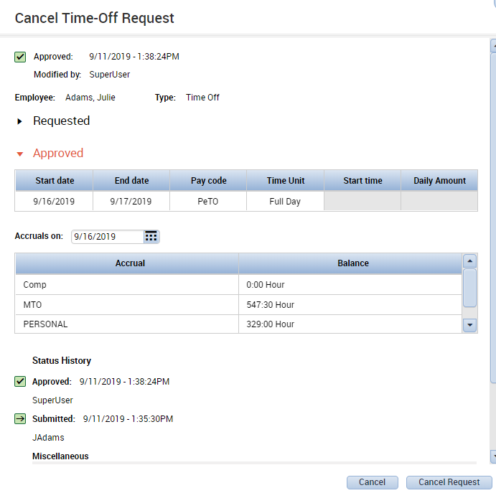
Note: If you request multiple days off in a single request, the cancel request will cover the same set of days. For example, if you request Monday & Tuesday off in the same request, the cancel request will also apply to Monday & Tuesday.

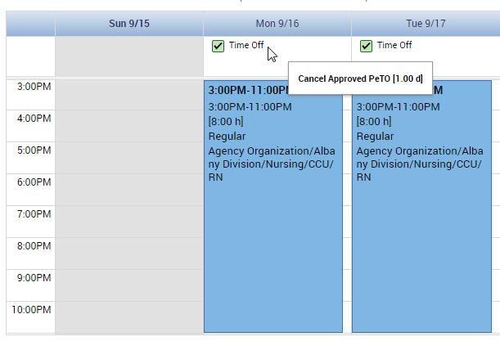
Once the cancellation is approved by your manager, the days will display normally in the employee calendar as shown below. The request still appears on the top of the day, but hovering over each request will show that it is cancel approved.

