Clock Firmware Updates
For 4500s, each firmware update must be done individually. For InTouch clocks, multiple clocks may be done at once. These need to be done from the system the clocks are currently communicating to.
Each firmware update will have the clock unavailable for about 10 minutes while the update processes.

- Highlight the clock to be updated. From the Actions menu, choose Load Firmware. 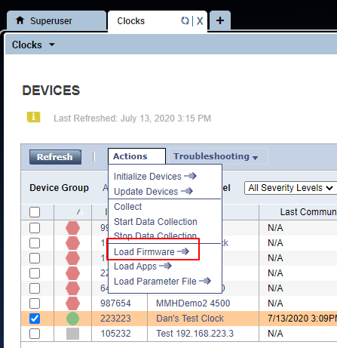
- Choose the firmware version to load. 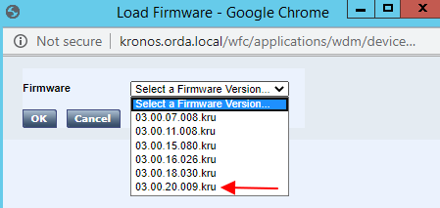
- After choosing the correct version, the clock will take 5-10 minutes to process. Click Refresh until the Last Action column shows Load Firmware and the Action Status is Success.
- After you receive the Success status, wait 2 - 3 minutes.
- Highlight the same clock. From the Troubleshooting menu, choose Test Device. Click Refresh until you see an Action Status of Success.
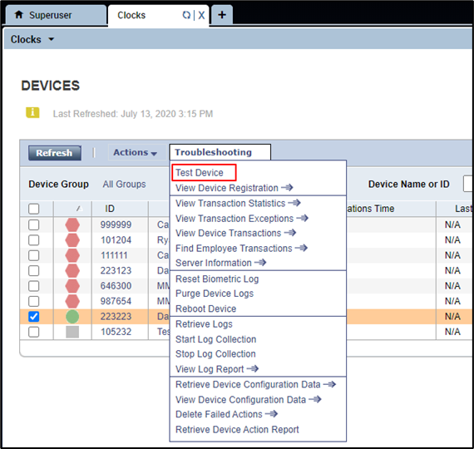
- Highlight the same clock. From the Troubleshooting menu, choose View Device Registration.
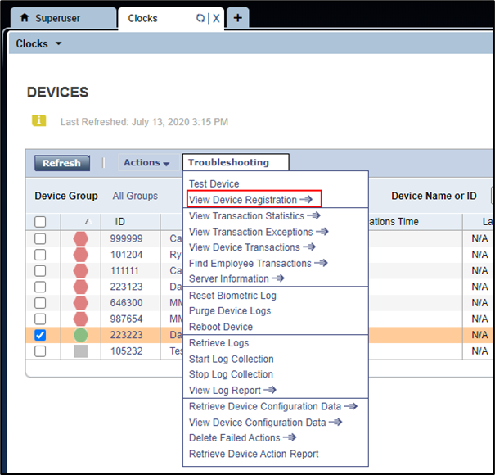
- At the very bottom of the screen in the software section, confirm the firmware version. 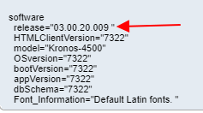
- Return to the Devices screen. Highlight the same clock. From the Actions menu, choose Initialize Devices. Click Refresh until you see an Action Status of Success. 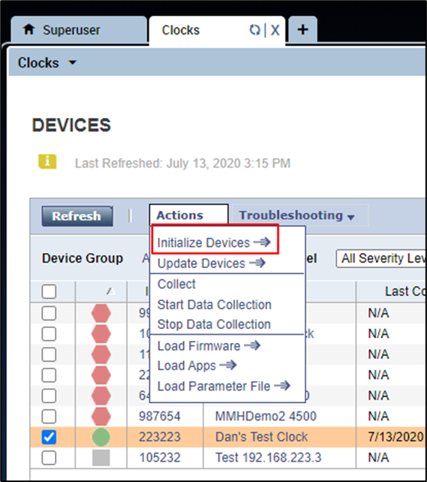
- Highlight the same clock. From the Actions menu, choose Start Data Collection. Click Refresh until you see an Action Status of Success.
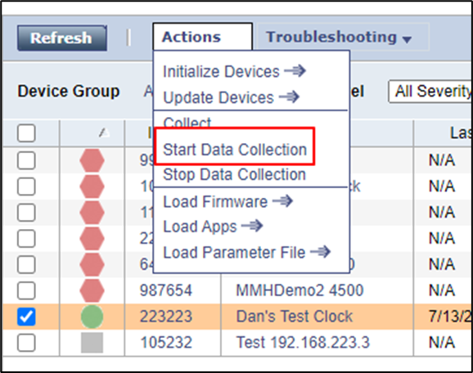
- Repeat for all clocks on the list.
For 4500s, each clock on the list needs to be done individually. For InTouch clocks, multiple clocks can be updated at a time if they are all going to the same version. Usually, up to 5 clocks can be updated at the same time. Updating any more than 5 clocks at once can cause system slowness. Keep in mind that the clock will be unavailable for the duration of the time that the update is processing, so these should be applied at a quiet time at the location.

