InTouch Terminals
  - kronos version 8.1

Contents
InTouch Terminals 3
PUNCHES 4
Viewing Recent Punches 5
Viewing Your Timecard 6
Initiating a Transfer 8
Transferring During a Shift 9
Work Rule Transfers 10
REQUESTING TIME OFF 11
ADDITIONAL ACTIONS 18
View Schedule 18
View Accruals 19

InTouch Terminals
InTouch terminals are touchscreen timeclocks. The buttons on each clock are custom for each organization. This guide is intended to provide an overview of common timeclock tasks. Each organization is different. You may not have access to every option mentioned in this guide. Your devices may have different text and images to the text and images displayed in this guide.

PUNCHES
To submit a punch from a timeclock, you may need to scan your badge, enter your badge number on the PIN pad, or scan your finger. Some organizations may require both a badge verification and a finger scan verification. Be sure to understand the requirements of your workplace.
For example, if your organization only requires a badge, simply scan or swipe your badge to generate a punch.
After registering a punch, you will see a green banner displaying that the punch was accepted.
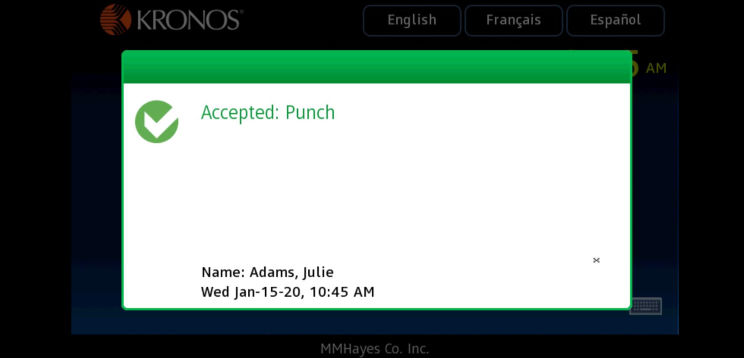
For transactions other than punches, tap the button first, then present your badge or finger.

Viewing Recent Punches
Reminder: Your timeclock may have different text and images than the examples shown here.
To see your recent punches:
- Tap the Review Punches icon. 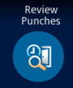 Verify your identity with your badge or finger.
- The Review Punches screen will show you the recent punches. The earliest punch is at the bottom of the list. The clock will store punches from up to the past 72 hours. Each timeclock will only display punches that were registered at that specific timeclock. It will not display web punches or a punch you submitted from a different timeclock. 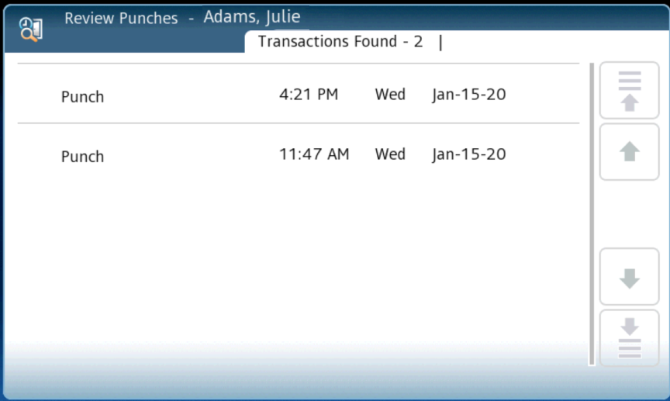

Viewing Your Timecard
Reminder: Your timeclock may have different text and images than the examples shown here.
To view your timecard:
- Tap the View Timecard icon. 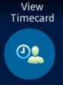 Verify your identity with your badge or finger.
- Choose the time period you would like to view. 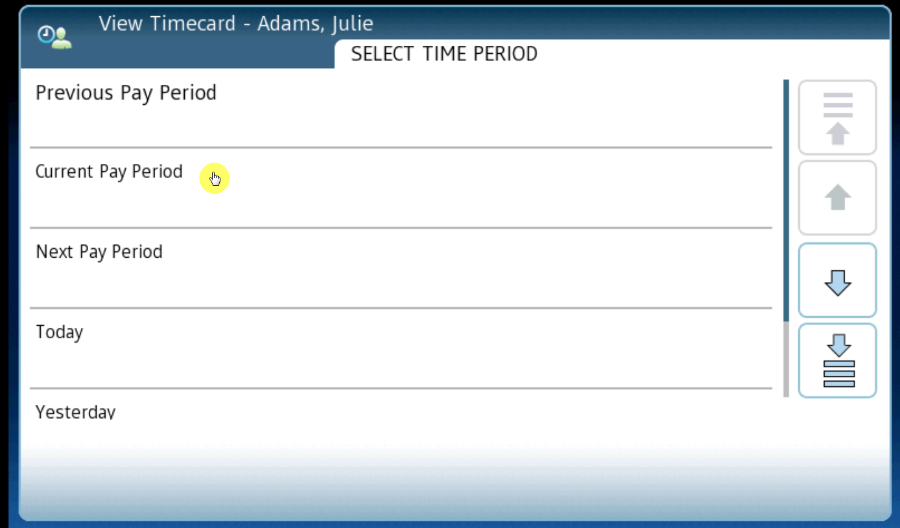
- Each day displays the hours of worked time. The triangle icon appears on a day if there is an exception such as a missed punch or an early/late punch. 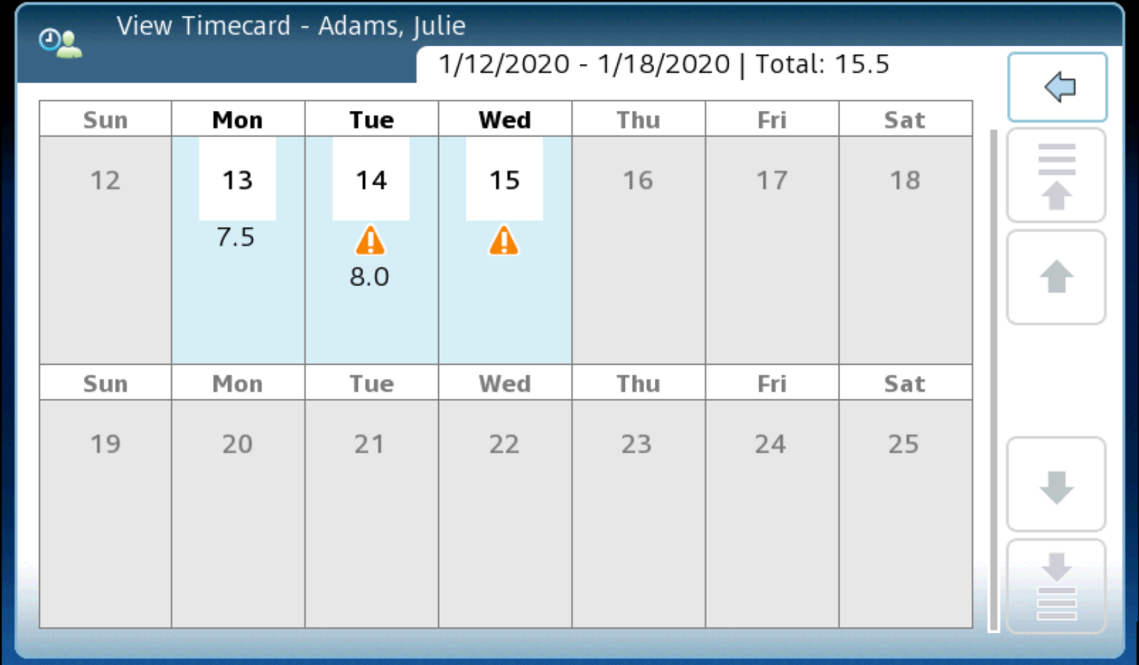
- Click on a day to get more information. You will see the in and out punches for each day as well as the shift total (amount of worked time) and daily total (worked time + non-worked time). Additional information about exceptions is also displayed.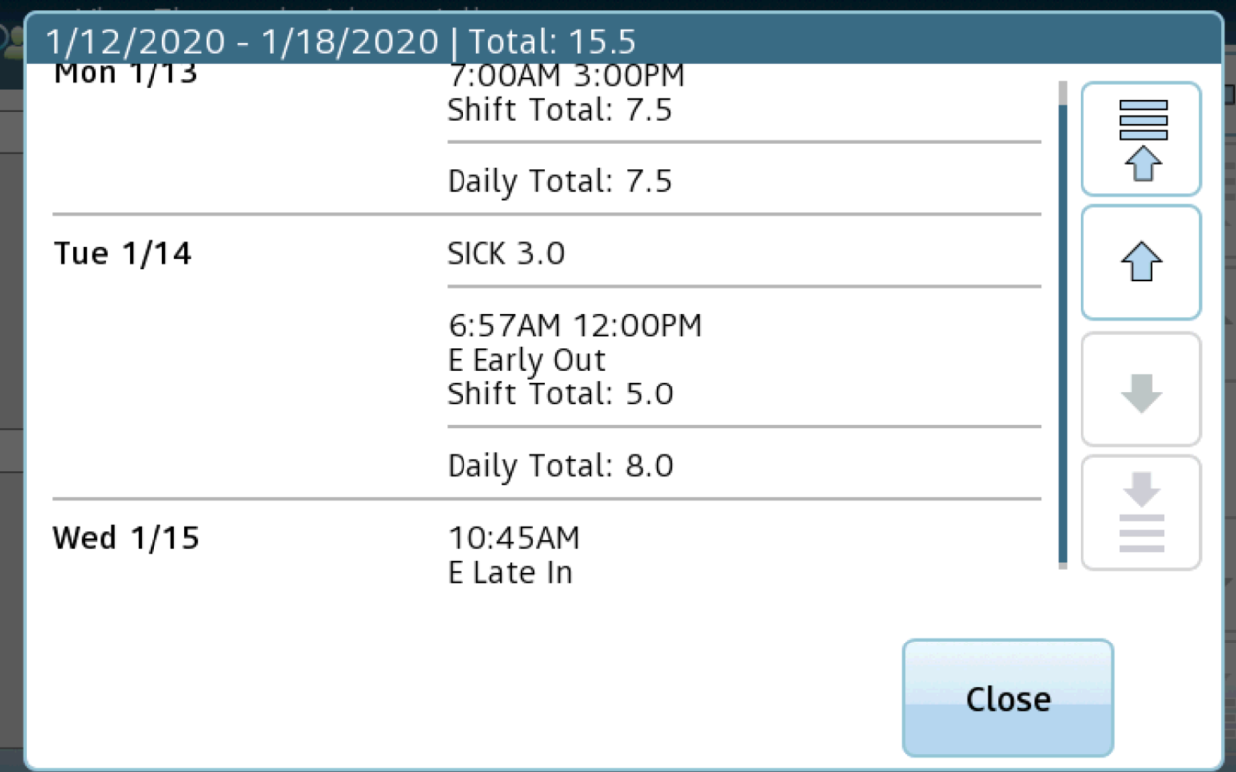

Initiating a Transfer
Reminder: Your timeclock may have different text and images than the examples shown here.
To initiate a transfer with your punch:
- Tap the Transfer icon. 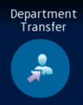 Verify your identity with your badge or finger.
- Choose Labor Level Transfer. You may have additional options, such as to transfer departments, jobs, or locations. This depends on your role and your organization setup.
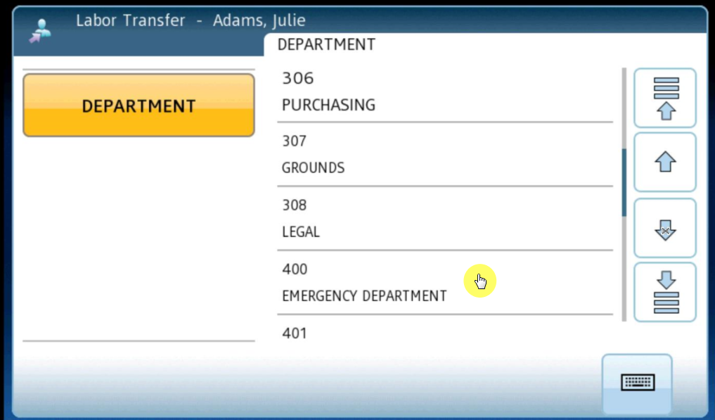
- You will be notified that your punch and the transfer were accepted. 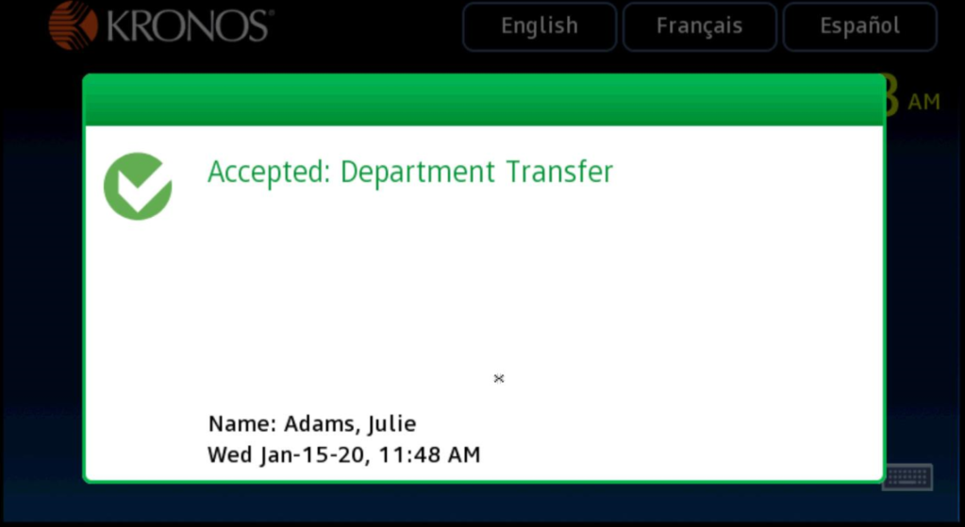

Transferring During a Shift
If you are already punched in for the day but now need to transfer to another location, DO NOT PUNCH OUT. Simply go to the clock and punch again by initiating a transfer.

The system will automatically recognize that you are ending work in your home location and beginning work in the new location.
Browser view:

Clock view: 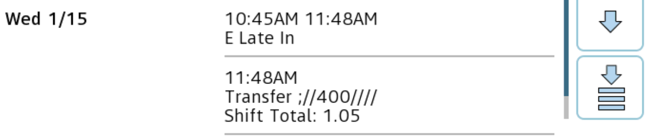

This prevents employees from needing to register an out punch for the previous work, waiting a full minute, and then punching in for their next type of work.

Work Rule Transfers
Work Rule Transfers are used when an employee is performing another activity that requires their time to be tracked differently. This could include attending a special meeting, a training, or being called in. Work Rule Transfers may be used to accommodate different pay rates or shift guarantees. We will use the example of an employee being called in to work a shift.
- Before punching, tap the Called In icon. 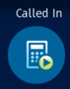 Verify your identity with your badge or finger.
- You may or may not be prompted to select additional Labor Level Transfer information. For example, if you were called in to work in another department, you may need to select the department.
- This will initiate a punch and any special accommodations needed with a call-in.
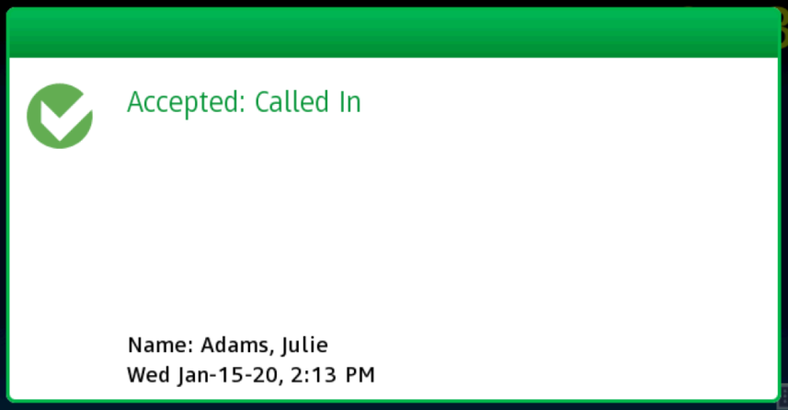
The call-in automatically appears on the timecard as designed by the organization:

REQUESTING TIME OFF
Reminder: Your timeclock may have different text and images than the examples shown here.
To request time off:
- Tap the Request Time Off icon. 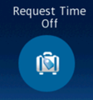 Verify your identity with your badge or finger.
- Select the type of time off request. 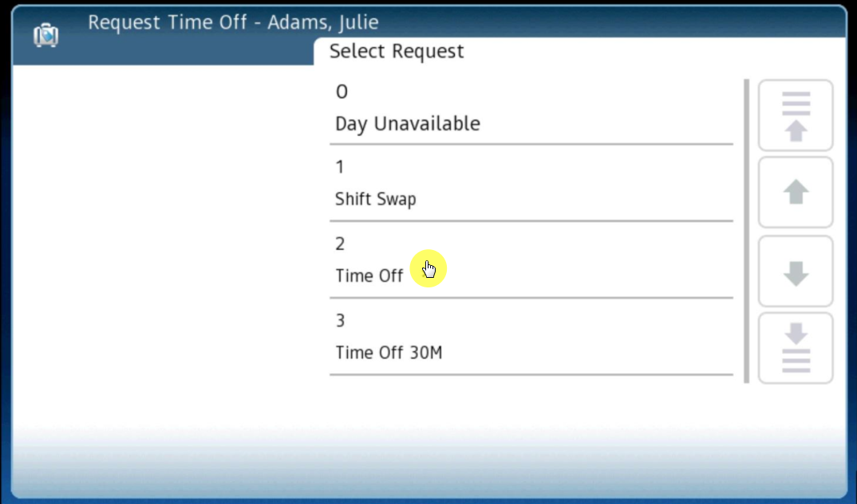
- Choose to submit a new request. You may also have the option to cancel an existing request. 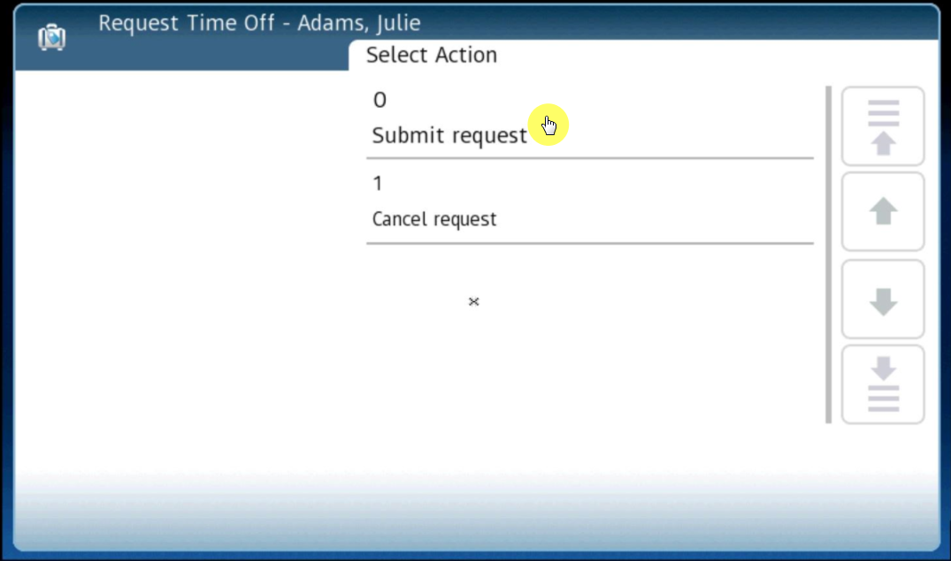
- Select the Start Date for the time off request. 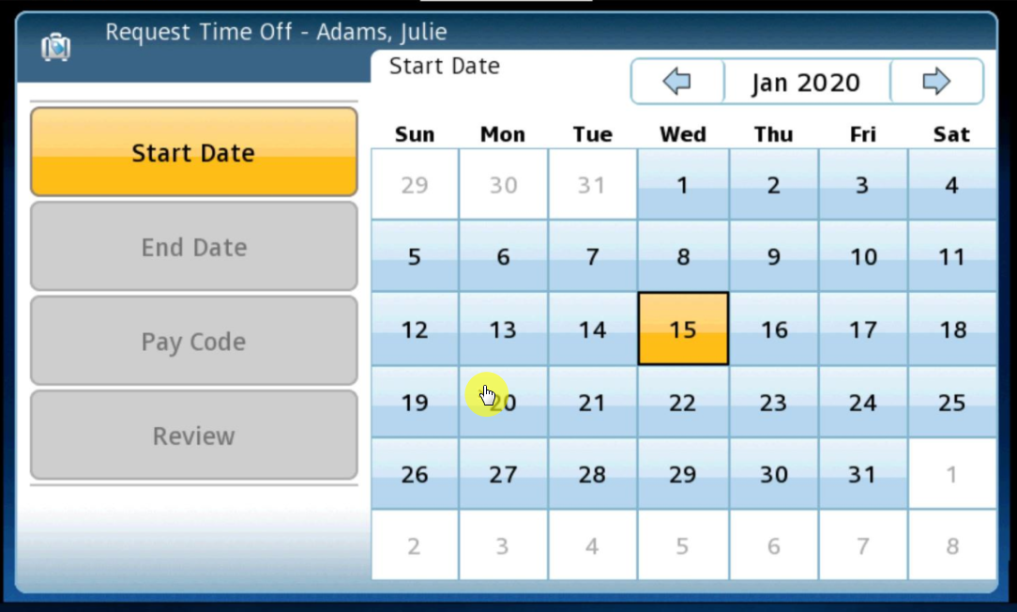
- Select the End Date of the time off request. 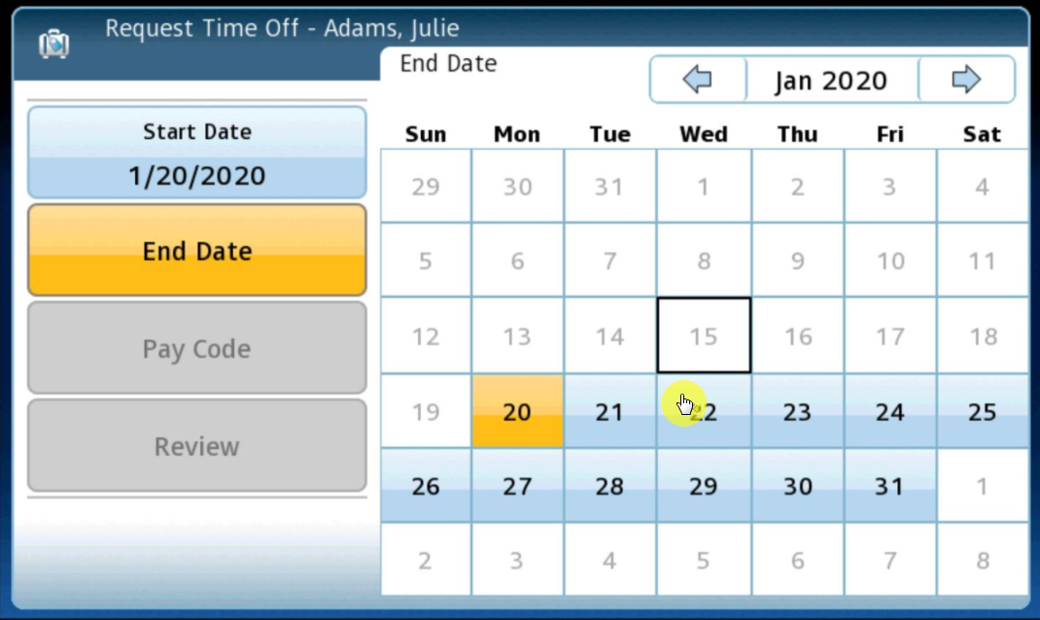
- If necessary, choose the pay code to allocate the time to. Your organization may not require this step if you only have one type of time off. 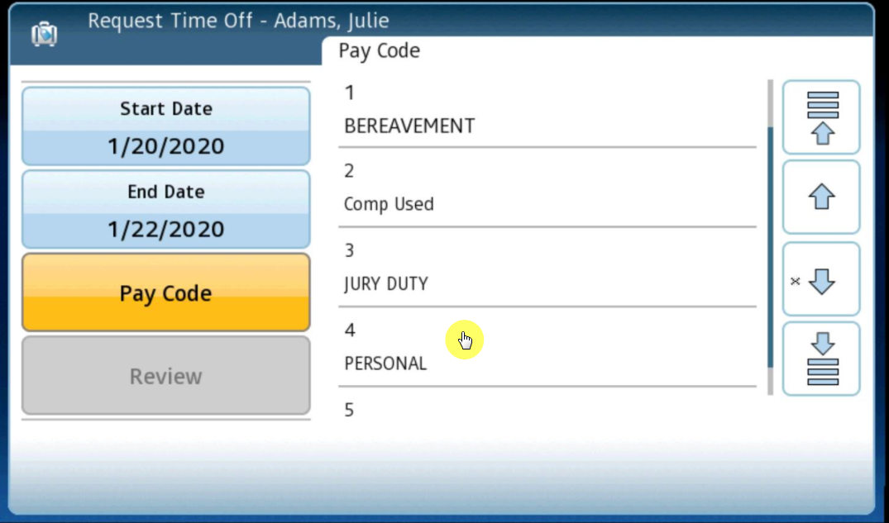
- Review the summary and tap Continue. 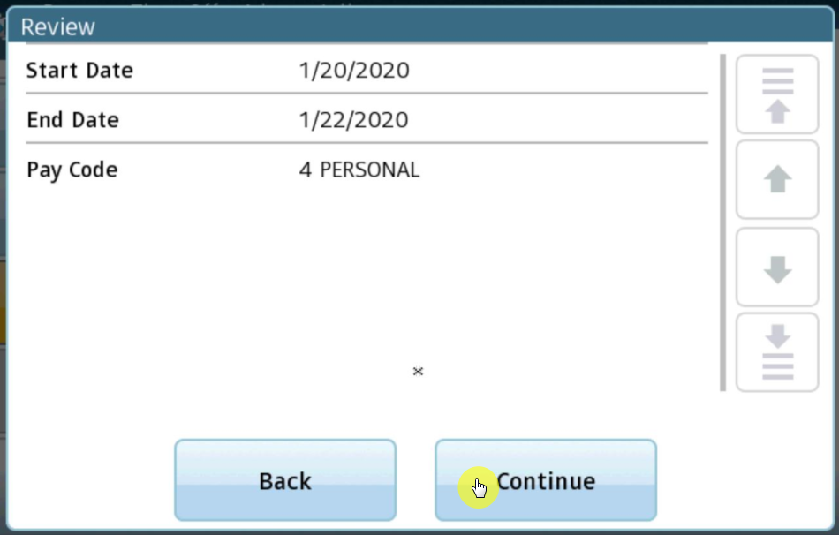
- Choose the Duration of the time off. Some organizations may allow you to charge time in increments of hours or full days. 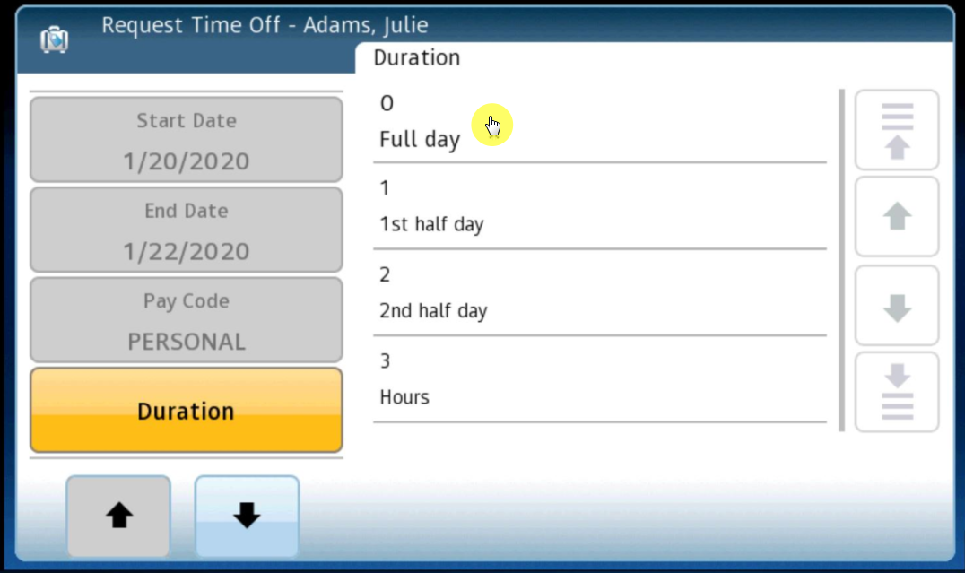
- Review the summary and tap Continue. 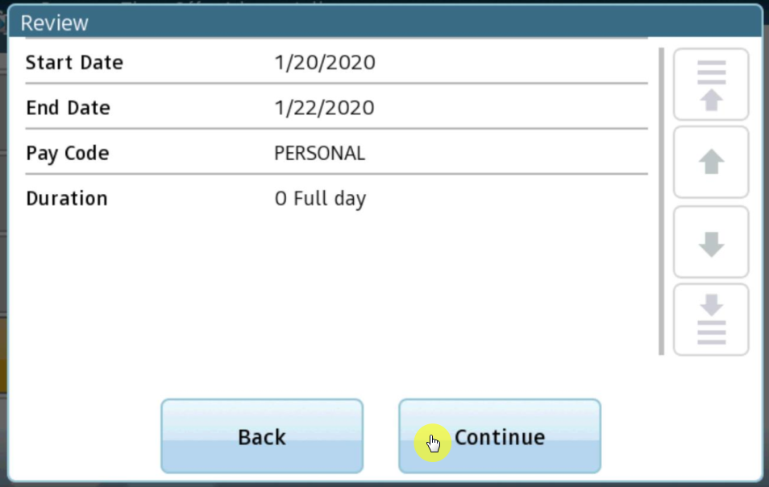
- Choose to Submit the request or Add Another Request. 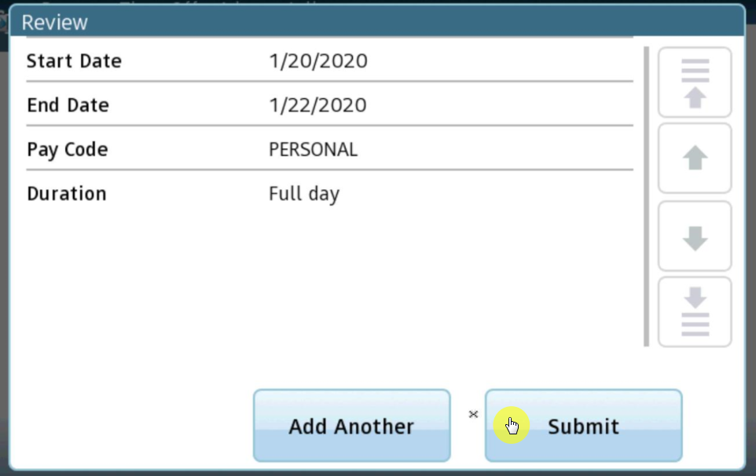
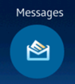
- When finished, you will see a successful verification message. 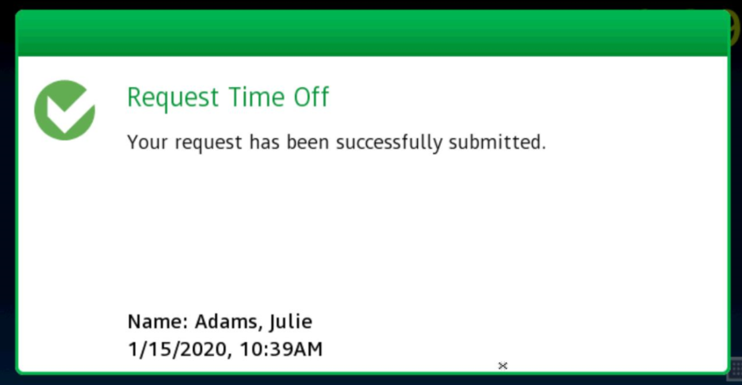
- When Time Off Requests or other types of requests have been approved, the employee may be notified through Messages at the clock. This is a decision at the organizational level. The company may also choose to notify employees through email.
Tap the Messages icon to display messages.
- The messages will tell the employee when requests have been approved. 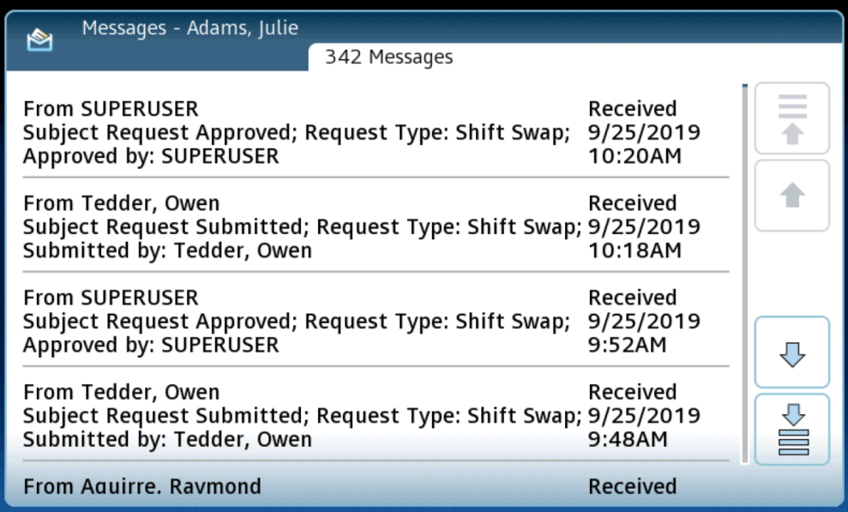
Please Note: Number Values

When requesting time off, you may notice numbers that appear above the options at each step of the request process. Please disregard these and be sure you are making your choice based on the written description of each choice.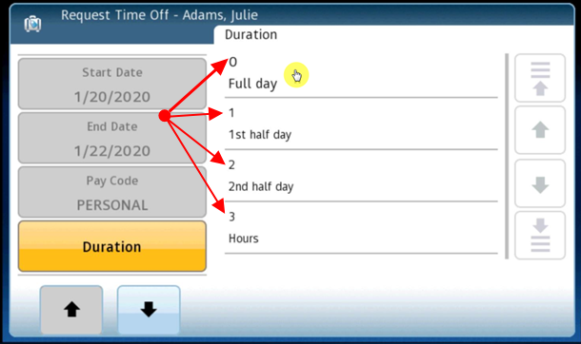

ADDITIONAL ACTIONS
Reminder: Your timeclock may have different text and images than the examples shown here.

View Schedule
Employees may view their upcoming work schedule from the clock.
- Tap the View Schedule icon. 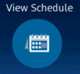 Verify your identity with your badge or finger.
- Upcoming scheduled shifts display: 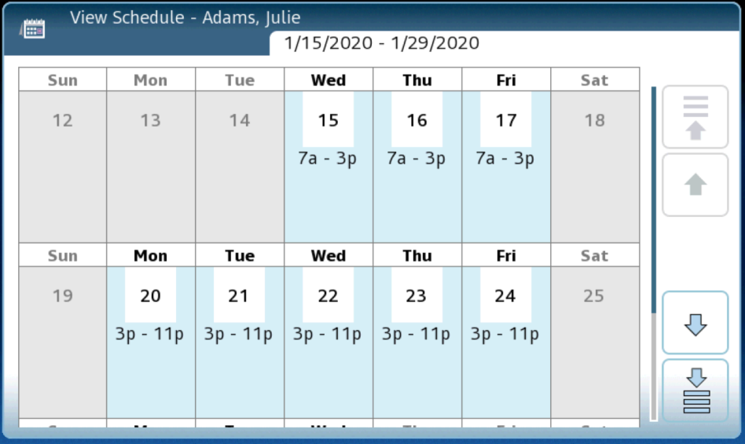

View Accruals
Employees may view their earned accruals from the clock.
- Tap the View Accruals icon. 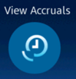 Verify your identity with your badge or finger.
- Choose a date to show the earned accrual balance as of that date. 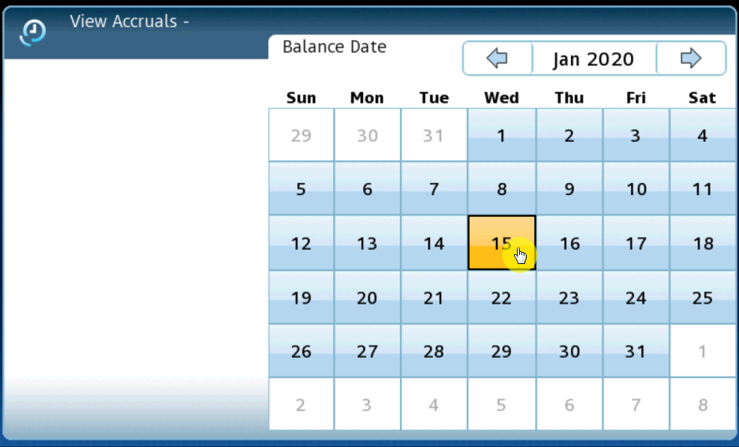
- Accrual balance information displays: 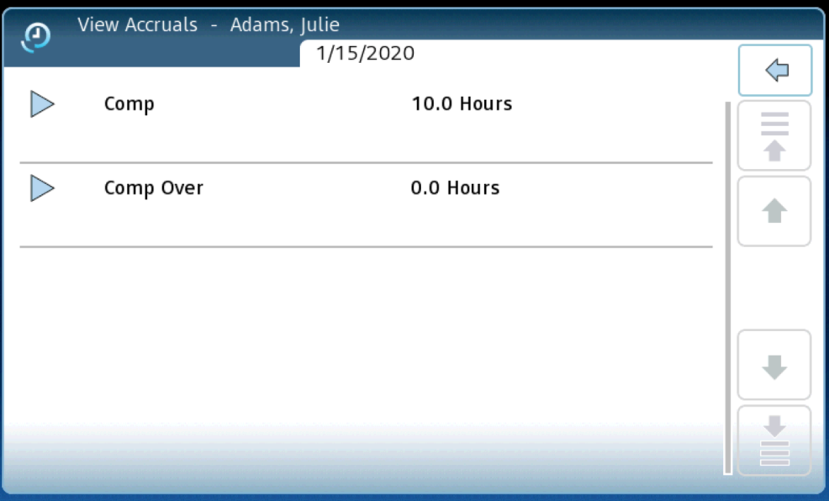
- If accruals are earned on a schedule, the organization may allow you to select a future date to display the accrual balance as of that date. 