Labor Level Entries
  - kronos version 8.1

Contents
LABOR LEVEL ENTRIES 3
Labor Level Sets As Employee Groups 7
Labor Level Sets As Transfer Sets 12
Assigning Transfer Sets 18
Assigning Labor Level Transfer Sets to Employees 18
Assigning Labor Level Transfer Sets to Managers 21

LABOR LEVEL ENTRIES
Labor Level Entries are available choices within each Labor Level. Every Labor Level must have at least one Labor Level Entry.
Labor Level Entries include all possible locations, departments, and jobs in an organization. Each Labor Level Entry has a name or ID and a description.
A group of Labor Level Entries is called a Labor Level Set.
To access your Labor Level Entries, navigate to Setup.
Under Organizational Setup, select Labor Level Entries.
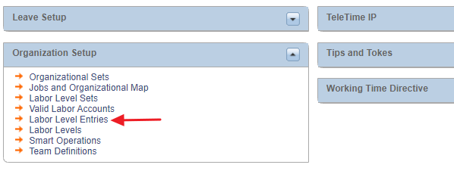
The Labor Level Entries for the first labor level will display. Here, it is the labor level called Company:
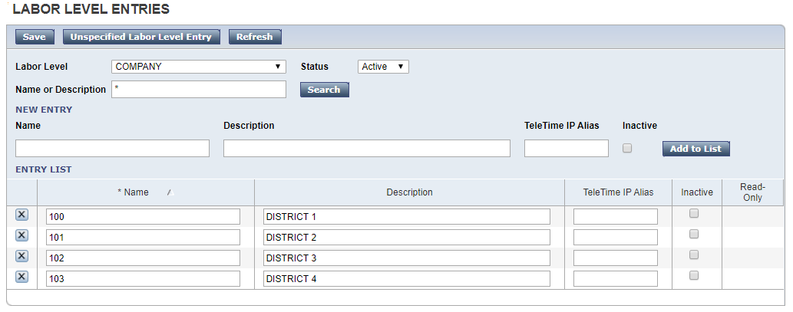

To see the entries for each subsequent labor level, use the dropdown arrow to select a different labor level. Then, click Search:
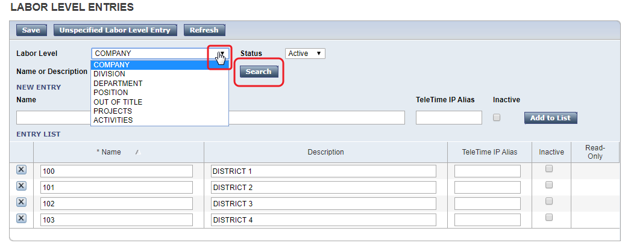
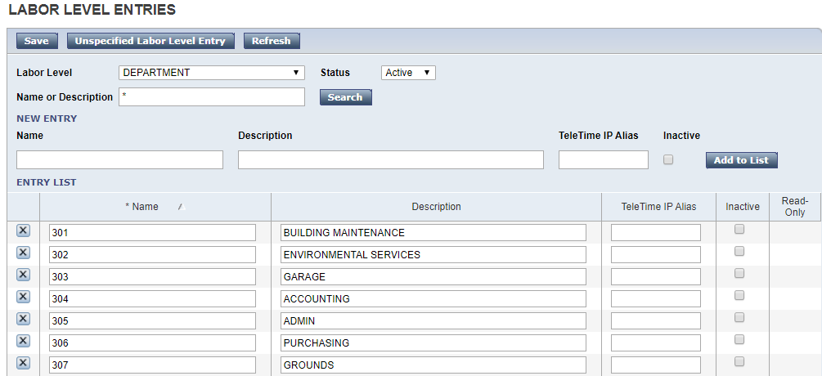
To add a new Labor Level Entry, type in the Name and Description consistent with the pattern your organization has established. Numeric names are common, as shown below, but your organization may use a different pattern. Click Add to List, then click Save. 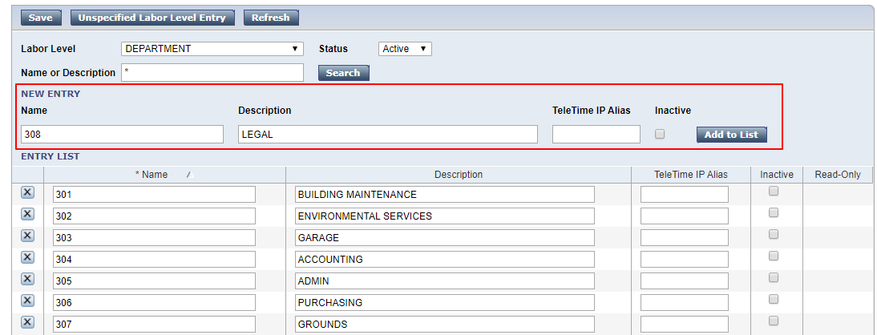

The new Labor Level Entry will now appear in the list. 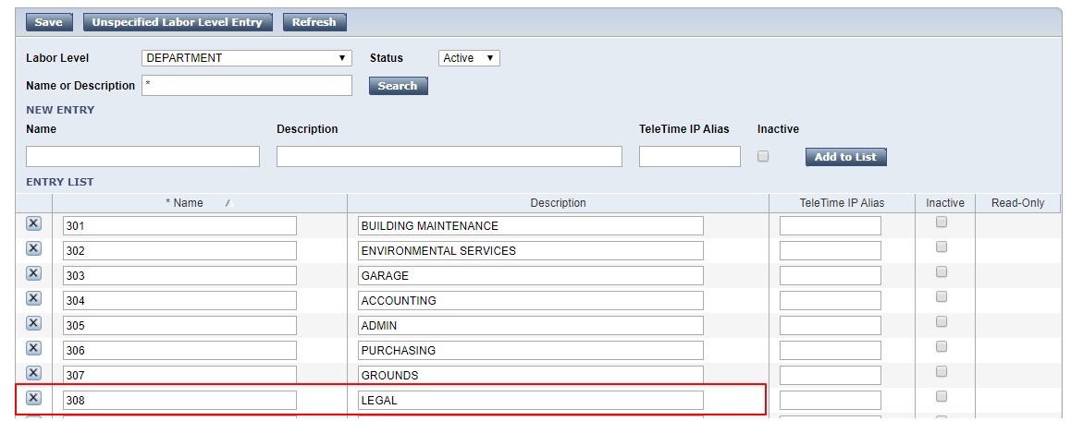

Once a Labor Level Entry has been used, it cannot be deleted. However, to prevent future use, the entry can be marked Inactive by using the Inactive checkbox. If the entry is needed again, you can unmark the checkbox.
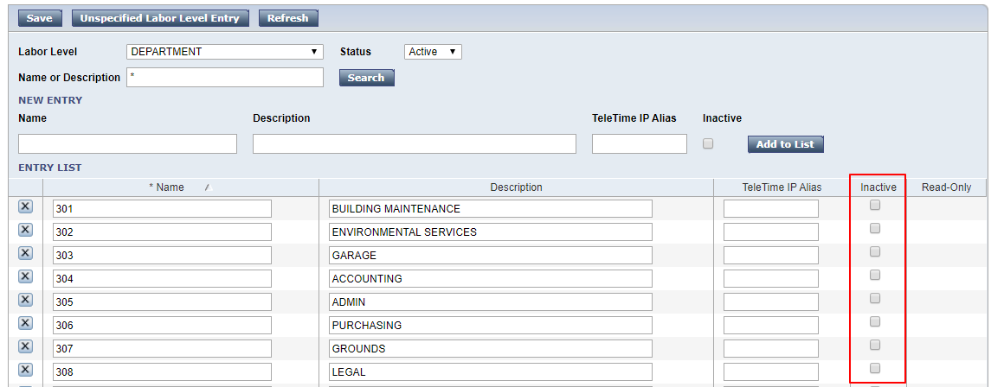

Labor Level Sets As Employee Groups
A Labor Level Set is a defined group of existing Labor Level Entries.
Labor Level Sets can be used to assign a manager’s Employee Group. The Employee Group determines the employees that a manager has access to.
To create a new Labor Level Set:
- Navigate to Setup.
- Under Organization Setup, select Labor Level Sets.
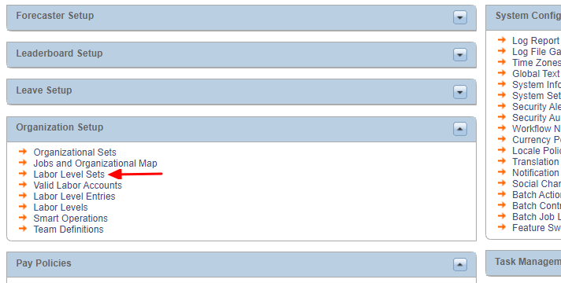
- At the top, select New to create a new Labor Level Set.
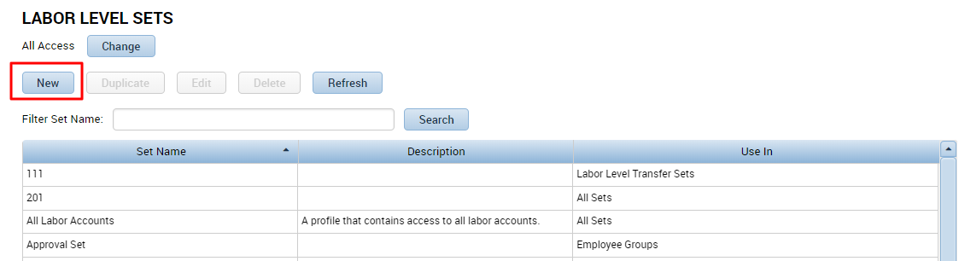
- Name the new group.
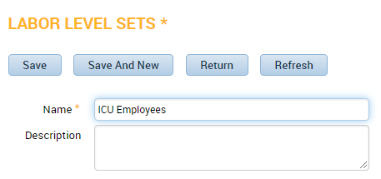
- Use the dropdown to choose where to use this group. To create a new Employee Group, select Employee Groups. 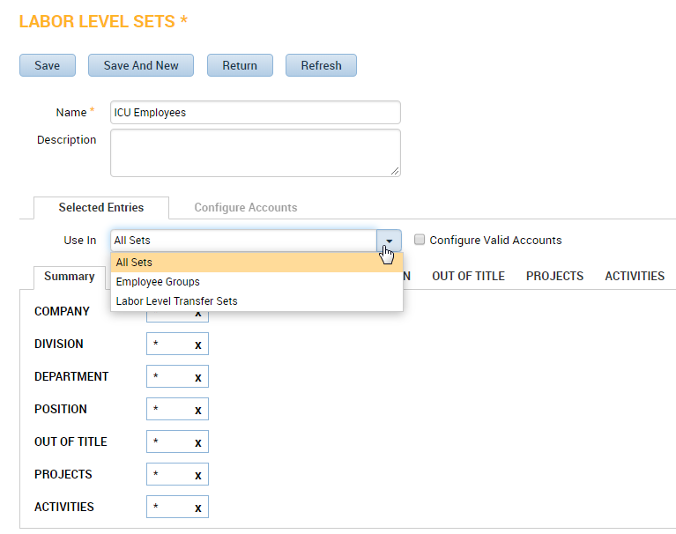
- Use the Labor Levels at the top to choose the departments, positions, jobs, etc. that are applicable to this Employee Group. Depending on your organization’s setup, the options that appear here may be different.
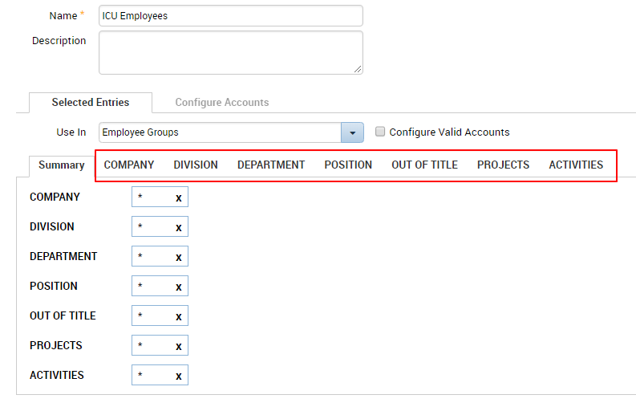
- Click on one of the tabs. Use the asterisk (*) in the search bar and click Search to display all Labor Level Entries associated with this Labor Level. 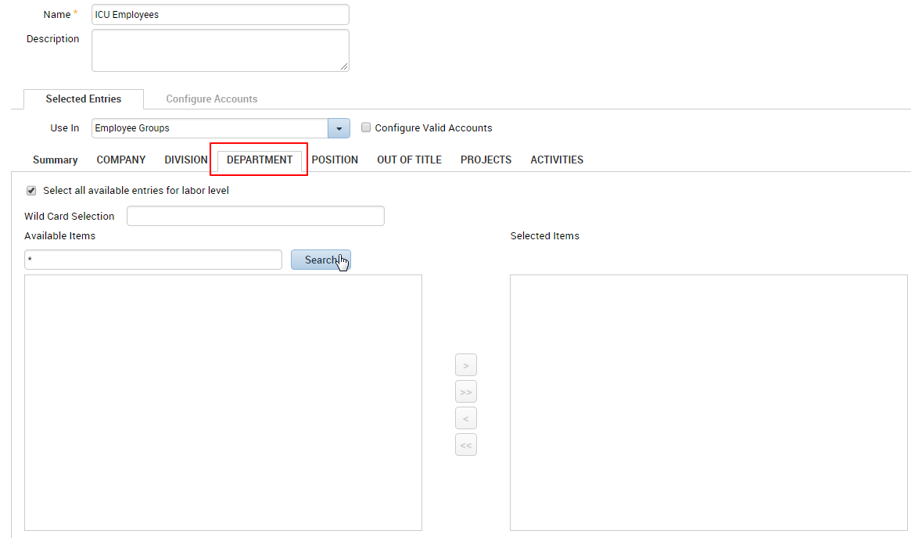
- Select the Labor Level entry that you want to use to build this employee group. 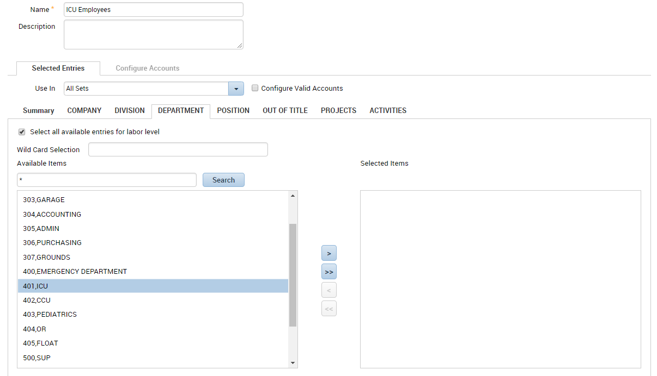
- Use the right arrow ( > ) to move the chosen item or items from the Available pane on the left to the Selected pane on the right. 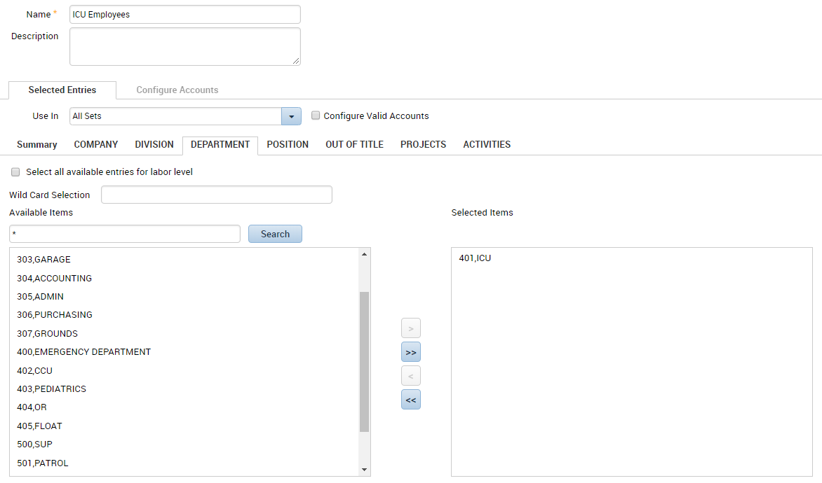
- If needed, select entries from other tabs. When finished, Save. The Labor Level Set you created now appears in the list of Labor Level Sets.
- To assign an Employee Group to a manager, navigate to the People Editor. On the Job Assignment tab, expand the Manager Role – General section. Use the Employee Group dropdown to assign the correct group.
The Labor Level Set can be modified by using the New or Edit buttons to the right. If using the Edit button, keep in mind that any changes will affect all other users who have the group assigned to them. Within the editing menu, there is a Save As button which can be used to create a new set.
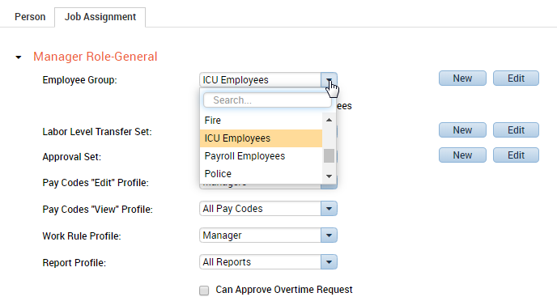
- The Employee Group assigned to a manager determines who the manager sees when they are using the All Home hyperfind. In this example, the manager will see any employees who are assigned to the ICU in their Primary Labor Account. 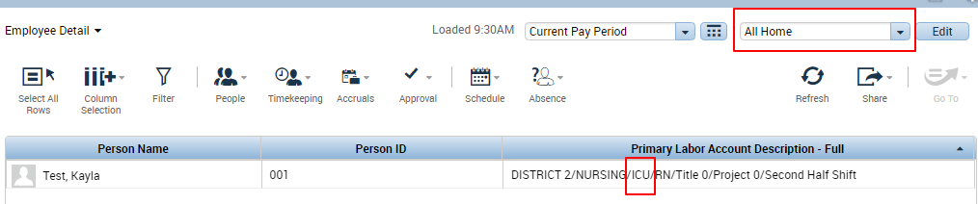

Labor Level Sets As Transfer Sets
Labor Level Transfer Sets determine the options that employees have when initiating transfers. If employees need to transfer departments, locations, etc., they can build this into their punches. Create a transfer set to restrict the choices that appear to the employees.
To create a new Labor Level Set:
- Navigate to Setup.
- Under Organization Setup, select Labor Level Sets.
- At the top, select New to create a new Labor Level Set.
- Name the new group.
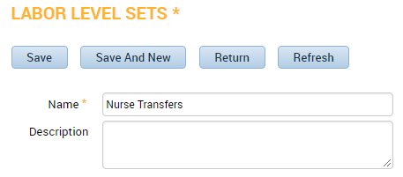
- Use the dropdown to choose where to use this group. To create a new transfer set, select Labor Level Transfer Sets.
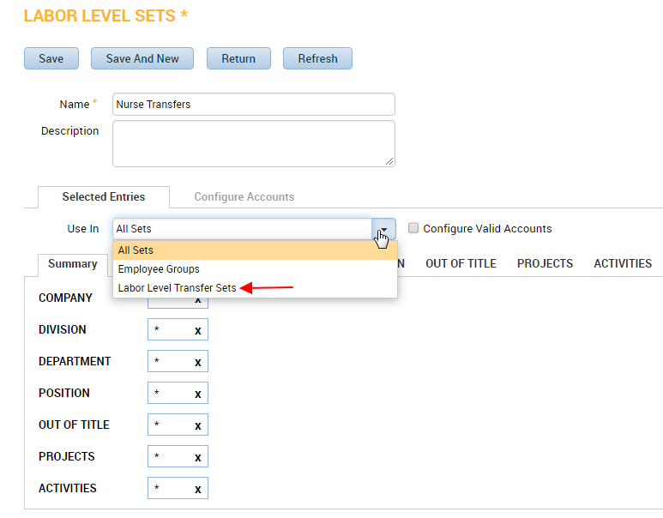
- Use the Labor Levels at the top to choose the departments, positions, jobs, etc. that are applicable to this transfer set. Depending on your organization’s setup, the options that appear here may be different.
Any option with an asterisk (*) means the employee will have access to all entries in that Labor Level.
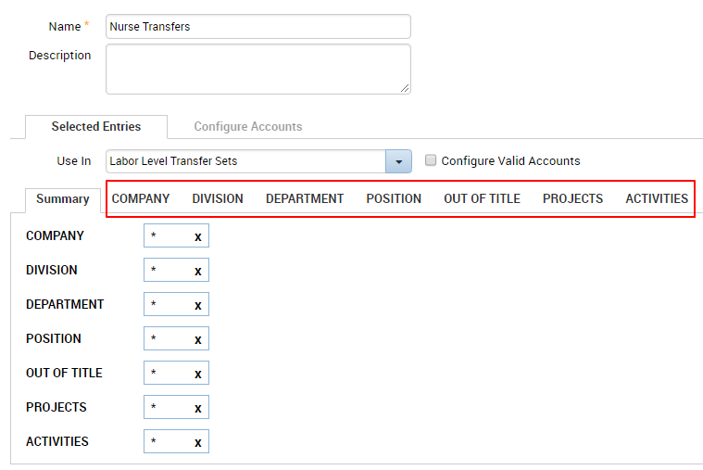
- Click on one of the tabs. Use the asterisk (*) in the search bar and click Search to display all Labor Level Entries associated with this Labor Level. 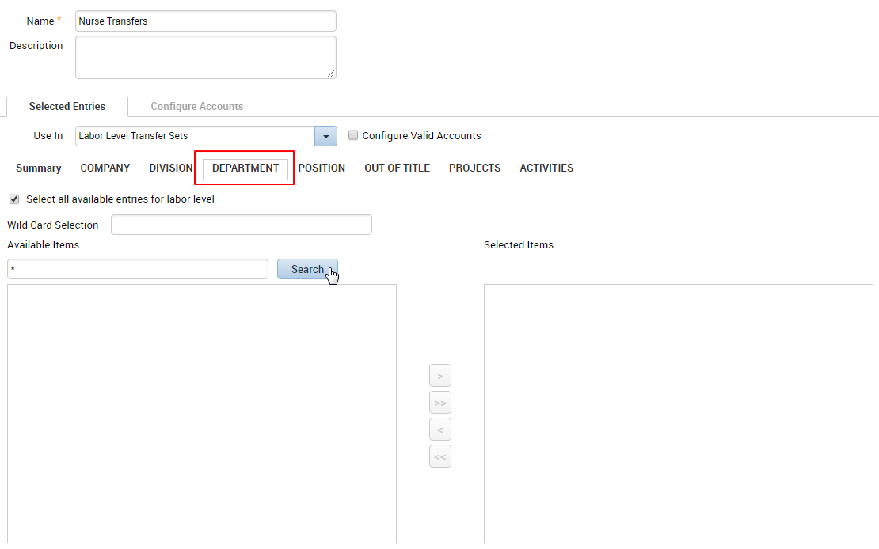
- Select the Labor Level Entries that represent where these employees should be able to transfer. 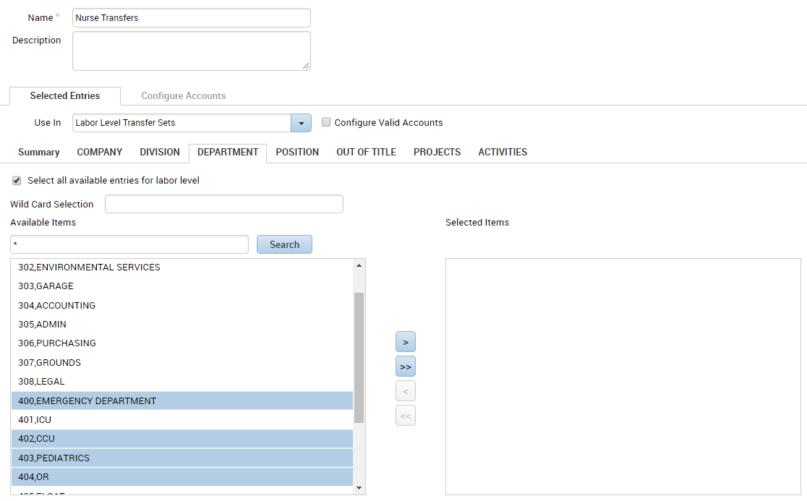
- Use the right arrow ( > ) to move the chosen item or items from the Available pane on the left to the Selected pane on the right. 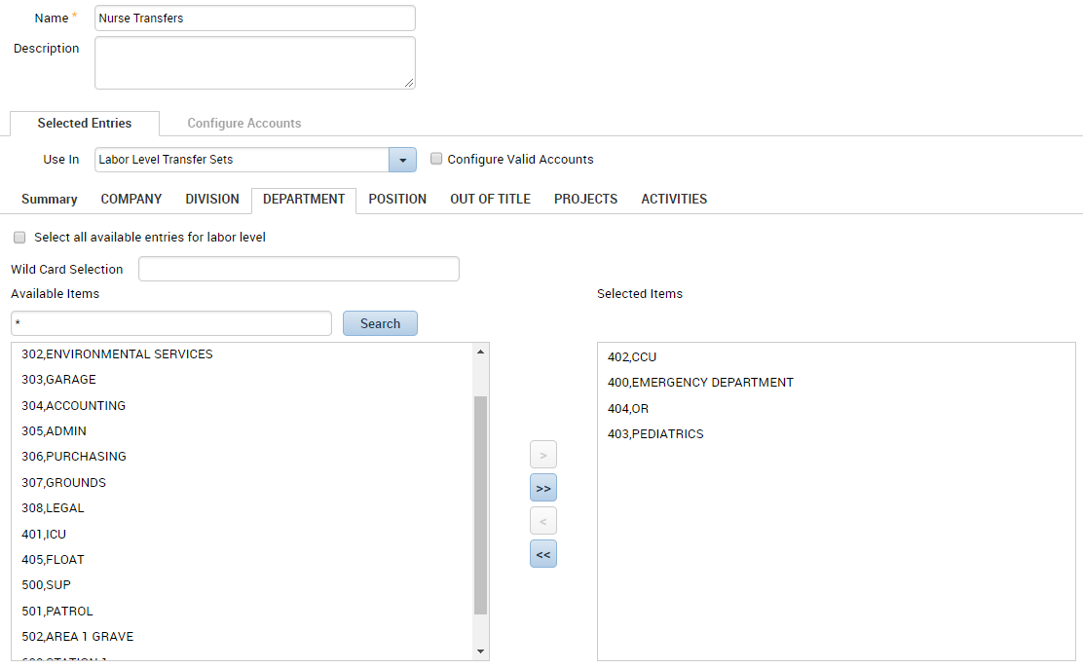
- Continue through the other Labor Levels to include any other entries that the employees may transfer between. 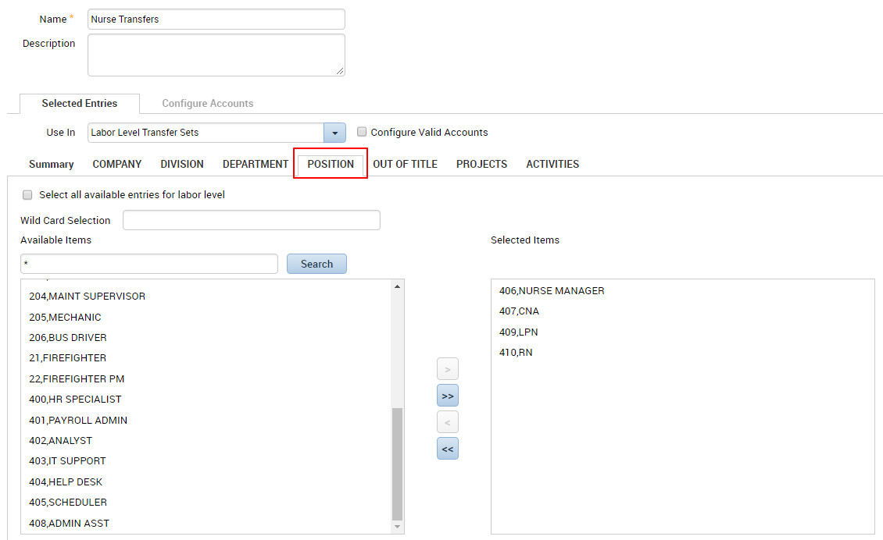
- Use the Summary tab to be sure you have included all the needed Labor Level Entries. 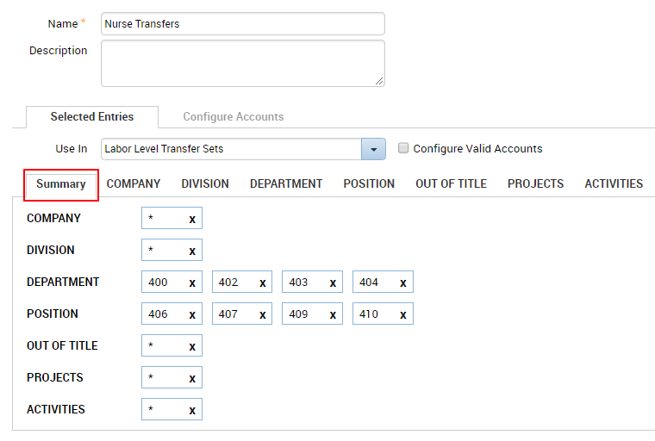
- If the employee should not have access to any other options, use the X to remove anywhere there is an * on the summary screen.
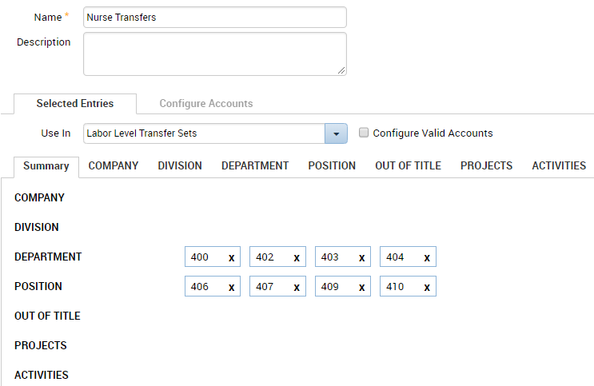
- When finished, click Save.

Assigning Transfer Sets

Assigning Labor Level Transfer Sets to Employees
- To assign a transfer set to an employee, select the employee and navigate to the People Editor. Under the Job Assigment tab, expand the Employee Role section. Use the Labor Level Transfer Set dropdown to assign the correct transfer set. Then click Save. 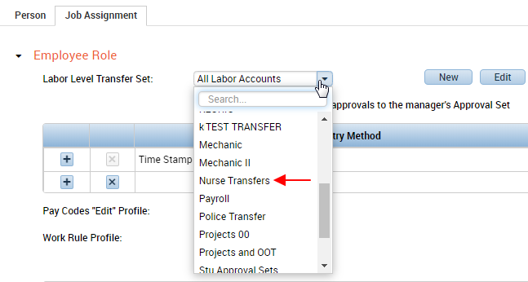
The Labor Level Set can be modified by using the New or Edit buttons to the right. If using the Edit button, keep in mind that any changes will affect all other users who have the transfer set assigned to them. Within the editing menu, there is a Save As button which can be used to create a new set.
- When the employee logs in, they can initiate the transfer within their punch.
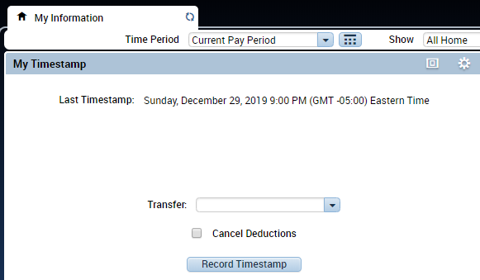
- The system will remember the previous 5 transfers. Use the Search option to access all the available choices.
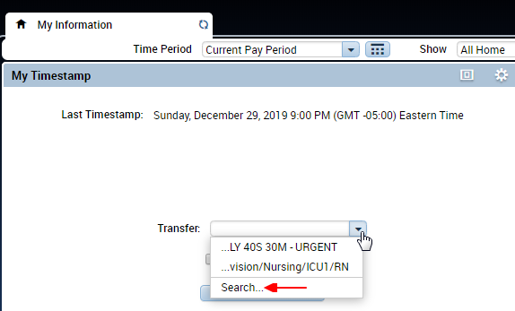
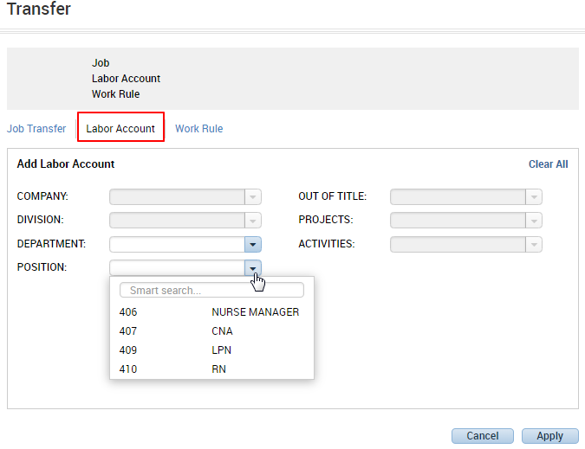
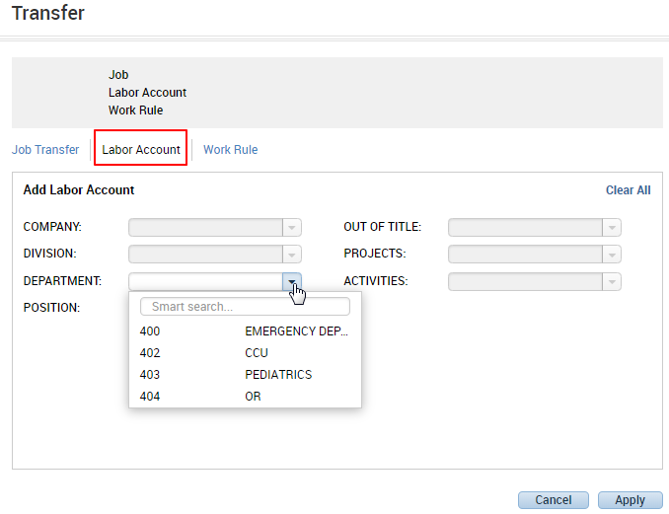
- The employee’s choices for transfers are now limited to only the Labor Level Entries that were included in the transfer set. The other options are grayed out and cannot be used.

- The employee can select one or more of the available choices as a transfer.
When finished, click Apply.
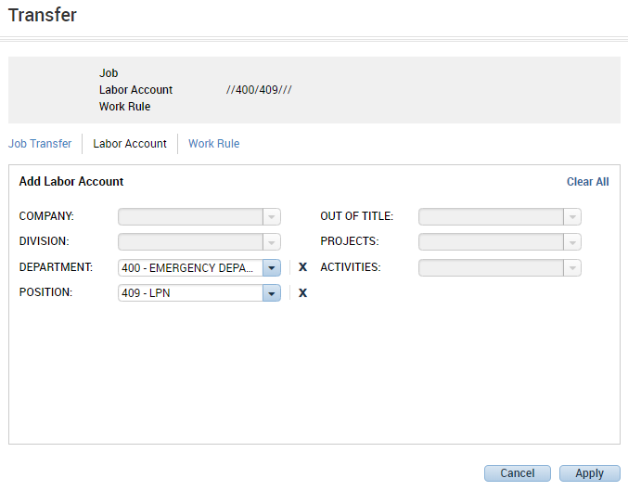
- Now the transfer will be built into the punch when the employee punches in. 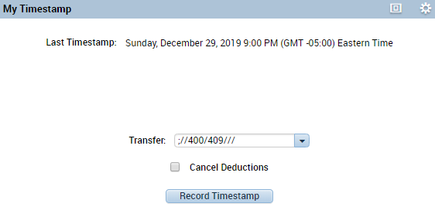
- The employee and manager will see the In Punch and the transfer appear on the timecard. 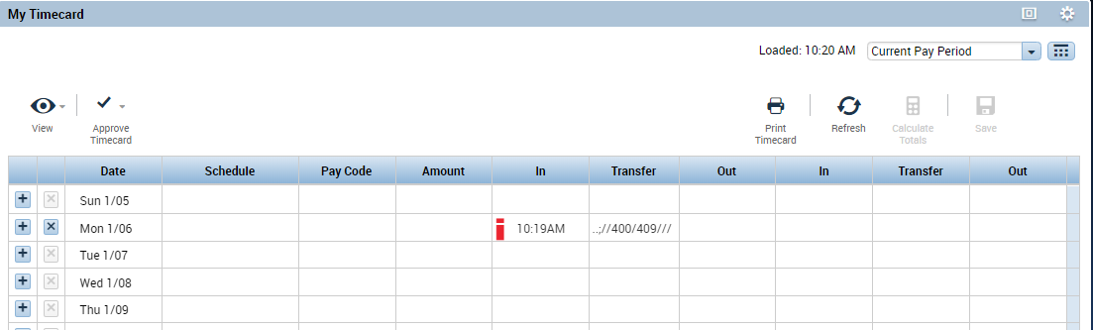

Assigning Labor Level Transfer Sets to Managers
- Select the manager and navigate to the People Editor.
- On the Job Assignment tab, expand the Manager Role – General section.
- Use the dropdown to assign the correct Labor Level Transfer Set. Then click Save.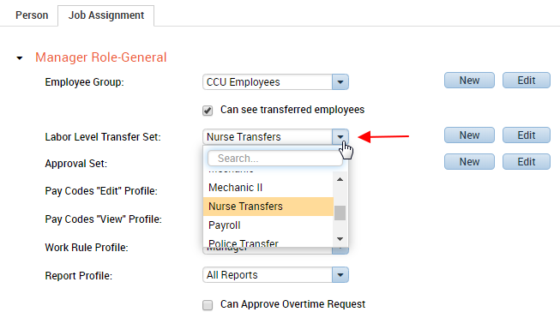
The Labor Level Set can be modified by using the New or Edit buttons to the right. If using the Edit button, keep in mind that any changes will affect all other users who have the transfer set assigned to them. Within the editing menu, there is a Save As button which can be used to create a new set.
- When the manager modifies employee timecards to add transfers, the manager will only be able to choose from the options defined in the transfer set. 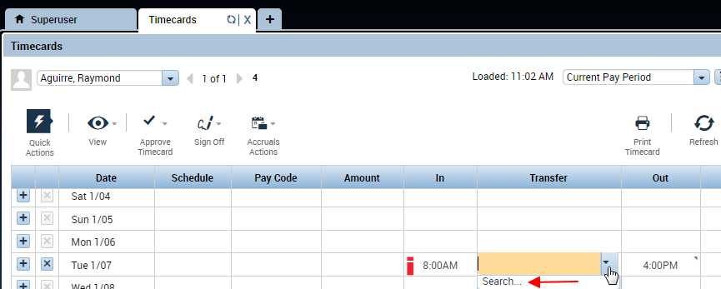
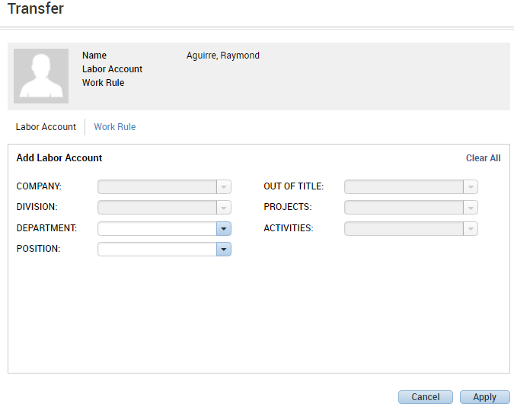
The manager may choose from the available options to add the transfer for their employee.
