Leave Procedures
  - kronos version 8.1

Contents
Leave Procedures 3
Person Record 3
Accruals & Leave tab 3
Person’s Dates tab 3
Create a Leave Case 5
Case Summary Page 5
Additional Information Page 6
Eligibility & Leave Types Page 6
Documents Page 9
Document Status Page 9
Frequency & Duration Page 10
Notifications Page 11
Employment Status Page 11
Leave Rules Page 12
Granting Leave Time to Employees 13
Method 1: Leave Case Editor 13
Method 2: Quick Leave Editor 18
Method 3: Time Off Requests 19
Method 4: Employee Access to Leave Requests 19
Ending a Leave Case 20

Leave Procedures

Person Record
Find the employee in a genie. Use the Go To button to access the People Editor.
Accruals & Leave tab: The employee’s Accrual Profile and Leave Profile will be set in the employee import, so they do not need to be modified. Optionally, use the Leave Administrator dropdown to assign a Leave Administrator. This is only needed if you would like to set up automated notifications within the leave case.
Person’s Dates tab: The Person’s Dates section will show dates associated with leaves. This example shows a section for “Leave Date,” but your organization will likely have each type of leave listed separately. You may see FMLA Date, Workers Compensation Date, and any other type of leave listed on individual lines.
The Override Date section needs to contain the date the accrual is granted. This date will most likely be imported from the HR system. If that is the case, you would not need to modify.
If you do need to update the date manually, consider the following:
If the employee has never been on leave before, you may see a date far in the future, such as 1/1/2200. This is to prevent the system from using the default date (hire date) and granting any leave-related accrual. Click into the date box and type the effective date that you need.
If the employee has been on that type of leave before, you will see the date from the first time they used this type of leave. Depending on the type of leave, you may not need to modify this date.
The system cannot grant leave time if the override date being entered is in a signed-off pay period. If this is the case, you would need to remove sign-off or manually update the accrual balance for the leave time.
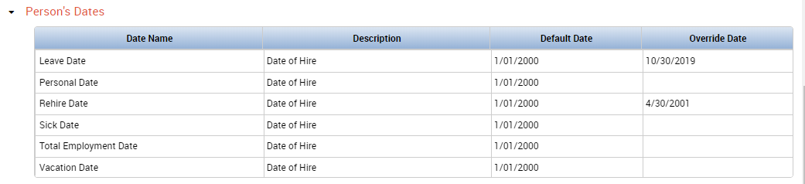

Once the override date is set in the Person’s Dates section, the accrual grant is visible in the Accruals tab beneath the employee’s timecard:
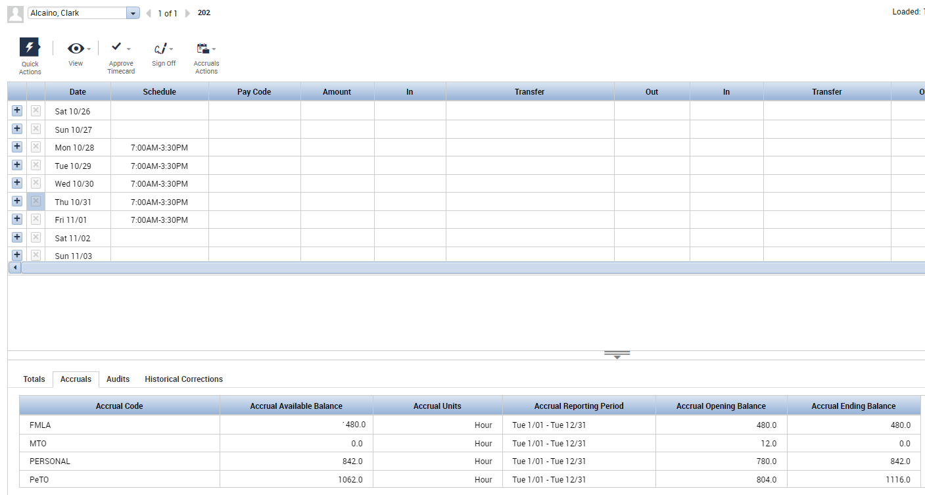

For privacy reasons, some organizations choose not to display leave-related accruals below the timecard. Employees could run an accrual report to find out their takings and available balance.

Create a Leave Case
Select the person in any genie. Use the Go To arrow and choose Leave Case Editor to create a new case.

Case Summary Page
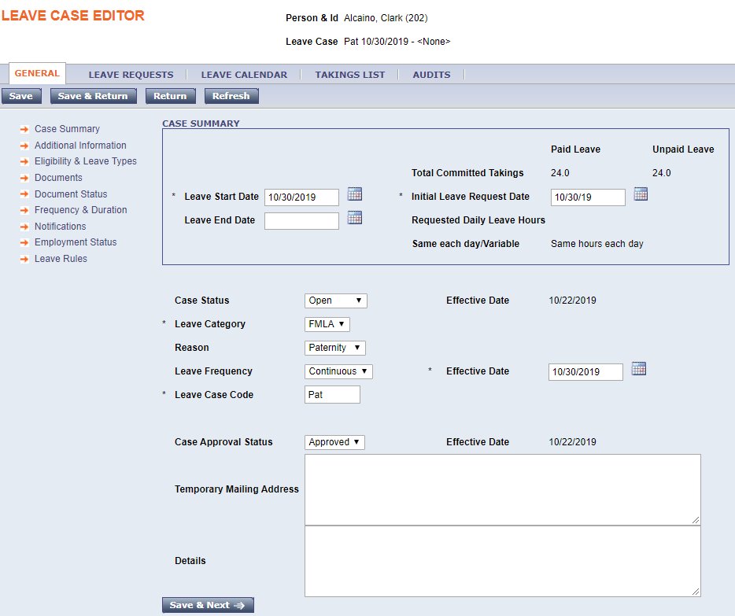
- Leave Start Date: Enter the start date of the leave.
- Leave End Date: Leave blank until you are ready to end the leave case.
- Initial Leave Request Date: Enter the date the employee initially requested leave. Or, use the same date as the Start Date.
- Case Status: Keep this set as Open.
- Leave Category: Select applicable leave category (ex., grand jury duty, FMLA).
- Reason: Select the reason for the leave from the dropdown (ex. maternity) and this will fill in the Leave Case Code.
- Leave Frequency: Continuous or Intermittent.
- Effective Date: Enter the start date of the leave.
- Case approval status: Choose Approved, Denied, or Pending.
- Enter any temporary mailing address or details.
- Choose Save & Next when finished.

Additional Information Page
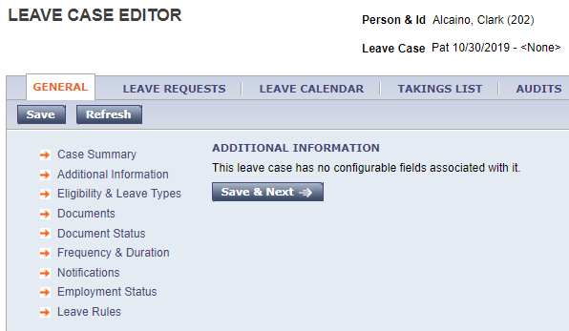
Fill in any additional information as prompted. Depending on your organization’s requirements, you may or may not need to enter any information on this page. When finished, choose Save & Next.

Eligibility & Leave Types Page
Some leave types have eligibility requirements, such as a required length of employment or previous number of hours worked. Select the blue Check Eligibility button.
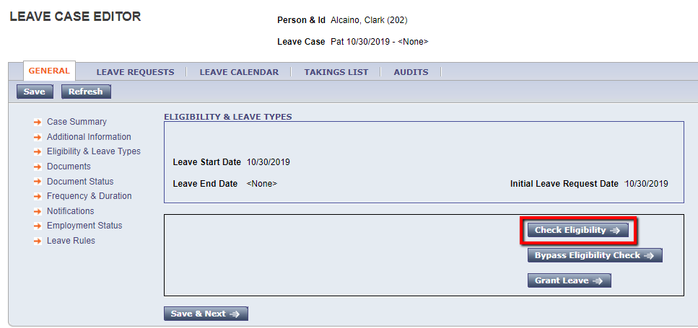

This will bring up an additional screen that verifies the eligibility. The information is displayed in duplicates because the system checks against all types of leave this employee may qualify for. Choose Save & Return at the bottom.
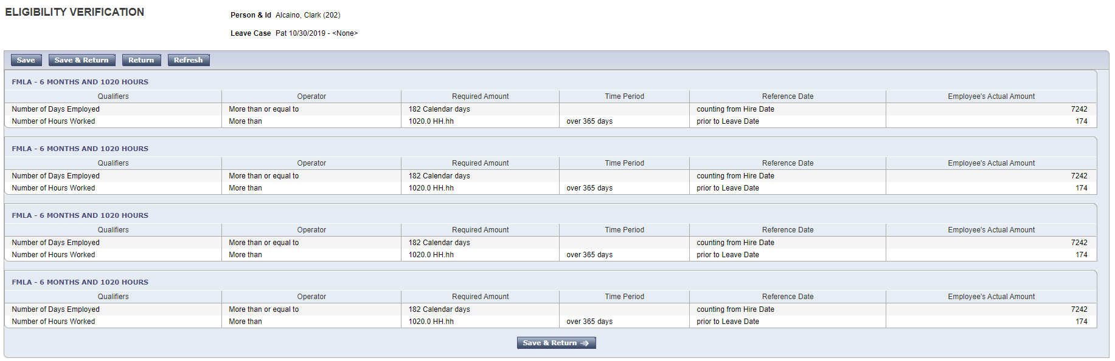

If Kronos does not have enough historical data to validate the employee’s eligibility, but you know they qualify for the leave, you may choose Bypass Eligibility Check. 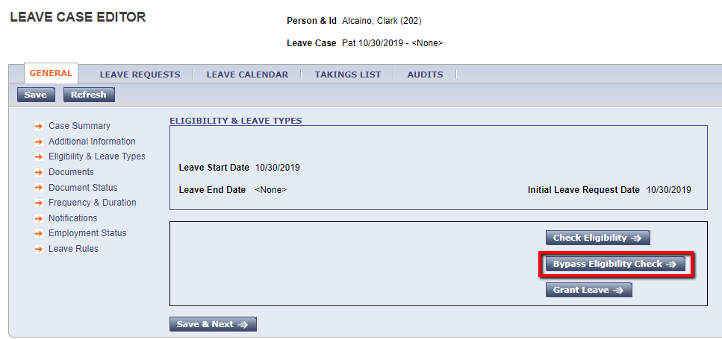

The screen will now display the types of Paid and Unpaid leaves the employee is able to take, as well as the available balance of each. Choose Save & Next.
You can uncheeck leave types you do not want used in the case. For example, if you uncheck Personal in the Use In This Leave Case column, then it will not be used in the takings.

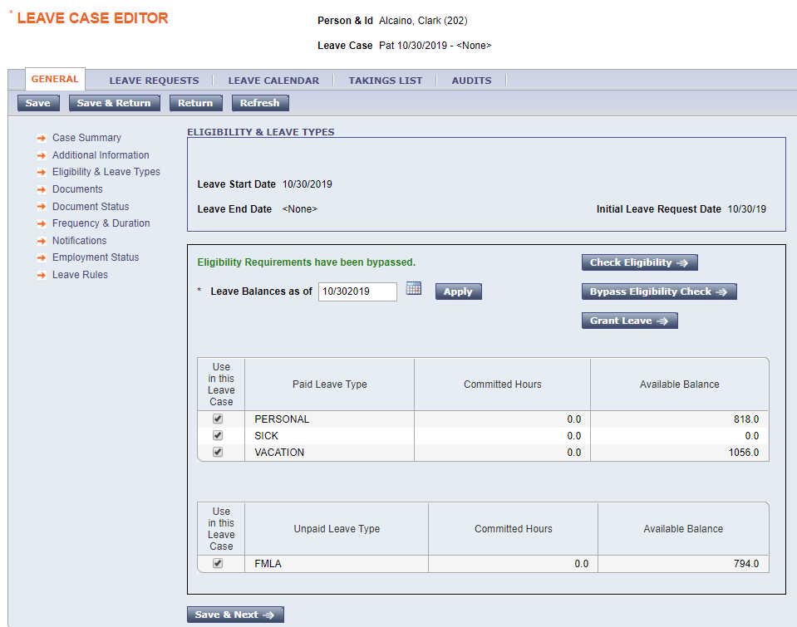

Documents Page
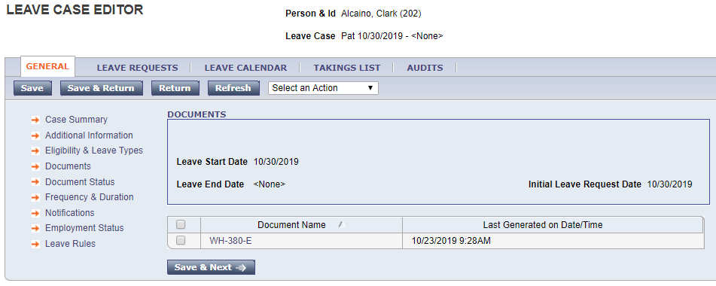
The Documents page allows the organization to include document templates that need to be filled out. Click the name of the document to open it. Generally, these documents will need to open in Microsoft Word. Print the document and complete according to organization requirements. Some organizations provide documents here, some do not.

Document Status Page
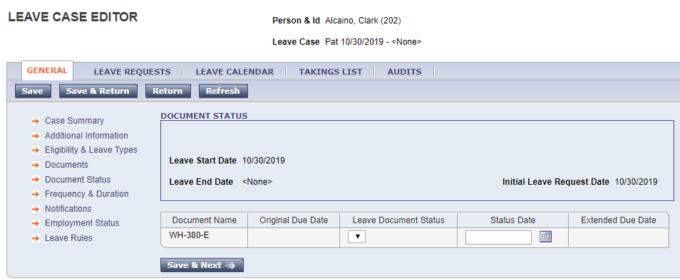
The Document Status page allows you to note when you completed the required documents from the Documents page. Choose the appropriate status from the dropdown and enter the date when the document was completed.

Frequency & Duration Page
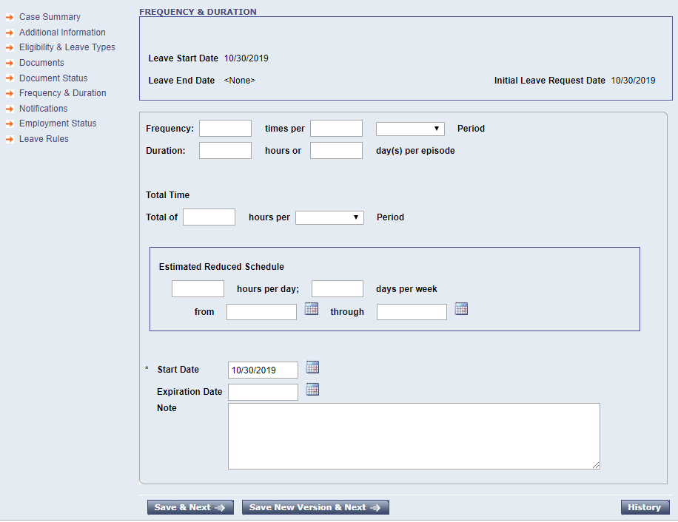
The Frequency & Duration page is useful for intermittent leaves. This allows you to record what the employee’s expected time off and schedule needs will be. Later, this can be compared to the actual time the employee took.

Notifications Page
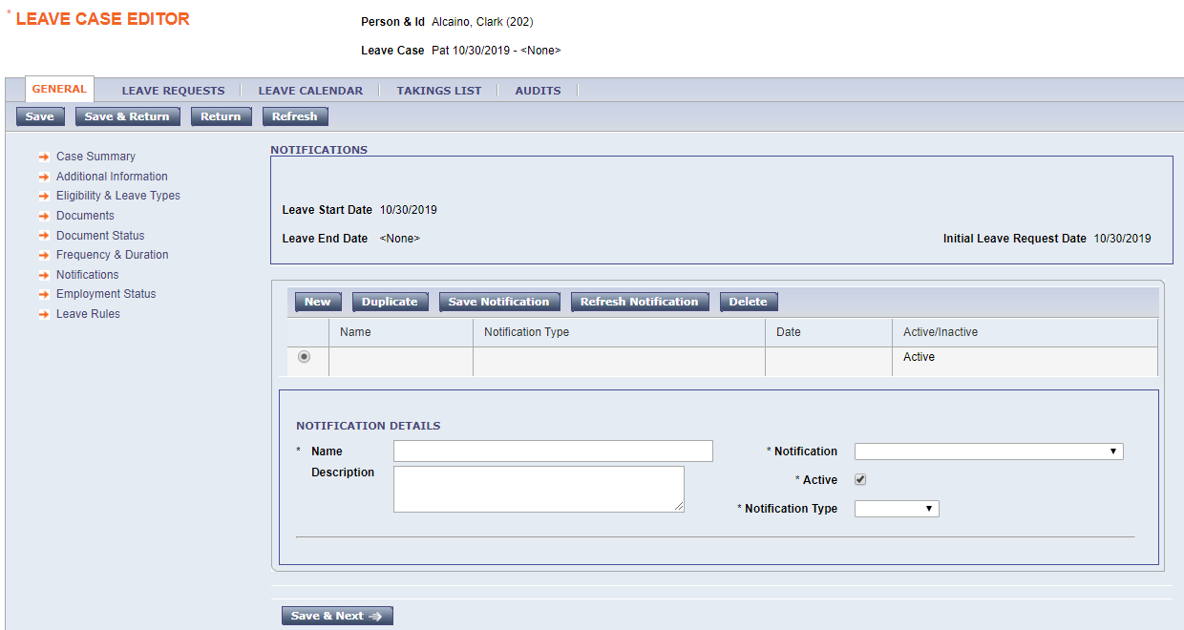
The Notifications page allows notifications related to leave documents, etc. to be set up. If email is configured, notifications can be emailed. This is not required.

Employment Status Page
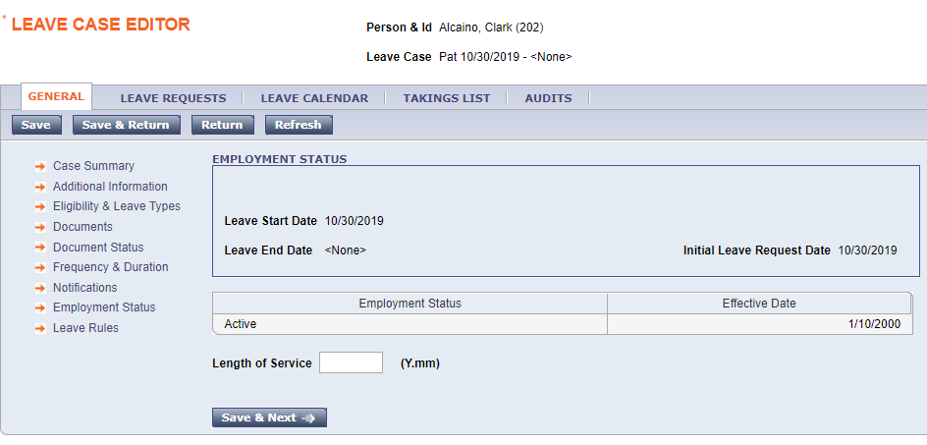
No further information needs to be entered on this page.

Leave Rules Page
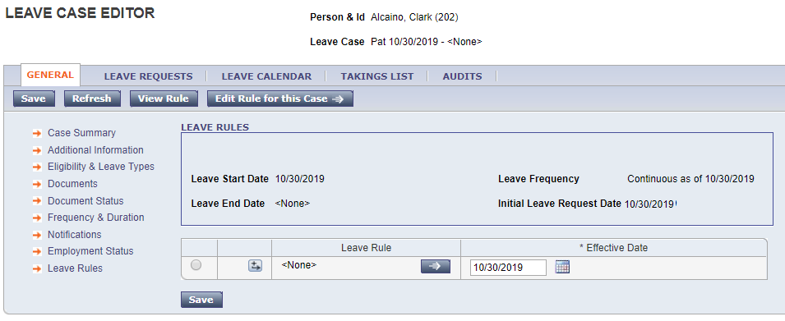
A Leave Rule must be entered on this page. Use the arrow to select a new Leave Rule. There may be more than one Leave Rule associated with a case. More than one Leave Rule may be needed if there is a difference in how the time is cascaded.
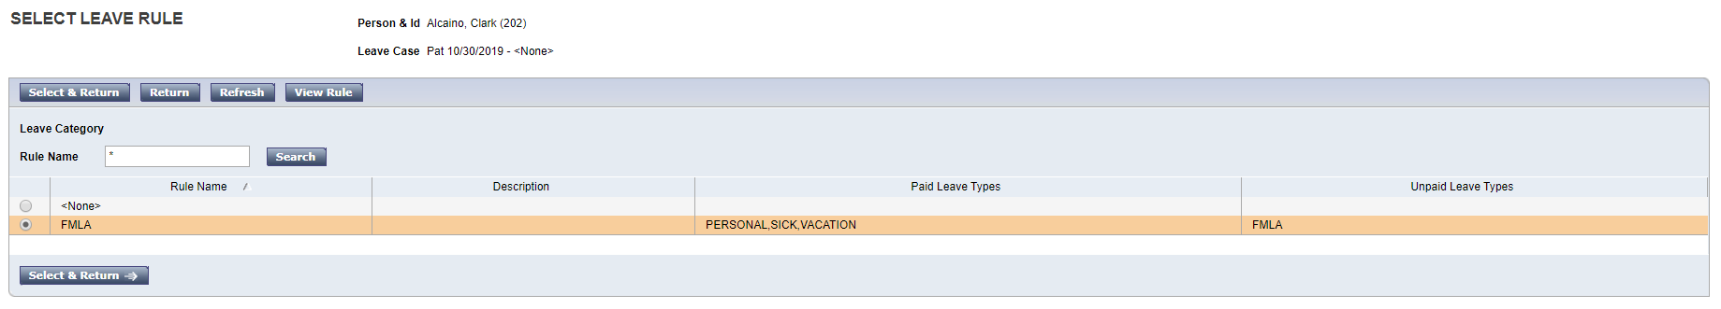

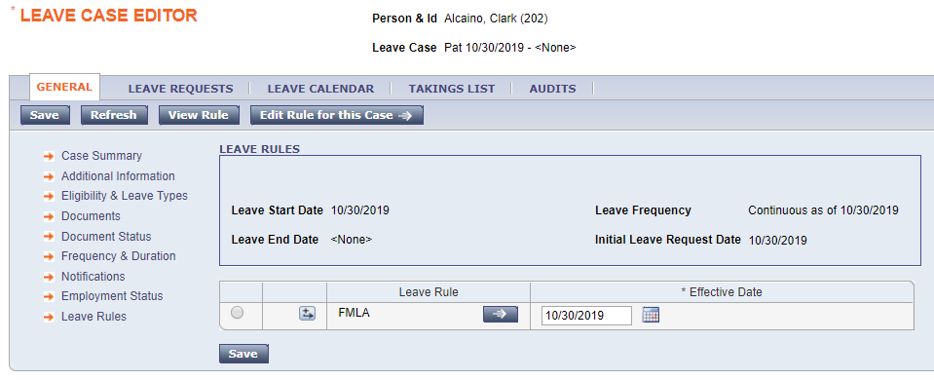
Save when finished. This completes the Leave Case creation.

Granting Leave Time to Employees
There are multiple methods used to record when employees are taking their leave time.

Method 1: Leave Case Editor
Find the employee in a genie. Use the Go To button to access Leave Case List. If the employee has more than one open Leave Case, they will be listed here. If you are accessing before the first day of the Leave Case, be sure your screen is set to the correct timeframe. Choose the Leave Case you wish to track time for. From the Leave Calendar tab, use the Select an Action dropdown to choose Add Projected Leave Time Over Long Range.
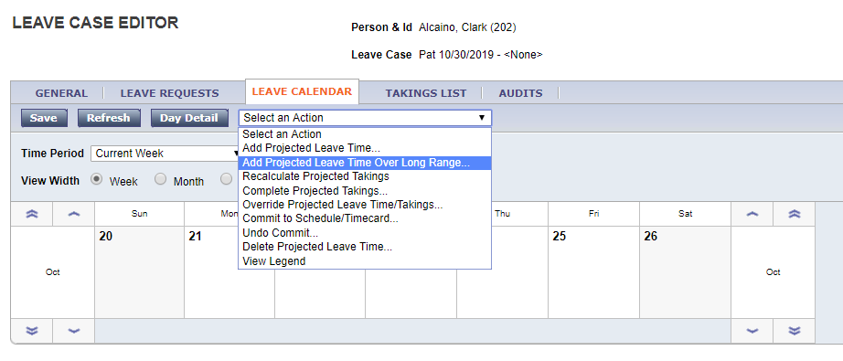
This will allow you to enter a start date and an end date. The specified amount of leave time will be applied to each day in the date range. This is useful for employees taking continuous leave.
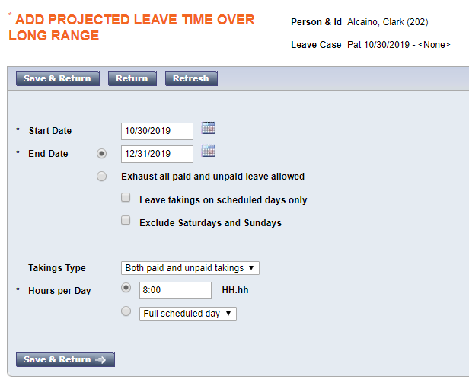
Choose Save & Return when finished.
After choosing Save & Return, the applied time will display in the calendar view as shown below.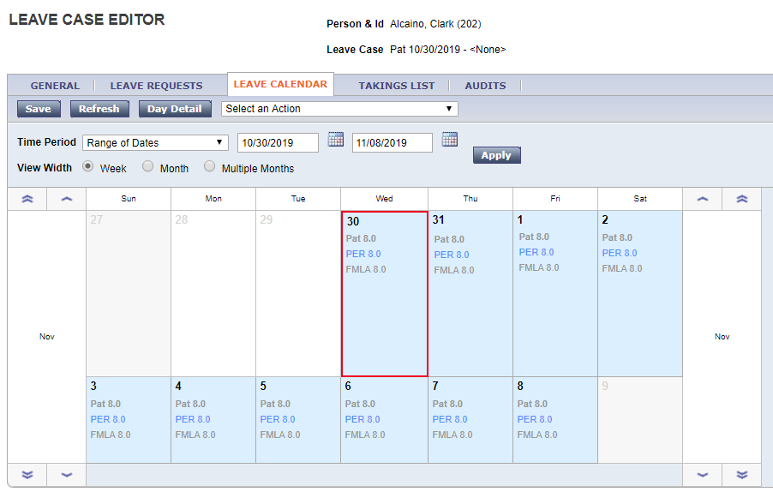
It will also display on the next tab, the Takings List tab.
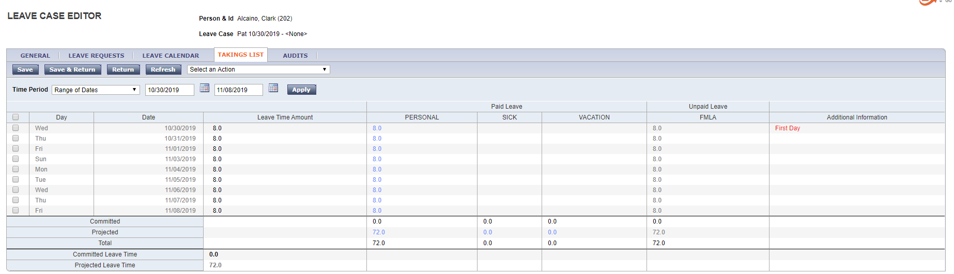
Smaller ranges of dates or single dates can be added from the Leave Calendar as well. Select the day or days by clicking on them in the calendar. Then use the Add Projected Leave Time option from the Select an Action dropdown.

At this point the time is considered Projected Leave Time.

Projected Leave Time needs to be pushed to the schedule and timecard with the Commit to Schedule/Timecard action.
Note: Once time is committed for a date in the future, leave time cannot be entered before that date. For example, if leave time is committed for November 10, and the administrator tries to commit leave time for November 5, they will see an error message: Leave date 11/5/2019 is not after the latest date with committed leave time: 11/10/2019.
The administrator would need to select Undo Commit for the future time. After that, the administrator would be able to enter the leave time as needed.
If an employee has more than one open leave case, committed leave time in any open case will cause this error message when adding time to another case.

Therefore, it is recommended to keep the time as Projected Leave Time until close to the date that the employee will be taking the time, especially when an employee takes their leave time intermittently. This makes it easier to put in additional time that may be needed in between known takings. At the point or the pay period when the employee is taking the time, commit the leave time to the timecard.
To push projected leave time to the schedule and timecard, choose the Select an Action dropdown and choose Commit to Schedule/Timecard. This will open an additional screen. Choose Timecard or Schedule from the Destination dropdown. Choose Save & Return to push the time to the chosen destination.
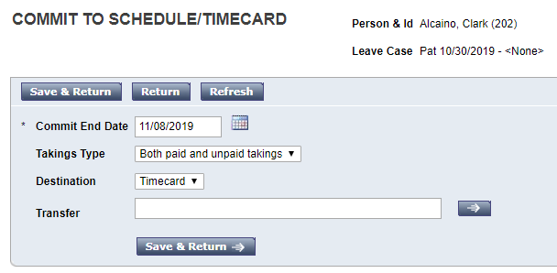
Now, the leave time will be displayed in the timecard.
There may be multiple ways this appears. One way is with separate codes for FMLA time and Personal time (here the pay code is called Personal, for your organization it may be called Personal, PTO, or

something else). Selection shown here, full timecard shown below: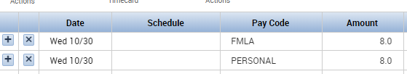

The FMLA code displays the number of hours being deducted from FMLA time. This is not related to employee compensation. It only serves to represent the deduction from the available FMLA balance.
The other pay code represents that the employee is still being compensated while they are out on FMLA time. Here the code is Personal. Once the employee uses all available Personal time, they may progress to using accrued Sick or Vacation hours.
We can see in the Daily column on the timecard that only the Personal pay code is contributing to a daily total, representing that the employee will still be paid for 8 hours on each day.
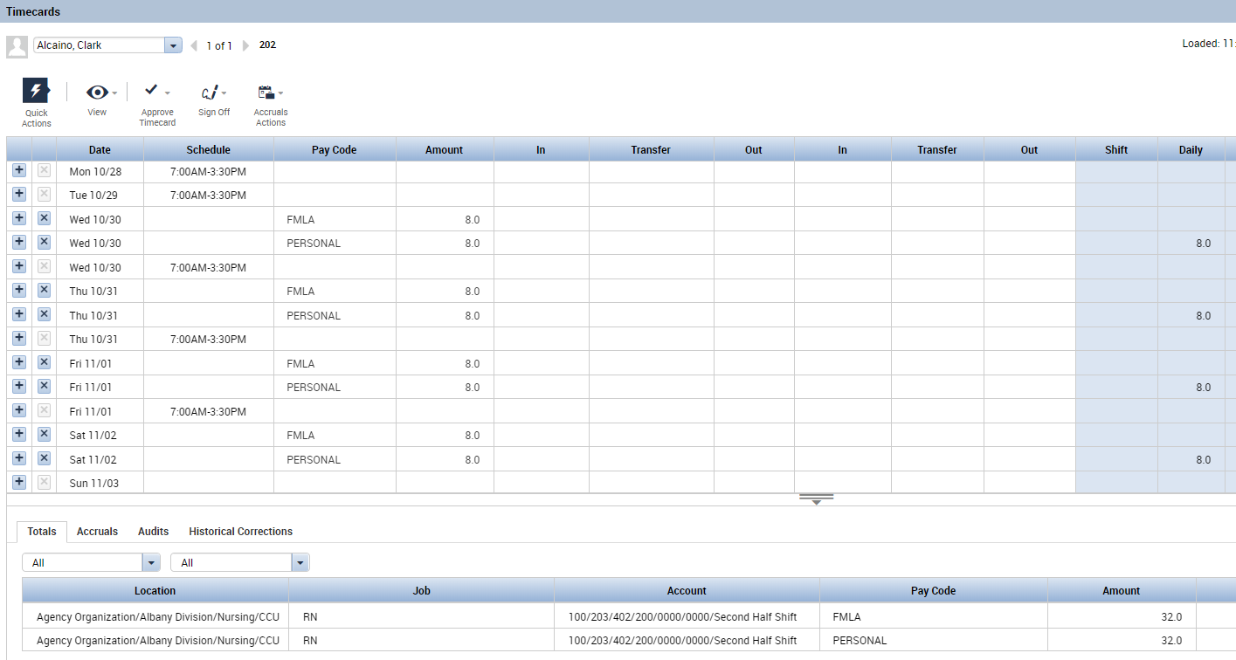
The other way the time may be represented is with a single pay code.

When the time is represented with a single pay code, the pay code name may be something such as FMLA PERSONAL. The pay code name will be displayed as well as the number of hours. Behind the scenes, this pay code will take 8 hours from the available FMLA hours and 8 hours from the available Personal hours. This will also result in the employee being paid for 8 hours. Once the employee’s Personal time is used up, the employee may then see an FMLA Sick pay code or an FMLA Unpaid pay code.
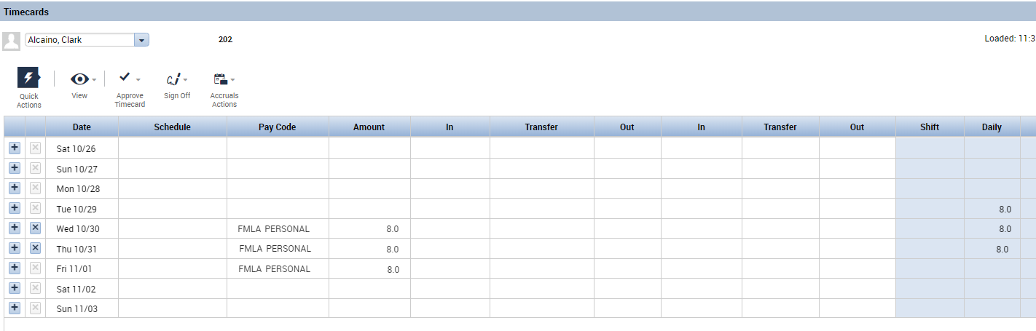

Other Available Options in Leave Case Editor:
- Recalculate Projected Takings would be used if a change in accruals was made or a change in the policy
- Override Projected Leave Time/Takings allows you to edit time taken by selecting the days to edit and change the amounts or codes taken before committing to timecard
- Undo Commit allows you to remove time from the timecard/schedule if changes are needed
- Delete Projected Leave Time can remove projected takings if needed
- View Day Detail brings up detail for codes taken on the day selected
General Tab:
You can go back to the case setup and change the properties if needed even after it is saved (most likely dates would be changed).

Method 2: Quick Leave Editor
Another way to record employee’s leave time is through the Quick Leave Editor. This works well for employees who use leave time intermittently. Access the employee’s timecard. From the timecard, use the Go To button to choose Quick Leave Editor.
Note: If you have projected leave time in the Leave Case for this pay period, you cannot use the Quick Leave Editor. You will see an error stating “One or more leave cases of the employee contain projected takings. Quick Leave Editor cannot be used until projections are committed from the full Leave Case Editor.” Go back to the Leave Case Editor and choose Commit to Schedule/Timecard to push the time to the timecard.
If your employee has more than one leave case open, they will all appear here. For example, an employee may be on workers’ compensation and FMLA at the same time.
Choose the name of the leave case you wish to apply time for.
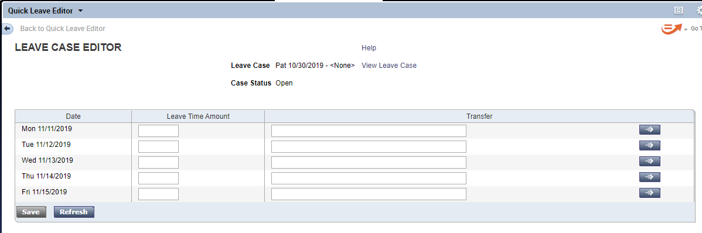
Add the hours of leave time for each day as needed: 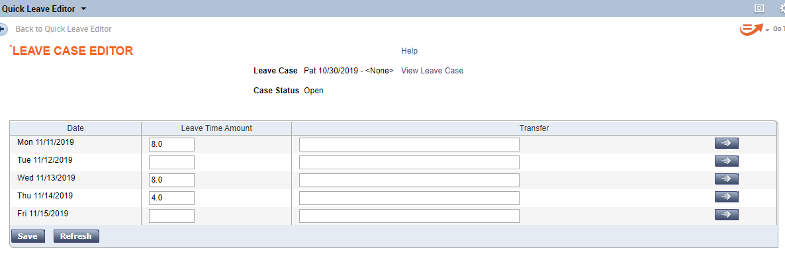
Save when finished.

Return to the timecard and Refresh. The hours now appear on each day as specified: 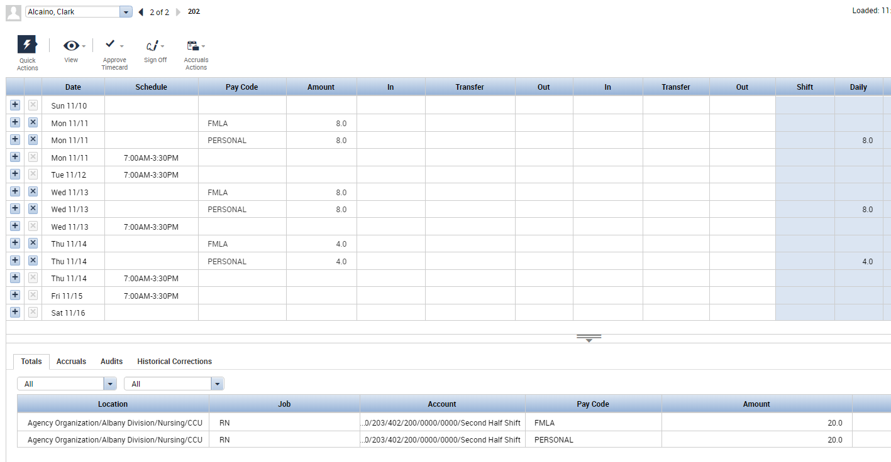
You can always access the Quick Leave Editor again to modify or delete time. You can also modify or delete directly in the timecard.

Method 3: Time Off Requests
Some organizations allow their employees to use Time Off Requests to submit their intermittent leave time. Employees are granted access to request time in leave-related pay codes. Once approved, the requested time flows directly into the schedule and timecard.

Method 4: Employee Access to Leave Requests
Employees can have access to the My Leave Requests widget in Kronos. This allows the employees to put in their own requests as they take intermittent leave time.
Discuss the pros & cons of Methods 3 and 4 with your Implementation Technician.

Ending a Leave Case
To end a leave case, return to the Leave Case Editor. On the Case Summary screen, enter the Leave End Date. Change the Case Status to Closed.
Save when finished. After the Leave End date, leave time may no longer be entered.
