Manager Delegations
  - kronos version 8.1

Contents
MANAGER DELEGATIONS 3
Creating a New Manager Delegation 3
System Settings 8
People Editor 8
Setup 9

MANAGER DELEGATIONS
Manager Delegations are useful when a manager will be absent and unable to access Kronos. Setting a Manager Delegation allows one manager to temporarily function as another manager to take care of timecard approval and other related tasks.

Creating a New Manager Delegation
- To create a new Manager Delegation, the manager who will be absent must navigate to the Manager Delegation request. This may be available as a widget in the drawer, or it may be within another widget, such as Actions. Select Manager Delegation.
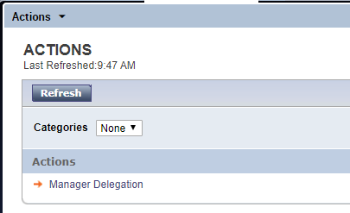
- From the Delegate dropdown, the requesting manager chooses the person to receive the delegation request. Choose the Start Date and End Date. The start & end date define the time frame that the delegate will be able to function as the requesting manager. Choose Save and Close to submit the request.
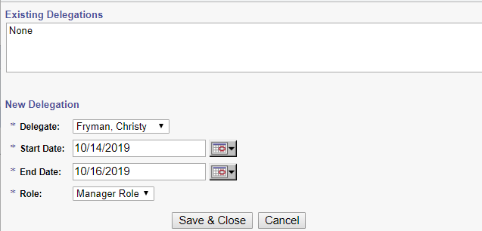
- The manager receiving the delegation request will see a notification in the Requests alert. If email notifications are set up, this manager will also get an email notification of the new request.
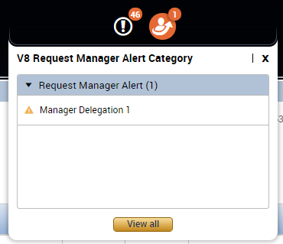
- The manager receiving the delegation request will need to navigate to the Requests widget to view details and accept the request. 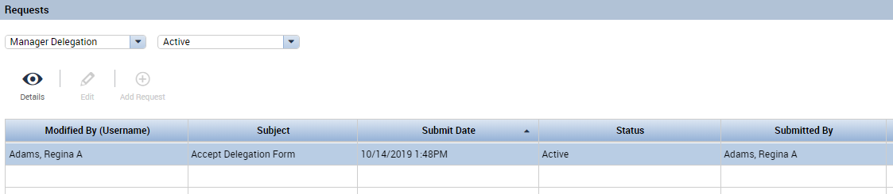

- If available, click the Accept Delegation icon. If no icon is displayed, double-click on the request to open the window to accept the request. 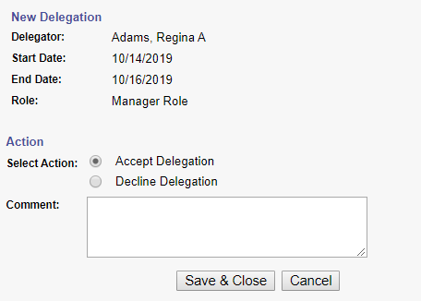
To accept the request, select the Accept Delegation radio button and choose Save and Close.
- If the delegation is starting on the current date, sign out and sign back in for the acceptance to take effect. If the delegation is for a future date, the option to switch roles will automatically be available upon sign-in on that future date.
- While the delegation is active, the manager who accepted the request will have a small arrow appear near their name (name appears above the Sign Out option in the upper right corner of the screen). Clicking on the arrow will allow the manager to choose to function as “Myself” or as the requesting manager. The manager may switch back and forth between roles as frequently as needed while the delegation is active.
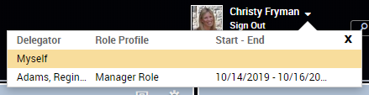
- Choosing to function as the requesting manager will cause the delegate’s screens to refresh. The delegate will now see the main screen with the requesting manager’s default view. The delegate will have all employees displayed exactly as the requesting manager views them. The delegate’s name will also display with “As” the requesting manager. If set up, the ID photo will also change to display the requesting manager.

- While functioning as the requesting manager, all edits to employee time will be recorded under the delegate’s name.
Here, Christy Fryman is functioning as Regina Adams. We can see the manager delegation is in effect by looking at the names in the upper right corner.
Christy added bereavement time in for one of Regina’s employees.
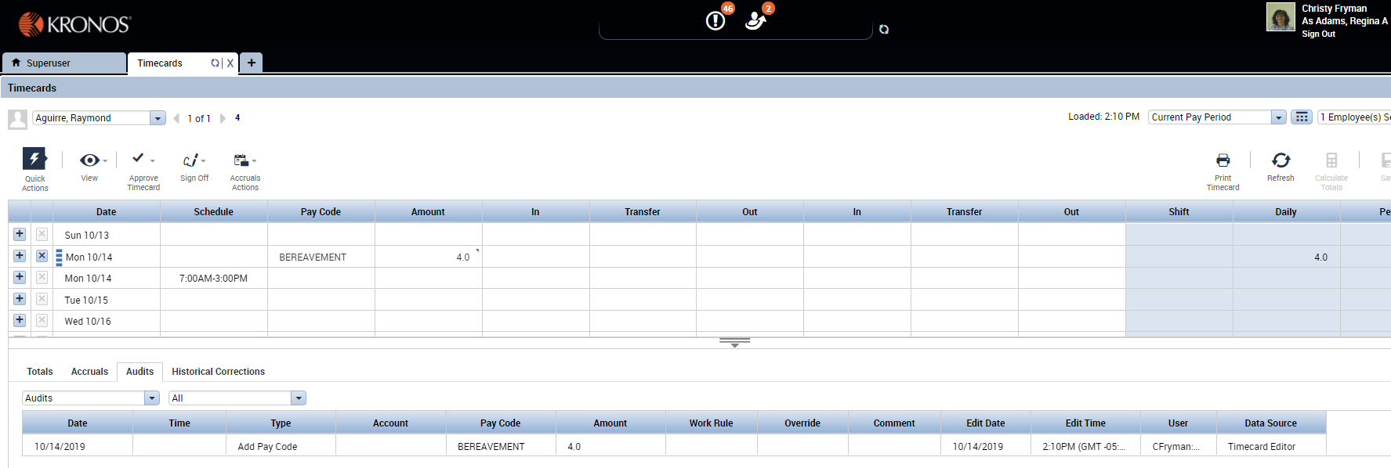

We can see from the Audits tab beneath the timecard that the user who made this edit is “CFryman:”
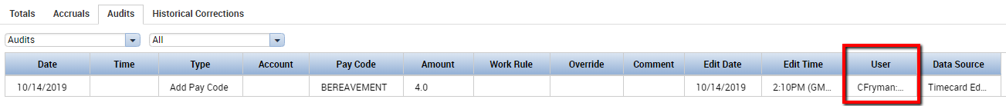
Even though the Manager Delegation is in effect, Christy’s changes to Regina’s employees display under Christy’s name.
- The manager delegation will automatically expire based on the End Date chosen when initially creating the request. However, the requesting manager can terminate the request earlier if needed. By choosing Manager Delegation again, the manager will be presented with a choice to create another delegation or remove an existing delegation: 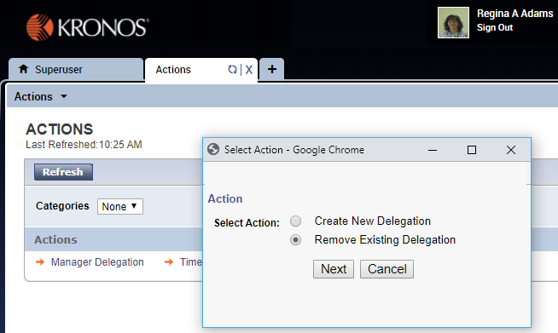
After selecting Remove Existing Delegation, the manager will be presented with a list of any active delegations. The manager can select the delegation to remove & click Delete. This process will immediately remove the delegate’s ability to switch roles.
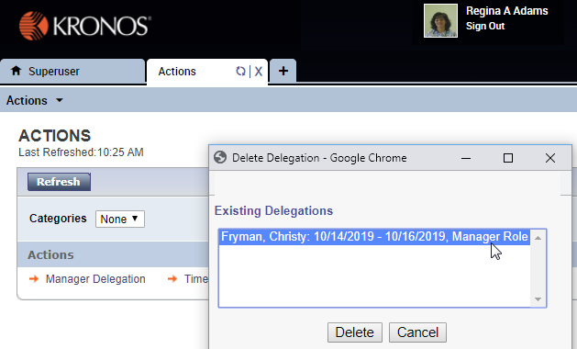

System Settings
If a manager is unable to create or receive manager delegations, check these settings:

People Editor
On the Person Tab, check the manager’s settings under Process Profiles. The manager must be assigned a Manager Profile.
On the Job Assignment Tab, check the manager’s settings under Access Profiles. The manager must be assigned a Delegate Profile.
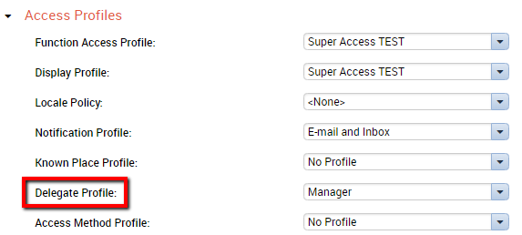

Setup
Under Setup and Common Setup, select Delegate Profiles.
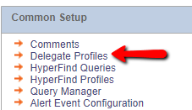
Select the Delegate Profile for Managers and choose Edit.
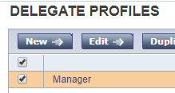

If there is a manager who has not been added to the profile, use the right arrow to move them from the Available Delegates section on the left to the Selected Delegates section on the right.
Use the * and click Search to pull any newly created managers into the Available Delegates list. Save when finished.
