Leave Cases:

Override Projected Takings
  - kronos version 8.1

OVERRIDE PROJECTED TAKINGS
- Select the employee and navigate to the Leave Case List. 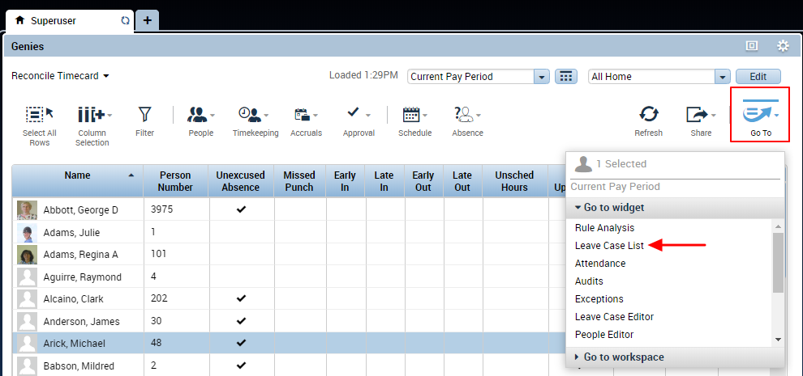
- Choose the correct Leave Case and choose Edit.
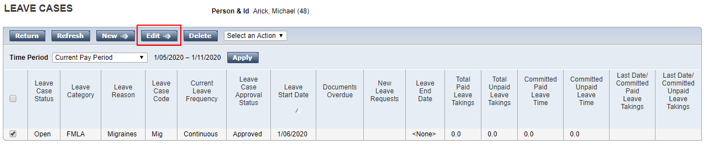
- Choose the Takings List tab. Use the Time Period dropdown to select the range of dates you need to work with. The projected and committed leave time for the case will display. You can only make changes to projected time.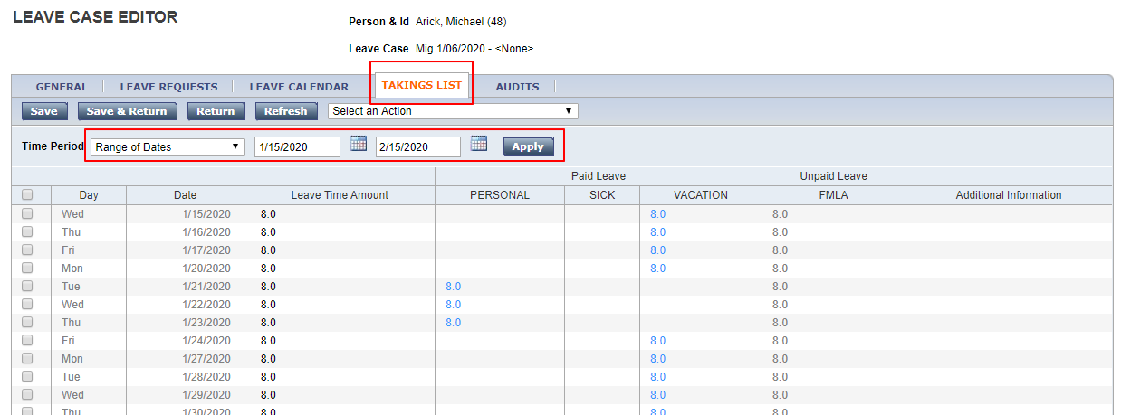
- Use the top checkbox to select all the takings in the time frame.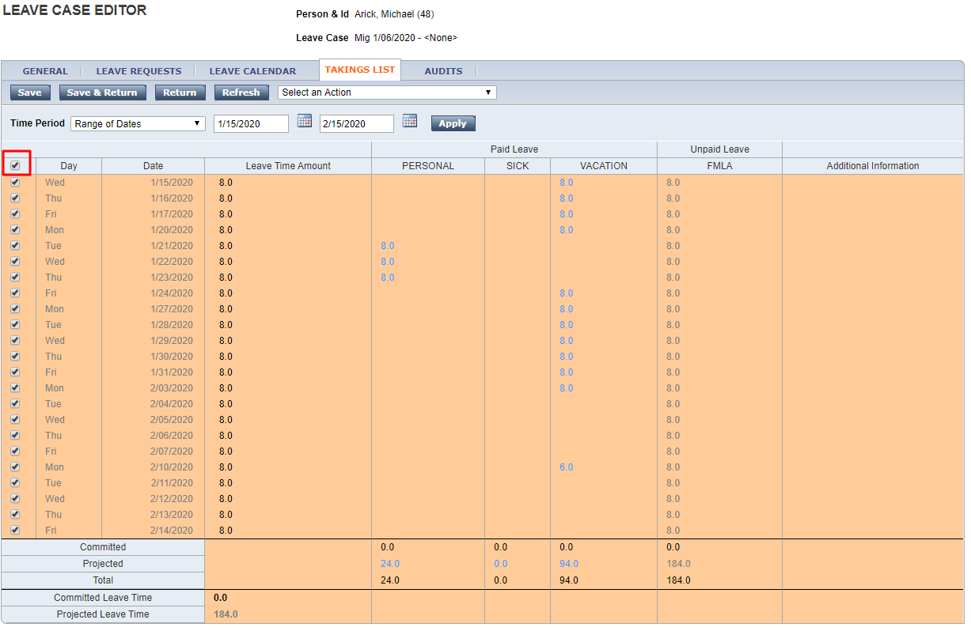
- From the Select an Action dropdown, choose Override Projected Leave Time/Takings.
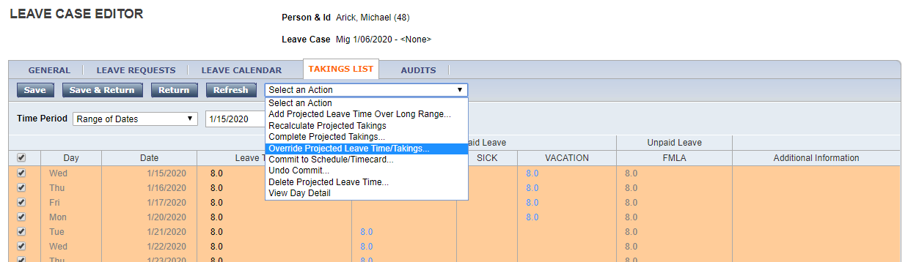
- This opens an editor where the takings may be switched from one paycode to another. 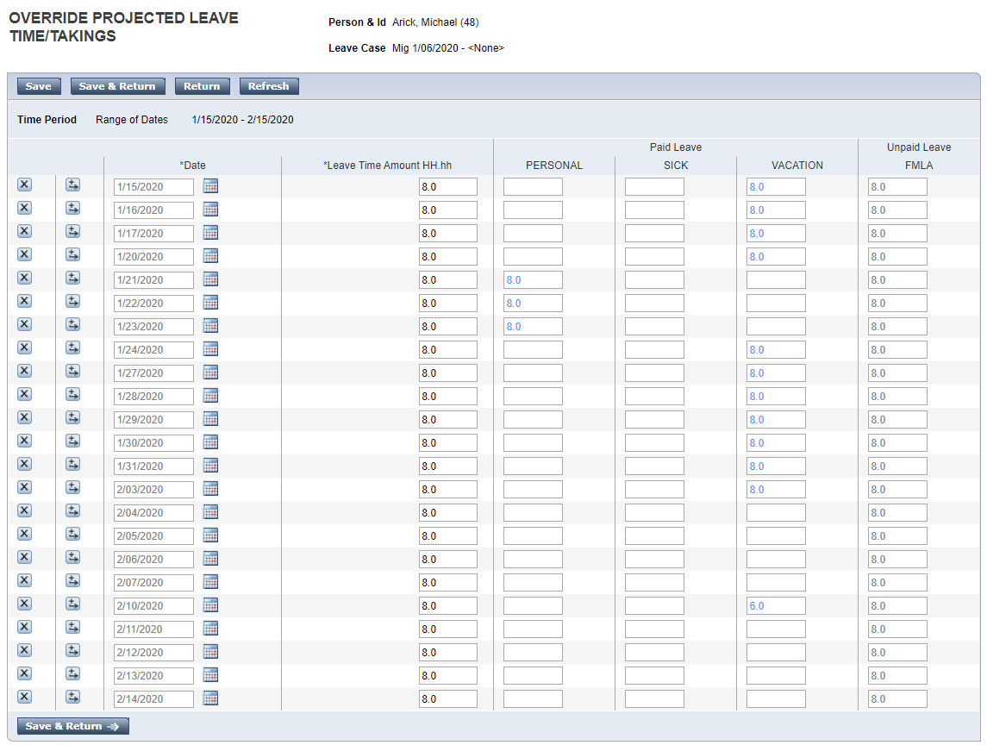
- To modify the projected time, delete from the existing pay code and type the amount into the desired pay code.
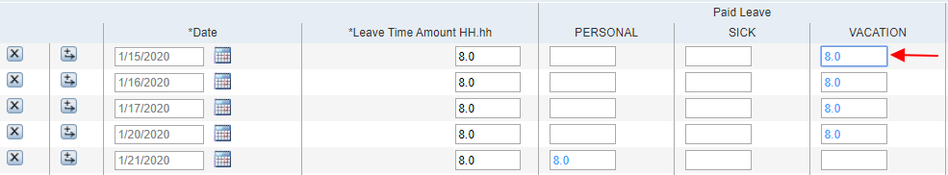
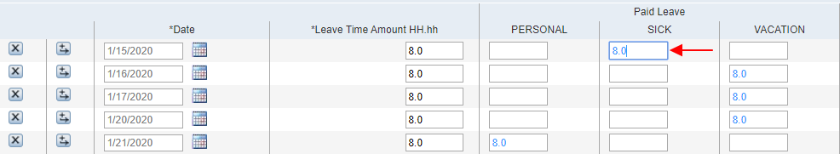
- Save after making changes. Once saved, any time that has been manually modified will display in red. 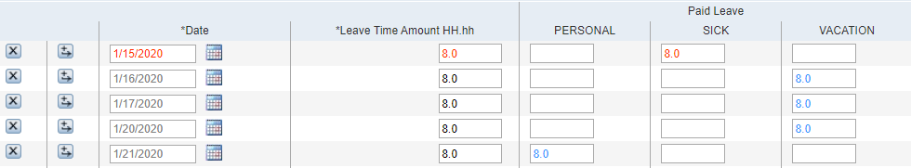
- Continue making changes, saving periodically. If there is not enough accrued time in a particular pay code, the changes will not be saved, and an error message will display with additional information about the overdraw. Moving time between the pay codes may affect time projected to those pay codes on future dates in the leave case.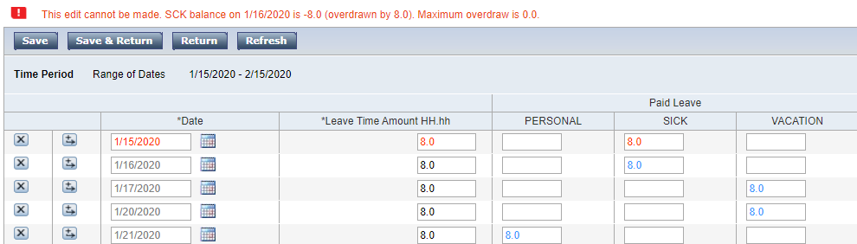
- When finished making changes, choose Save and Return.
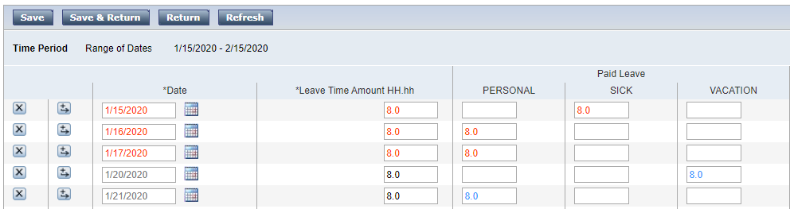
- Dates that have been manually modified will still display in red. 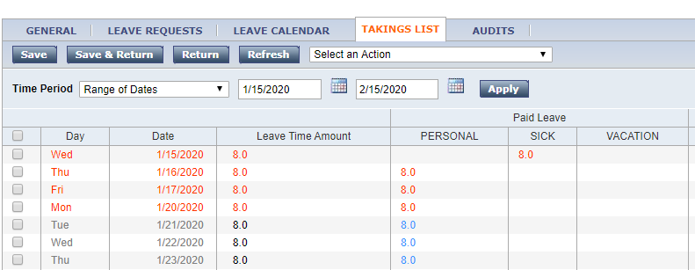
- When needed, the time can be committed to the schedule and/or timecard.

