Request a Shift Swap
  - kronos version 8.1

Contents
REQUESTING A SHIFT SWAP 3
Creating a New Request 3

REQUESTING A SHIFT SWAP
Swapping shifts allows you to ask another employee to trade shifts. A swap can only occur between two employees who are qualified to work the same shift. The jobs are typically at the same location, but don’t have to be.
The shift swap cannot be completed if it will violate a schedule rule that has been set up. This may include overtime rules. In such an event, the employee will see an error message and will not be able to submit the request.

Creating a New Request
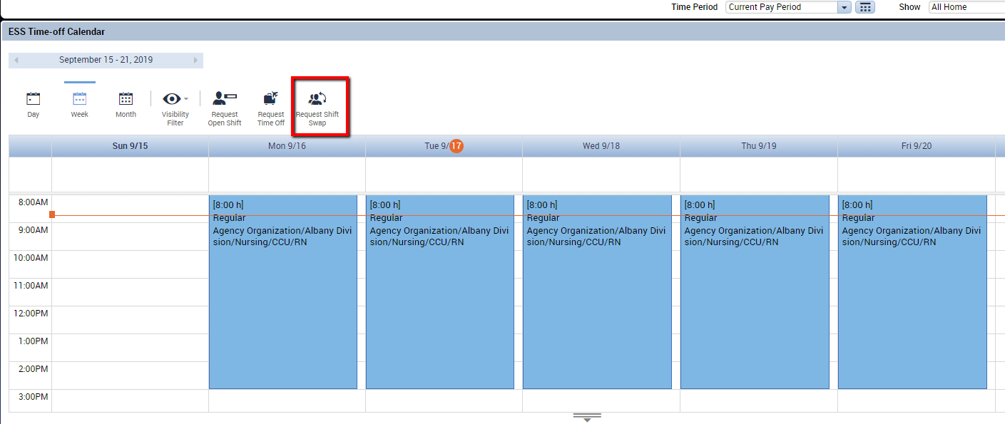
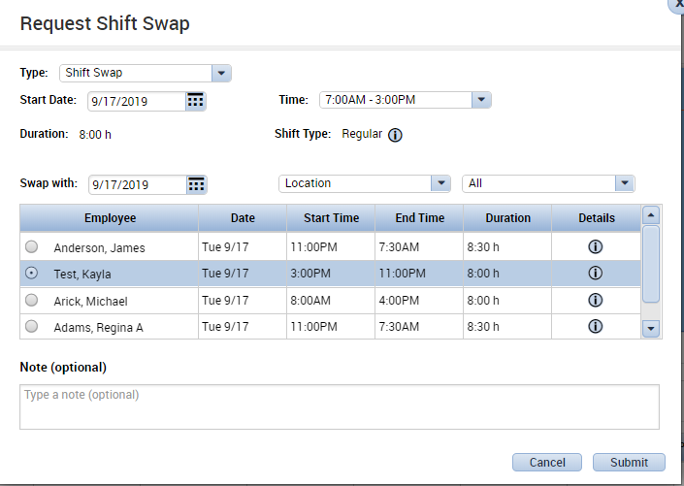
- The employee requesting the swap should select Request Shift Swap in the Calendar widget.
The Request Shift Swap window appears:
- Set the Start Date (day of shift to be swapped) and Time (time span of shift to be swapped).
If you select a Start Date where you do not have a schedule, the drop down in the Time field will be blank. Based on the date selected Start Date and the Swap With date, the list of available employees may change.
The list of available employees is typically made up of employees who have a similar job to the person requesting the swap. For instance, if the person requesting the swap is an RN, the list of
available employees will be other RNs.
- Select the employee who you would like to swap with. Type a note if needed. Click Submit when finished.
Note: The Swap With date does not have to be the same as the Start Date.
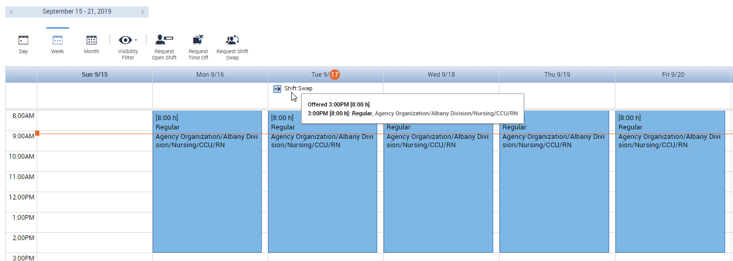
- The employee requesting to swap now sees Shift Swap appear on the Calendar widget. The schedule is not modified unless the swap is accepted. At this time, the employee could right click to cancel the request if they no longer need to swap.

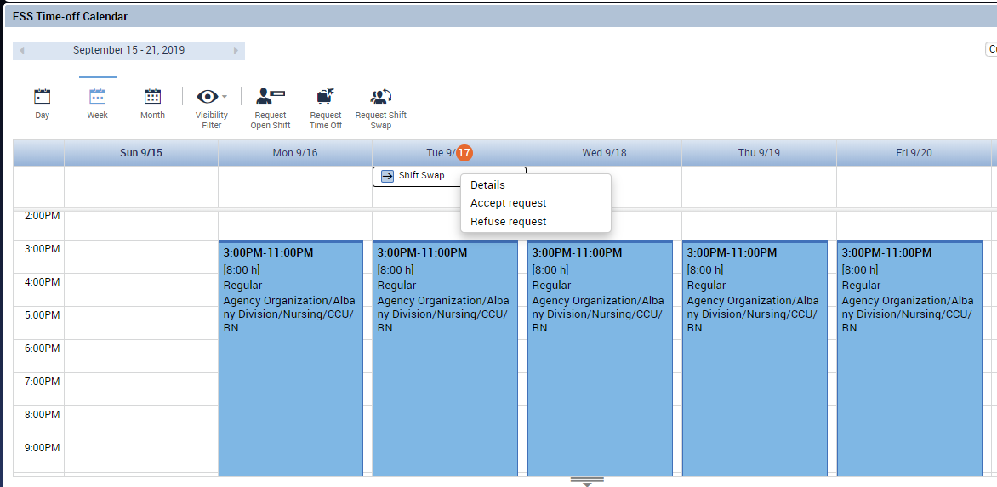
- Logging in as the employee who was offered the swap, we see that a Shift Swap has appeared on the day in the Calendar widget. If email notifications are activated in Kronos, this employee will also receive an email about the swap request. The employee who was offered the swap can right click on the swap to view details, accept, or decline the request.
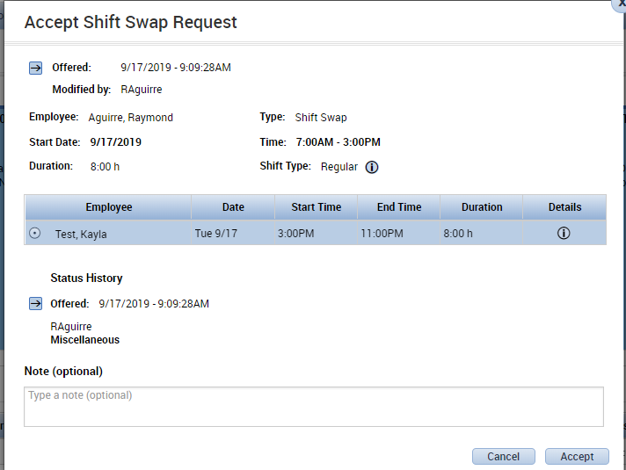
- Selecting Accept Request will display an additional screen of details:
- Finally, once the 2nd employee accepts the swap, it must be approved by the manager. The request for shift swap approval will appear in the manager’s Alerts and Request Widget. If email notifications are activated in Kronos, this employee will also receive an email about the swap request. In the Request Widget, the manager can select Approve to complete the swap. Once this is completed by the manager, the employees’ schedules will both be modified. The employees will also receive email notifications that the swap has been approved.
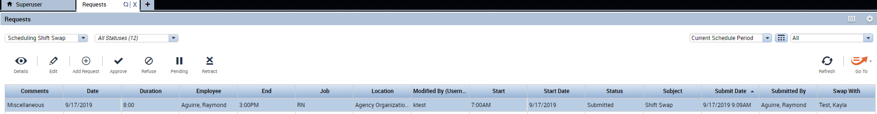
- The employee who requested the swap now has the afternoon shift on Tuesday:
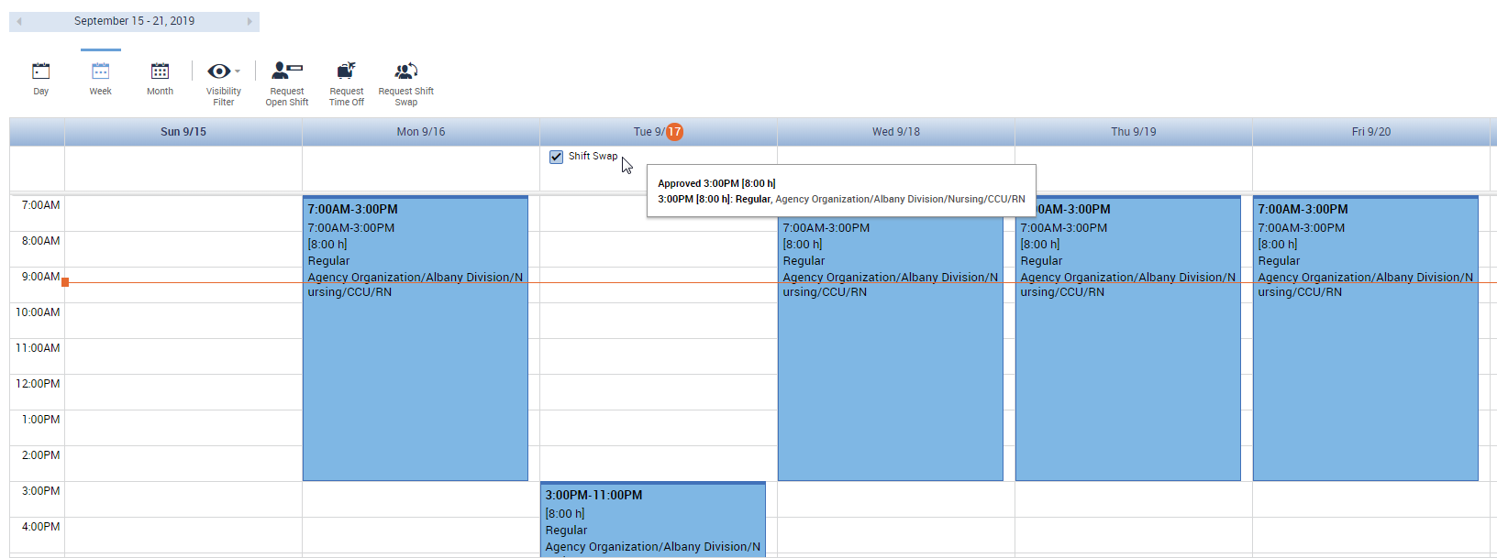
- The employee who accepted the swap now has the morning shift on Tuesday: 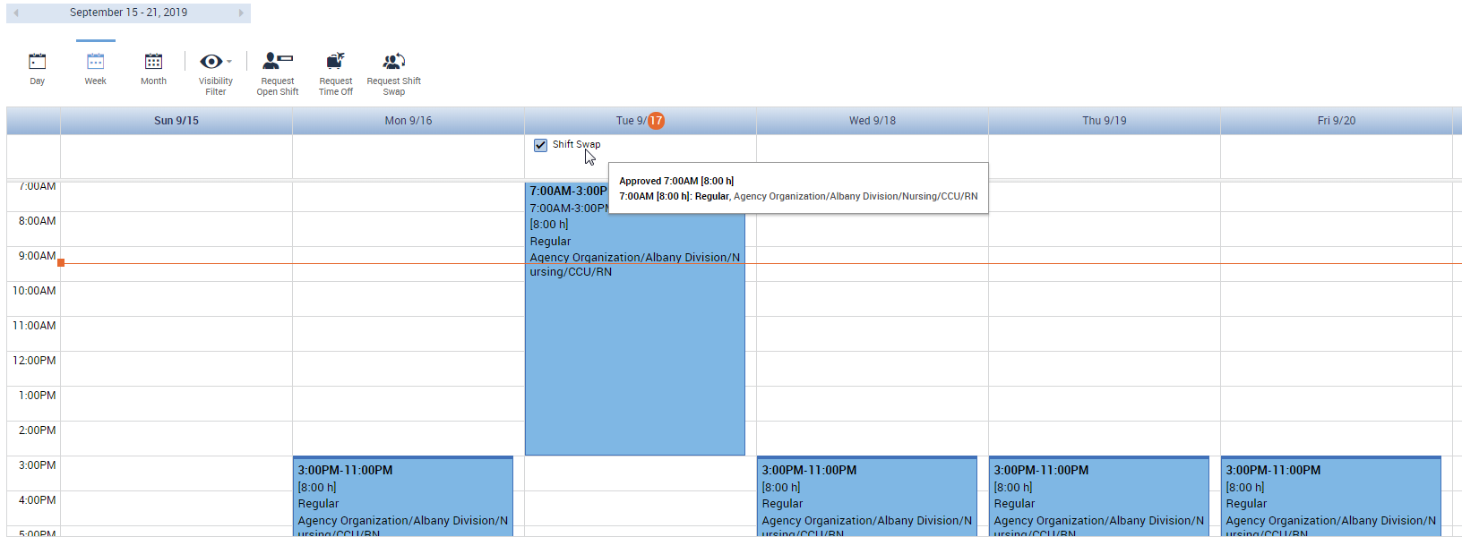
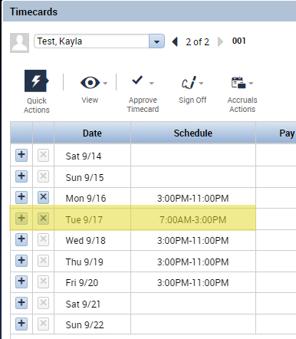
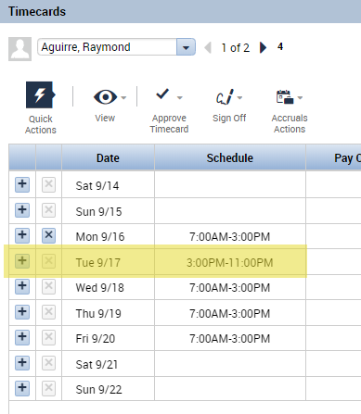
- This change is also reflected in both employees’ timecards.

