Request to Cover
  - kronos version 8.1

Contents
REQUEST TO COVER 3
Creating a Request to Cover 3

REQUEST TO COVER
If you are not able to work a shift, you can generate a Request to Cover, which is sent to available employees who can accept or refuse your request.
If you do not want to use time off (vacation, sick, etc.) and do not want to swap shifts with somebody, you can use the Request to Cover option. Requests to Cover must be approved by the manager.

Creating a Request to Cover
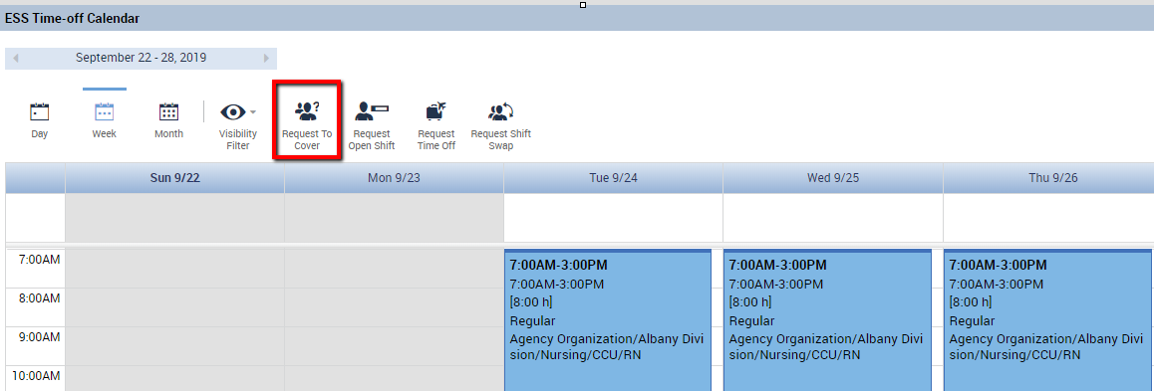
- The employee who cannot work uses the Request to Cover button to generate a new request. This is located in the My Calendar widget.

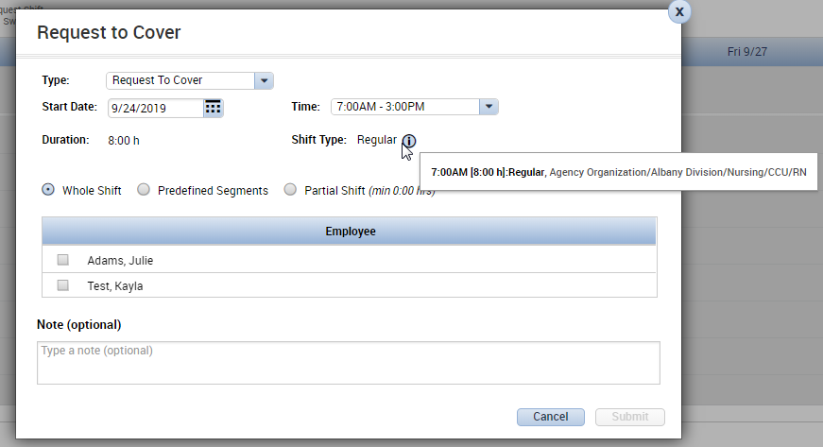
- Set the Start Date for the request. Depending on the organization’s setup, the employee may be able to request for part of a shift to be covered (select radio button for Partial Shift). Some organizations may only allow a Request to Cover for a full shift. Hover over the (i) icon to display the location and job that is being submitted for coverage.

- Select one or more of the displayed employees to send the request to. The employees who are displayed are qualified to work the job and are not already scheduled at the requested time. The request will go to the all the selected employees. Typically, the maximum number of employees that can be selected is three.
Type a note if needed, and click submit when finished.
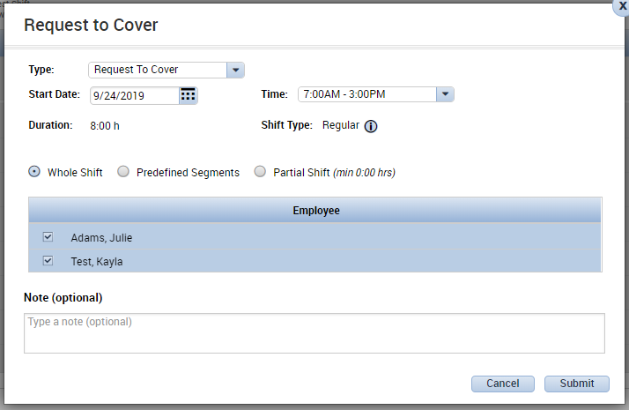
- The Request to Cover now appears in the employee’s calendar. The schedule is not modified yet. The employee could right click on the request to cancel if the coverage is no longer needed.
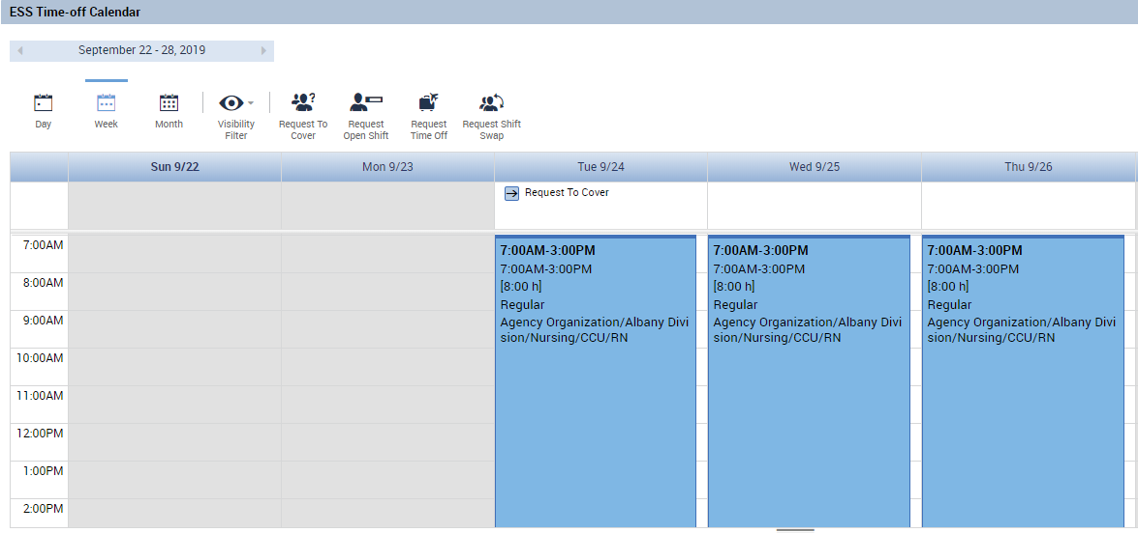

- An employee who receives the request will see the Request to Cover appear in the Calendar widget for the day of the shift. The employee can right click on the request to view details, accept the request, or refuse the request. 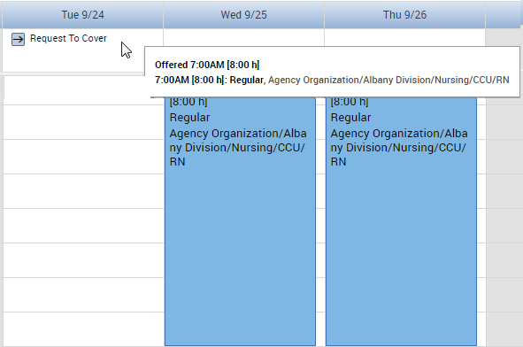
- The employee can accept the request. The schedule will not be modified until manager approval.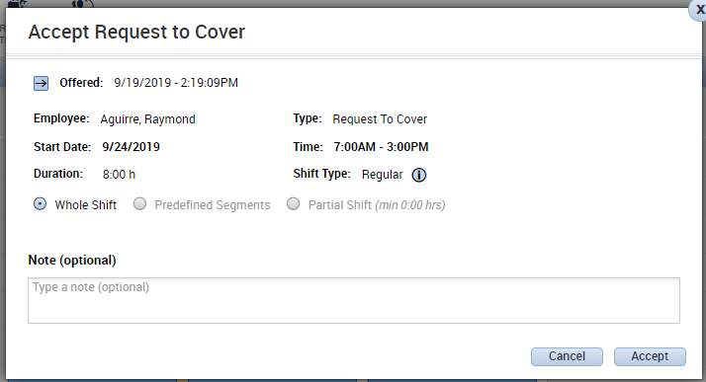

- Once an employee accepts the Request to Cover, the manager must also approve the request. If email notifications are enabled, the manager will get an email to approve this Request to Cover. The manager will also see a notification in their Requests Alerts.
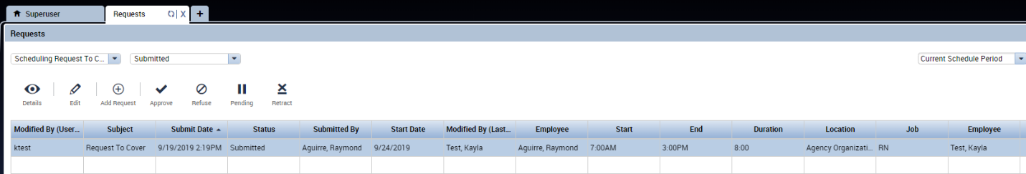

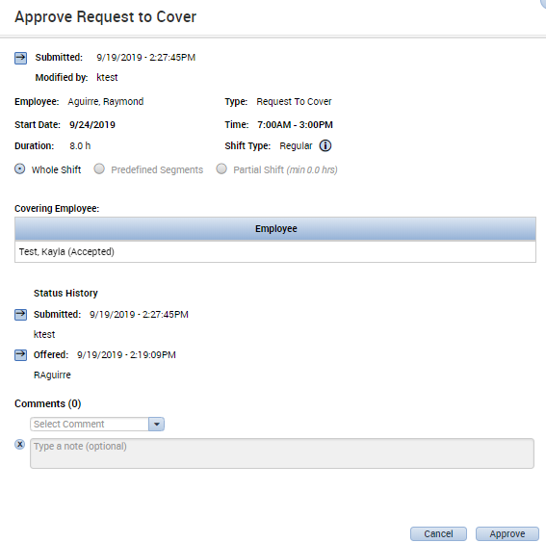

- Once the request is approved by the manager, the change will be reflected in both employees’ schedules. The employees will also receive email notifications (providing email notifications are set up). The first employee will no longer have a scheduled shift. This employee is not using any vacation or sick time, they are simply unscheduled and unpaid for this day.
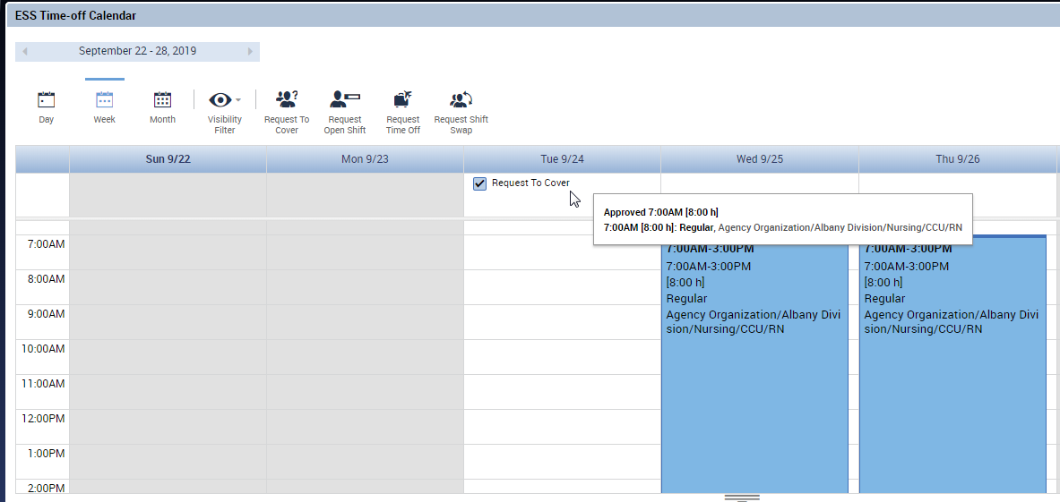
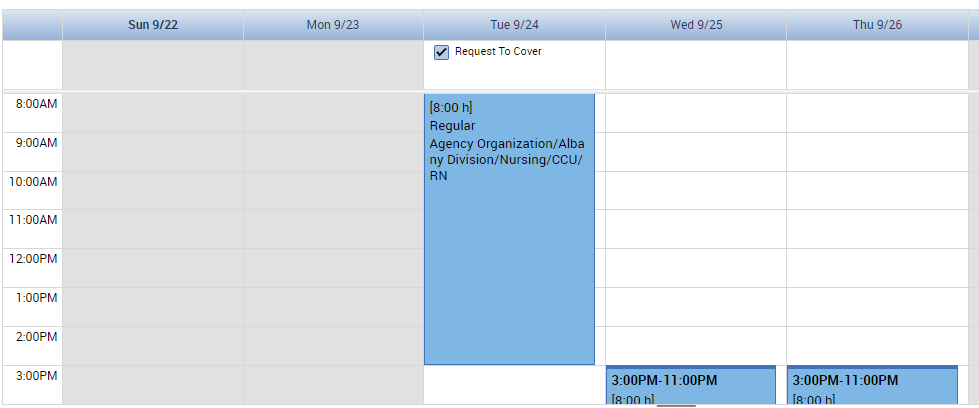
The second employee is now scheduled for the 7a-3p shift on that day.

The manager can also see this change reflected in both employees’s timecards and schedules.

