Reports
  - kronos version 8.1

Contents
REPORTS 3
Running Reports 3
Creating Favorite Reports 8
Scheduling Reports 9

REPORTS

Running Reports
- Reports can be accessed by opening the Reports widget from the drawer. 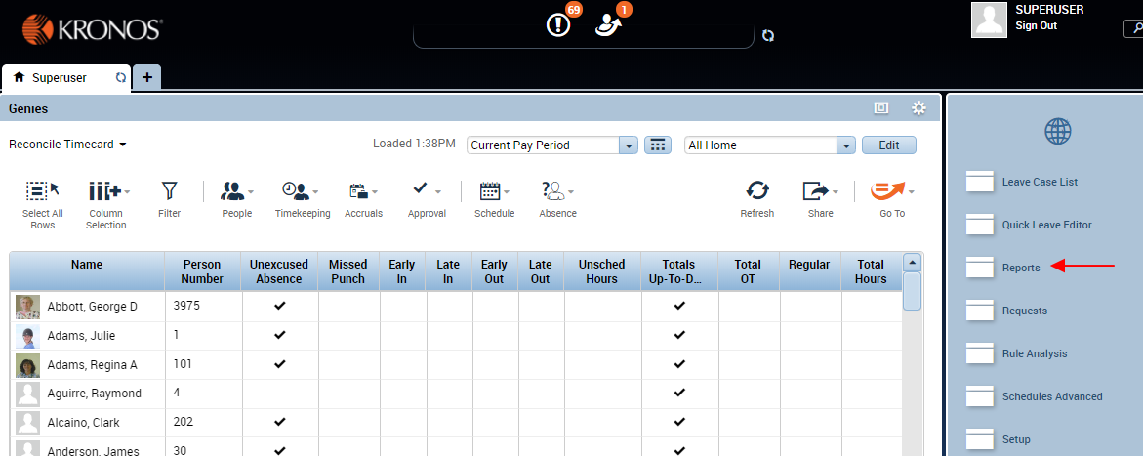
- Find the report you wish to run by clicking the + sign to expand the category. Expand the All category to see all available reports. 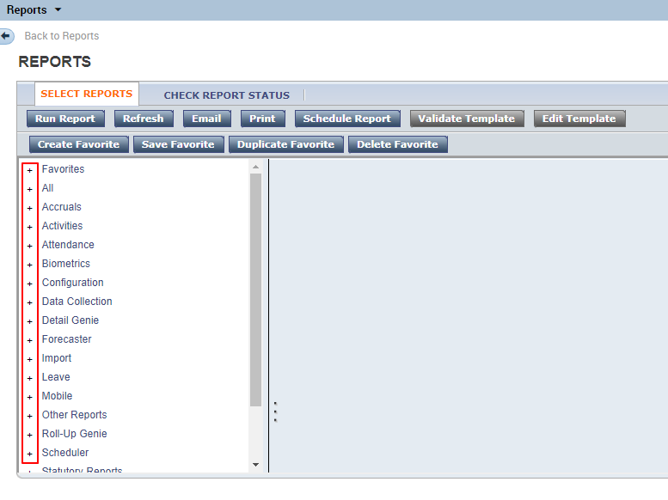
- Select a report from the left pane of the screen. The right pane shows a description of the report, as well as other choices that are specific to each report.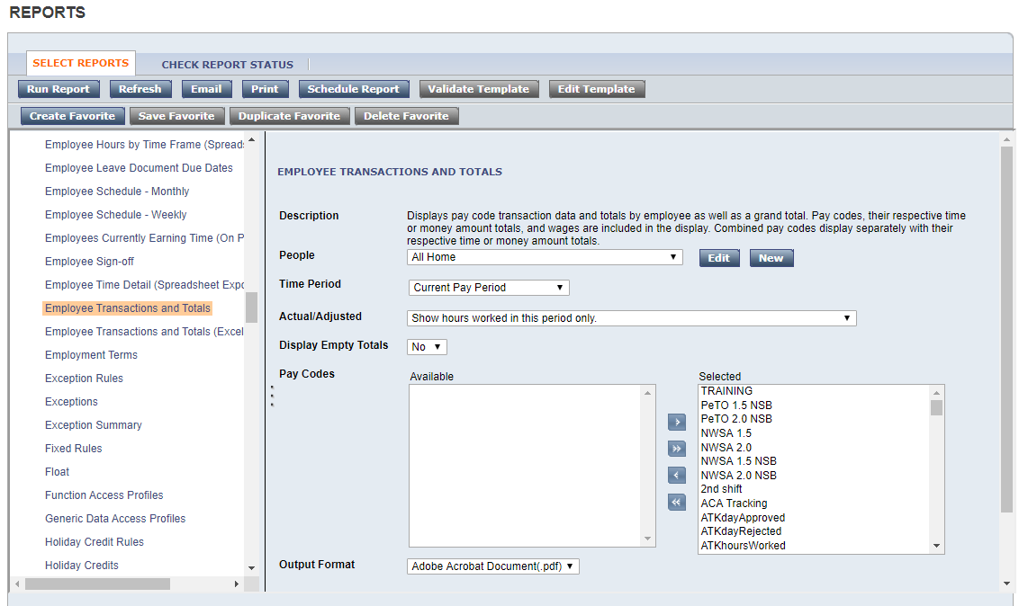
- Determine the employee who will show up in this report by selecting from the People dropdown. The choices that appear here are the hyperfinds that you have access to. 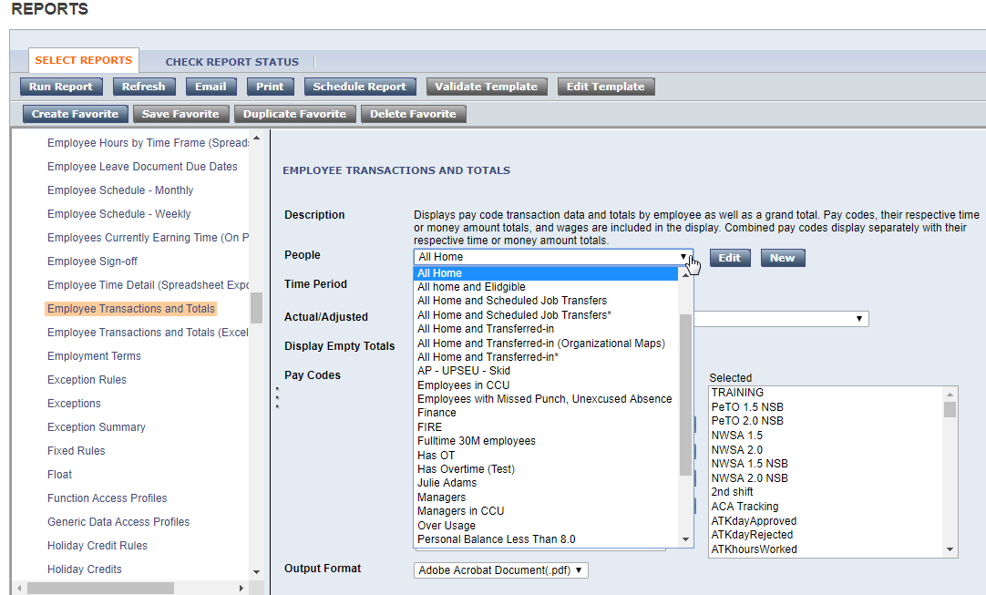
- To run a report on one person or a specific group of people, find the person or people in any genie. Select the person or people and use the Go To button to navigate to Reports. 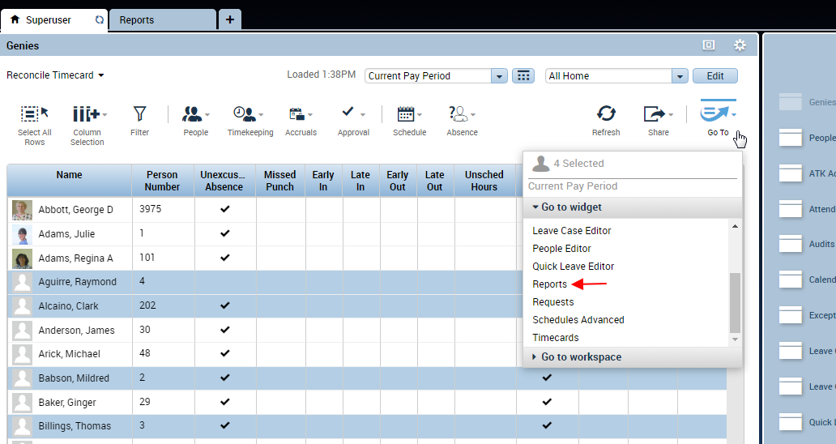
- The People field on the report screen now shows Previously Selected Employees(s). 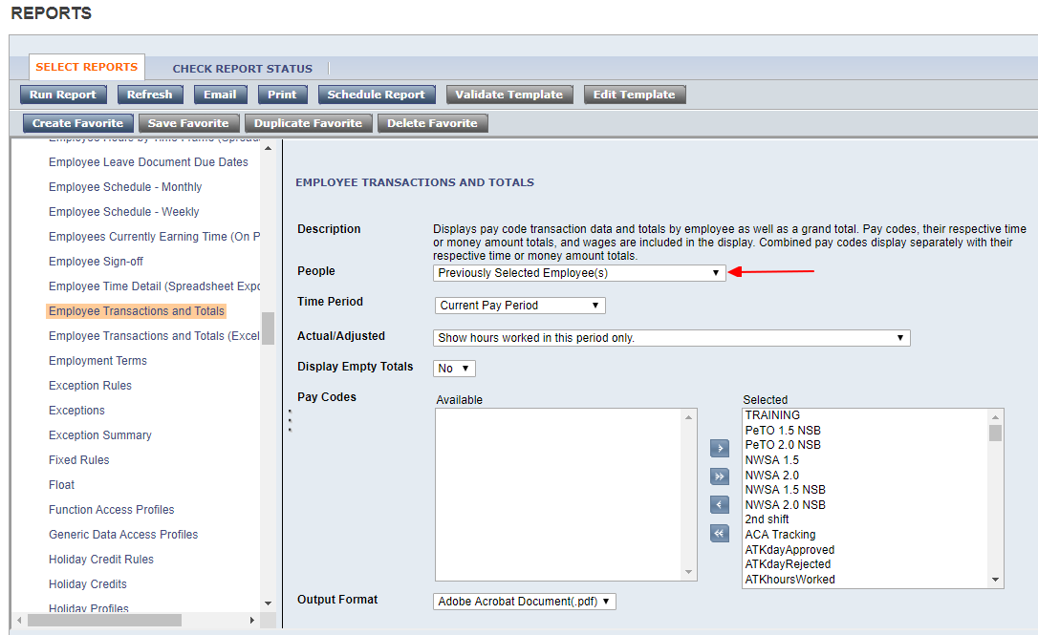
- Select the other report settings as needed. Each report has different settings, but most reports require setting the Time Period and the Output Format. To set a custom range of dates, choose Range of Dates from the Time Period dropdown.
Most reports are only available in PDF format. If a report has “(Excel)” or “(Spreadsheet Export)” in the name, you will still need to select Microsoft Excel Document from the Output Format dropdown. 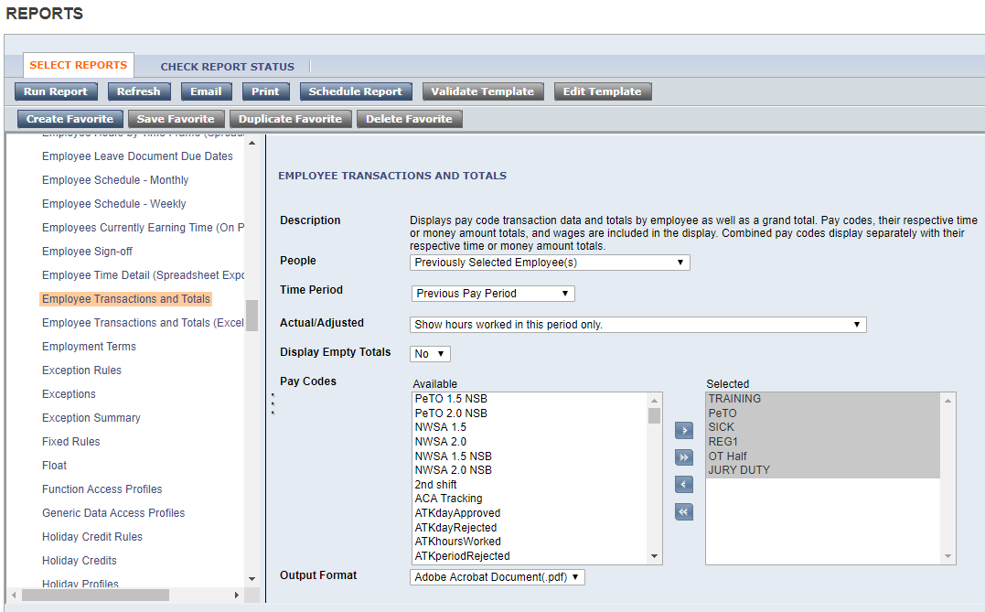

- When finished, click the Run Report button in the top left. 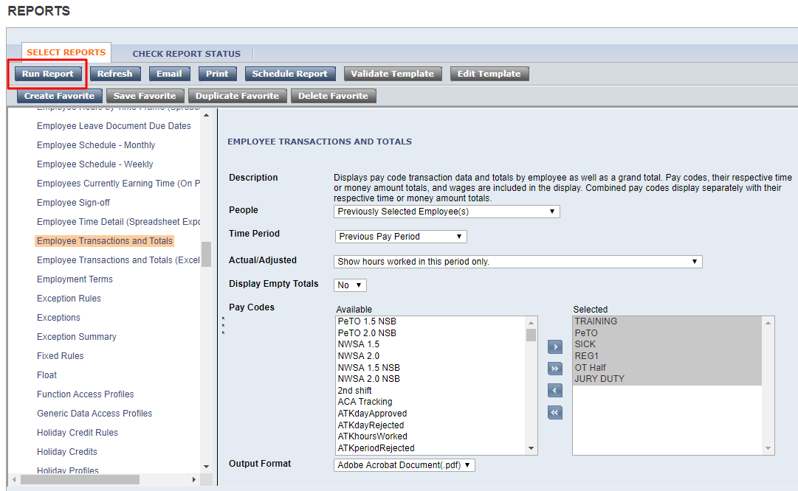
- The screen will switch to the Check Report Status tab. Click the Refresh Status button until the report status changes to Complete. 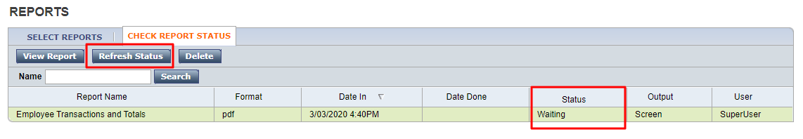
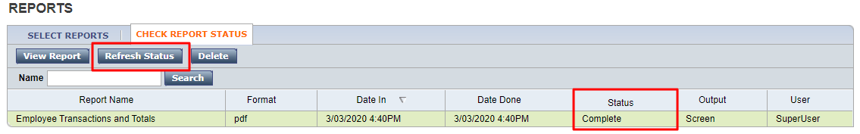
- Double-click on the report to open it. Or, use the View Report button. 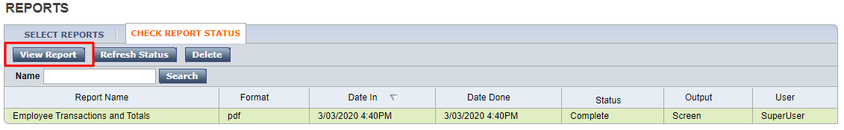
- The report will open as a PDF or Excel document, depending what choices were available for the Output Format.
- The report will stay visible on the Check Report Status screen for 3 days. The report can be opened again from this screen by using the View Report button or double-clicking. Keep in mind that this does not re-run the report. Opening a report again from this screen will not pull in any updated information. It will simply display the same exact report over again.
If you need to re-run the report, start over from the Select Reports tab.

Creating Favorite Reports
- When you have the report set the way you want, click the Create Favorite button at the top of the screen. In the Favorite Report field, type the name you wish to use to save this favorite report. When finished, click Save Favorite.
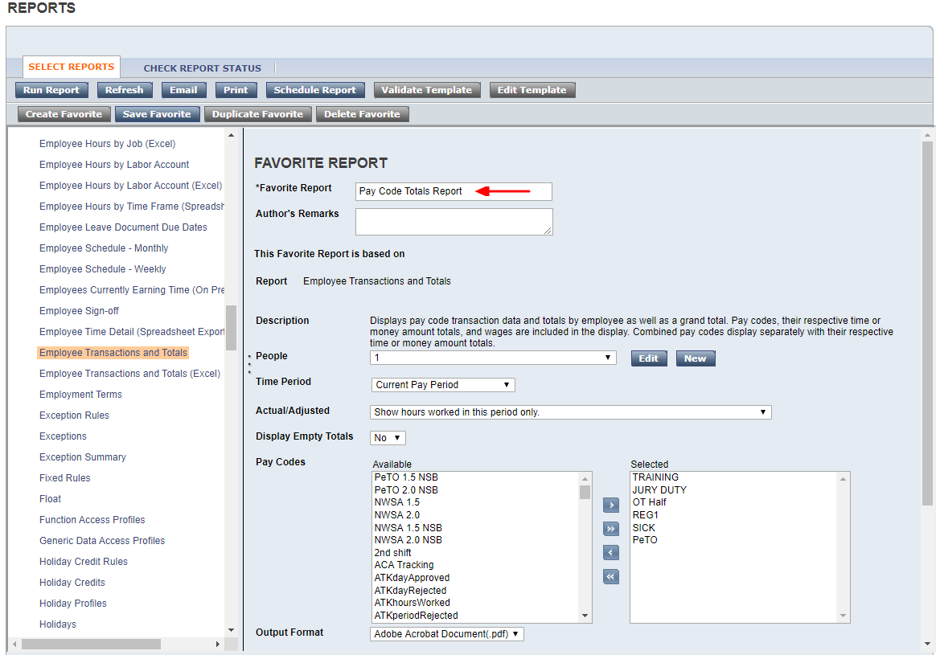
- The report now displays when expanding the Favorites section at the top of the list of reports.
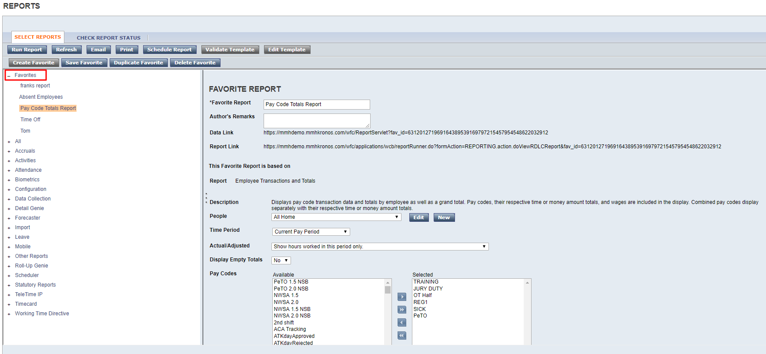

Scheduling Reports
- Reports can also be scheduled to run and even emailed to individuals. Select and set up a report, then use the Schedule Report button at the top.
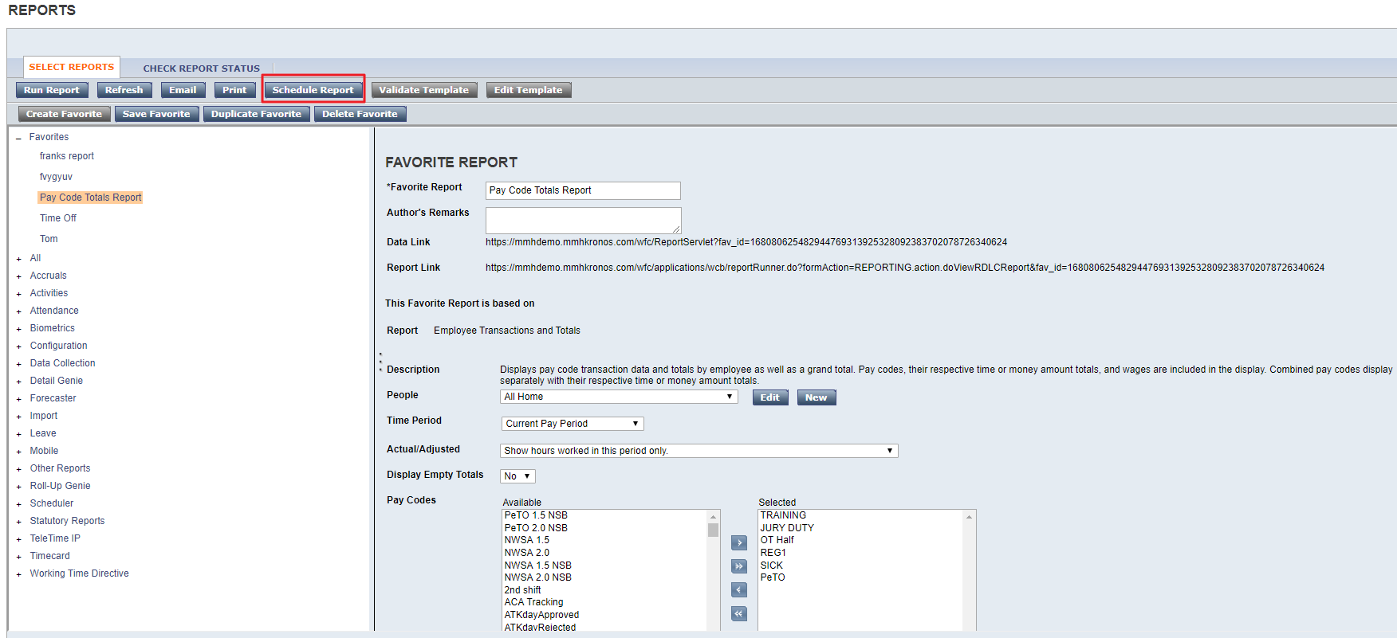
- Set up the Event Schedule and the Event Output. Save when finished.