Scheduling
  - kronos version 8.1

Contents
Scheduling in Workforce Timekeeper 3
Helpful Tools 4
Creating Shift Templates 4
Naming Shift Templates 6
Creating Pattern Templates 7
Creating and Editing Schedules 8
Assigning a Pattern Template to Employees in the Schedule Widget: 8
Group Schedules 9
Naming a Group Schedule 9
Assigning a Schedule to a Schedule Group 10
Assigning Employees to Group Schedules from the Schedule Widget 12
Important Information About Group Schedules 13
Creating Initial Employee Pattern 14
Anchor Dates 16
Changing Existing Employee Pattern 17
Making Temporary Changes to Employee Schedules 18
Schedule Quick Actions 20
Schedule Views 21
Tabular View 21
Gantt View 21
Comments 24
Additional Visibility Filter Preferences 27
Shift Duration vs. Shift Label 27
Pay Code Name vs. Pay Code Short Name 28
Sorting 29
Request Periods 30
Request Period Frequency 32
Schedule Indicators 33

Scheduling in Workforce Timekeeper
Employee schedules are administered in the Schedule widget.
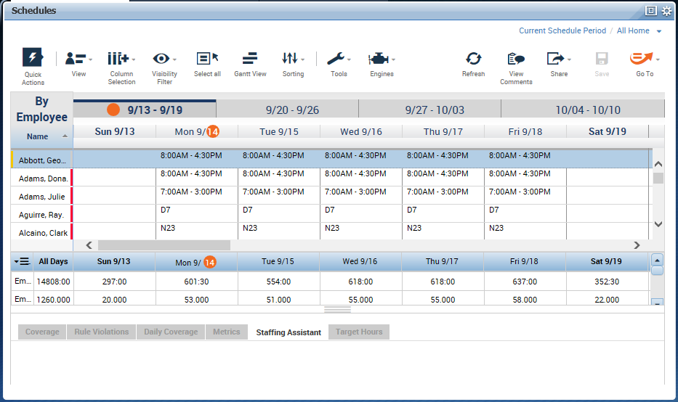
Access to scheduling features is controlled by the Function Access Profile assigned to each manager. Some of the functionality described in this guide may not be available to all managers depending on the privileges granted in their Function Access Profile.
Schedules are made up of three building blocks, some or all of which may be used in your company.
- Shift – A unit of time with a designated start and end (ex: 7a-3p)
- Pattern – A series of shifts over time (ex: 7a-3p Mon-Fri)
- Group – A way of classifying employees whose schedules are the same (e.g. First Shift, Second Shift, Third Shift)
Schedules can be assigned to employees in several different ways:
- Shifts can be manually assigned to an employee on a daily or weekly basis. This is rarely done, but may be useful in the case of part time or per diem employees.
- Schedule Patterns can be assigned to employees. Once assigned, the manager or scheduler needs only to adjust the schedule if the employee’s workday deviates from the schedule. For example, if one employee swaps shifts with another employee.
- Employees can be assigned to a Group Schedule. There are two types of Group Schedules: Inheritance and Non-inheritance. When an employee is assigned to an Inheritance Group, they automatically acquire the schedule pattern assigned to the Group. Non-inheritance Groups have no schedule pattern assigned to them. Employees assigned to a Non-Inheritance Group generally have their own individual schedule patterns.

Helpful Tools
Shift Templates – predefined shifts which can be used over and over for creating and modifying schedules
Pattern Templates – predefined patterns which can be assigned to individual employees and group schedules

Creating Shift Templates
Once built, the shift templates can be used as building blocks in the rest of configuration. Shift templates can be built into pattern templates or assigned to employees directly in the schedule planner. They can also be used to build schedule patterns for schedule groups. Creating shift templates helps to standardize shift naming.
- Go to Setup > Schedule Setup > Shift Templates. 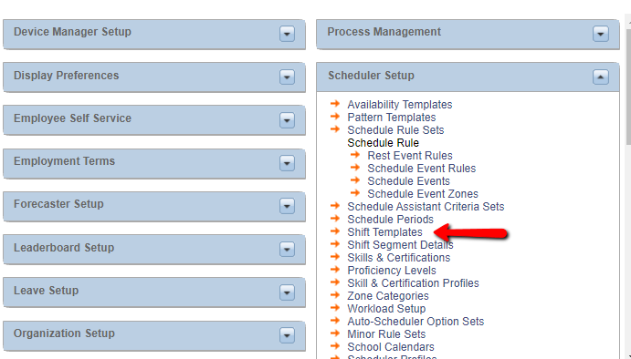
- Enter the name of the shift – be descriptive (e.g. “7a-5p”). See additional considerations on naming below (jump to section).
- Enter the start time of the shift in the Start Time cell.
- Enter the end time of the shift in the End Time cell. Note: If the end time occurs on a different day than the start time, change the Day column to “2” for the end time.
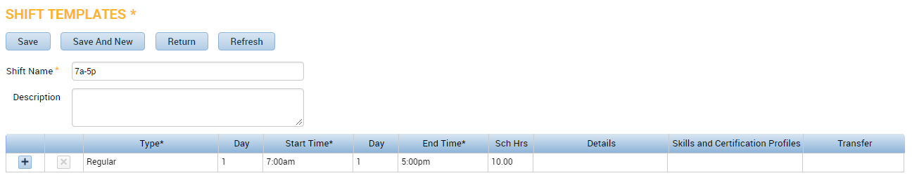

To include a break in the shift (such as a meal break), use the + icon to insert a row, change the Type column to “Break,” then enter the start and end times on that line in the appropriate cells.
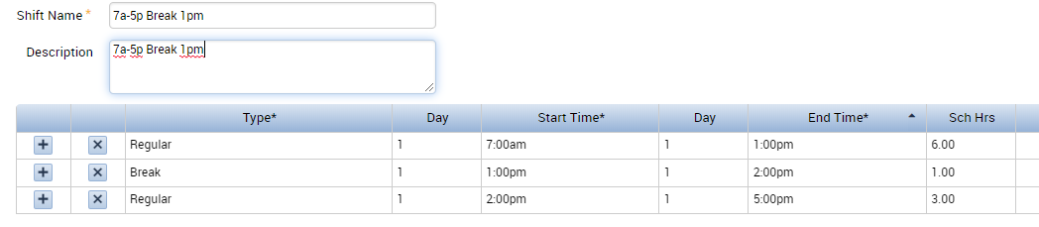

To include a transfer in the shift (such as when the employee works in a different department or job than his Home labor account), insert a row and change the Type column to “Transfer.” Enter the start and end times when the employee will work in this other department/job, then click into in the Transfer column.
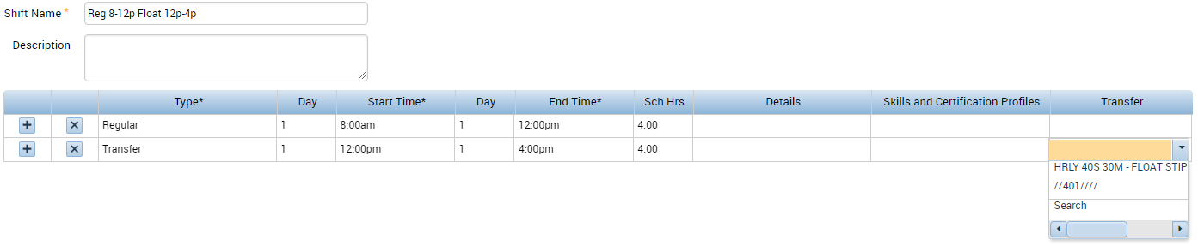
The drop down list will display recently-used items.
If the needed item is not listed, click Search to locate it:
Select the correct entry for the appropriate labor account. Or, move to the Work Rule tab to select a work rule transfer (such as On-Call).
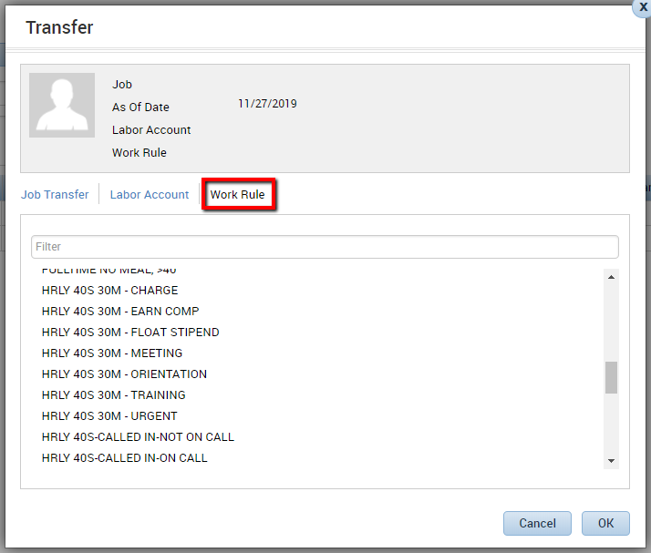
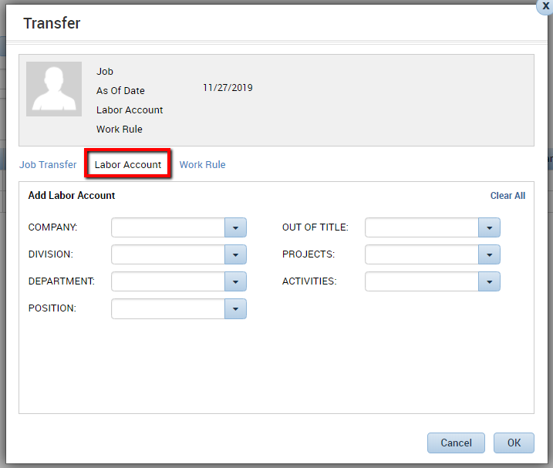

Click OK to apply to the timecard.
The selected Transfer now appears in the Transfer column of the shift.
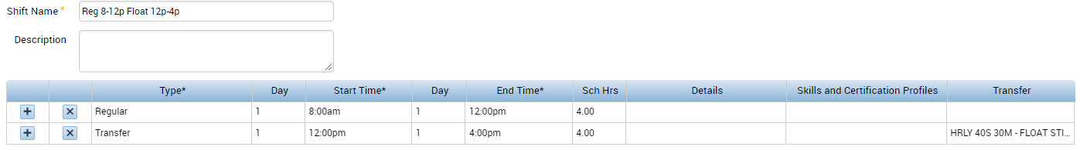
When finished creating a shift template, Save.

Naming Shift Templates
When naming shift templates, consider using a short name such as D7 for a Day Shift that starts at 7am, or N23 for a Night shift that starts at 2300h.
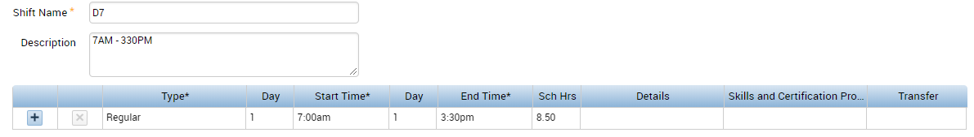
When making changes in the Schedule Editor you can type the name of that shift, instead of the duration, to make a quick change to an employee’s schedule.
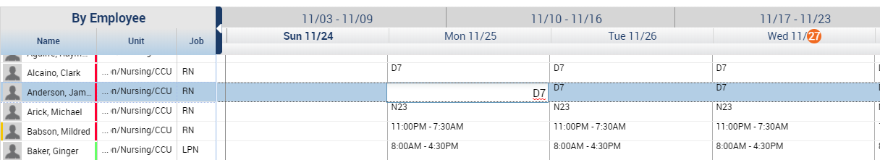

Additionally, when viewing the schedule over an extended time period, the shorter shift names can help as they display in an easier to read format. 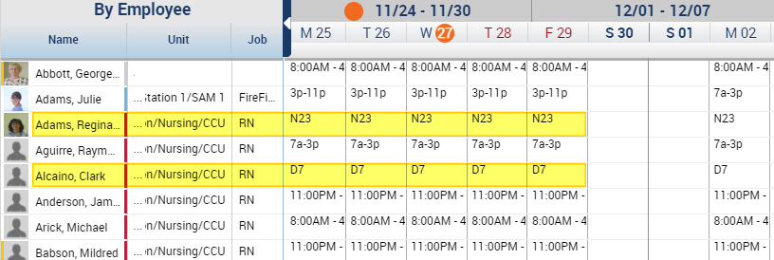

Creating Pattern Templates
Pattern templates are a predefined group of shifts in a designated order. Pattern templates can be assigned to group schedules. Or, they can be assigned to one or more employees at a time in the Schedule Planner.
- Go to Setup > Scheduler Setup > Pattern Templates 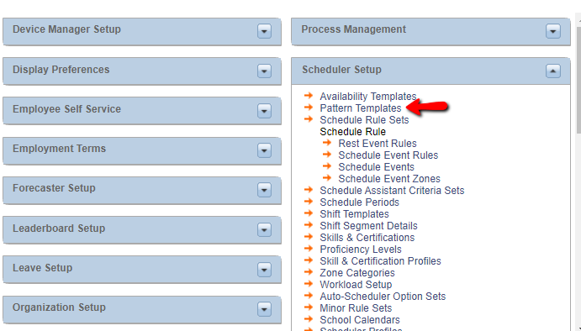
- Enter the name of the pattern – be descriptive (e.g. “7a-3p M-F”).
- Change the Recurring Weeks/Days number to reflect how often the pattern repeats. For example, a Monday through Friday schedule repeats every 1 week. An “every other weekend” pattern repeats every 2 weeks.
- Highlight the worked days in the pattern by clicking and dragging or using Ctrl/click on the appropriate days.
- There are two ways to add shifts to a Pattern Template:
  - To insert a predefined shift template, click the Insert Shift button, select the appropriate shift template, and then click OK. The highlighted days should now contain the shift you selected. 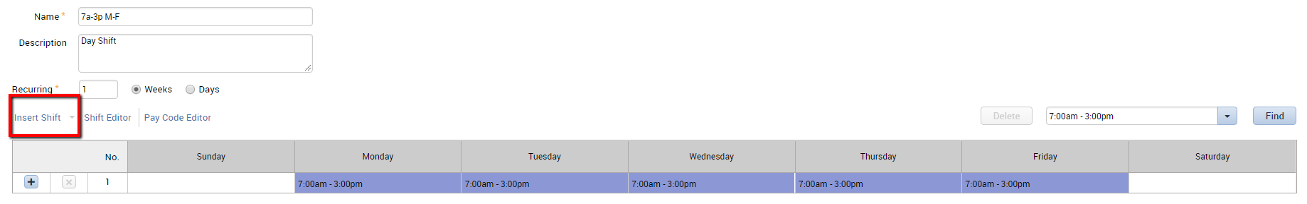
  - To type in the shift durations manually, click into each box. Or, use the Shift Editor button if you need to build in transfers or breaks.
- Repeat this process for all worked days in the pattern.
- When finished building the pattern, click Save.

Creating and Editing Schedules
Most scheduling functions are performed in the Schedule widget. Schedule edits can be applied to multiple employees simultaneously provided the same edit is being applied to each employee. For example, the same pattern can be assigned to multiple employees with one transaction.

Assigning a Pattern Template to Employees in the Schedule Widget:
- In the Schedule widget, right click on the employee name, then choose the Schedule Pattern.
- On the Schedule Pattern screen, click the Pattern Template ▼ button, select the appropriate pattern, and then click OK. 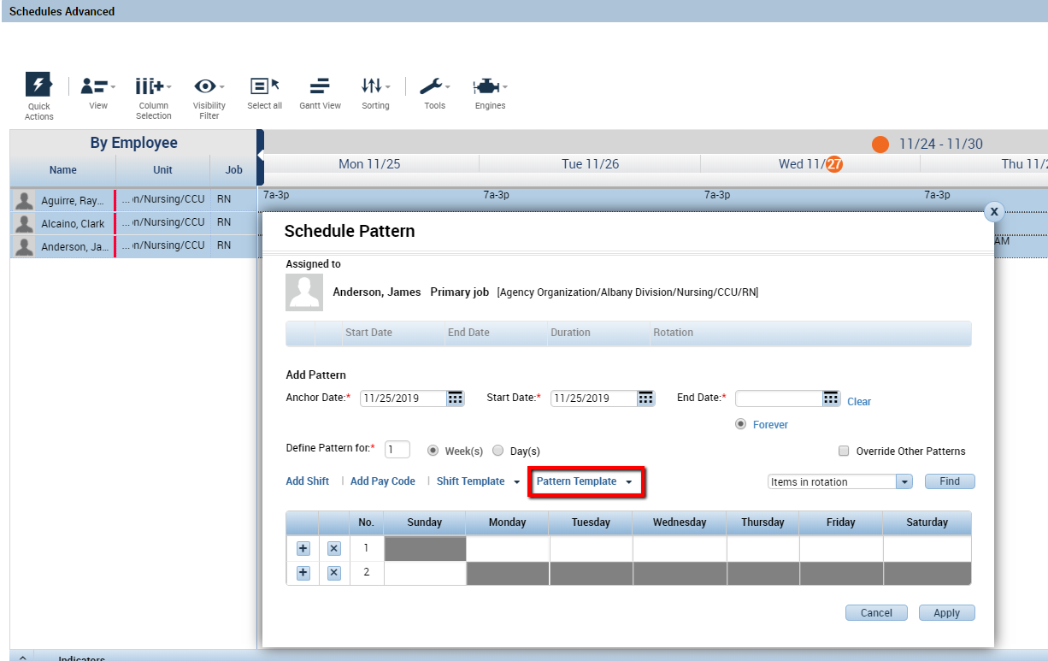
- Select the appropriate pattern from the pick list.
- Click OK.
- Enter the Work Start Date (Note: must be within the date range currently selected for the Schedule Editor Genie).
- Leave the Forever box checked or uncheck the Forever box and enter the End Date.
- If the employee has an existing pattern that you want to replace, check the Override Other Patterns box.
- Save.
Note: The Anchor Date is applicable only to rotating patterns (for example a pattern where every other weekend is scheduled). Typically, for a pattern that repeats every week, you do not have to change the Anchor Date from the default date.

Group Schedules
Group schedules are primarily used for classifying employees into standard shifts such as First Shift, Second Shift, and Third Shift. There are two types of group schedules, inheritance groups and non-inheritance groups. When employees are assigned to an inheritance group, they inherit the pattern that is assigned to the group schedule. Employees can be assigned to a group schedule from the Schedule widget. Employees can be a member of multiple group schedules, but can only be assigned to one inheritance group.
To create a Group Schedule, access Setup to name the new group. Later, access the Schedule Widget to associate shifts with the schedule.

Naming a Group Schedule
- Go to Setup > Scheduler Setup > Schedule Groups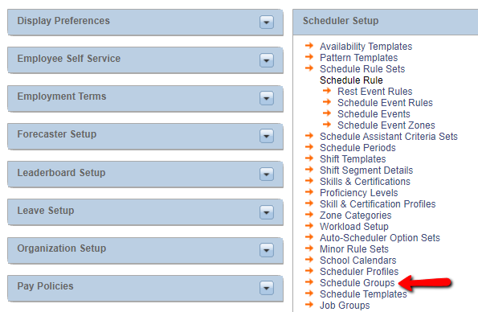
- Click New.
- Enter the Group Name.
- Check the Allow Schedule Inheritance box if you want employees to inherit their schedule when assigned to the group.
- Save & Return.
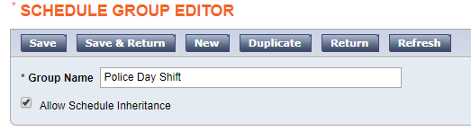
Best Practices: It is recommended that you check the Allow Schedule Inheritance box.

Assigning a Schedule to a Schedule Group
After naming the schedule group in setup, navigate to the Schedule Widget. This is where to associate the time frame and duration of the schedule with the new schedule group.
- Click the View button (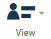) in the Schedule widget, then select By Schedule Group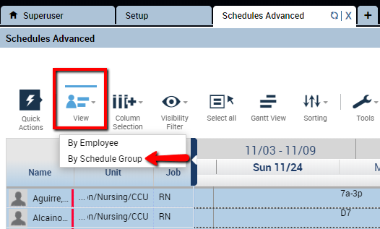
- Click the Load Group button (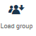), select the appropriate Group, then click Apply. 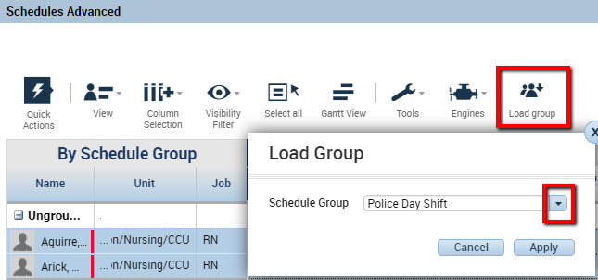
- Find the selected Group in the schedule, right click and select Schedule Pattern. 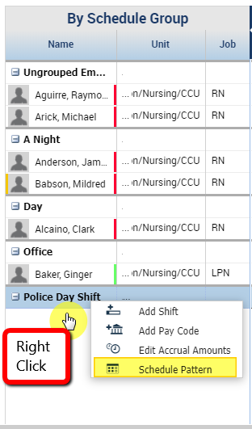
- On the Schedule Pattern screen, enter the Start Date.
- Leave the Forever box checked or uncheck the Forever box and enter the End Date.
- If the Group already has an existing pattern that you want to replace, click the Override Other Patterns box.
- There are several ways to add in the shifts that make up this schedule:
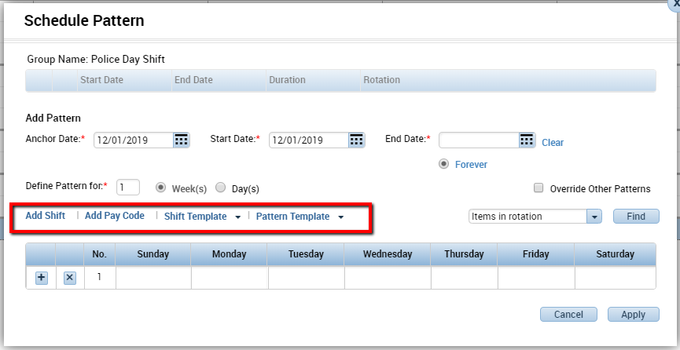
  - click the Pattern Template ▼ button, select the appropriate pattern, and then click OK
  - click on a day, click the Shift Template▼ button, select the appropriate shift, then click OK
  - click on a day, click the Add Shift button, and build a new shift
  - click on a day and type the duration of the shift into the cell (ex.: 7a-2p).
- When finished, click Apply.
- Review the summary screen. If you need to make any additional changes to the pattern, use the pencil icon. Click OK.
- Save.

Assigning Employees to Group Schedules from the Schedule Widget
- Click the View button () in the Schedule widget, then select By Schedule Group
- Right click the employee’s name. Select Add to Group. If you are adding multiple employees to the same group, you can add them all the same time. Hold the CTRL key and click each employee’s name to select multiple people at once. 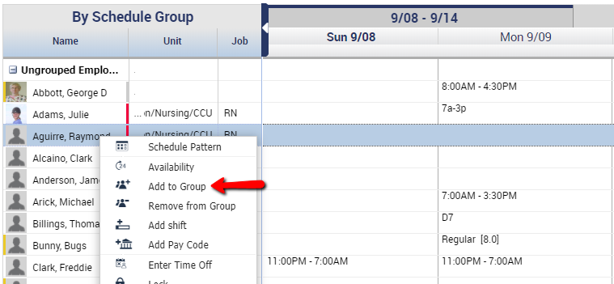
- Select the appropriate Group from the pick list.
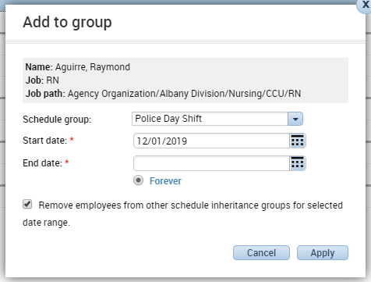
- Enter the Start Date and End Date (or Forever).
- If the employee is currently assigned to another inheritance group, check the box for “Remove employees from other inheritance groups for selected date range.” Click Apply when finished.
- Now that the employee is assigned to that group, the employee will have the schedule that is associated with that group (provided the group is set up for schedule inheritance).

Important Information About Group Schedules
- Employees can be assigned to more than one group. This is not recommended. When switching an employee to a new group, the best practice is to remove them from their previous group.
- Non-inheritance group schedules do not have patterns associated with them. Patterns can be assigned to employees whether they are in a schedule group or not.
- Use the Schedule Group Multi-line Genie to see what group(s) employees are assigned.

Creating Initial Employee Pattern
If an employee does not fit into an existing schedule group, you can still assign a pattern to that person.
- In the Schedule widget, right click on the employee’s name and select Schedule Pattern.
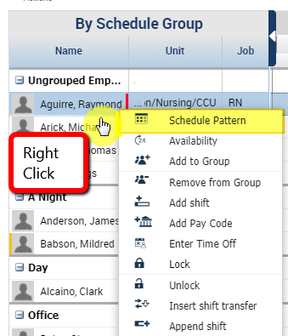
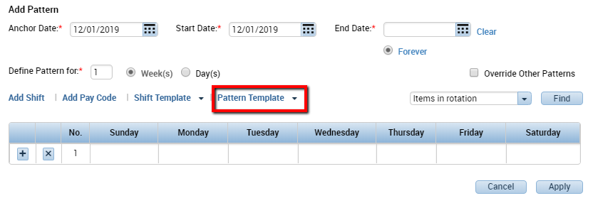
If the employee’s schedule matches an existing Pattern Template, use the Pattern Template ▼ button to choose from a predefined pattern template.
If the employee’s schedule does not match with a pre-existing schedule group or pattern template:
- In the Schedule widget, right click on the employee’s name and select Schedule Pattern.
- In the Schedule Pattern screen, change the “Define Pattern for” number to reflect how often the pattern repeats. For example, a Monday through Friday schedule repeats every 1 week. An “every other weekend” pattern repeats every 2 weeks.
- To enter the duration of the shifts:
  - Type the shift into each day (ex. 7a-2p). Or:
  - Highlight the days in the pattern that the employee works the same shift. Hold the Ctrl key down to select multiple days.
  - Click the Add Shift button.
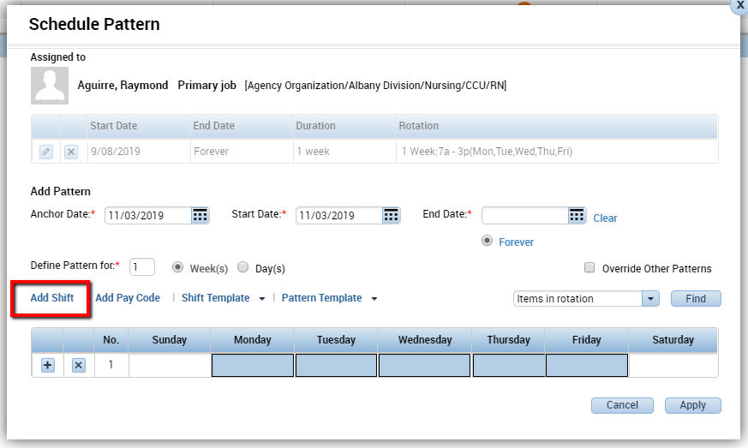
  - Enter the Start and End times for the shift. Remember that this is only for the days that are highlighted on the previous screen. 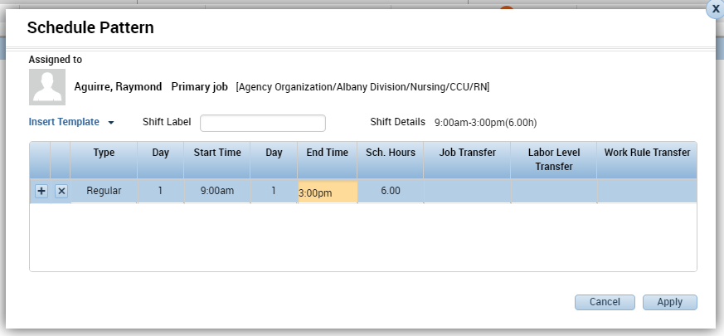
  - Click OK. The highlighted days should now have shifts in them: 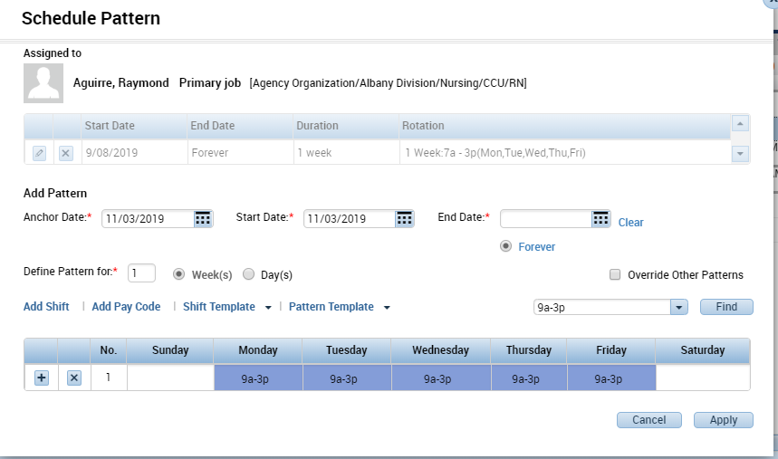
- Repeat this process if the employee works other shifts on different days of the week until all worked days have been accounted for.
- Enter the Start Date that the employee begins this new pattern. The Start Date defines the first day the employee will work. The Anchor Date defines the first day of the pattern. For a weekly pattern, these are usually the same date.
- Leave the Forever box checked for the End Date.
- Click OK. You should now see the pattern assigned to the employee in the Schedule widget. Refresh if needed.
- Save.

Anchor Dates
The Start Date may be different from the Anchor Date if the employee is not starting on Day 1 of the pattern.
► In this example, an employee will have a schedule where he works 4 days on and 3 days off.
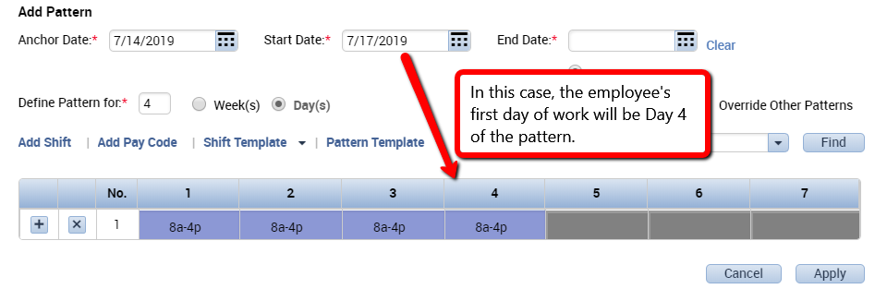

Changing Existing Employee Pattern
If an employee already has an existing pattern with an end date of Forever, it is possible to assign them a new pattern without deleting their existing pattern.
- Right click on the Employee name and choose Schedule Pattern. You should see a window with a summary of the existing pattern. Do not modify the existing pattern. Instead, select Add Pattern in the lower left corner.
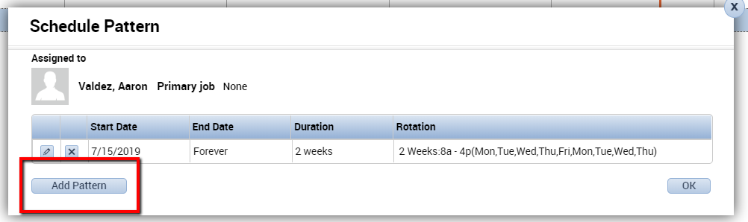

- Add the new pattern and choose the start date that the employee will begin the new pattern. Check the box next to Override Other Patterns.
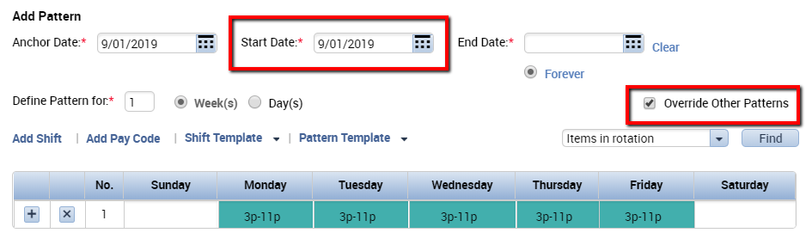
► Note: Selecting Override Other Patterns will cause warning messages to appear:
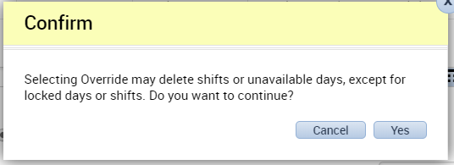

- Click Apply and click Yes to continue through the warning messages.
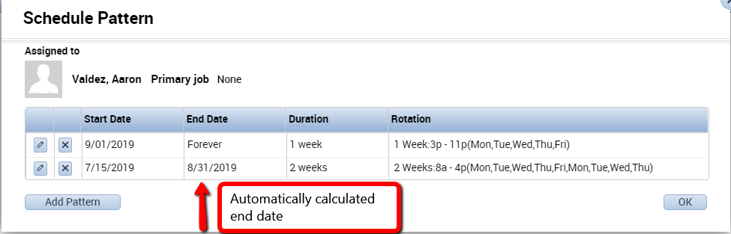
- Notice that Kronos will automatically calculate the end date of the previous pattern. This is based on the start date you entered for the new pattern.
- Click OK to apply the new pattern.
- Save.

Making Temporary Changes to Employee Schedules
If an employee works something other than his or her normal schedule on a given day, you can make temporary changes that will not become part of the permanent schedule. For example, an employee who normally works 8:00am to 4:30pm Mon-Fri may be asked to work 10:00am to 6:30pm on a given day. The manager can change the employee’s schedule for that one day using one of three methods:
- In Cell Editing – In Cell Editing can only be done in tabular view. The tabular view displays the weeks in tabs across the top and the schedule duration in a spreadsheet-like format as shown here: 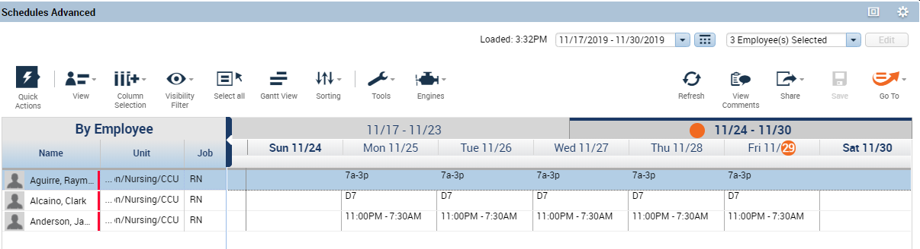 To make a temporary change with In Cell Editing, simply click the cell for the day in question, delete the existing schedule, and type the new shift into the cell using the following format: 1030a-630p.
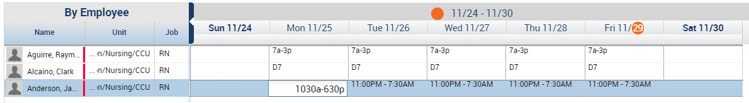
After making the needed changes, click Save.
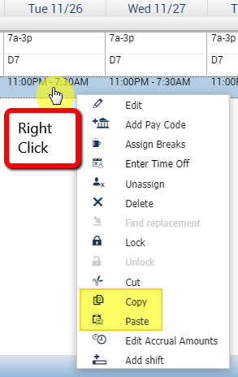
- Copy/Paste – click on a cell from another employee which matches the shift start and stop times that you want, hit Ctrl+C on your keyboard to copy the shift to the Clipboard, then click on the appropriate cell for your employee and hit Ctrl+V to paste the shift to the new cell. You can also use Ctrl+X then Ctrl+V to cut and paste shifts.
You can also right-click and choose Copy or Paste
from the pop-up menu.
- Insert Shift Template – right click on the cell for the day in question and choose Add Shift from the dialog box. Click the Insert Template button that matches the start and stop times for the employee’s temporary shift and click OK. This feature is particularly useful for inserting shift templates which are already configured with transfers to other departments or jobs.
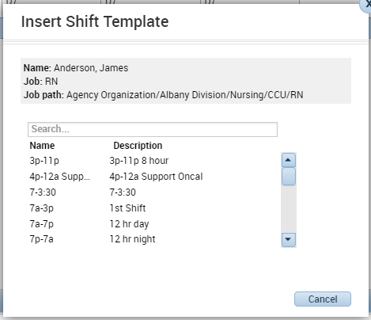
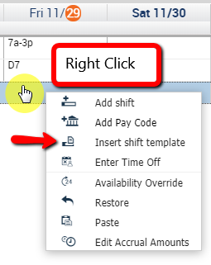

Schedule Quick Actions
The Quick Actions button in Schedules opens a new set of icons that can be used to quickly modify the schedule.
The Quick Actions icon is in the top left corner of the Schedule widget:
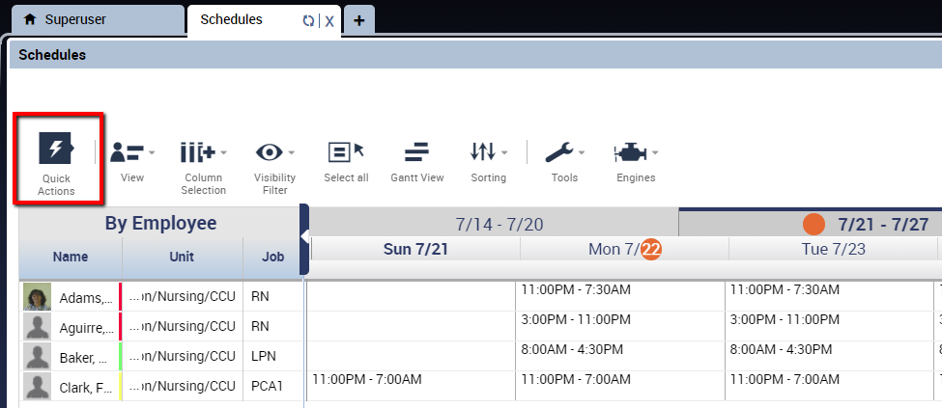
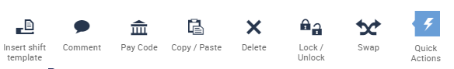
Clicking the Quick Actions icon opens a new tray of Quick Actions:

Click the Quick Actions icon again to close the tray.

The options you have available as Quick Actions will be determined by your system administrator, but here are some of the most common:
Insert Shift Template: Select a pre-defined shift and select the employee and date to assign.
Comment: Add a comment to a shift.
Pay Code: Select a pay code and then select a shift, the pay code will replace the scheduled shift for the number of hours.
Copy/Paste: Select to copy and paste.
Delete: Delete schedule items (shifts, pay codes).
Swap: Choose two employees’ shifts to swap.
Once you select an action, directions will appear in a blue bar. Here, Copy/Paste is selected: 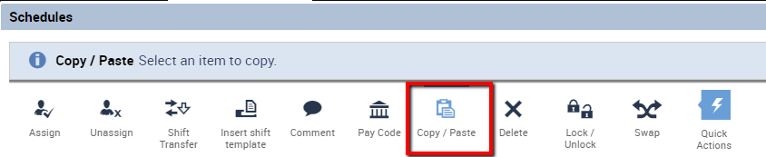

Schedule Views
Employee Schedules can be viewed in either the Tabular View or the Gantt View. The button to switch between views is located at the top of the widget, as shown below:
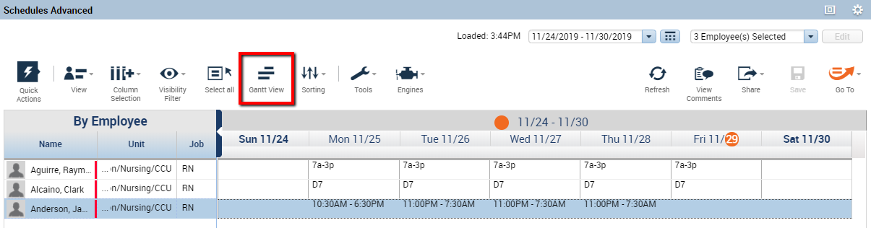
Whichever view you are currently using, the same icon will give you the option to switch to the alternate view.

Tabular View
Tabular View displays the schedule in cells:
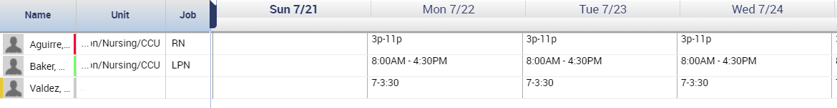
When in Tabular View, click this icon to switch to Gantt View:

Gantt View
Gantt View displays the schedules in bubbles. This visual representation can be used to show gaps or overlap in coverage:
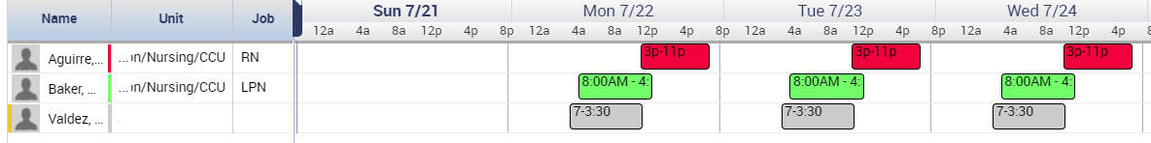

In Gantt View, the scheduled time can be lengthened or shortened by dragging the boundary of the bubble to the left or right.

In Gantt view, the worked shifts typically display in blue and any time allocated to pay codes (ex. Jury Duty, Bereavement, PTO) will display in green:
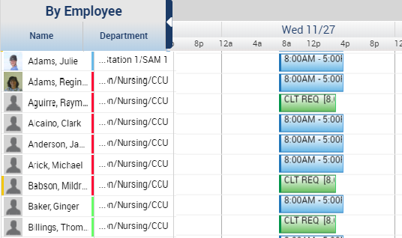
This can provide a quick way to visualize which members of your team will or will not be present on a given day.
To see only employees who will not be present, use the Visibility Filter icon and deselect the checkbox for Assigned Shifts.

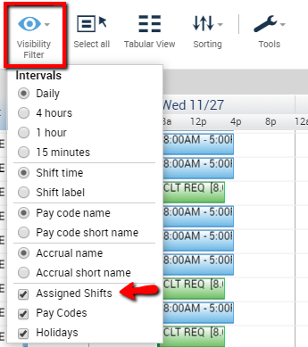

Now, only the time for pay codes will be displayed.
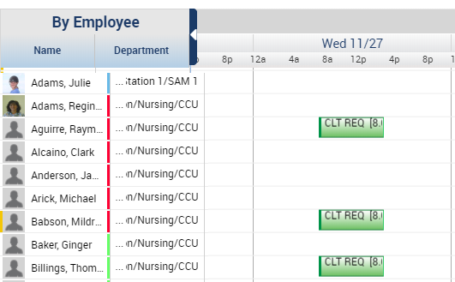

In Gantt View, there is also an option to view the day broken down into smaller intervals. Use the Visibility Filter icon and select either Daily, 4 hours, 1 hour, or 15 minutes.
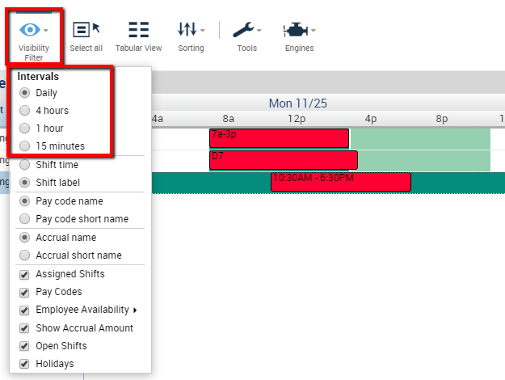

Here, selecting 1 hour shows the day with a dividing gridline representing each hour:
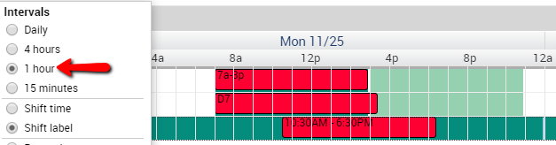
This can be help when looking for overlap in coverage, gaps in coverage, or ensuring the correct start for staggered shifts.
When in Gantt View, click this icon to switch to Tabular View:

Comments
Adding comments to a schedule can be a useful communication tool for managers.
- Right click on a shift and choose Edit.
- In the comment section, select a comment and type an additional note if needed.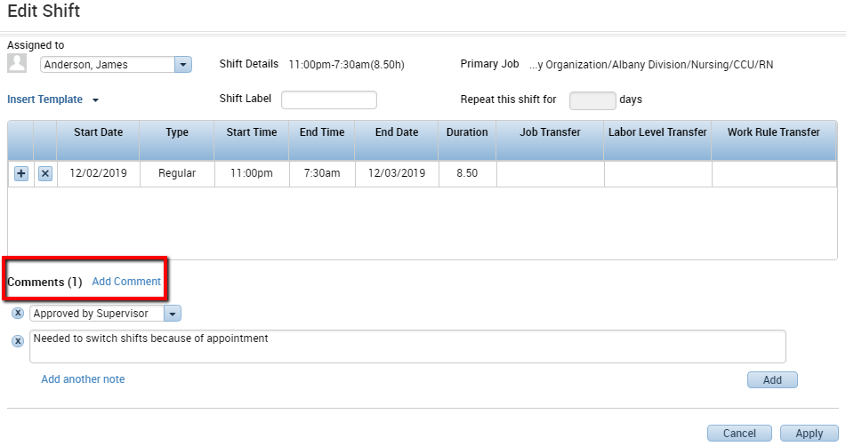
- Click Apply when finished.
- When a comment is attached to a shift, “(c)” appears after the shift duration: 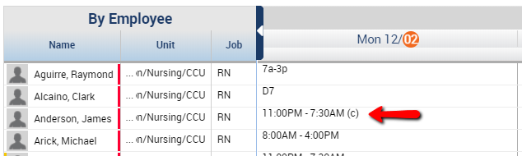
- For a quick view, hover over the shift to display the comment.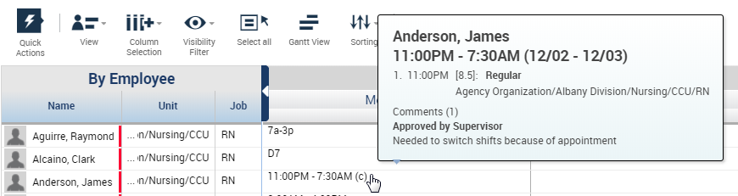
- To view all comments in the time period, choose the View Comments icon in the top right corner of the widget. 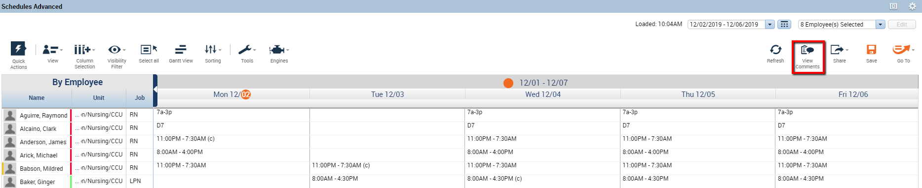
This will pop up an additional screen that displays all of the comments applied for the period you have selected. Hover over the Note to display the full text of the note as well as the user who created it. Click OK to close this window.
.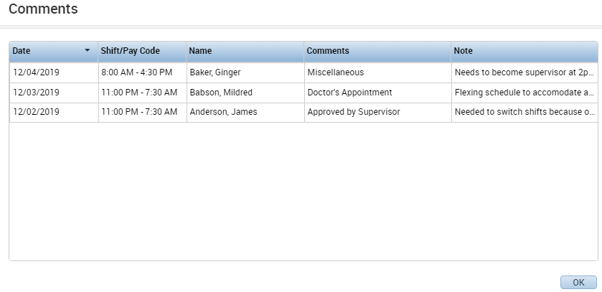
Any managers who have access to the same employees will all be able to see the same comments. This makes comments a useful method of communication between managers to explain schedule changes or other day-to-day changes.

Additional Visibility Filter Preferences
The Visibility Filter icon provides a few other options to customize your view. 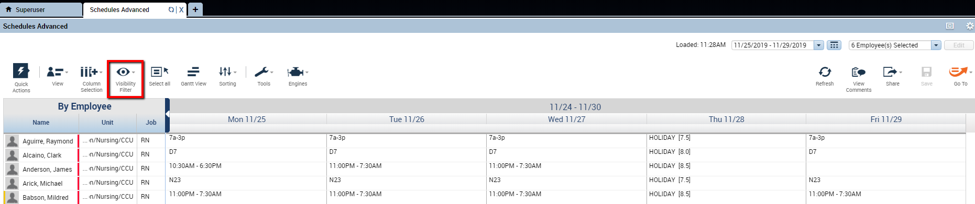

Shift Duration vs. Shift Label
One option within the Visibility Filter is to display the shift time either by duration or by label. 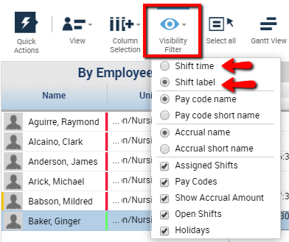
Choosing Shift Time will display all shifts with the duration of the shifts. 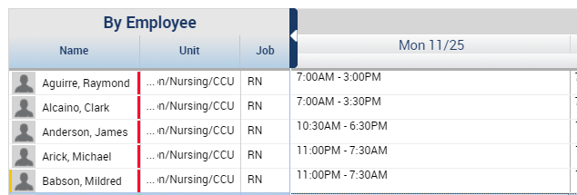
Choosing Shift Label will display the label of the Shift Template name for any shifts that are built from a template. Naming Shift Templates is mentioned previously in this guide.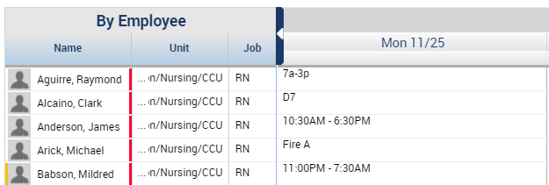

Pay Code Name vs. Pay Code Short Name
The Visibility Filter also give the option to display pay codes by name or by short name.
Choosing Pay Code Name will display any pay codes with the full name of the pay code. 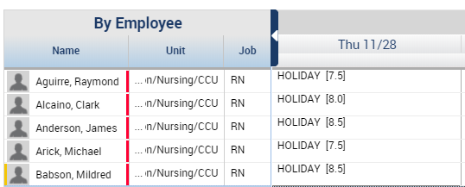

Choosing Pay Code Short Name will display the 3-character short name for the pay code. 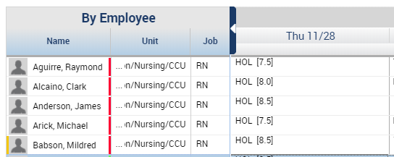

Sorting
Use the Sorting icon to sort the schedules in different ways. 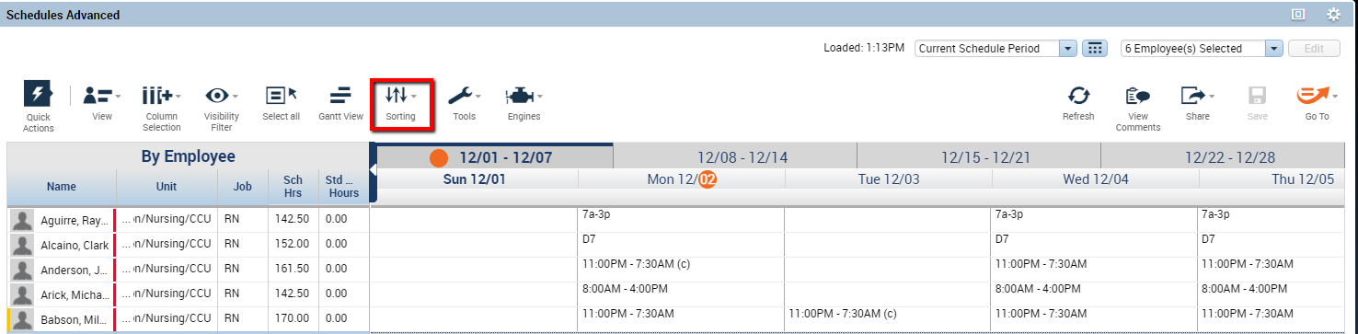
The Column Selection icon shows all available columns, whether they are currently displayed or hidden. These columns make up the available Sort By options in the sorting menu. 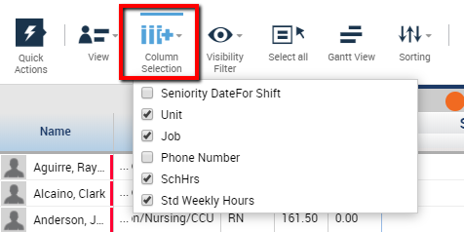
To sort the available information:
- Click the Sorting icon to display the options to sort. From the dropdown, choose the column you wish to sort by. The ▲and ▼ arrows to the right of the dropdowns allow you to choose whether you want an ascending or descending sort order. Click Apply to apply the sort.
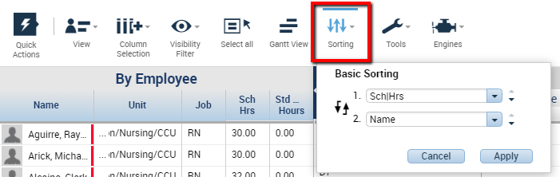
- The employee information in the left pane rearranges according to the chosen sort (in this case, sorted by Scheduled Hours, ascending from least to greatest). 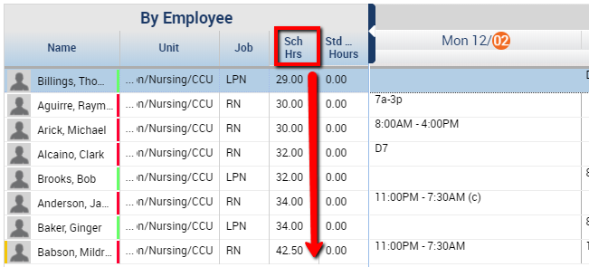

Request Periods
Request Periods are managed from the Tools icon. Request periods allow an organization to restrict when an employee can submit a request, and what time period the request can be submitted for.
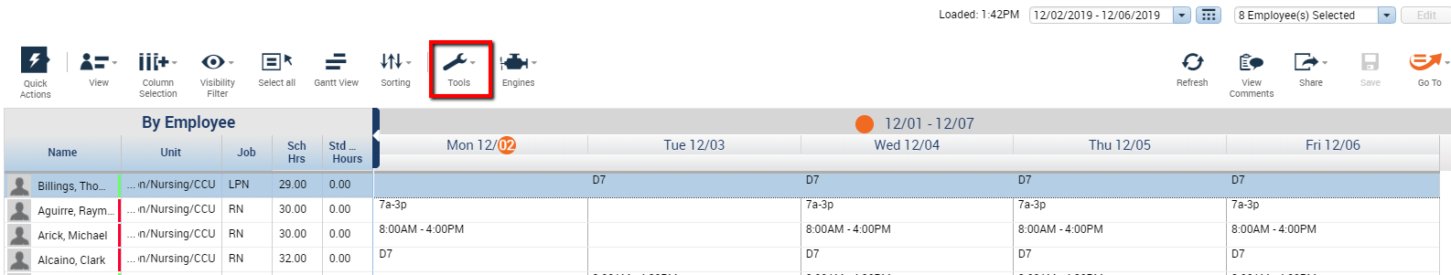
To set up employee request periods:
- Click the Tools icon choose Manage Employee Request Periods.
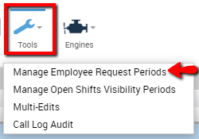
- This will display the Request Periods that are currently set up for each type of request that is configured. If you wish to modify an existing request period, click the pencil icon to the left of the request to modify. Or, use the Add Request Period button in the lower left to create a new request period. 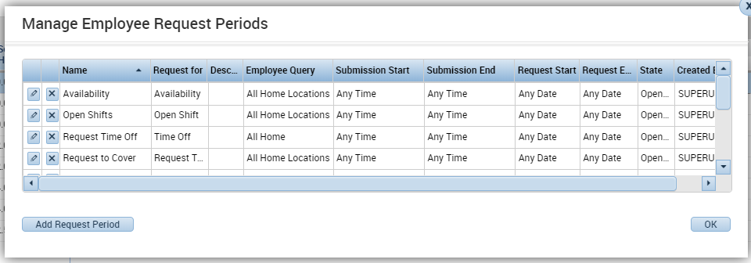
- Components of a Request Period: 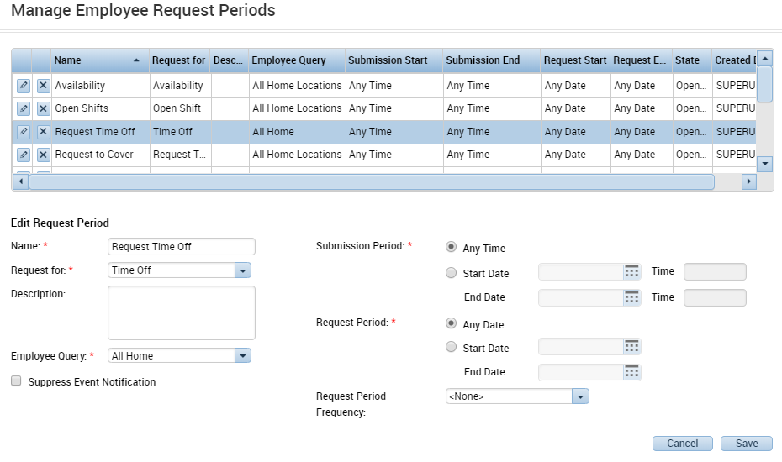
Employee Query: The employees in the hyperfind chosen here are the only employees who will have access to this request.
Submission Period: The submission period controls when the employees can submit this type of request. Most organizations leave this at the default selection of Any Time. For further restriction, choose the Start Date and End Date and time when this request should be available.
Request Period: The request period controls what days the employees can request for. Most organizations leave this at the default selection of Any Time. For further restriction, choose the Start Date and End Date and time when this request should be available.

Request Period Frequency
For request periods that change on a scheduled basis, create a rolling request period by setting the Request Period Frequency. Speak with your implementation technician about how best to set this up for your organization.
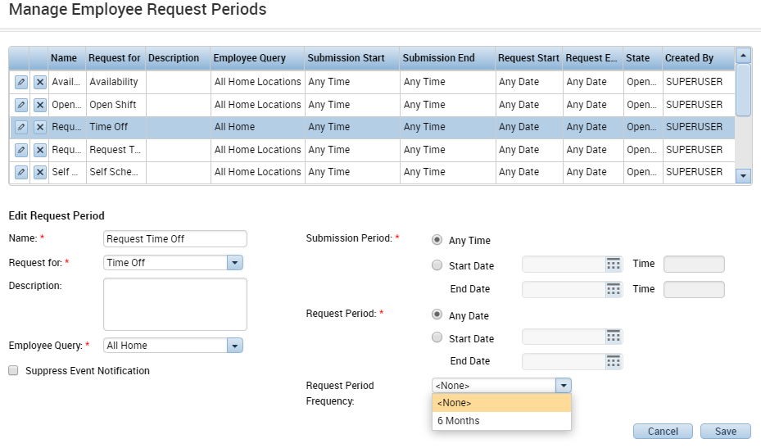

Schedule Indicators
The indicators beneath the schedule provide additional information about totals. 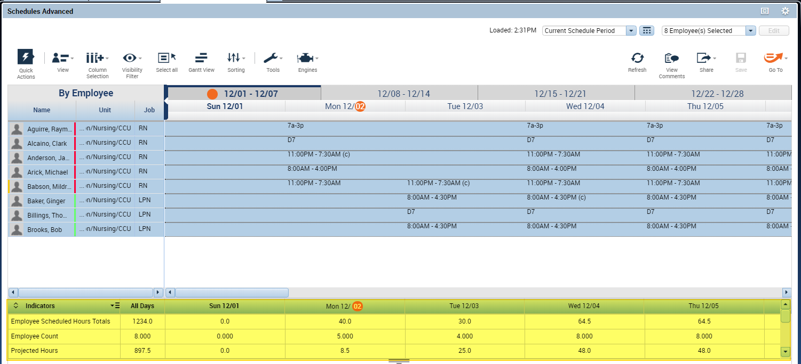
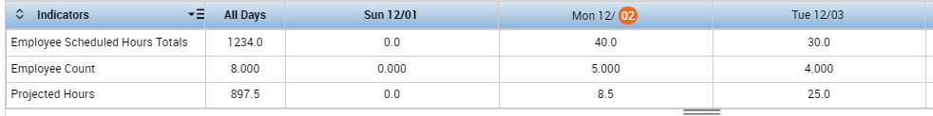
Employee Count: Provides the total number of employees scheduled to work on that day.
Employee Scheduled Hours Totals : Indicates how many hours are scheduled for all the employees on that day.

