Setting up a Manager
  - kronos version 8.1

Contents
SETTING UP A MANAGER 3
Licenses 3
User Information (Person tab) 3
Access Profiles (Job Assignment tab) 4
Manager Role – General (Job Assignment tab) 5
Manager Role – Scheduler (Job Assignment tab) 6

SETTING UP A MANAGER

Licenses
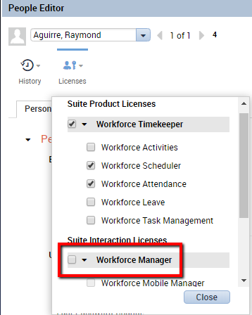
Select the employee and access the People Editor.
This may be done from a genie by using
the Go To button.
At the top, assign a Workforce Manager license.
Depending on your organization setup, you may
wish to disable the Workforce Employee license from
the user at this time.

User Information (Person tab)
If the employee had a Workforce Employee license, this access may already be set up. If not, set up the manager’s access so they can log in to Kronos. Your organization will likely have a standard for how managers should be set up. Reference another manager’s set up if needed.
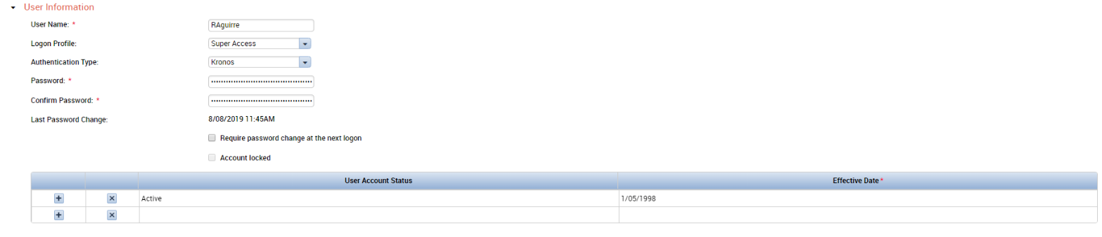

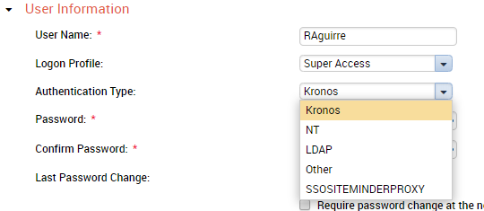
It is important to know if your organization uses
Kronos, NT, or LDAP Authentication.
If your organization uses NT or LDAP,
you will only need to assign the employee
a username.
If your organization uses Kronos authentication,
you will need to assign the employee a generic
password such as “Welcome,” and mark the
checkbox to “Require password change at the next logon.”

Access Profiles (Job Assignment tab)
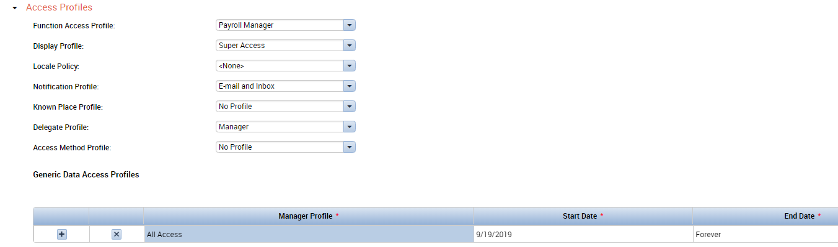
Function Access Profile: The Function Access Profile sets permissions for what this manager can do in the system. Your organization will likely have Function Access Profiles for different roles already set up. Reference another manager’s set up if needed to view the specifics for your organization. The Function Access Profile that is appropriate for managers will likely have “Manager” in the name.
Display Profile: The Display Profile controls how the system will appear to the manager when they log in. Again, reference another manager’s setup if needed. The Display Profile that is appropriate for managers may also have “Manager” in the name.
Notification Profile: The Notification Profile controls how the manager will receive notifications from Kronos. This includes being notified of time off requests that need to be approved. It is best to select Email and Inbox, even if the Inbox within Kronos is not configured. Verify the email address that is provided on the Person tab in the Contacts section.
Delegate Profile: Assign a Delegate Profile if the manager will ever delegate their role or receive delegations from other managers. If you do assign a Delegate Profile, switch back to the Person Tab and assign a Process Profile as well:

Delegations allow a manager to take over another person’s role and perform actions within Kronos as that other person. This can be useful in cases when a manager is on vacation or leave.
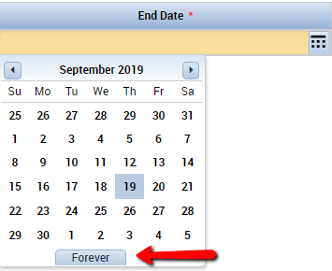
Generic Data Access Profile: For most organizations, the Generic Data Access Profile can be set to All Access and restricted as needed with other settings. Click in the End Date box to assign an End Date of “Forever”:

Manager Role – General (Job Assignment tab)
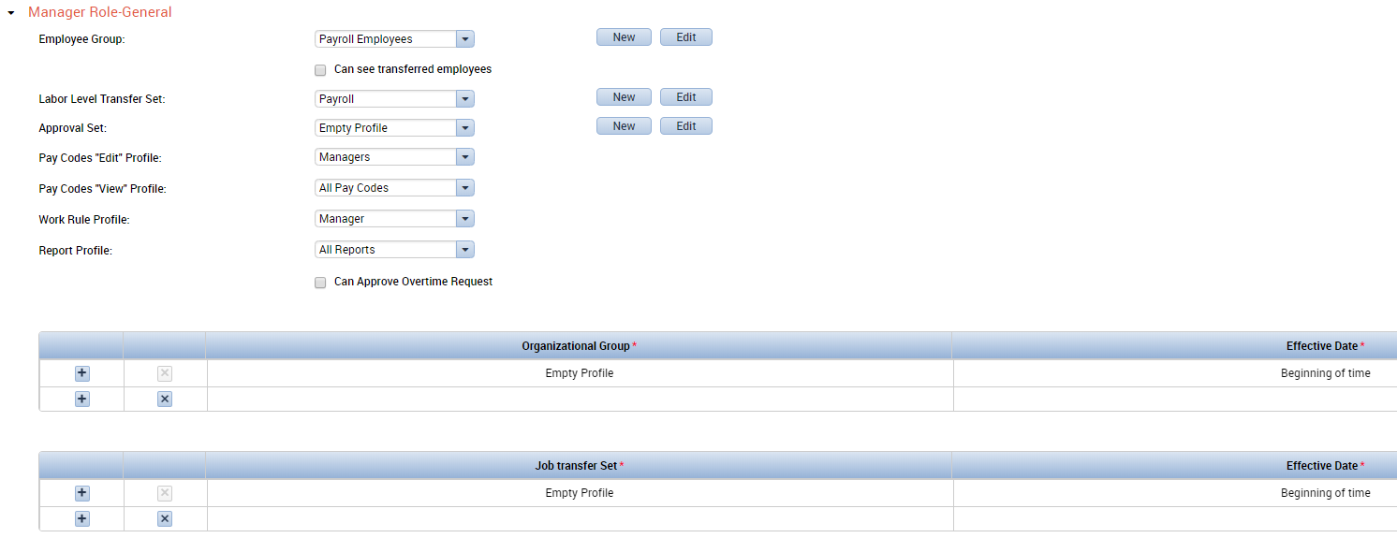
Employee Group: This setting controls who this manager will be able to see in Kronos. This manager may be assigned an existing employee group, or use the New button to the right to build a new group of employees by labor level. Select the checkbox for “Can see transferred employees” if the manager needs to see employees who transfer in or out of the department or location. This is common for managers who have employees who work in different roles or locations.
Labor Level Transfer Set: This setting controls which labor levels transfers this manager can apply in the employees’ schedules and timecards.
Pay Codes “Edit” Profile: This setting controls which pay codes the manager can apply in the employees’ schedules and timecards. There is typically a Pay Codes Data Access Profile set up specifically for managers. Common pay codes that managers can apply include “Sick” and “Vacation.”
Pay Codes “View” Profile: This setting controls which pay codes the manager can view in reports and calendars. This is typically set at All Pay Codes. This is useful when combined pay codes such as “Total Overtime” are in use by the organization.
Work Rule Profile: This setting controls which work rules the manager can apply in the employees’ schedules and timecards. For example, managers may designate a work rule transfer if an employee is being paid comp time.
Report Profile: This setting controls which reports the manager can run in Kronos. This is typically set to “All Reports.”
Organizational Group & Job Transfer Set: These settings are applied for managers who will be working with Advanced Scheduler. They are similar to the Employee Group and Labor Level Transfer Set.

Manager Role – Scheduler (Job Assignment tab)
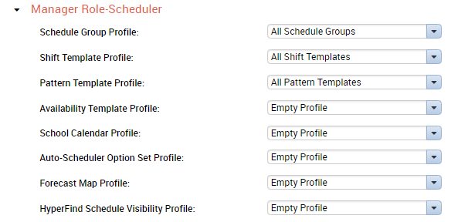
Schedule Group Profile: This controls which Schedule Groups this manager can place employees into. This is typically set to All Schedule Groups.
Shift Template Profile & Pattern Template Profile: These controls which shifts managers can assign to employees, and which shifts can be built into pattern templates. Again, these are typically set to All Access.

When finished, save to apply changes:

