Update or Reset Accruals
  - kronos version 8.1

Contents
UPDATE AND RESET KRONOS ACCRUALS 3
Updating Kronos Accruals 3
Accrual Update Information 3
Updating Earned Accruals within the Workforce Application 3
Resetting Kronos Accruals 6
Accrual Reset Information 6
Resetting Kronos Accruals within the Employee’s Timecard 6
Resetting Kronos Accruals from within a Workforce Central Genie 8

UPDATE AND RESET KRONOS ACCRUALS

Updating Kronos Accruals

Accrual Update Information
- Update is used to add or subtract from the existing balance as of an effective date.
- To subtract from the balance, enter a negative amount.
- Multiple updates can be entered with the same effective date.
- Updates cannot be deleted or overwritten, but additional updates can be entered to counteract earlier updates. Updates are cumulative.
- When the accrual contains other transactions on the same date, updates happen after resets and grants, and before takings, in the order of operations.
- Update is not available from the accrual menu in the timecard editor. It can only be done as a group edit on the Accrual menu in QuickFind or in a genie.
- To determine whether an update was successful, go to the Group Edit Results Widget.

Updating Earned Accruals within the Workforce Application
- Log on to Workforce Central.
- Select a specific employee or a group of employees using QuickFind or any other Genie. NOTE: Do not open the timecard! Just select the employees from the list by highlighting them.
- Go to: Accruals > Update Earned Accruals from the menu bar. This displays the Update Earned Accruals dialog box.
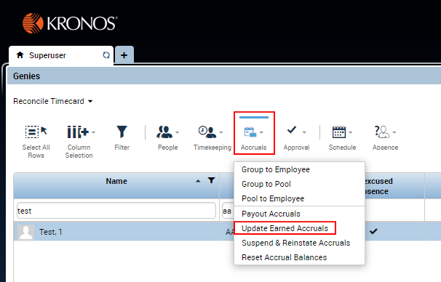
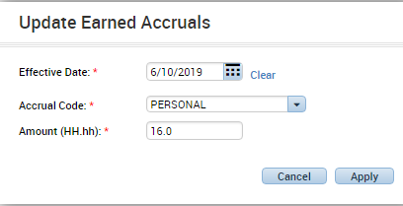
- Select the desired Accrual Code. This drop-down list contains all the accrual codes that are configured in the system. If an accrual code that does not apply to the selected employees is chosen, the update will fail.
- Select the desired Accrual Amount. This is the amount to add to the hours or money in the selected accrual code, expressed as a number or in hours and minutes (hh:mm). Negative amounts are conditionally allowed based on the user's access rights and configuration.
- Select the desired Effective Date.
- This date must be in a pay period that is not signed off.
- Clicking the calendar icon next to the Date box displays a calendar of the current month.
- Click a day to select it.
- To change the month, click the current month and year title on the top of the calendar.
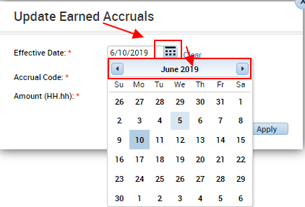

- To change the year, click the year title on the top of the calendar.
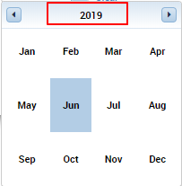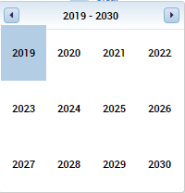
- The calendar for the new month now appears. Select the desired Effective Date.
- Click Apply to submit the group edit for processing.
- Check the Group Edit Results Widget to confirm that the update succeeded.
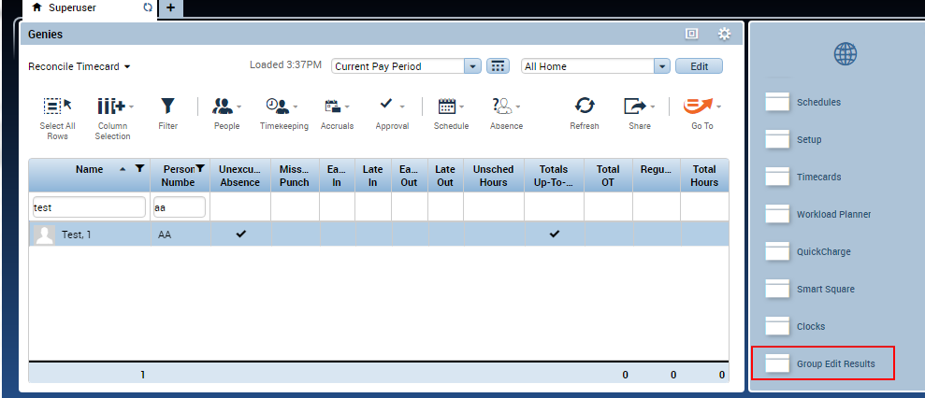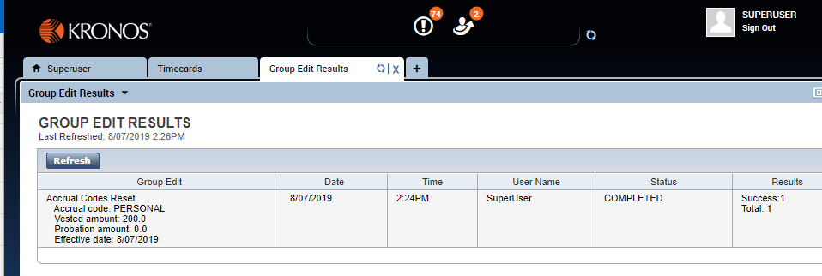

Resetting Kronos Accruals

Accrual Reset Information
- Resets accrual vested balance and/or probation balance as of an effective date.
- When an accrual reset is entered, the previous balance is discarded and replaced with the new balance.
- There can be only one reset on a given effective date.
- Accrual resets cannot be deleted, but they can be overwritten with new accrual resets on the same effective date.
- When the accrual contains other transactions with the same effective date, the accrual reset will happen before any grants or takings.
- Reset is on the Accrual menu in the timecard editor. It can also be done as a group edit on the Accrual menu in QuickFind or in many genies.

Resetting Kronos Accruals within the Employee’s Timecard
- Go to the Employee timecard, place cursor on desired reset date.
- Choose Accruals Actions > Reset Accruals. 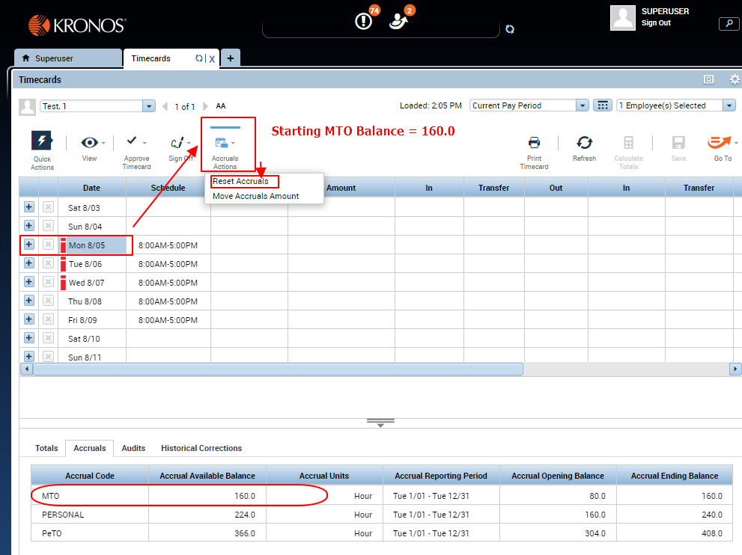
- Enter the desired Vested Amount balance– these hours can be used immediately. Enter the balance as it should read (this is an override and will take effect on the date chosen). Make sure the date in the window is the correct override date.
- Enter the desired Probation Amount – these hours can be used once the employee meets completes their Probationary Period. This is typically for new hires and re-hires. Enter the balance as it should read (this is an override and will take effect on the date chosen). Make sure the date in the window is the correct override date.
- Click OK, then SAVE.
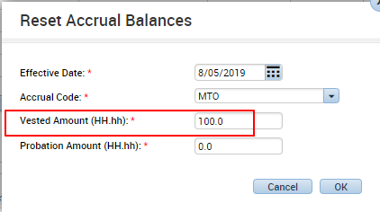
- Optional: Add a comment to an available amount/punch entry to record the change. A common practice is to enter a Pay Code with an amount of "0" in order to add a Comment/Note.
- Place cursor on the date chosen to see the change reflected in the Balance on Selected Date field.
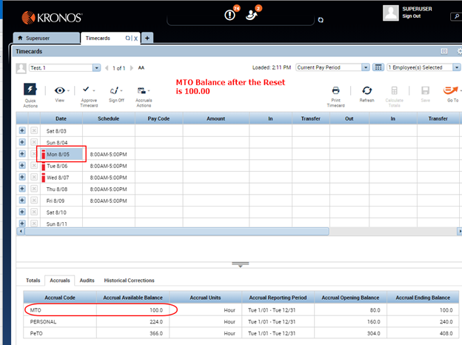

Resetting Kronos Accruals from within a Workforce Central Genie
- Log on to Workforce Central.
- Select a specific employee or a group of employees using QuickFind or any other Genie. NOTE: Do not open the timecard! Just select the employees from the list by highlighting them.
- Go to: Accruals > Reset Accrual Balances from the menu bar. This displays the Reset Accrual Balances dialog box.
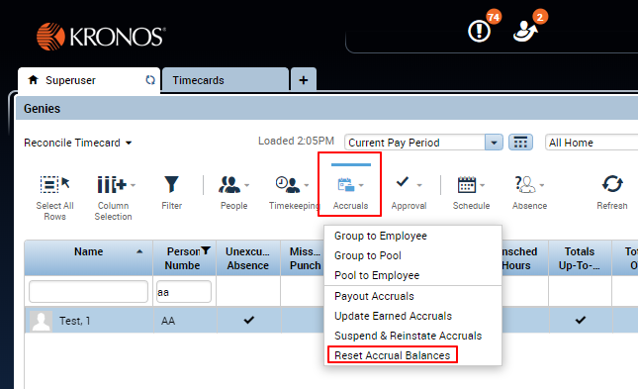
- Select the desired Accrual Code. This drop-down list contains all the accrual codes that are configured in the system. If an accrual code that does not apply to the selected employees is chosen, the reset will fail.
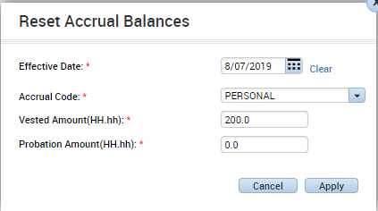
- Select the desired Vested Amount – these hours can be used immediately. Enter the balance as it should read (this is an override and will take effect on the date chosen). Make sure the date in the window is the correct override date.
- Select the desired Probation Amount – these hours can be used once the employee meets completes their Probationary Period. This is typically for new hires and re-hires. Enter the balance as it should read (this is an override and will take effect on the date chosen). Make sure the date in the window is the correct override date.
- Select the desired Effective Date.
- This date must be in a pay period that is not signed off.
- Clicking the calendar icon next to the Date box displays a calendar of the current month.
- Click a day to select it.
- To change the month, click the current month and year title on the top of the calendar.
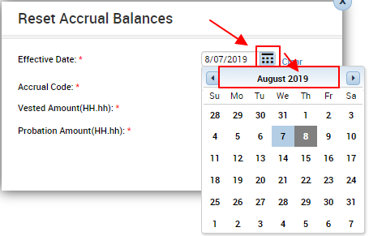
- To change the year, click the year title on the top of the calendar.
- The calendar for the new month now appears. Select the desired Effective Date.
- Click Apply to submit the group edit for processing.
- Check the Group Edit Results Genie to confirm that the reset succeeded.
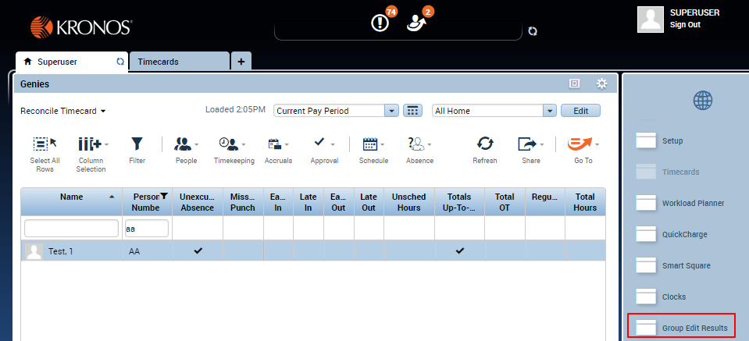
Referenced: ARTICLE NUMBERs 000001454, 000036519 & 00002768

