Work Time Request
  - kronos version 8.1

Contents
WORK TIME REQUESTS 3
Creating a Work Time Request 3
Manager Tasks 6
Additional Use 8

WORK TIME REQUESTS
A Work Time request allows employees to submit for worked time when they were not able to punch. This type of request can be used if an employee worked unscheduled time or was asked to report to a location without a timeclock to punch.

Creating a Work Time Request
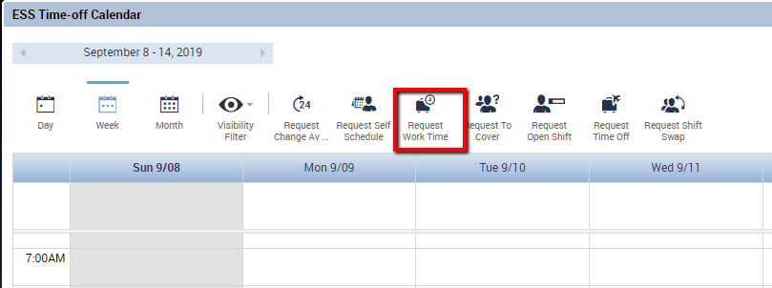
The employee can use the Work Time Request to notify their manager of time that has already been worked. This can be requested for time in the current pay period or any previous pay period that is not already signed off. Select the Request Work Time icon to start a new request.
When submitting a Work Time Request, the employee may need to designate that they worked in a different position or job.
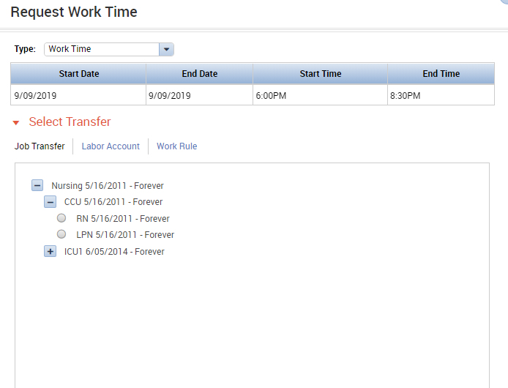
Depending on the organization’s setup, the employee may see different options to designate how they spent their worked time:

If applicable, the employee may
indicate a Job Transfer. In this case the
employee would indicate that they
reported to work and worked outside
of their normal role.

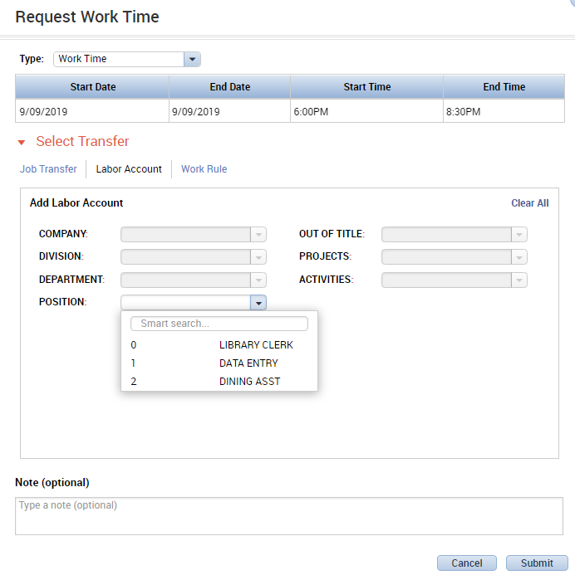
The employee may indicate that their
work should be transferred to another
Labor Account. Options that the
employee can choose from here can be
restricted as needed.

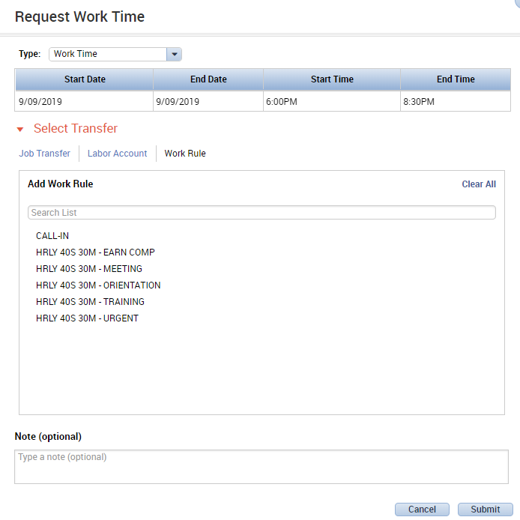
The employee may indicate that they
worked their normal role but reported to
work at an unscheduled time for a
meeting or training.

Depending on setup, the employee may choose one or more combinations of the Job Transfer, Labor Account Transfer, or Work Rule Transfer. Or, if appropriate, the employee does not need to select any type of transfer. By not selecting a transfer, the employee is just indicating that they reported to work at an unscheduled time and did not punch to represent their worked time.
Before submitting the request, the employee must also indicate the Start Date and End Date as well as the Start Time and End Time of their worked time.
Note: If the worked time ends after midnight, the End Date must be set to the next day.

When complete, the employee also has the option to type a note to the manager. The employee will click Submit in the lower right corner to submit the request.

Sample Request:
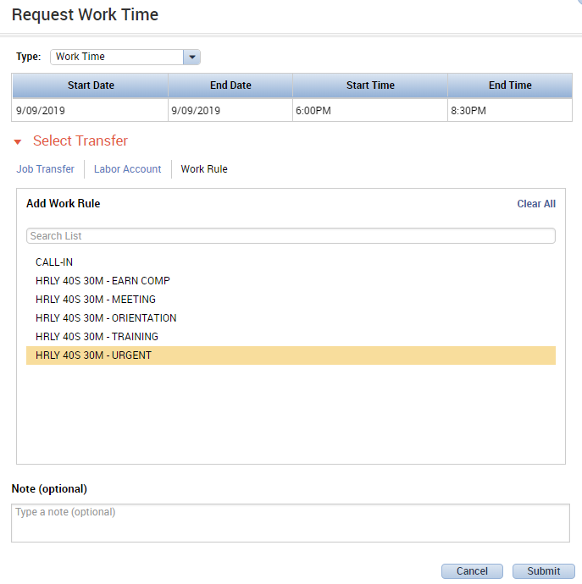

Manager Tasks
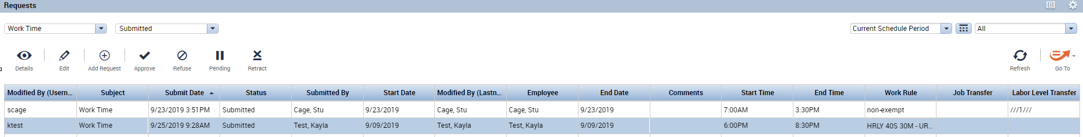
Once the request is submitted by the employee, the manager must approve the request. If email notifications are set up in Kronos, the manager will receive an email indicating that there is a new request to approve. The manager must approve the request in the Request widget. The manager can use the icons in the top left to view details about the request, approve the request, or refuse the request.

Once the manager approves the request, the employee will see the time added to their calendar.
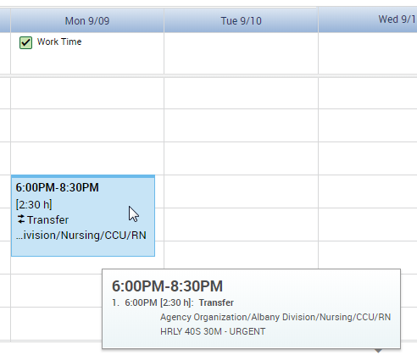

Depending on configuration, the manager may see the worked time appear on the timecard in one of two ways.
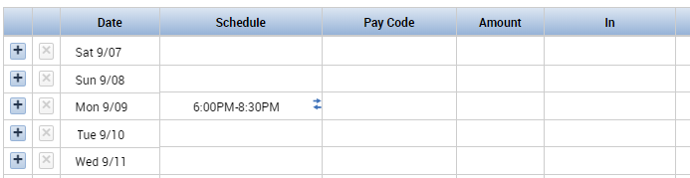
First, the manager may see the worked time populate to the schedule:

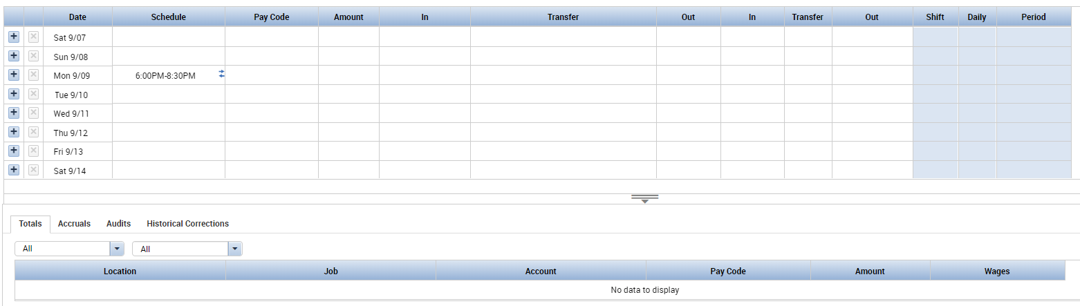
The manger would need to enter the start and end time of the work as In and Out punches in order for the employee to be paid for the time. As seen in the Totals tab, without the punches, the employee is not yet being paid for this time.

Alternatively, the manager may see the worked time come across with a paycode and punches that represent the amount of worked time:
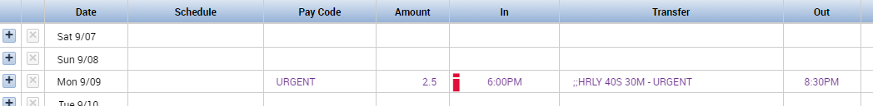

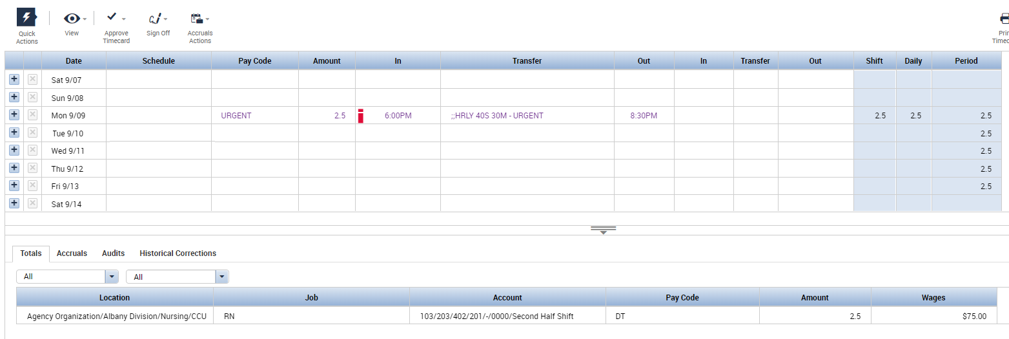
As shown in the Totals tab, this worked time is already entered as needed for the employee to be paid.

Additional Use
Another use for Work Time Requests is as a communication tool from employee to manager. If the organization is set up to allow future requests, the employee can notify the manager of a day they would like to work in the future. For example, an employee can submit a Work Time request for the coming Saturday. This makes the manager aware that if someone is needed to work Saturday, this employee is already willing to do so. This can prevent last-minute searches for coverage.

