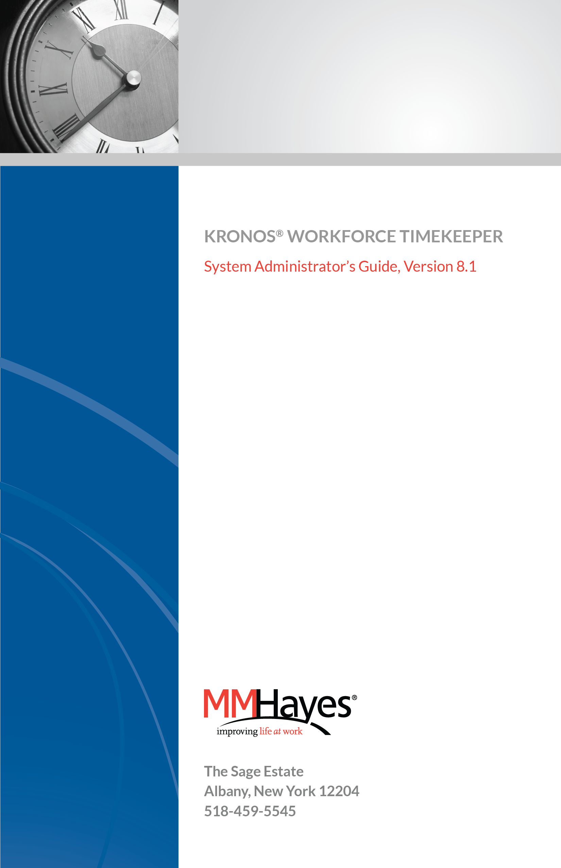

Workforce Accruals, Workforce Central, Workforce Central Suite logo, Workforce Genie, Workforce Manager and Workforce Employee are trademarks of Kronos Incorporated.
Acrobat is a registered trademark of Adobe Systems Corporation.
Windows, Internet Explorer and SQL Server are registered trademarks of Microsoft Corporation.
Netscape is a registered trademark of Netscape Communications Corporation.

When using and applying the information generated by Kronos products, customers should ensure that they comply with the applicable requirements of federal, state and local law, such as the Fair Labor Standards Act.

Workforce Timekeeper System Administration 3
Accessing Setup 4

Organizational Setup 5
Labor Level Entries 5
Labor Level Sets 7

Access Profiles 10
Logon Profiles 10
Pay Code Profiles 12
Report Profiles 15
Schedule Profiles 17
Function Access Profiles 19

Workforce Genies 21
Creating Column Sets 21
Detail Column Sets 21
Roll-up Column Sets 23
Creating Workforce Genies 25
Workforce Genie Profiles 27
Display Profiles 29

Calendar Genies 31

Assigning Profiles to Managers 37

Common Setup 40
HyperFind Queries 40
Types of HyperFind Queries 40
Query Conditions 41
Creating HyperFind Queries 41
Query Manager 43
Comments 44

Workforce Timekeeper System Administration
This manual contains instructions for performing most of the functions which are the responsibility of Kronos System Administrators. Access to these functions is allowed through the Function Access Profile that is assigned to you. Accordingly, you may not have access to all the functions described in this manual.

Accessing Setup
Most of the functions that you, as a SuperUser, will be performing are in the “Setup” portion of the system.
To access this section of Workforce Timekeeper, click the Setup link that is provided to you. This may be in the drawer or within another widget, such Quick Links.
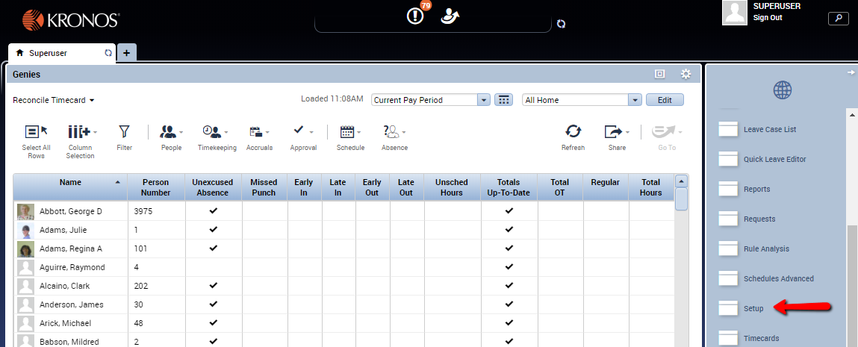

When you click on Setup, a screen similar to the one below will appear. Note that depending on your access level, some options displayed below may not be available to you.
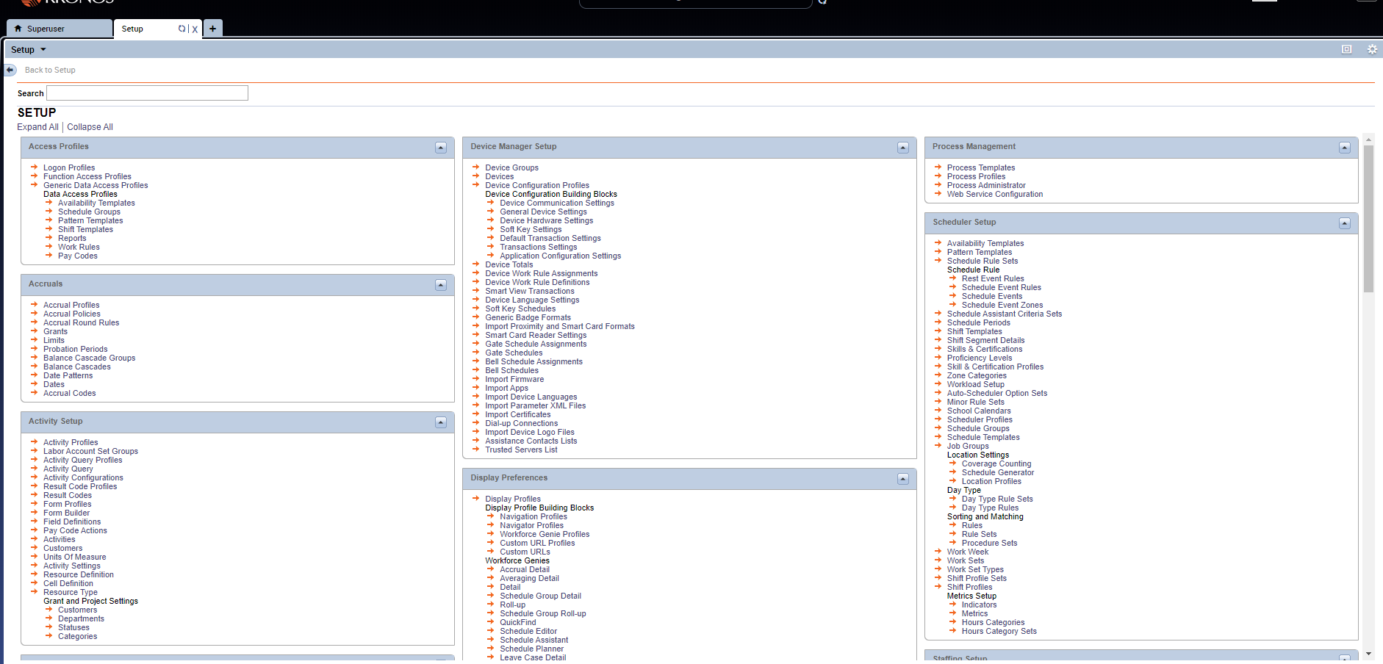

Organizational Setup

Labor Level Entries
As part of the initial configuration of your Workforce Timekeeper system, labor levels were established to track where hours are charged for each employee. An example of a Labor Level structure appears below. Initially the labor levels must be populated with entries before any employees may be entered into the system. Ongoing maintenance of the labor structure consists of adding new entries and/or inactivating entries that are no longer being used. For example, if a new job code is established by your organization, that code must be entered into Workforce Timekeeper before any employee can be assigned to it.

To add new labor level entries:
- Log in to the Workforce Timekeeper application.
- 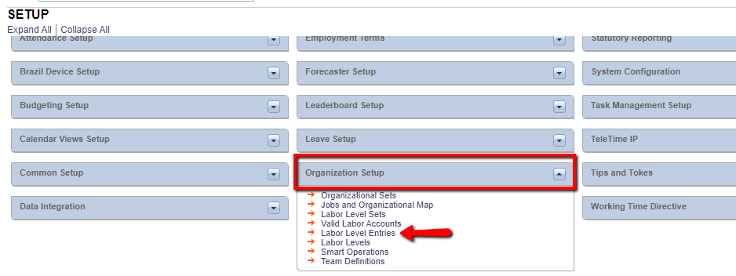Go to Setup > Organization Setup > Labor Level Entries.
- 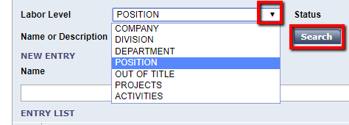Click the down arrow in the Labor Level box.
- Choose the labor level to which you wish to add or edit entries.
- Click Search. 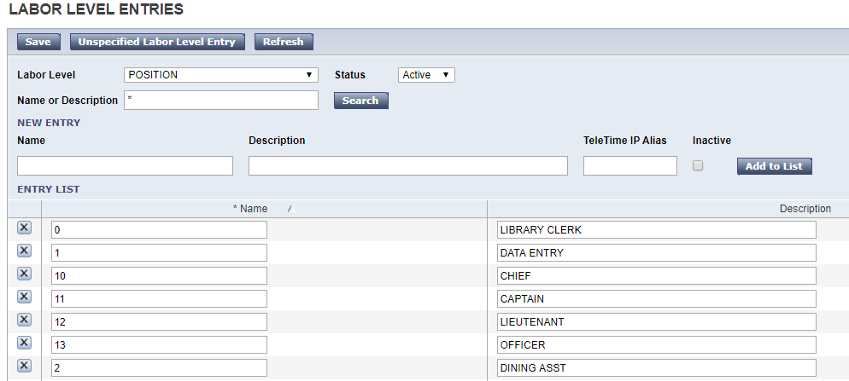
- To add new entries, click the Name field under New Entry, and enter the alpha-numeric code for the new entry.
- Enter the description of the new entry in the Description field.
- Click the Add to List button.
Save.

To edit existing labor level entries:
- Follow steps 1-5 above.
- Click the Name or Description of the entry you want to edit and make the change.
- To inactivate an entry so it no longer appears in pick lists inside the application, check the Inactivate box.
- Save.
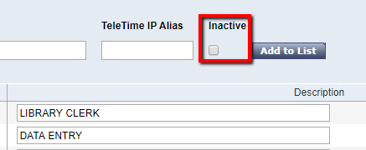
Labor Level Sets
Labor Level Sets allow you to 1) assign employees to a manager (known as an Employee Group), and 2) restrict what labor level entries can be used for account transfers (Labor Level Transfer Set).
To create a Labor Level Set:
- 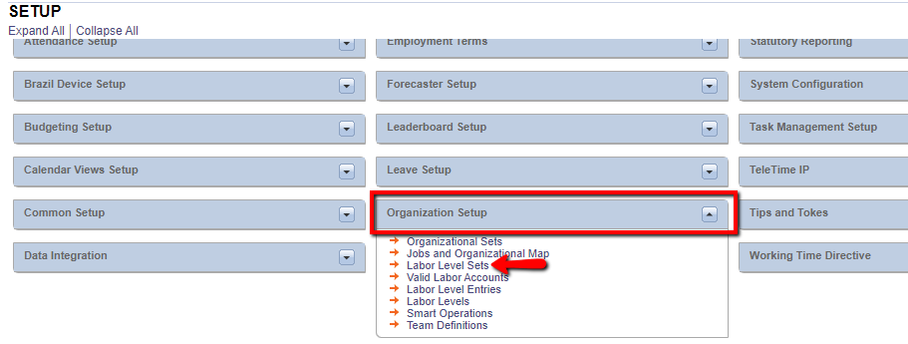Go to Setup > Organization Setup > Labor Level Sets.
- Click the New button – the Labor Level Set Editor will appear showing your labor levels.
- Name the new Labor Level Set, e.g. “Plant Operations.”
- Click the down arrow in the Use In box and choose what type of labor level set you are creating. 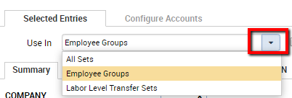
- 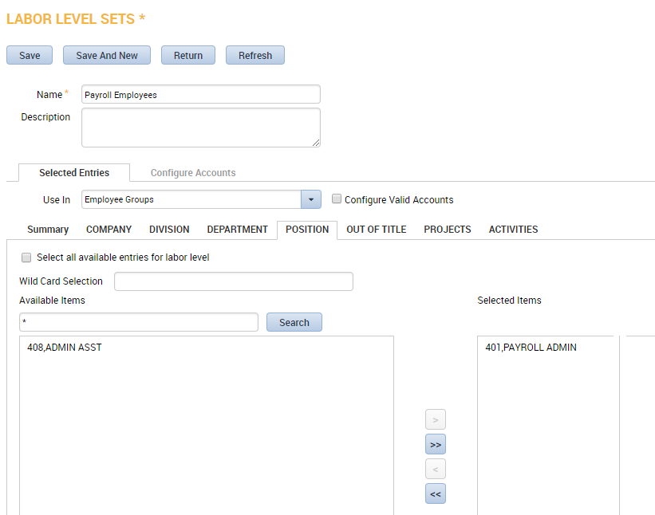Click the tab representing each labor level, select the appropriate entries from the Search Results box, then click Add. Your selected entries will appear in the Selected Items box to the right of each labor level.
Repeat step 5 for each labor level that includes entries for your selection criteria. For example, if you are creating a labor level set for your Finance manager so s/he only has access to Finance employee timecards, you would click the Department labor level, click Finance in the Search Results box, then click the Add button. If the Finance manager is only allowed to see the staff accountants, you would then click to the Position labor level, and select the staff accountant job code(s) in the Search Results selection box.
Note: Labor Level Sets can also be created from the Manager Role – General screen in the People Editor by clicking the “New” button next to “Employee Groups” and/or “Labor Level Transfer Set.”
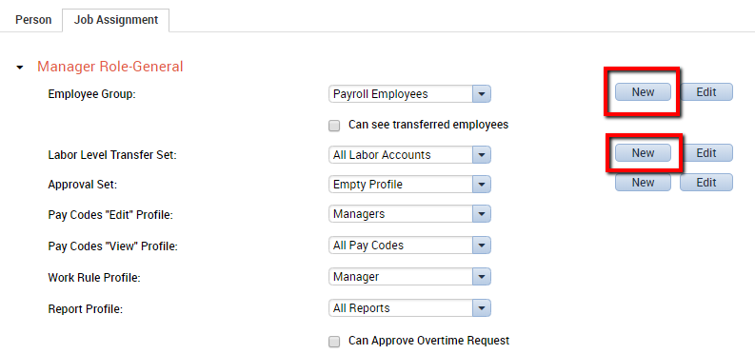

Access Profiles
When managers and employees log in to Workforce Timekeeper through a browser, the system reads a number of profiles which are attached to their account. These profiles tell the system what the manager or employee is allowed to see and do while logged into the application.

Logon Profiles
Logon Profiles controls passwords and session restrictions.

To create a Logon Profile or modify an existing one:
- Go to Setup > Access Profiles > Logon Profiles.
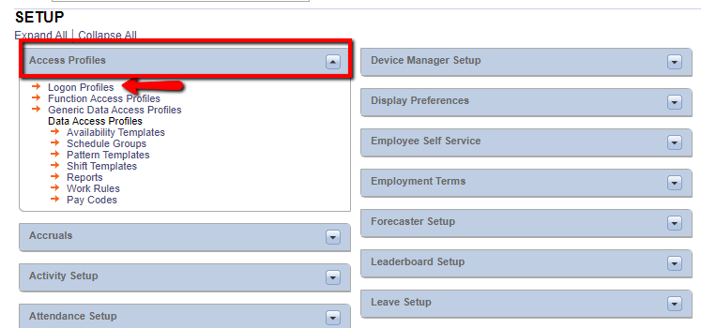
- To create a new profile, click New. To edit an existing profile, click the profile name.
- Name the Logon Profile (usually your company name).
- On the Password tab, set the Expires value to the number of days when the system will prompt the user to change their password.
- Set the Minimum Length value.
- Set the Reuse Monitoring value to the number of passwords that are kept in history.
- On the Session Restrictions tab, click the Enabled radio button to turn on the lockout feature.
- Set the Lockout After value to the number of failed attempts before lockout.
- Set the Lockout Duration value to the hours and minutes after which the system will automatically unlock the user account if the maximum number of failed attempts has been exceeded. Note: If the Forever radio button is checked, the user account will remain locked until someone manually unlocks it in the People Editor.
When finished, click Save & Return.

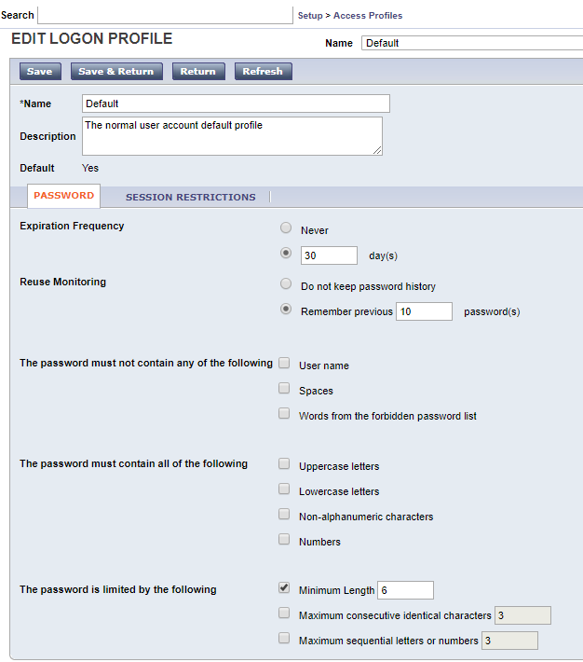

Pay Code Profiles
Pay Code Profiles limit the pay codes that managers and employees can see and use in Pay Code Edits and Move Hours.

To create a Pay Code Profile:
- Go to Setup > Access Profiles > Data Access Profiles > Pay Codes.
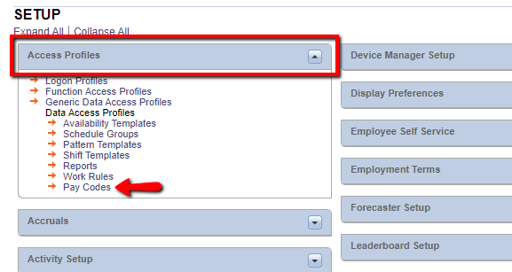
- Click New to create a new profile. Name the profile for who will be using it, for example, “Managers.”
- 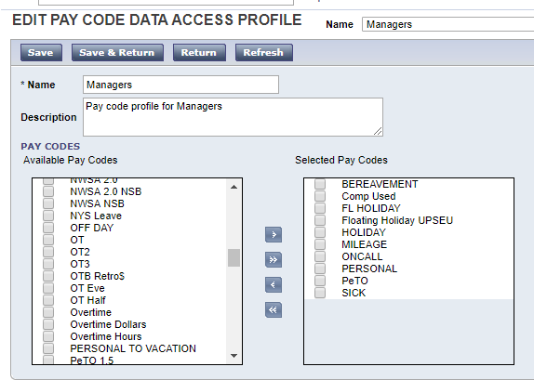Click the check box in the Available column for the pay codes the user will be able to use for pay code edits in timecards and schedules. Click the right arrow button (>) to move the pay codes to the Selected column. To move all pay codes to the Selected column, click >>.
- When finished, click Save & Return.
Repeat this procedure for each new Pay Code Profile.
Note: There are two separate Pay Code Profile settings for each manager account in Workforce Timekeeper. These are set in the People Editor under Manager Role – General. The Pay Codes Edit Profile controls which pay codes the manager can use. The Pay Codes View Profile controls which pay codes the manager can view in reports.
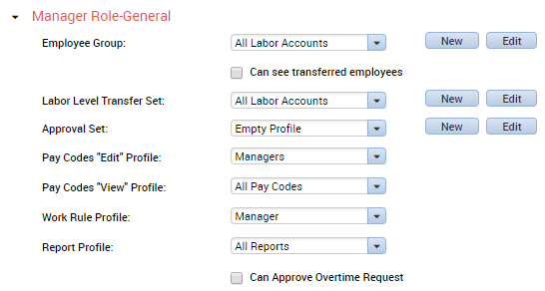
Work Rule Profiles
Work Rule Profiles limit the Work rules that managers and employees can use in timecard and schedule transfers.

To create a Work Rule Profile:
- 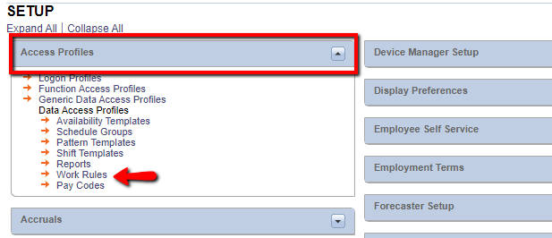Go to Setup > Access Profiles > Data Access Profiles > Work Rules.
- Click New to create a new profile.
- Name the profile, e.g. “Managers.”
- Click the check box in the Available column for the Work rules the user will be able to use for transfer in timecards and schedules, then click the right arrow button (>) to move the pay codes to the Selected column. To move all Work rules to the Selected column, click >>.
- Repeat this procedure for each new Work Rule Profile.
- 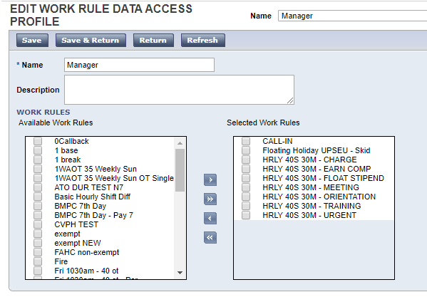When finished, click Save & Return.

Report Profiles
Report Profiles limit the reports that managers can run in the Workforce Timekeeper application.

To create a Report Profile:
- Go to Setup > Access Profiles > Data Access Profiles > Reports. 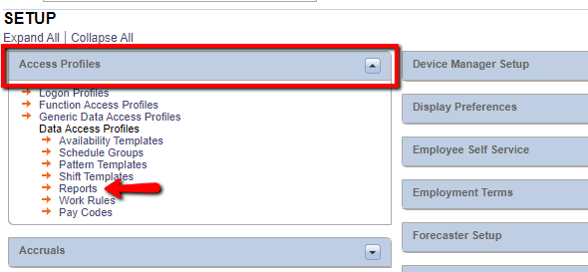
- Click New to create a new report profile.
- Name the profile, e.g. “Manager Reports.”
- 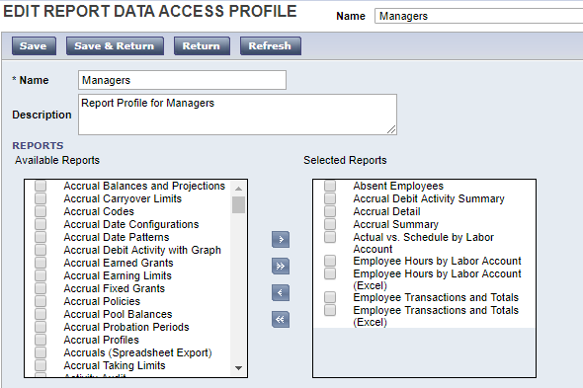Click the check box in the Available column for the reports the manager will be able to run, then click the right arrow button (>) to move them to the Selected column. To move all reports to the Selected column, click >>.
- When finished, click Save & Return.
The following reports are typically given to Managers:
Absent Employees | Employees Currently Earning Time
Accrual Balances & Projections | Exceptions
Accrual Debit Activity Summary | Holiday Credits
Accrual Detail | Hours by Job *
Accrual Summary | Hours by Labor Account
Actual vs Schedule by Job * | Hours by Labor Account w/ Graph
Actual vs Schedule by Labor Account | Person Attributes
Badge Numbers | Person Job Assignment
Employee Hours by Job * | Punch Origin
Employee Hours by Job * (Excel) | Schedule by Labor Account – Monthly
Employee Hours by Labor Account | Schedule by Labor Account – Weekly
Employee Hours by Labor Account (Excel) | Time Detail
Employee Transactions & Totals | Timecard Audit Trail
Employee Transactions & Totals (Excel)
* These reports are only applicable for systems that are configured with the Organizational Maps and Jobs feature.

Schedule Profiles
Schedule Profiles include Schedule Groups, Pattern Templates, and Shift Templates. Each of these profiles limits the schedule groups, pattern templates, and shift templates which are available to managers.

To create a Schedule Group Profile:
- Go to Setup > Access Profiles > Data Access Profiles > Schedule Groups. 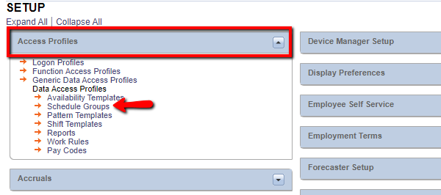
- Click New to create a new profile.
- Name the profile, e.g. “Support Schedule Groups.”
- Click the check box in the Available column for the Group Schedules the manager will be able to see, then click the right arrow button (>) to move them to the Selected column. To move all Group Schedules to the Selected column, click >>.
When finished, click Save & Return.

To create a Pattern Template Profile:
- Go to Setup > Access Profiles > Data Access Profiles > Pattern Templates. 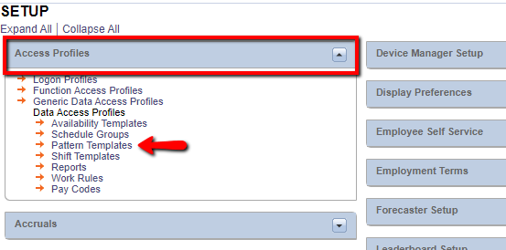
- Click New to create a new profile.
- Name the profile, e.g. “Support Pattern Templates.”
- Click the check box in the Available column for the Pattern Templates the manager will be able to see, then click the right arrow button (>) to move them to the Selected column. To move all pattern templates to the Selected column, click >>.
When finished, click Save & Return.

To create a Shift Template Profile:
- Go to Setup > Access Profiles > Data Access Profiles > Shift Templates.
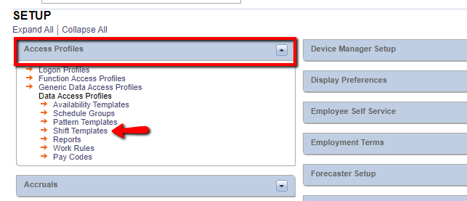
- Click New to create a new profile.
- Name the profile, e.g. “Support Shift Templates.”
- Click the check box in the Available column for the Shift Templates the manager will be able to see, then click the right arrow button (>) to move them to the Selected column. To move all shift templates to the Selected column, click >>.
When finished, click Save & Return.

Function Access Profiles
Function Access Profiles determine what privileges a manager or employee has in the Workforce Timekeeper application. There are over 450 switches which can be turned on (Allowed) or turned off (Disallowed) in the Function Access Profile.

To create a new Function Access Profile or modify an existing one:
- Go to Setup > Access Profiles > Function Access Profiles. 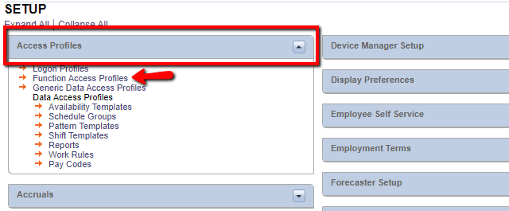
- Click New to create a new profile.
- To copy an existing profile, check the box next to the profile you want to copy, then click Duplicate.
- Name the profile, e.g. “Managers with Wages”
- Click the + sign next to each category in the profile and determine if the individual functions under that tree are applicable to the persons who will be assigned to this profile. Set the Access Scope value to “Allowed” for each function that you are giving access to.
- When finished, click Save & Return.
Repeat this procedure for each new Function Access Profile.
Note: You can save time by duplicating an existing profile that closely resembles the one you are creating, and then editing the copy to Allow or Disallow the appropriate functions.
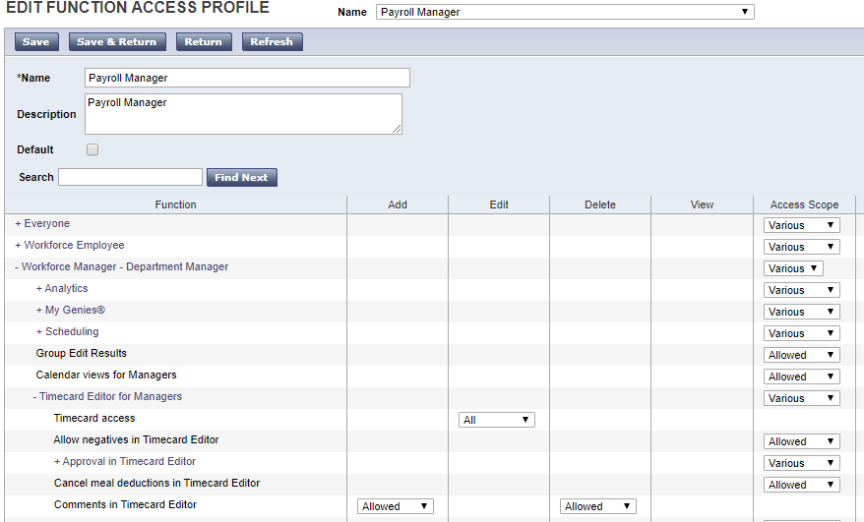

Workforce Genies
Genies are made up of multiple components. There are three main steps to building a Genie:
- First, build the column set (either a Detail Column Set or a Roll-up Column Set).
- Then, set the default genie information (such as HyperFind and time period).
- Finally, provide the managers access to the genie by creating a profile.
Each of these components is described below.

Creating Column Sets
Column sets are the foundation of all Genies. The column set determines what information is displayed when the Genie is called. There are several types of column sets, but the most common are Detail and Roll-up column sets.

Detail Column Sets
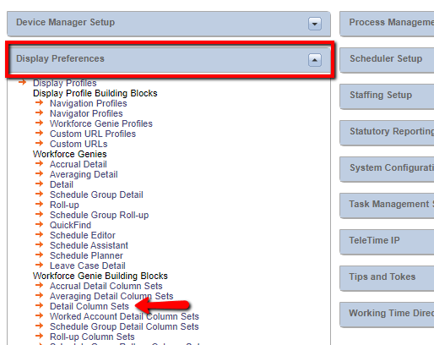A Detail column set contains employee-specific information. “Reconcile Timecard” and “Pay Period Close” are examples of a Detail column set. To create a new Detail column set or modify an existing one: Go to Setup > Display Preferences > Workforce Genie Building Blocks > Detail Column Sets.
- 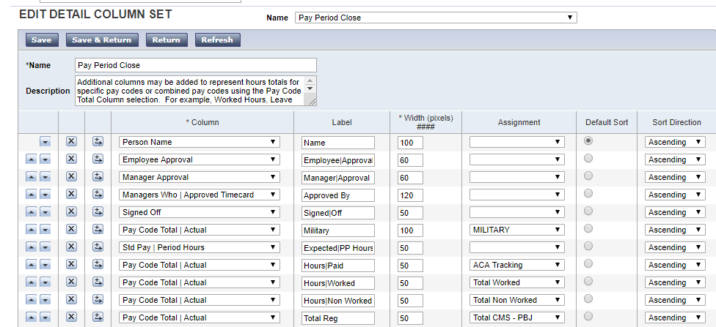Click New or click an existing column set name to modify it.
- Add columns by clicking the Insert Row icon ( ) on the left side of the screen.
- From the Column pick list, choose the database field to be displayed.
- Change the Label to what you want the column to be named when displayed. Words can be wrapped by placing a pipe (Shift+Backslash) between the words in the label, e.g. “Missing|Punch.”
- Change the width of the column as appropriate.
- For certain fields such as Exceptions, Pay Code Totals, and Custom Fields, select the appropriate data element in the Assignment pick list, e.g. Exception > Missed Punch.
- Click the Default Sort button for the column that will be the Primary sort when the Genie is opened. Select whether the sort will in ascending or descending order.
- Change the order of the columns using the up and down arrows on the left side of the screen.
When finished, click Save & Return.
Note: While you may add as many columns as you’d like, the purpose of a Genie is to display key information at a glance, so try to make your Genies fit on the screen without having to use the horizontal scroll bar at the bottom of the screen to view the entire Genie.

The top to bottom order of the columns is how they will appear left to right for end users:
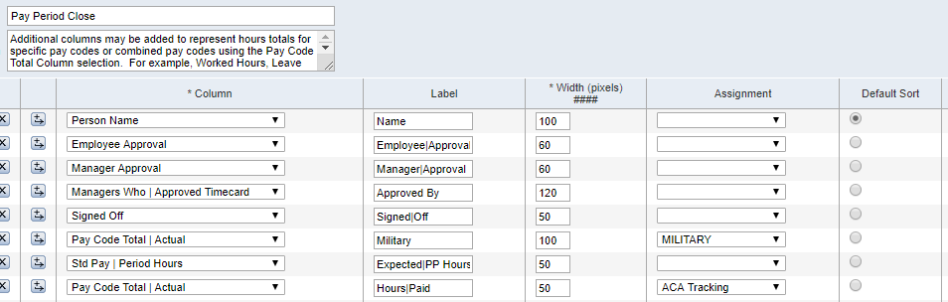

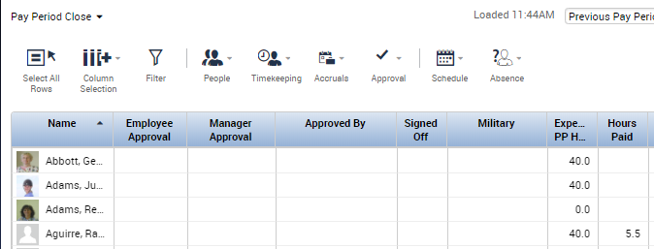
Roll-up Column Sets
A Roll-up column set contains information related to labor levels.
A Roll-up Genie is different from a Detail Genie. Instead of displaying employee information, the Roll-up Genie displays summary information based on labor levels. For example, a Roll-up Genie can show the number of employees in specific departments and all hours charged to those department(s):
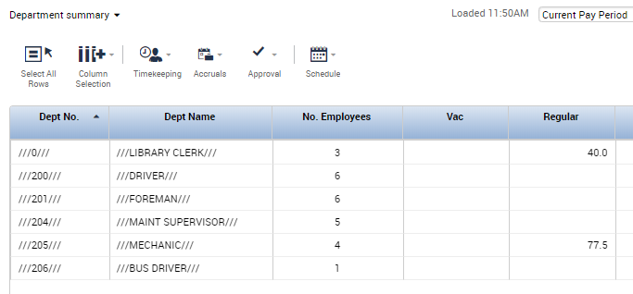 Several standard Detail Genies are supplied with Workforce Timekeeper, but there are no standard Roll-up Genies, so they must be built from scratch.

To create a new Roll-up column set:
- Follow the same steps listed previously for creating a Detail column set.
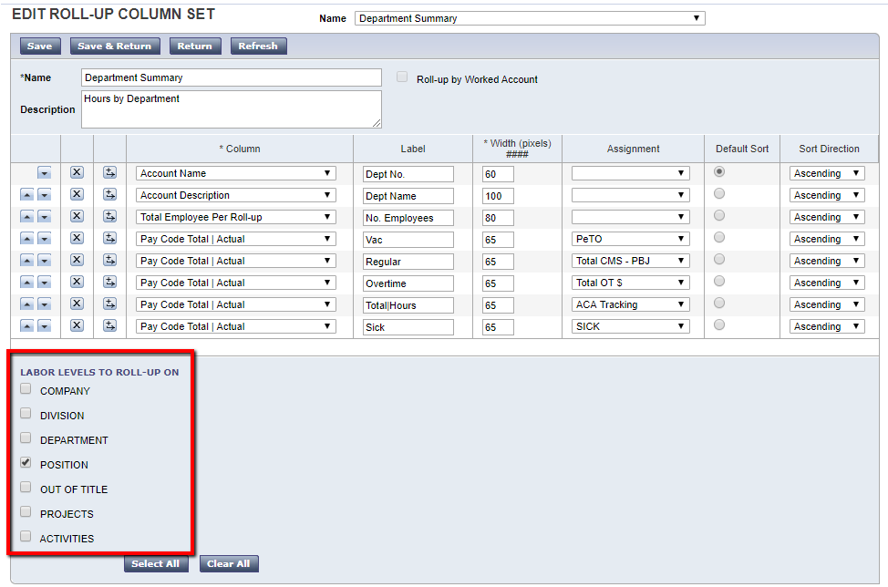When finished adding columns, check the box next to the Labor Level(s) that you want to roll up on.

Creating Workforce Genies
After you have created a Detail or Roll-up column set, you must then attach it to a Workforce Genie. The Workforce Genie specifies the name by which the Genie is recognized, the default HyperFind Query used for the Genie, the default time period, and the column set attached to the Genie. The following procedure applies to both Detail and Roll-up Genies.

To create a new Workforce Genie or modify an existing one:
- Go to Setup > Display Preferences > Workforce Genies > Detail [or Roll-up].
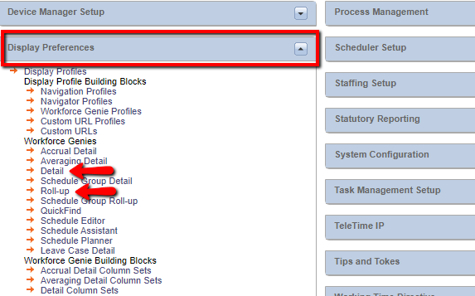
- Click New or click an existing Workforce Genie name to modify it.
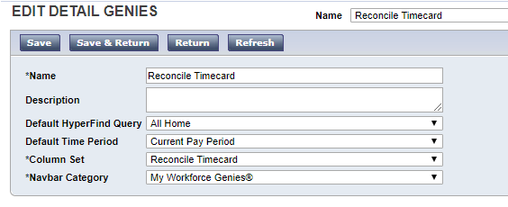
- Name the Genie – this is the name that will appear on the menu tab in the application:
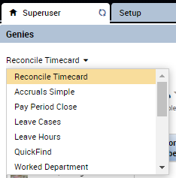
- Select the default HyperFind Query for the Genie. Note: must be a Public Query.
- Select the default Time Period for the Genie.
- Select the Column Set to be displayed. If you are editing an existing genie, you may wish to go back to the column set editor if any changes are needed to the column set.
- Select the NavBar category. Choose My Workforce Genies or Timekeeping. This functionality remains in v8.1 but has little impact on genie access.
Click Save & Return.

Workforce Genie Profiles
Workforce Genie Profiles control what Genies a manager sees when s/he logs into Workforce Timekeeper.

To create a new Workforce Genie Profile or edit an existing one:
- Go to Setup > Display Preferences > Display Profile Building Blocks > Workforce Genie Profiles. 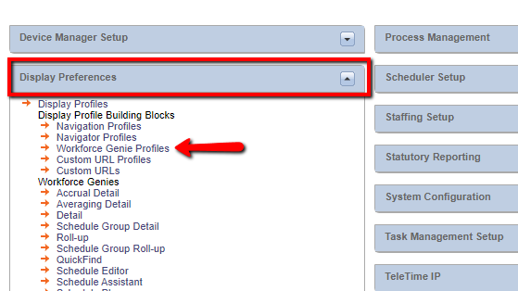
- Click New or click an existing Workforce Genie Profile name to modify it. 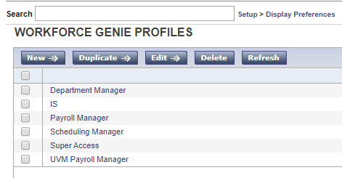
- Assign a Name to the new Workforce Genie Profile.
- Select the Genies for this profile from the Available column on the left and click Add to move them to the Selected column on the right. 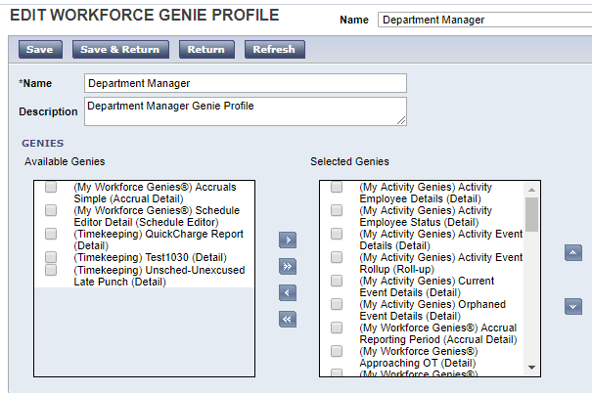
- Change the order that the Genies will be listed in the menu tab using the arrows on the right to move the Genies up or down in the list. The order that the genies appear in here is the order in which they will appear in the dropdown.
When finished, click Save & Return.

Display Profiles
After you have created a Workforce Genie Profile, you must then assign it to a Display Profile. In addition to determining what Genies are displayed, the Display Profile controls such things as the format for punches (standard time vs. military time), the format for hours (minutes vs. decimals) and the format and default length of schedules.

To create a new Display Profile or edit an existing one:
- Go to Setup > Display Preferences > Display Profiles.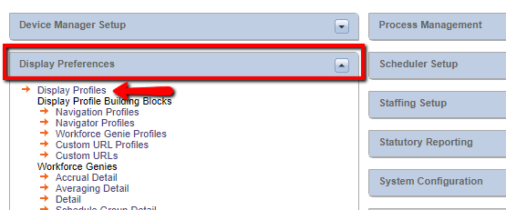
- Click New. Or, click an existing Display Profile name to modify it.
- Name the new Display Profile, e.g. “Department Manager.”
- On the Display Format tab, select the format for durations (hours/minutes or hours/decimals), punches (12 hour or 24 hour), and schedules (start/end time or shift labels). 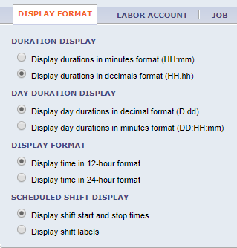
- On the Labor Account tab, check all boxes.
- The Job tab is only applicable if utilizing Organizational Maps and Jobs.
- The Timecard tab is only applicable if any of your employees are using the Project View Timecard and you allow employees to edit their own timecards through the browser.
On the Manager Selections tab, choose the default Schedule Period, the Workforce Genie Profile (see above), the Custom URL Profile (if applicable) and the Calendar Genie Profile, then Save & Return.
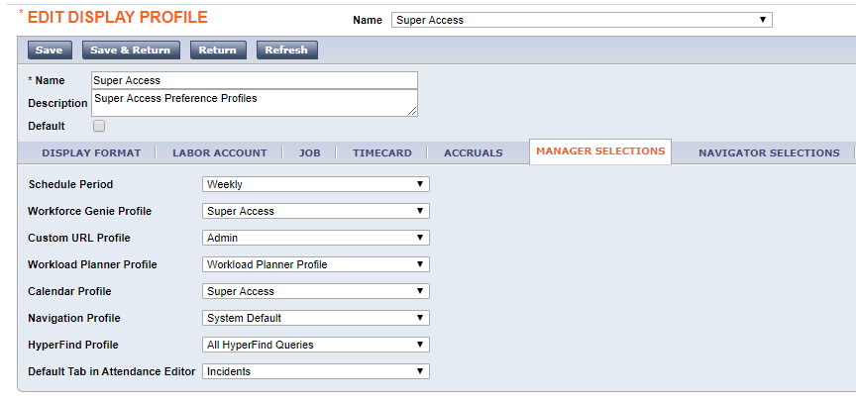

Calendar Genies
Calendar Genies provide managers and employees with a snapshot of timekeeping, scheduling, and attendance activities for a selected date range – typically 12 months. Calendar Genies can display exceptions, pay codes, hours worked (e.g. Regular, Overtime, Total Hours), shifts, and attendance events (requires Workforce Attendance licensing). Viewable formats include Weekly, Monthly, and Multi-monthly.
The system comes with a Calendar Genie template called “Work & Absence Summary,” which can be configured to your company’s specific needs.
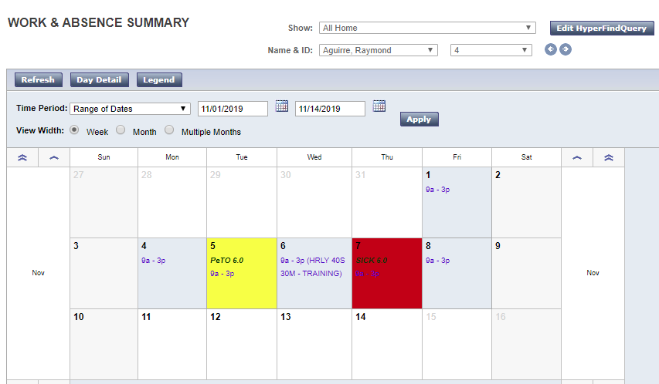
You can also create your own Calendar Genies using the steps on the following pages.
Calendar Genies, like standard Genies, are made up of building blocks:
Shift Time Bands define the starting time for each shift so that scheduled shifts can be identified as a background color when viewing an employee’s record. The system comes with three standard shifts – First, Second, and Third. Additional shifts can be added as necessary.
Calendar Data Elements define the specific activities or transactions which can be displayed in a cell of a Calendar Genie. Data elements can be configured to display in a different background or border color, text font/color, and options to include the description (long name or short name), amount, or transfer indicator. The system comes with several Timekeeping and Scheduling data elements which can be configured to your specific needs, or you can add new data elements.
A Calendar Data Set is simply a collection of Data Elements assigned to a Calendar Genie; similar to choosing the columns in a Detail Genie. The Calendar Data Set can be made up of data elements from any Domain (Timekeeping, Scheduling, Attendance) and Category (pay codes, exceptions, shifts, comments).
A Generic Calendar is similar to a Workforce Genie. The Generic Calendar defines the default HyperFind Query, the default time period (usually a range of dates), the Calendar Data Set, and the default view format (weekly, monthly, multi-monthly). Generic calendars can be assigned to both managers and employees (requires Workforce Employee licensing). The system comes with a generic calendar for employees and one for managers. Additional generic calendars can be created as necessary.
Calendar Profiles define which Calendar Genies a manager or employee is allowed to see. This is similar to the Workforce Genie Profile used for assigning standard Genies to managers. The system comes with a Calendar Profile called Super Access.

To modify or create new Shift Time Bands:
- Go to Setup > Calendar Views Setup > Shift Time Bands. 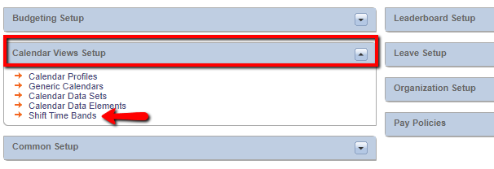
- Enter the earliest starting time for each shift (colors will be selected later).
- If adding a new shift, click New, then fill in the appropriate information.
When finished, click Save.

To modify or create new Calendar Data Elements:
- Go to Setup > Calendar Views Setup > Calendar Data Elements. 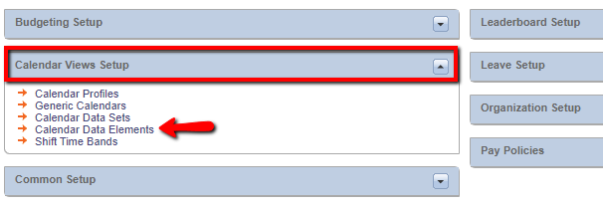
  - If modifying an existing data element, check the box next to the data element name, then click Edit.
  - If creating a new data element, click New.
- Select the appropriate Domain.
- Select the appropriate Category.
- Enter a name for the Data Element (must be unique).
- Select the appropriate pay code, exception, comment, or shift in the Available column and move it to the Selected column. For example, if you were creating a data element for Holiday, you would move the Holiday pay code to the Selected column.
- Click the Visual Presentation tab.
- Select either the Background or Border attribute, then click the browse button ( ) to select the color of the cell and the data within the cell.
- Select the font style for the text.
- Click the Data Display Options tab.
- Select the appropriate data options that are available for the type of data element being created. This is the text that will appear in the cell.
When done, click Save & Return.
Note: Each Data Element category has different options available for display. For example, a pay code data element allows you to choose colors for the cell and text, as well as font style and four data types. Comment data elements do not allow you to choose the color or text that appears in the cell.

To modify or create a new Calendar Data Set:
- Go to Setup > Calendar Views Setup > Calendar Data Sets. 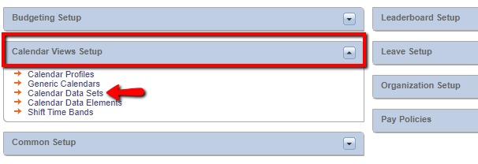
- If modifying an existing Calendar Data Set, check the box next to the data set you want to modify, then click Edit.
- If creating a new Calendar Data Set, click New.
- Enter the Calendar Data Set name – must be unique.
- Select the Domain (e.g. Timekeeping, Scheduling, Attendance).
- Select the Data Elements from each Domain that should be included in the Data Set by moving them from the Available column to the Selected column.
- Click the Data Display Order tab.
- Use the arrow buttons to define the order in which data elements will be listed if two or more elements occur on the same day.
- Click the Color Priorities tab.
- Use the arrow buttons to define what color is displayed if two or more data elements occur on the same day.
When done, click Save & Return.

To modify or create a new Generic Calendar:
- Go to Setup > Calendar Views Setup > Generic Calendars. 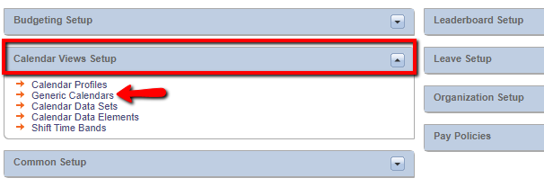
  - If modifying an existing Generic Calendar, check the box next to the generic calendar you want to edit, then click Edit. If creating a new Generic Calendar, click New.
- Enter the Generic Calendar name – must be unique.
- Enter the Display Name – this is the name that will appear in the Genie menu tab.
- Enter a description of the generic calendar (optional).
- Select the default HyperFind Query from the pick list.
- Select the default Time Period from the pick list. This is generally a Relative Range of Dates which will provide the employee or manager with a rolling time period, so a new time period doesn’t have to be selected each time the Genie is opened.
- Select the Calendar Data Set from the pick list. This determines what data elements will be displayed in the Calendar Genie.
- Select the default view format.
- Define the number of months across the screen in a multi-month view.
- Select the NavBar category under which the Calendar Genie will appear.
When finished, click Save & Return.

To modify or create a Calendar Profile:
- Go to Setup > Calendar Views Setup > Calendar Profiles. 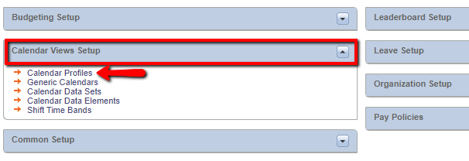
  - If modifying an existing Calendar Profile, check the box next to the profile you want to modify, then click Edit. If creating a new Calendar Profile, click New.
- Enter the Calendar Profile name. It must be unique.
- Click the appropriate tab for Manager or Employee.
- Select the Calendar Genies that the manager or employee can see by moving the Genies from the Available column to the Selected column.
- When finished, click OK.
- Go to Setup > Display Preferences > Display Profiles.
- Select the appropriate Display Profile and choose Edit.
- Click the Manager Selection tab in the Display Profile.
- Select the appropriate Calendar Profile from the pick list.
Click Save & Return.

Assigning Profiles to Managers
Now that you have created all the profiles that are needed, it’s time to assign them to the manager (and employee) accounts.
- Go to any Detail Genie, click on the manager or employee name, and use the Go To button to access the People Editor.
- If the user is not already assigned a manager license, open the License screen, then click the box for Workforce Manager.
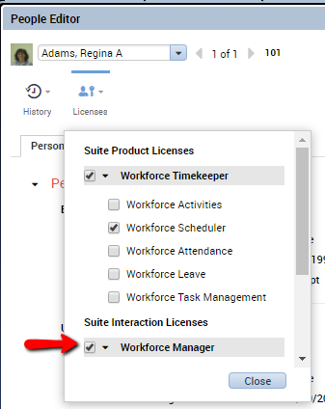
- 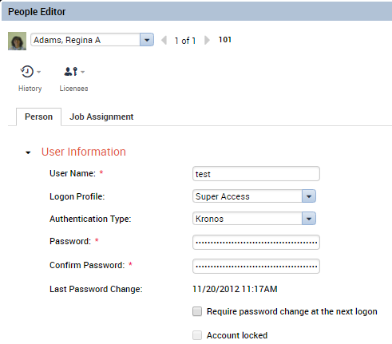Open the User Information section. Each organization is different, and you may or may not need to assign the username and password information.
If needed:
  - Type the username the manager will use to log in.
  - Assign the Logon Profile you created previously (jump to section).
  - Assign a generic password and confirm on next line.
  - Check the box to require a password change.
- Click the Job Assignment tab. 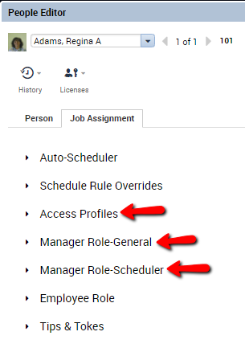
- Open Access Profiles.
  - Select the appropriate Function Access Profile (Jump to section).
  - Select the appropriate Display Profile (Jump to section).
- Open the Manager Role – General screen.
  - Select the Employee Group from the list (Jump to section). You can also create an Employee Group on the fly by clicking the New button.
  - Check the “Can see transferred employees” box.
  - Select the Labor Level Transfer Set (Jump to section).
  - Select the Pay Code profiles (Jump to section).
  - Select the Work Rule profile (Jump to section).
  - Select the Reports profile (Jump to section).
- Open the Manager Role – Scheduler section.
  - Select the Schedule Group, Pattern Template, and Shift Template profile from the lists (Jump to section).

Common Setup
The “Common Setup” area includes a number of functions that are typically maintained by the Kronos System Administrator

HyperFind Queries
HyperFind Queries are simply filters which allow managers to select a subset of employees from all their Home employees. For example, if a manager has responsibility for more than one department or unit, he or she may want to create HyperFind Queries so employee timecards for each department can be viewed and/or approved separately. The ability to create HyperFind Queries is granted in the Function Access Profile assigned to each manager.
HyperFind Queries are also used by the system to generate automatic notices that can be sent via email to employees and/or managers. These notices, which are called Workflow Notifications, are typically set up by the Kronos System Administrator.

Types of HyperFind Queries
Depending on the rights granted in their Function Access Profiles, managers can have the ability to create one or more of the following types of HyperFind Queries:
Ad Hoc – a temporary Query, good for as long as the manager is logged in or until it is changed.
Personal – visible only to the person who created it or to whom it is assigned.
Public – visible to all Workforce Managers. The ability to create Public Queries is generally reserved for the Kronos System Administrator.

Query Conditions
The manager’s Function Access Profile controls what filters can be used to create HyperFind Queries. Some of the filters that you may have access to include: Employee Name or ID, Primary Account, Worked Account, Pay Codes, Pay Rules, Exceptions (such as Late-In or Missing Punch), Employment Status, and many others. The conditions you have access to will be displayed on the “HyperFind Query” screen under the “Filter” column.

Creating HyperFind Queries
As previously mentioned, there are many conditions (filters) that may be used to create HyperFind Queries. The most commonly used filter is Primary Account, which will segregate employees based on one or more labor entries which make up their Home account.
The following is a list of steps to create a HyperFind Query based on Department using the Primary Account filter:
- Go to Setup > Common Setup > HyperFind Queries. 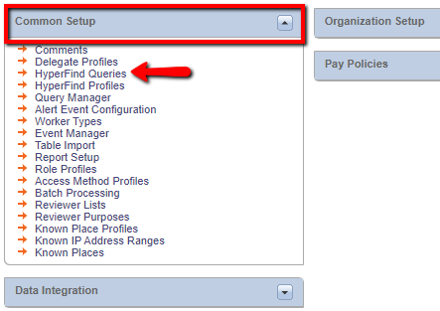
- On the HyperFind screen click New (or click New in the Show box of any Workforce Genie).
- Click the Primary Account filter (depending on the settings in your Function Access Profile, this may be the default).
- Click to the tab of the labor level which designates departments in your company, e.g. “Department.”
- Select the department for which you are creating the Query. You can either select it from the Search Results list and then click the Add button or, if you know the code for the department, you can key it directly in the box to the right of the Department labor level.
- Click the Add Condition button. You should now see this condition displayed in the Selected Conditions box at the bottom of the screen.
- Click the + sign next to the Timekeeper filter.
- Click Employment Status. Notice that it defaults to employees whose status is active as of today.
- Click the Add Condition button to select this as a condition.
- Click Save.
- In the visibility dropdown, select Personal – this will be saved as a Personal Query, visible only to you.
- Name the Personal Query with the name of the department you selected in step 5 above.
Click OK.
To test the Query, go to any Workforce Genie and click the down arrow in the “Show” box at the top of the screen. The Query you created will be displayed in the list along with any other Queries you have access to.
Note 1: You can select multiple departments within one Query.
Note 2: You can create Queries using other filters using the same logic used in the Query you created using the Primary Account filter.

Query Manager
After the Personal HyperFind Queries have been created, they can be assigned to the appropriate managers using the Query Manager:
- Go to Setup -> Common Setup -> Query Manager. 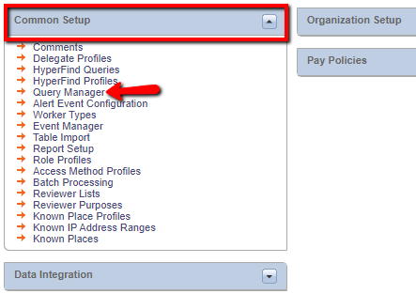
- Click the Find button on the Query Manager screen to display a list of all Personal HyperFind Queries that you have access to. The manager’s name will be displayed next to the Query name if it is assigned to that manager.
- Right click on the Query that you want to assign. Choose Assign from the pop-up menu.
- Find the manager’s name in the pick list and click to highlight it, then click OK.
- The system will display a message indicating the assignment was successful.
Repeat this process to assign the appropriate HyperFind Queries to the rest of the managers who will need them.
Note: In most organizations, the Kronos System Administrator (SuperUser) is generally responsible for creating a Personal Query for each department, and then assigning the Queries to the appropriate managers using the Query Manager.

Comments
Comments allow managers and employees to document specific information in employee timecards and schedules. Comments must be pre-entered in the “Comment” table in the database before managers and/or employees can use them. As noted in the Manager’s Guide, free text notes may be attached to comments.

To create a new comment for use in your system:
- Go to Setup > Common Setup > Comments. 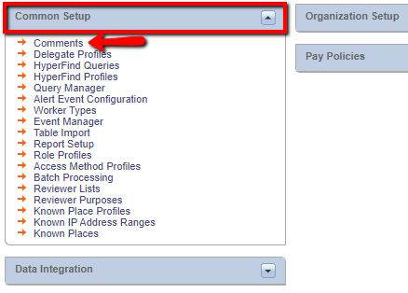
- Click New.
- Type the new comment in the Comment Text box.
- Assign a code number (optional – use only if you want to display comments in something other than alphabetic order which is the default).
- 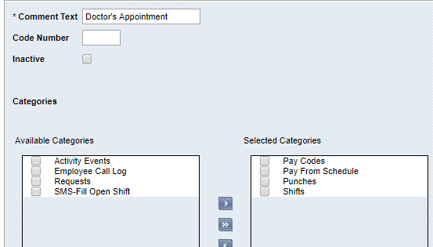Select which categories the comment can be used in by moving the appropriate category from the Available column to the Selected column. When finished, click Save & Return.

