Updating the Holiday Table
  - Kronos version 8.1

Contents
HOLIDAY TABLE 3
Holiday Table Initial Setup 4
Holiday Table Setup – Carrying Holidays Forward 5
Adding a Newly Recognized Holiday 6

HOLIDAY TABLE
A Holiday is a day for which an organization suspends normal operations. The Holiday Table contains all the holidays for an organization for the year. This master list of holidays must contain all holidays for all locations in the organization.
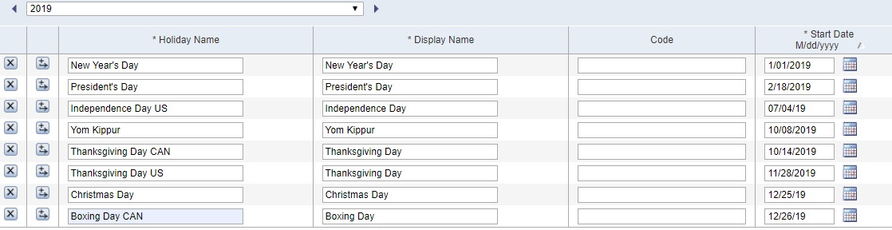

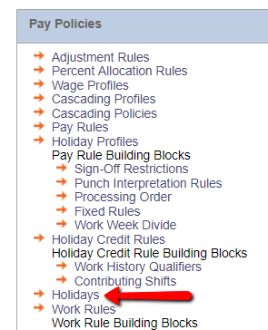
To access the Holiday Table,
access Setup and select
Holidays under the
Pay Policies menu.

Holiday Table Initial Setup

The holiday table setup will be completed during implementation. The holiday table contains the following information:
- Holiday Name and Display Name: All Holiday Names must be unique, but the Display Names can be the same. Example: Thanksgiving Day CANADA and Thanksgiving Day US can both be set to a Display Name of Thanksgiving Day.
- Start Date and End Date: will automatically populate but can be changed if needed.
- Code: a short name for the holiday that is used in calendar views.
- Start Time and End Time: default to midnight (12:00AM) but can be changed if needed.

Holiday Table Setup – Carrying Holidays Forward
- To carry holidays to the next year, use the right arrow to go forward to the next year.

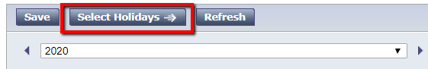
- Use the Select Holidays button to access the list of previously created Holidays.

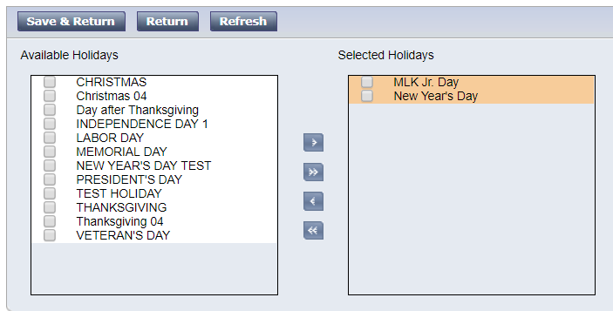
- In the Available Holidays box on the left, select all Holidays you wish to carry forward. Use the right arrow ( > ) to move them to the Selected Holidays box on the right. Then click Save and Return.
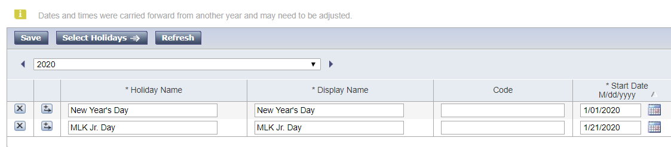
Adjust the start date if needed. The exact date from the previous year is carried forward. Holidays that typically need to be adjusted include Memorial Day, Labor Day, and Thanksgiving. When finished, click Save.

Adding a Newly Recognized Holiday
If you need to add a new holiday that your organization will be recognizing, the procedure is similar.
Note: It is recommended you reach out to the MM Hayes Helpdesk should you need to add a new holiday.

- Access the Holiday Table from the Pay Policies menu.
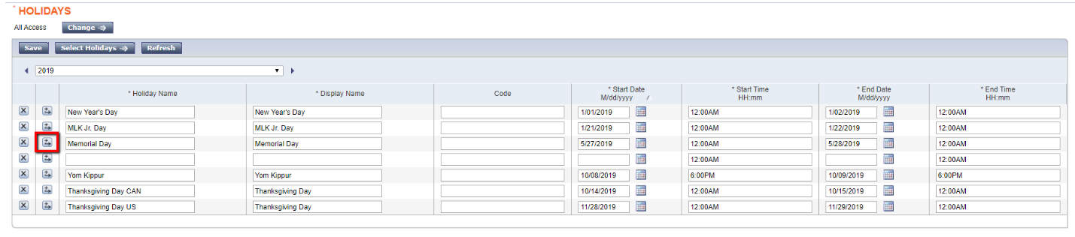
- Add a new row where the new holiday occurs chronologically. In this example, we need to add a new holiday for Labor Day. We will add a new row beneath Memorial Day, since this holiday occurs between Memorial Day and Veteran’s Day.
- Complete the holiday information across the table.

Updating Pay Rules
After you add a new holiday, you will need to apply it to each Pay Rule.
- Navigate to Setup > Pay Policies > Pay Rules. 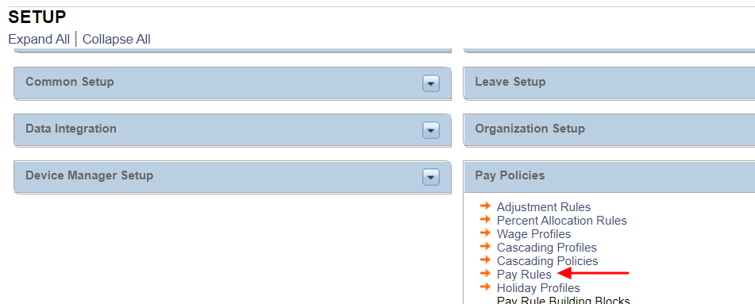

- Open each Pay Rule that the holiday will apply to. Check the box for the new holiday that you created. Repeat for each Pay Rule as needed. When saving, choose to “Create New Version Effective” and choose a date prior to the new holiday. Versioning the Pay Rules makes it easier to revert if there are any corrections needed to the new information. 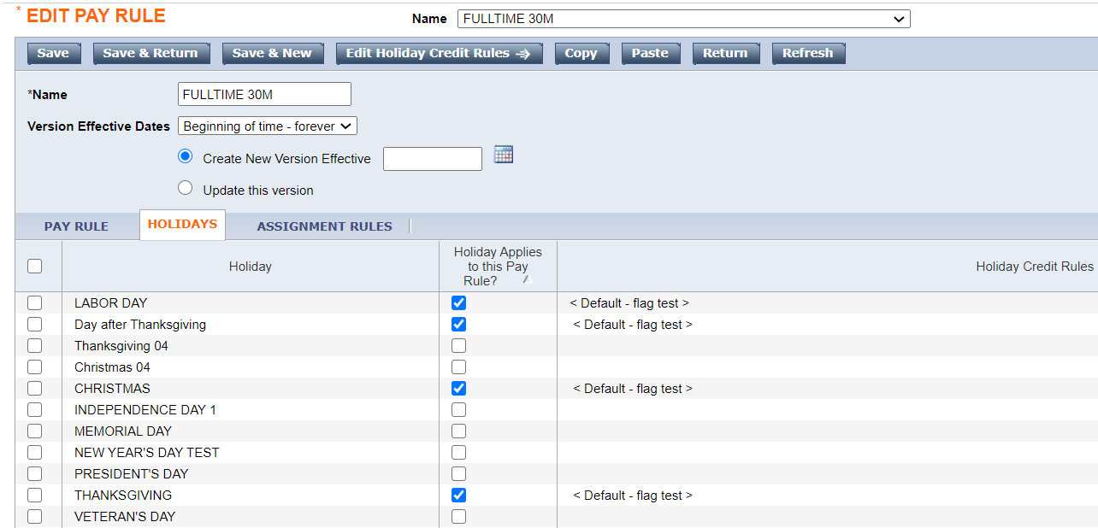

Updating Zones
The new holiday will also need to be included in the holiday zone. Navigate to Setup> Pay Policies> Zones. 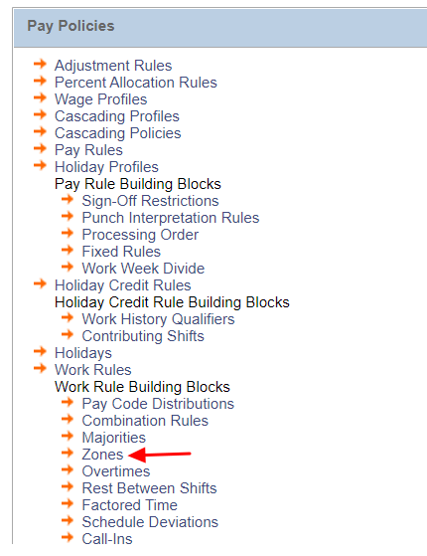
- Open the zone that contains the holidays for your organization. Typically, this zone is named “Holiday” or “Observed Holidays.” Find the new holiday that you created in the Available pane on the left. Select it and use the arrow to move it to the Selected pane on the right. Save.
