

Historical Corrections

kronos version 8.1

Contents

WORKFORCE TIMEKEEPER HISTORICAL CORRECTIONS 3

Version 8.0 Service Release 13 and Above 3

Enable Timecard Edits Following Payroll Processing 3

Add Historical Corrections 4

Historical Corrections Tab 7

Edit Historical Corrections 8

Delete Historical Corrections 11

View Historical Corrections from Current Pay Period 12

# WORKFORCE TIMEKEEPER HISTORICAL CORRECTIONS

## Version 8.0 Service Release 13 and Above

In version 8 Historical Adjustments are replaced by Historical Corrections. To do Historical Corrections, the Previous Pay Period needs to have edits enabled.

## Enable Timecard Edits Following Payroll Processing

Timecards in a signed-off period are un-editable during payroll processing. Depending on how you configured the Edits After Sign-off option, the system automatically makes the timecards editable, or, you can manually enable editing in the timecards.

Use Group Edits or an API to enable editing in timecards.

As stated above there are a number of ways to accomplish this. The options will be discussed during the Implementation or Upgrade of your system. At that time your company’s policy will be established.

The instructions listed below provide the steps to manually enable edits through a Group Edit. Please note that some managers might not be given the authority to complete this step. This will be defined by your company.

Group Edits

1. In a Genie, such as Pay Period Close or QuickFind, select the employee or group of employees.
2. Select Approvals and Enable Edits.
3. Click Yes in the confirmation box.
4. 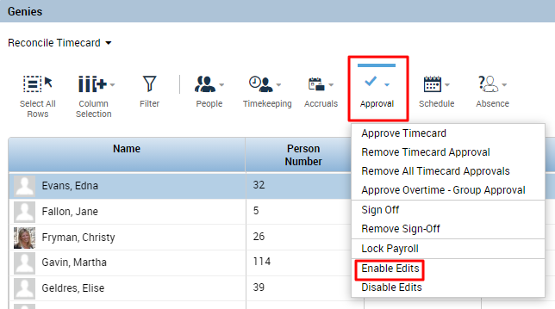Please note: The Enable Edits option appears only if the Allow Enable Edits for Employees access control point is set to Allowed in the manager’s Function Access Profile.
5. Select **Group Edit Results** to verify that the enable edit was successful.

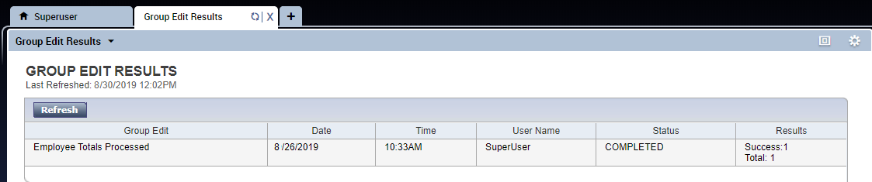  
  
  
In Version 8.1.9 and higher, there is an option to Enable Historical Edits from the timecard.   
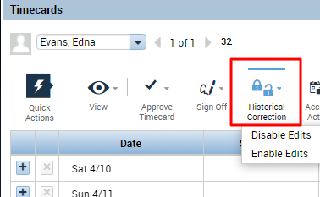

Edit signed off timecards. You can perform any edit in a signed-off timecard that you can perform in the current timecard.

## Add Historical Corrections

Users can only add historical corrections if Edit signed off time is set to Allowed in the Functional Access control Point (FAP) for the employee or manager.

1. Navigate to the pay period you wish to edit in the employee timecard.

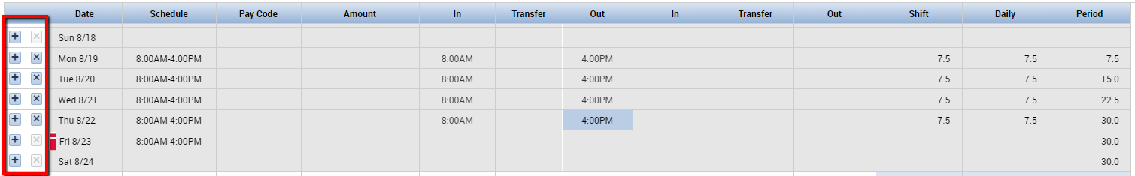

The “+” and “x” buttons on the left side of the timecard will be enabled when the signed-off timecard

is editable.

1. Enter a pay code or punch and the associated time.

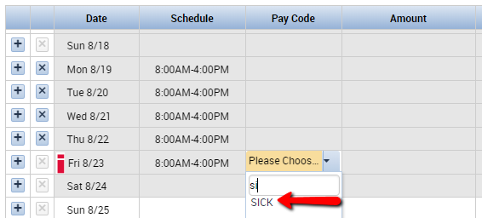

1. Choose **Calculate Totals ( )** in the upper right cornerto verify the results of the correction before saving. A black dot shows as the visual indicator that a Historical Correction was done on that day.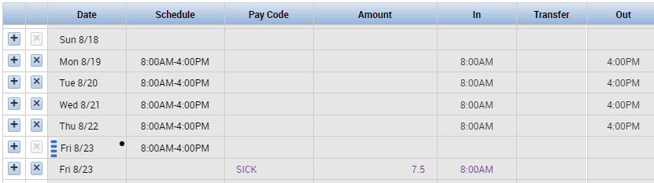
2. The Historical Correction will now also appear in the Historical Corrections tab beneath the timecard grid.   
   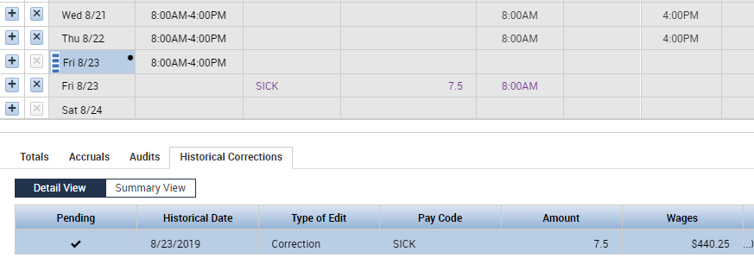

Optionally, right-click one of the pending corrections in the Historical Corrections add-on,

select **Edit** and perform the following actions:

* Enter or select an **Effective Date** for the historical correction to override the default effective date selected. The effective date depends on how your system is configured. Generally, it is the current date.
* Your system will have a default setting for the **Include Edits in the Totals** check box. The default setting may be to have this check box selected or unselected.  
  Select to **Include Edits in the Totals** if you want to pay the employee this amount in their next paycheck. (See the section on View Historical Corrections From Current Pay Period.)  
    
  Un-select the **Include Edits in the Totals** check box if you intend to handle payment  
  another way, such as a check paid to the employee directly. The correction will appear as “(paid)” on the Historical Corrections tab:



1. Right Click the Historical Correction and select **Add Comment**.

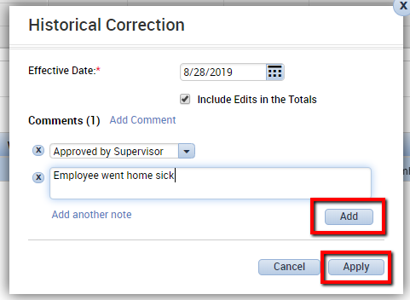  
Select a comment from the drop-down menu. Enter note text. Click **Add**, then click **Apply.**

**Note**: Kronos recommends that you add at least one comment to pending historical corrections.

## Historical Corrections Tab

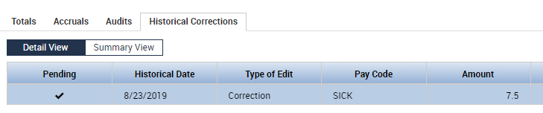

The pending historical correction will display in the Historical Corrections add-on. A check mark will

display in the Pending column for a new historical correction, or a modified historical correction that

has not been saved.

**Note**: Kronos recommends that you use the **Calculate Totals** button to **verify the results** of historical corrections in the Totals, Audit, and Historical Correction timecard tabs before you click **Save**.

You can also toggle between the Detail View and the Summary View to view information about the Historical Correction.

Detail View:



Summary View: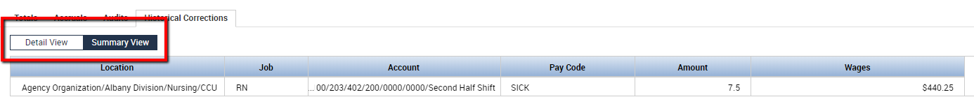

1. Optionally, edit or delete historical corrections prior to save:

* Right-click on a historical correction in the Historical Corrections add-on, or select multiple

historical corrections and right-click.

* Click **Edit** to edit historical corrections or **Delete** to delete historical corrections.

1. Click **Save**.



**Note**: A notification message will display if you attempt to make additional edits in the timecard before saving pending historical corrections.

A black circle will display in timecard days affected by signed-off edits, and a diamond will display in

timecard shifts affected by signed-off edits.

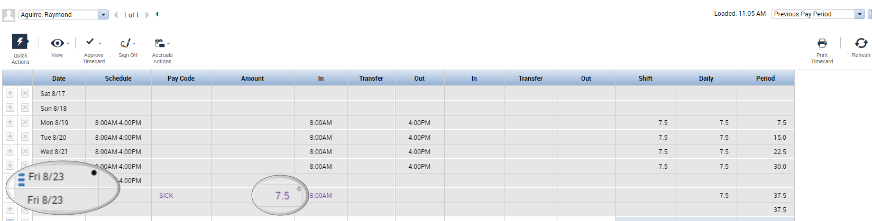

## Edit Historical Corrections

1. Navigate to the employee timecard and pay period with historical corrections you wish to edit.
2. Enter or modify a pay code or punch and the associated time, and then click **Save**.
3. If needed, click the **splitter bar** to view the timecard add-on tabs.
4. Click on the **Historical Corrections** add-on tab.
5. Right-click on a historical correction or select multiple historical corrections and right-click.

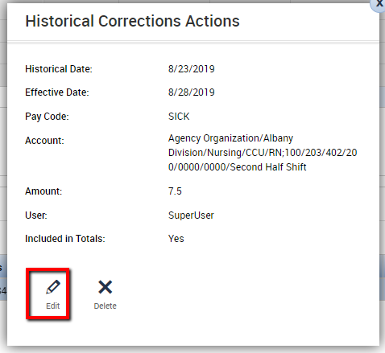

1. ****Click **Edit**.
2. Perform the following actions:

* Modify the **Effective Date**.
* Select or un-select the  
  **Include edits in the Totals** check box.

**Note**: When you modify multiple historical edits at the same time and their values differ (e.g., they

have different effective dates), the field or check box will display in a neutral state. If you leave

these values unchanged and click **Apply**, their values will remain the same. If you enter or select a

new value, the selected historical corrections being edited will be changed to that value (e.g. the

**Effective Date** selected).

**Note**: Kronos recommends that you use the **Calculate Totals** button to verify **the results** of historical corrections in the Totals, Audit and Historical Correction timecard tabs before you click **Save**.

1. Optionally, if you are editing historical corrections with different comments added to them, select one of the following options to update the comments accordingly:



* Keep Comment(s)
* Append Comment(s)
* Delete Comment(s)
* Replace Comment(s)

**Note**: Kronos recommends that you add at least one comment for each historical correction.

1. Click **Apply**.
2. Click **Save**.
3. In Versions 8.1.9 and higher, you have the option to disable edits at this point. Select the employee in either the timecard or the genie and choose the Disable Edits option.

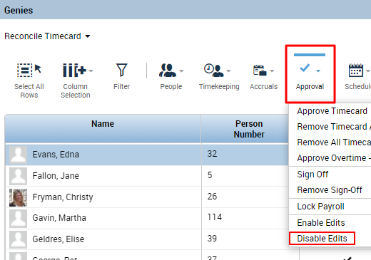

Editing will now be disabled on the timecard, preventing further edits from being made.  
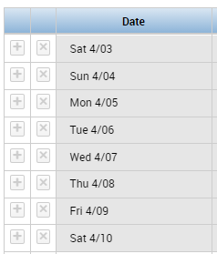

## Delete Historical Corrections

Users can only delete historical corrections if Allow delete of corrections is set to Allowed in the

Functional Access control Point (FAP) for the user.

1. Navigate to the employee timecard and pay period with historical corrections you wish to delete.
2. Click the **splitter bar** to view the timecard add-on tabs.
3. Click on the **Historical Corrections** add-on tab.  
     
   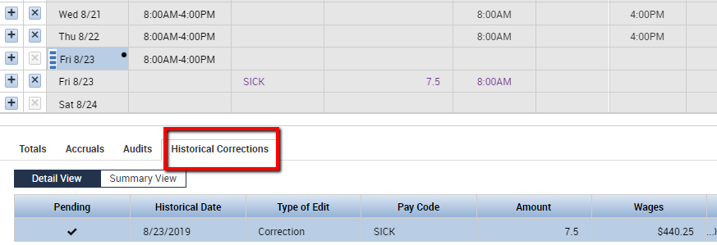

4. Right-click on a historical correction or select multiple historical corrections and right-click.

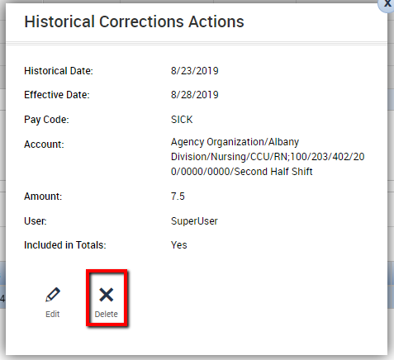

1. Click **Delete**.
2. Click **Save**.

View Historical Corrections from Current Pay Period

If you selected **Include Edits in the Totals**, navigate to the current pay period to see the effects of the historical correction in the current totals.

The 7.5 hours to be paid are included in the totals beneath the timecard grid.

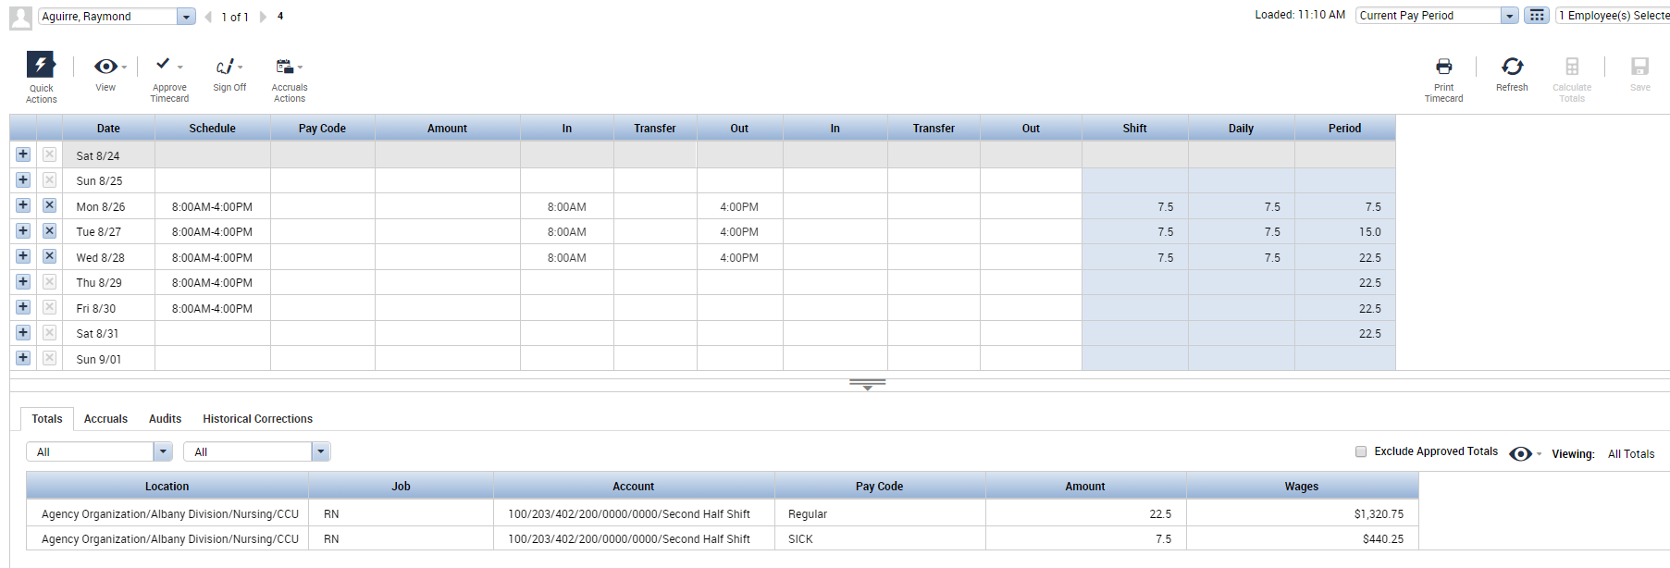

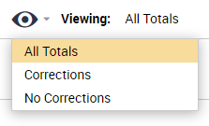  
  
  
  
  
  
  
  
  
  
  
  
  
  
Use the Viewing All Totals icon in the right corner  
to see the current pay period totals  
with or without the historical corrections  
that were carried forward.

Choose **Corrections** to view   
only the historical corrections.