Comment Enforcement Profiles
  - Kronos version 8.1.9+

Comment Enforcement Profiles
Building comment enforcement profiles was introduced in version 8.1.9. Comment enforcement profiles can be used to require a user to add a comment on a timecard. They can be required when adding or deleting a punch or a pay code, or for an overtime approval. There are three levels of comment enforcement:
- None: No enforcement.
- Warning: An informational message shows the user that comments are recommended.
- Error: Comments are required. If the user attempts to save a change without entering a comment, a message will appear, notifying the user that the change cannot be saved until a comment is added.

creating comment enforcement profiles
- Navigate to Setup > Common Setup > Comment Enforcement Profiles.
- Name the new profile. Use the dropdowns to set the enforcement levels for each different timecard action. The “Hours Worked” and “Hours Worked with Override” pay codes are system-generated codes for Project View timecards.
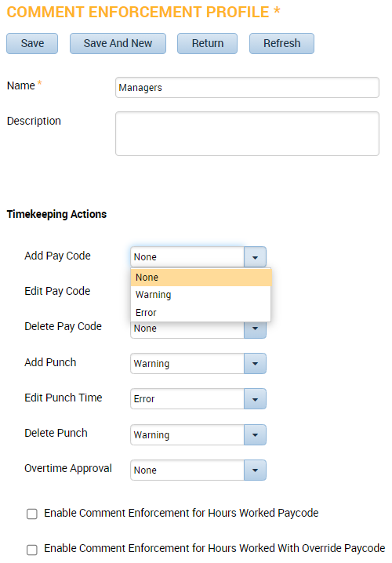
- If enforcing comments on pay codes, you must also enable comment enforcement on any pay codes that you want this policy enforced with. Navigate to Setup > Pay Policies > Pay Codes > Definition. Select the pay code that will be required to have a comment. Check the “Enable Comment Enforcement” checkbox. Repeat for all the pay codes that have comment enforcement.
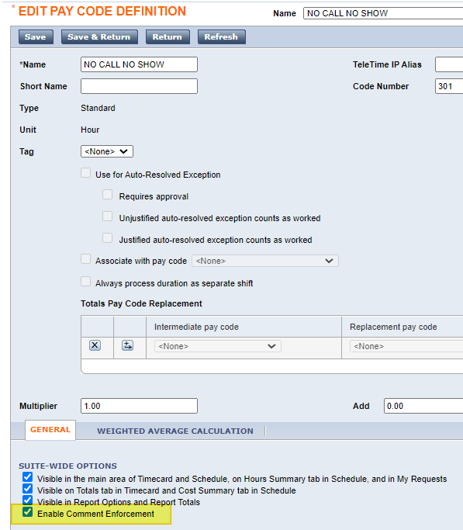

Assigning Comment Enforcement Profiles
Assign the Comment Enforcement Profile to the users. Select your employee and navigate to the People Editor and the Job Assignment tab. Expand the Access Profiles section. Assign the Comment Enforcement Profile.
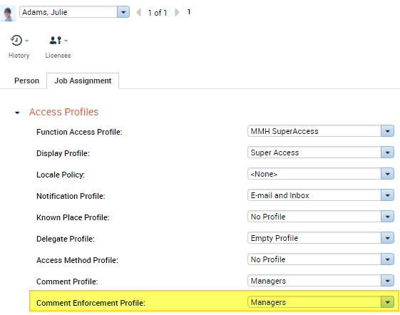
Please note: If your user also has a Comment Profile assigned, be sure that their Comment Profile contains the comments needed to meet the requirements of the Comment Enforcement Profile.

Enforcing Comments

Warning
When users perform a timecard action that is set to “Warning” in the Comment Enforcement Profile, they will see this message display if they try to save without adding a comment:
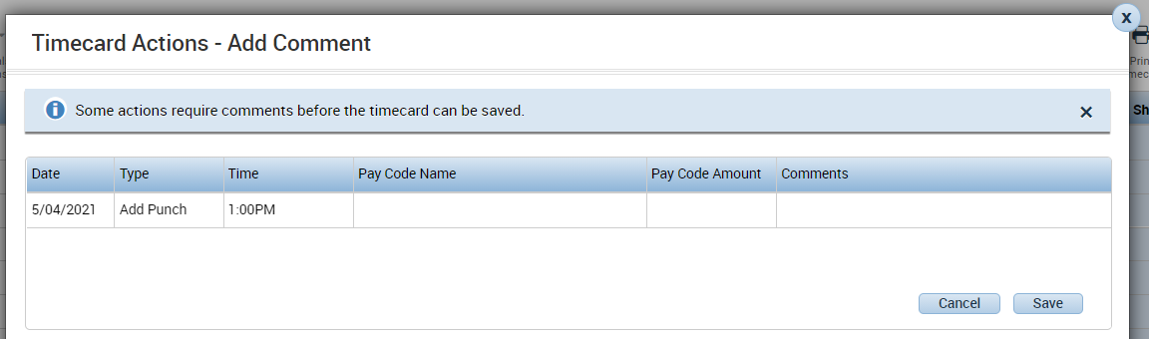
The user may click Save to continue without adding a comment. To add a comment from this screen, the user may click into the Comments field, then choose “Add Comment” to select from the dropdown list of comments.

Error
When users perform a timecard action that is set to “Error” in the Comment Enforcement Profile, they will see this message display if they try to save without adding a comment:
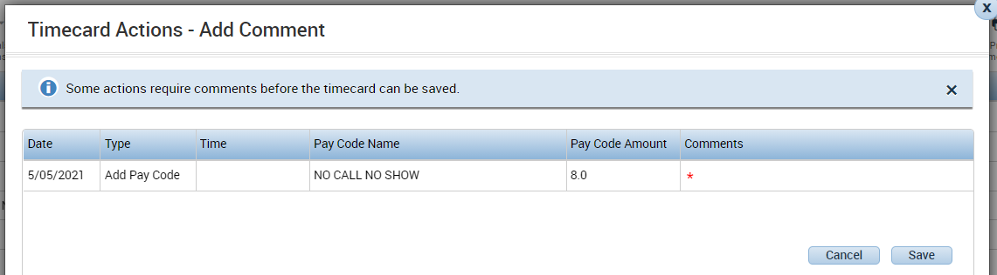
Note that a red asterisk appears in the Comments field, indicating that a comment is required. The user cannot click Save and continue from this screen without adding a comment. The user needs to click into the Comments field, then choose “Add Comment” to select from the dropdown list of comments.
The comment indicators on the timecard remain the same. 