Comment Profiles
  - kronos version 8.1.9

Comment Profiles

Building Comment Profiles
Building comment profiles was introduced in version 8.1.9. Comment profiles allow you to define a set of comments that are available to a user. Comment profiles are assigned to employees and managers in the People Editor. Building a comment profile allows you to customize the comments that are available to the users. The comment profile can be used to restrict access to comments in the Timecard, Schedule, Leave, and Request widgets.
- To build a comment profile, navigate to Setup > Common Setup > Comment Profiles.
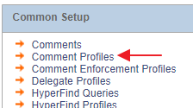
- Select New to build a new profile. Select the comments the users should have access to by moving the comments from the Available pane on the left to the Selected pane on the right.
Save when finished.
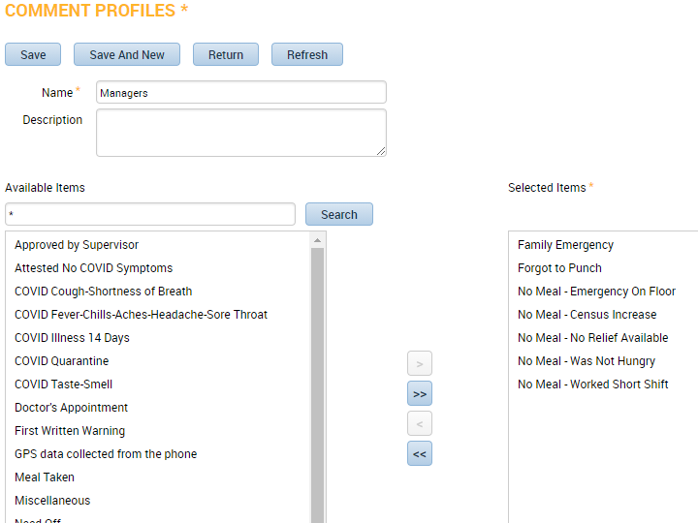

Assigning Comment Profiles
- Select the employee and navigate to the People Editor. On the Job Assignment tab, expand the Access Profiles section. The Comment Profile is assigned here. 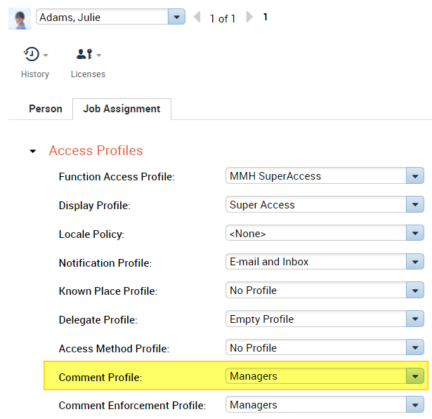
Now this user will only have access to the comments that are specified in the assigned profile.
