Time Periods

kronos version 8.1.9+



Contents

Time Periods 4

Creating Custom Time Periods 4

Time Period Profiles 6

Assigning Time Period Profiles 7

# Time Periods

Typically, there are 14 predefined time periods available in the Time Frame selector.   
These time periods are available for use in genies, timecards, schedules, and many other areas of the Kronos system.  
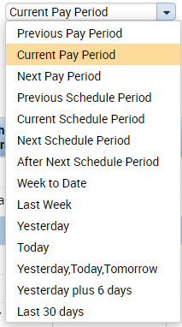

## Creating Custom Time Periods

Version 8.1.9 introduced the capacity to create a custom time period.  
To create a custom time period:

1. Navigate to Setup > Common Setup > Custom Time Period.

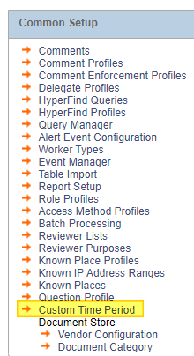

1. Set the specifications for the custom time period. The Time Period Type allows you to select the unit of time. Use the checkbox “To Current Date” to build a time period such as “Year to Date.”  
   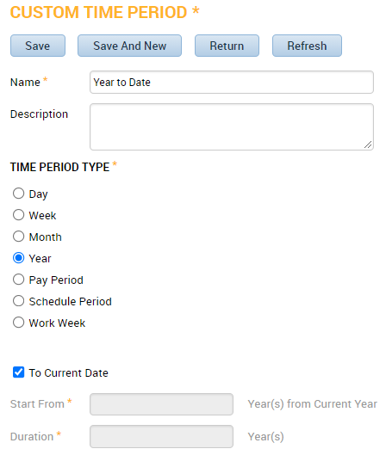  
     
   Or, use the Start From and Duration fields to set a range. Use a negative number in the Start From field to start the time frame in the past. For example, we are using a “-1” to build this time frame for “Previous Month.”  
     
   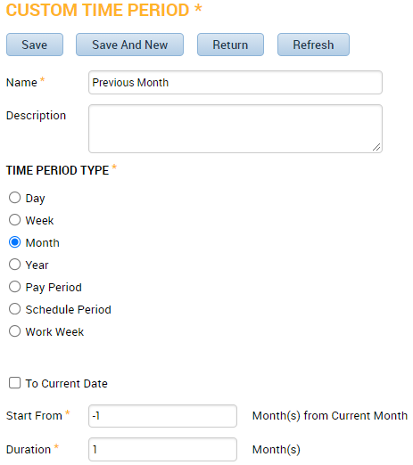
2. You may need to log out and log back in to see the new time period in the   
   Time Frame Selector. 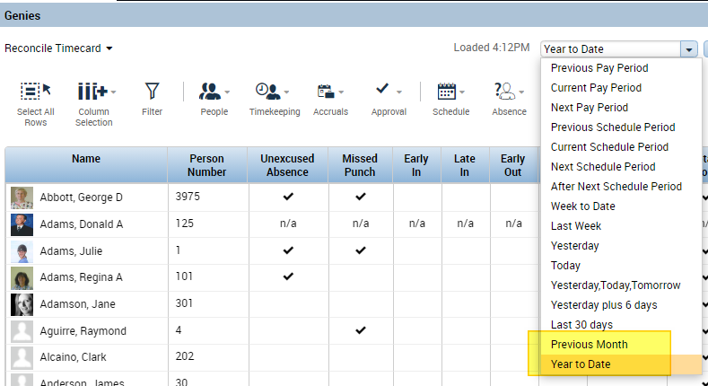

## Time Period Profiles

Version 8.1.7 introduced the option to create Time Period Profiles. The Time Period Profile allows you to limit the options that appear in the Time Frame Selector dropdown. Time Period Profiles are a building block of Display Profiles.   
  
Creating Time Period Profiles

1. Navigate to Setup > Display Preferences > Time Period Profiles.  
   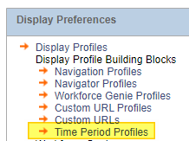
2. Name the profile. Select the time periods that the users will have access to. Move the selected time periods from the Available pane on the left to the Selected pane on the right. Save when finished.  
   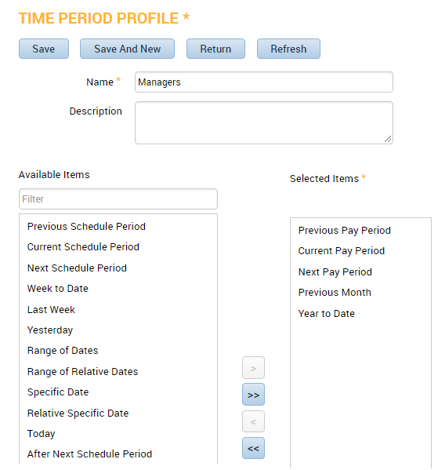

### Assigning Time Period Profiles

1. Select your employee and navigate to the People Editor. On the Job Assignment tab, expand the Access Profiles section. Confirm the Display Profile that is assigned to this employee. 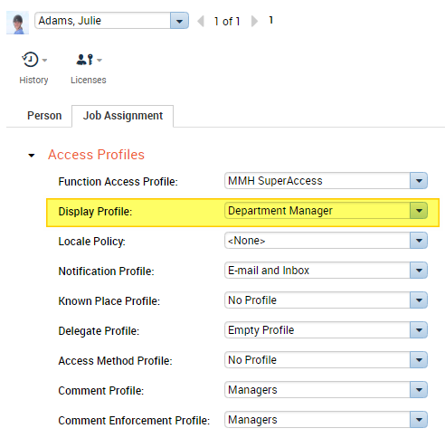
2. Navigate to Setup > Display Preferences > Display Profiles.   
    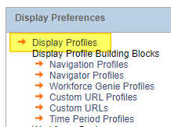
3. Select the Display Profile you wish to modify.   
   On the Manager Selections tab, set the Time Period Profile. Save when finished.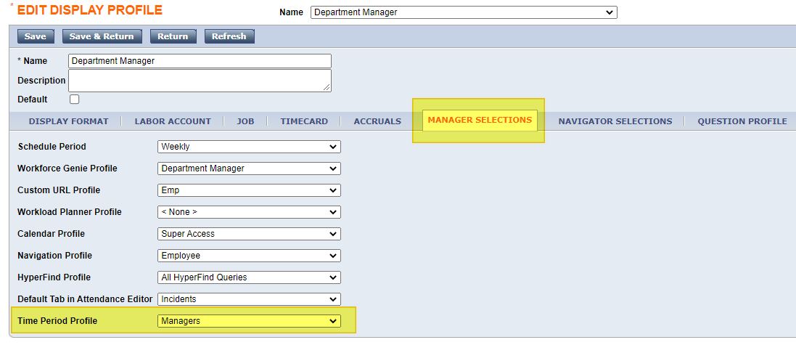
4. This employee will now have access to only the time periods selected in the Time Period Profile. 